placeholder-base---neutral.png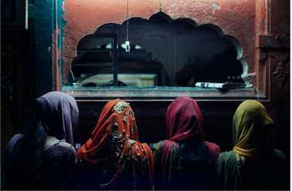

Emily Echevarria

TUL 560

Summer 2014

Poverty Assessment

Nizam nagar, nizamuddin, delhi

# Based off the Grameen Foundation’s PPI for India

✹

✹

DEMOGRAPHICS

On June 2nd, 2014, I intereviewed three women from the Nizam Nagar basti of Nizamuddin in Delhi. Zareena, Jana, and Tabassum answered questions from the Grameen Foundation’s India Progress Out of Poverty (PPI). The India PPI survey is geared to measure poverty in India from a simple survey that measures wealth by accounting for certain wealth-indicating possessions within the respondent’s home. The questionnaire can be modified for different countries and cultures, in order to measure poverty within that specific context.

Nizam Nagar basti is located in the traditionally Muslim Nizamuddin neighborhood. The portion of the basti in which the three respondents live is built upon a cemetery. Houses mix with graves, and the children play with goats upon Urdu-inscribed tombs. This neighborhood is not zoned to exist, and though most houses are brick-and-mortar, they stand precariously, vulnerable to governmental eradication.

And now, to introduce the respondents. Zareena is a 21-year-old woman living with her family in the basti. Her father passed away 10 years ago, so now she, her mother, and her brother provide financially for the extended family. She recently received her B.A. in History from Delhi University, making her the first person in her family to go to college. Jana is a wife and mother of four children. She stays home and takes care of the family while her husband works as a painter. Tabassum is 18-years-old. She recently became the first person in her family to complete 12th class exams, and in the fall, will become the first person in her family to attend college. She lives with her mother, father, and four younger siblings.

|  |  |  |  |
| --- | --- | --- | --- |
| Question | Zareena | Jana | Tabassum |
| 1. How many household members are 17 years or younger? | C) Two.  (11 points) | A) Four.  (0 points) | A) Four  (0 points) |
| 2. What is the general education level of the male head/spouse? | A) No male head/spouse.  (0 points) | D) Secondary  (5 points) | C) Middle  (3 points) |
| 3. What is the household type? | A) Labour – Housekeeping  (0 points) | A) Labour – Painter  (0 Points) | A) Labour – Construction  (0 points) |
| 4. What is the primary source of energy for cooking? | B) Gas stove.  (3 points) | B) Gas stove.  (3 points) | B) Gas stove.  (3 points) |
| 5. Does the household possess any casseroles, thermos, or thermoware? | B) Yes.  (5 points) | B) Yes.  (5 points) | B) Yes.  (5 points) |
| 6. Does the household possess a television and a VCR/VCD/DVD player? | C) Yes, both.  (9 points). | A) No, neither.  (0 points) | B) Yes, only TV.  (4 points) |
| 7. Does the household possess a mobile handset and a telephone instrument (landline)? | B) Yes, only a mobile.  (9 points) | B) Yes, only a mobile.  (9 points) | B) Yes, only a mobile.  (9 points) |
| 8. Does the household possess a sewing machine? | A) No.  (0 points) | A) No.  (0 points) | B) Yes.  (1 point) |
| 9. Does the household possess an almirah/dressing table? | B) Yes.  (5 points) | A) No.  (0 points) | B) Yes.  (5 points) |
| 10. Does the household possess a bicycle, motorcycle/scooter, or motor car/jeep? | B) Yes, bicycle only.  (1 point) | A) No, none.  (0 points) | A) No, none.  (0 points) |
| TOTAL | 43 points | 22 points | 30 points |

The respondents’ scores were then compared with the PPI Lookup Tables. These tables convert the scores from the PPI with poverty likelihoods of different amounts. I primarily used the R66 chart, as it uses more recent data than the other charts in Grameen’s resources.

According to the R66 table, of respondents who scored 22 points (such as Jana), 49.7% fall below the $1.25 poverty line, 89.8% below the $1.88 poverty line, 98.1% below the $2.50 poverty line, and 11.1% meet the qualifications of USAID “extreme” poverty. Of respondents such as Tabassum, who score 30 points on the PPI assessment, 30.5% are below the $1.25 poverty line, 74.7% are below the $1.88 poverty line, 91.7% are below the $2.50 poverty line, and 5.9% meet the qualifications of USAID “extreme poverty”. Finally, of respondents such as Zareena, who scored 43 points, 15.9% are below the $1.25 poverty line, 57.3% are below the $1.88 poverty line, 80.7% are below the $2.50 poverty line, and 2.0% meet the qualifications of USAID “extreme” poverty.

NOTES

While the PPI captures much information about the respondents’ poverty levels, it could not capture all of the nuanced information the women gave me. This valuable information should be weighed as well.

The respondents informed me that none of the basti’s residents have landline telephones because their neighborhood is not zoned for residential purposes. Their houses are built on a cemetery, and they technically live there illegally. All three respondents reported using gas stoves for cooking. However, the survey was unable to capture that when Zareena’s family’s gas tank runs dry, they cook over wood fire outdoors.

Both Zareena and Tabassum’s families have an almirah (armoire). However, they both qualified that it was only a small almirah. Zareena said she just recently got hers- it’s her first almirah ever, and she spoke of it with excitement. She shares the almirah with her brother’s 6-mont-old daughter. Jana’s family does not have an almirah. Her family’s only furniture is the family bed, which opens to store their clothes and belongings under the mattress.

RESULTS

The PPI results of Zareena’s family may not accurately reflect her family’s poverty status. She teaches Hindi to several foreigners, and thus has relationships with others who have a significantly different level of wealth than she has. When foreigners move, they often give things to Zareena’s family, knowing that they will be put to use. In this way, her family aquires things that are related to wealth without actually possessing the wealth to purchase them. For Tabassum and Jana, the PPI accurately reflects their wealth and poverty, but a different assessment tool may be better suited to measure wealth in Zareena’s family.

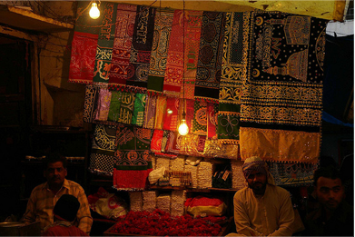

REFERENCES

“Progress Out of Poverty Index: A Simple Poverty Scorecard for India”. (2012). Grameen Foundation: Washington D.C.