The Course Logistics

The civil construction vocational training is a five-day course for unemployed males, ages 18-35, who have completed at least ensino fundamental (primary and lower secondary education). However, some exceptions are made for people over the age perimeter and for those who have not completed the educational prerequisites. The course does not guarantee employment upon completion but trains the participants in the entry position of an “auxiliar de trabalho”, more commonly referred to as “servante”. Upon completion of the course the graduates are assured up to three job interviews.

On the first day the participants perform an initial self-evaluation about how they feel in regards to their participation in the training. Another, more extensive self-evaluation is performed on the last day of the course. The course also focuses on training soft skills for the work place such as: communication, networking, attitude, professionalism and teamwork. The training is divided into two modules: “the work world” and “the civil construction world” (see Table 4). The former teaches practical work dexterities that may be considered as common knowledge by those with prior profession work experience. These lessons include subjects that address self-esteem and other psychological attributes. The latter portion of the course focuses on practical skills for working in the civil construction field. Topics such as safety, terminology and techniques are taught during this portion of the course.

The final day of the course reinforces lessons taught throughout the week regarding “soft skills” and substance abuse prevention. The course concludes with a one-on-one feedback time with each participant and a member from SECONCI whereby the participant receives a hardcopy evaluation from their overall participation. The evaluation process is carried out by the course mediators based on each participant’s communication, motivation, punctuality, conviviality, concentration and participation. The final component of the course is a time of celebration. During this time the participants, mediators and staff from SECONCI share reflections and commemorate the tremendous sacrifice and accomplishment of having completed the week endeavor.

During the first day of the course the participants receive a t-shirt that they are required to wear throughout the week. They are also given a backpack with a notepad and a pen to take notes and two booklets that serve of the guide of the course. Everything is free of charge including lunch and a snack, Monday through Friday. Mid-week the participants are even given a food basket and a small stipend to help pay for travelling to the two offsite training locations.
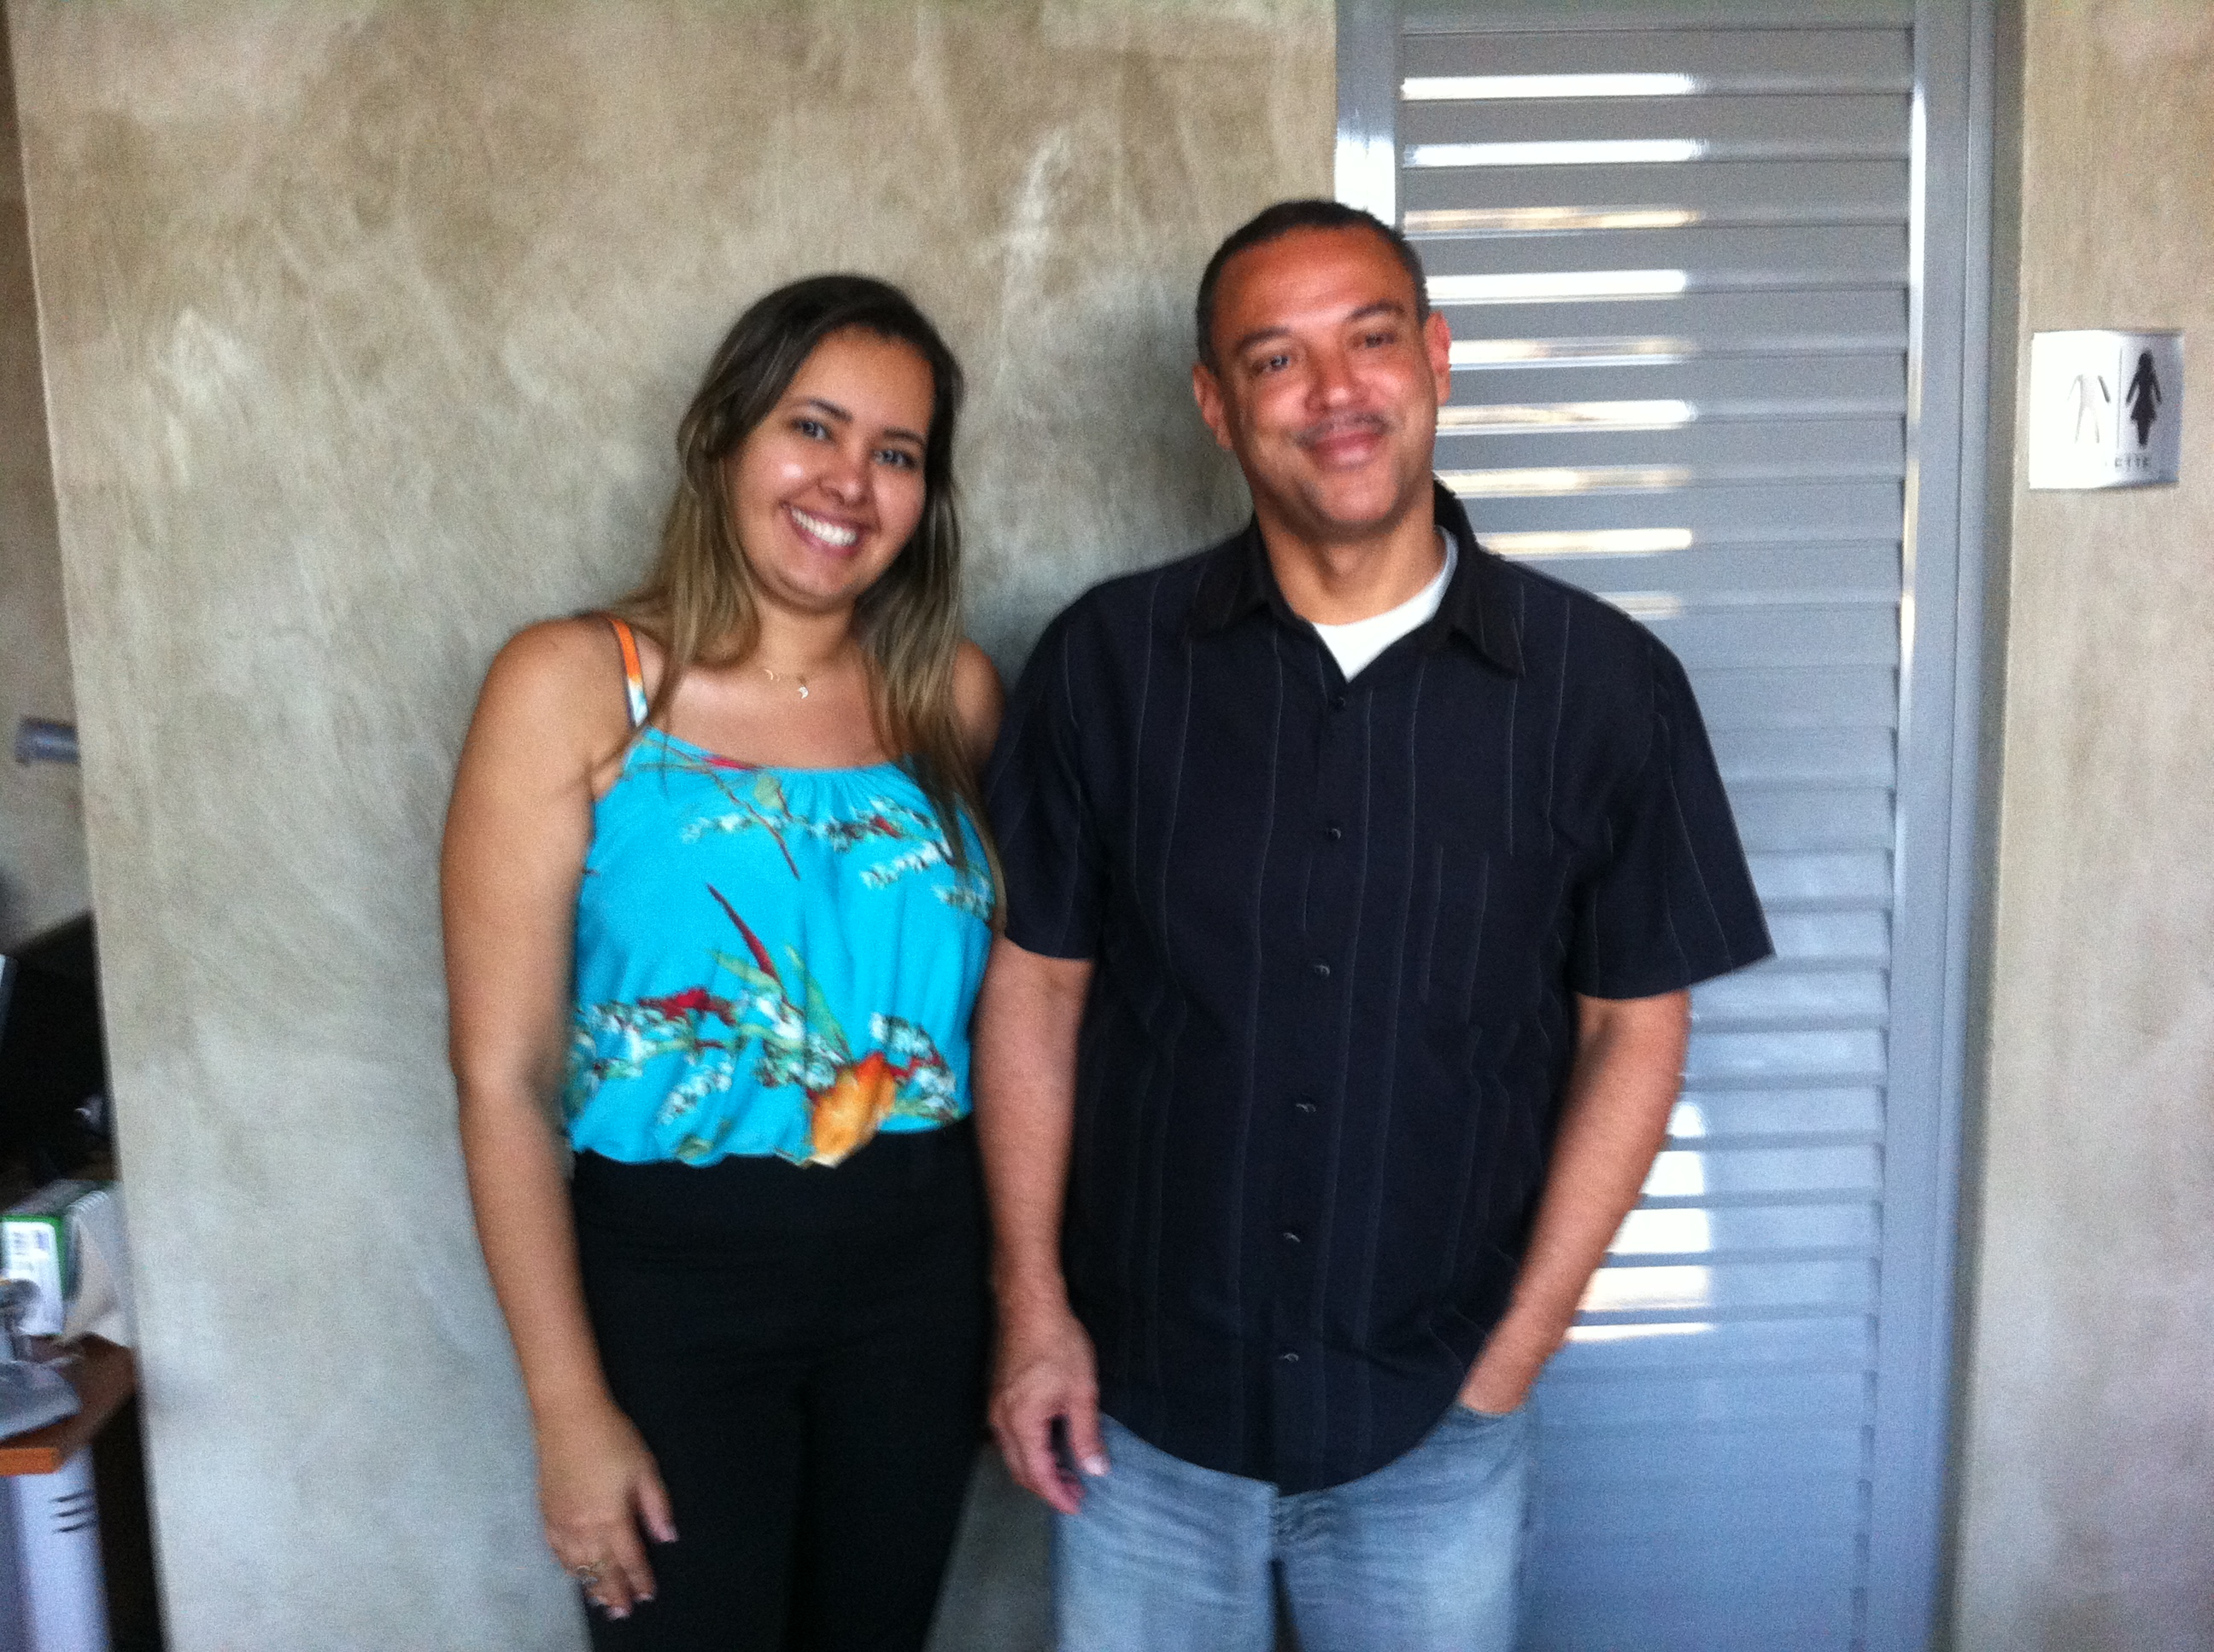
Figure 13-Rio de Paz Members: Janaina (left) and Marcos (left) are the members from the NGO in charge of all the work on the ground, including the training course of this study.

Term 10

On the morning of June 2, 2014 I walked from the Avenida Dom Hélder Câmara bus stop past the unpaved path occupied by homeless people, both young and old, sleeping on the trash infested grounds. A few had woken up early, or possibly did not sleep, to start smoking crack-cocaine, as I usually witness whenever crossing this dirt path past the municipal elementary school and exposed rubbish heaped train tracks to enter the community of Jacarézinho. Entering through the hole in the concrete wall one can see the multitude of makeshift homes divided by the Jacaré canal. My destination, the NGO Rio de Paz, is found in the heart of the community in front of this the sewage filled channel.

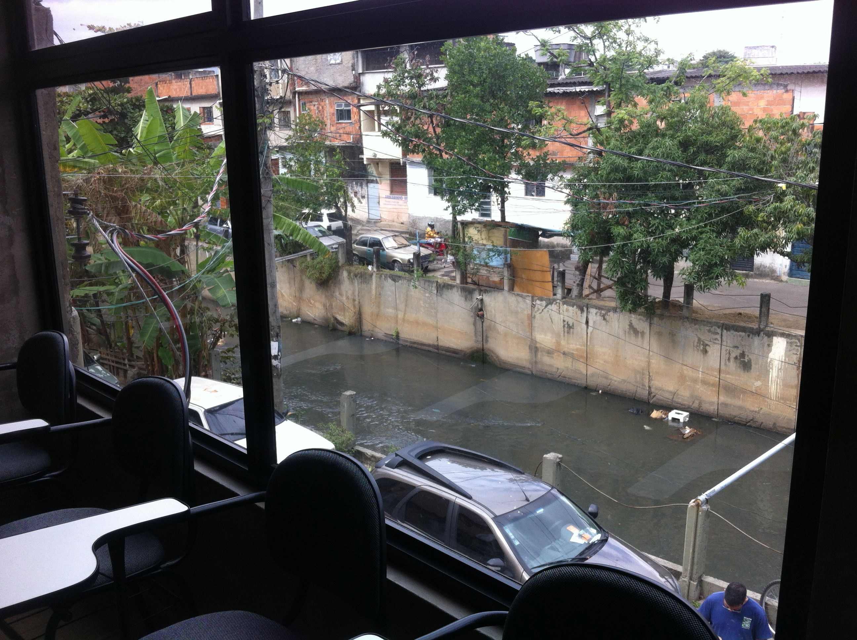
Figure 14- Classroom View: One can see the rubbish in the Jacaré canal that runs through community from the classroom where in course in administered.
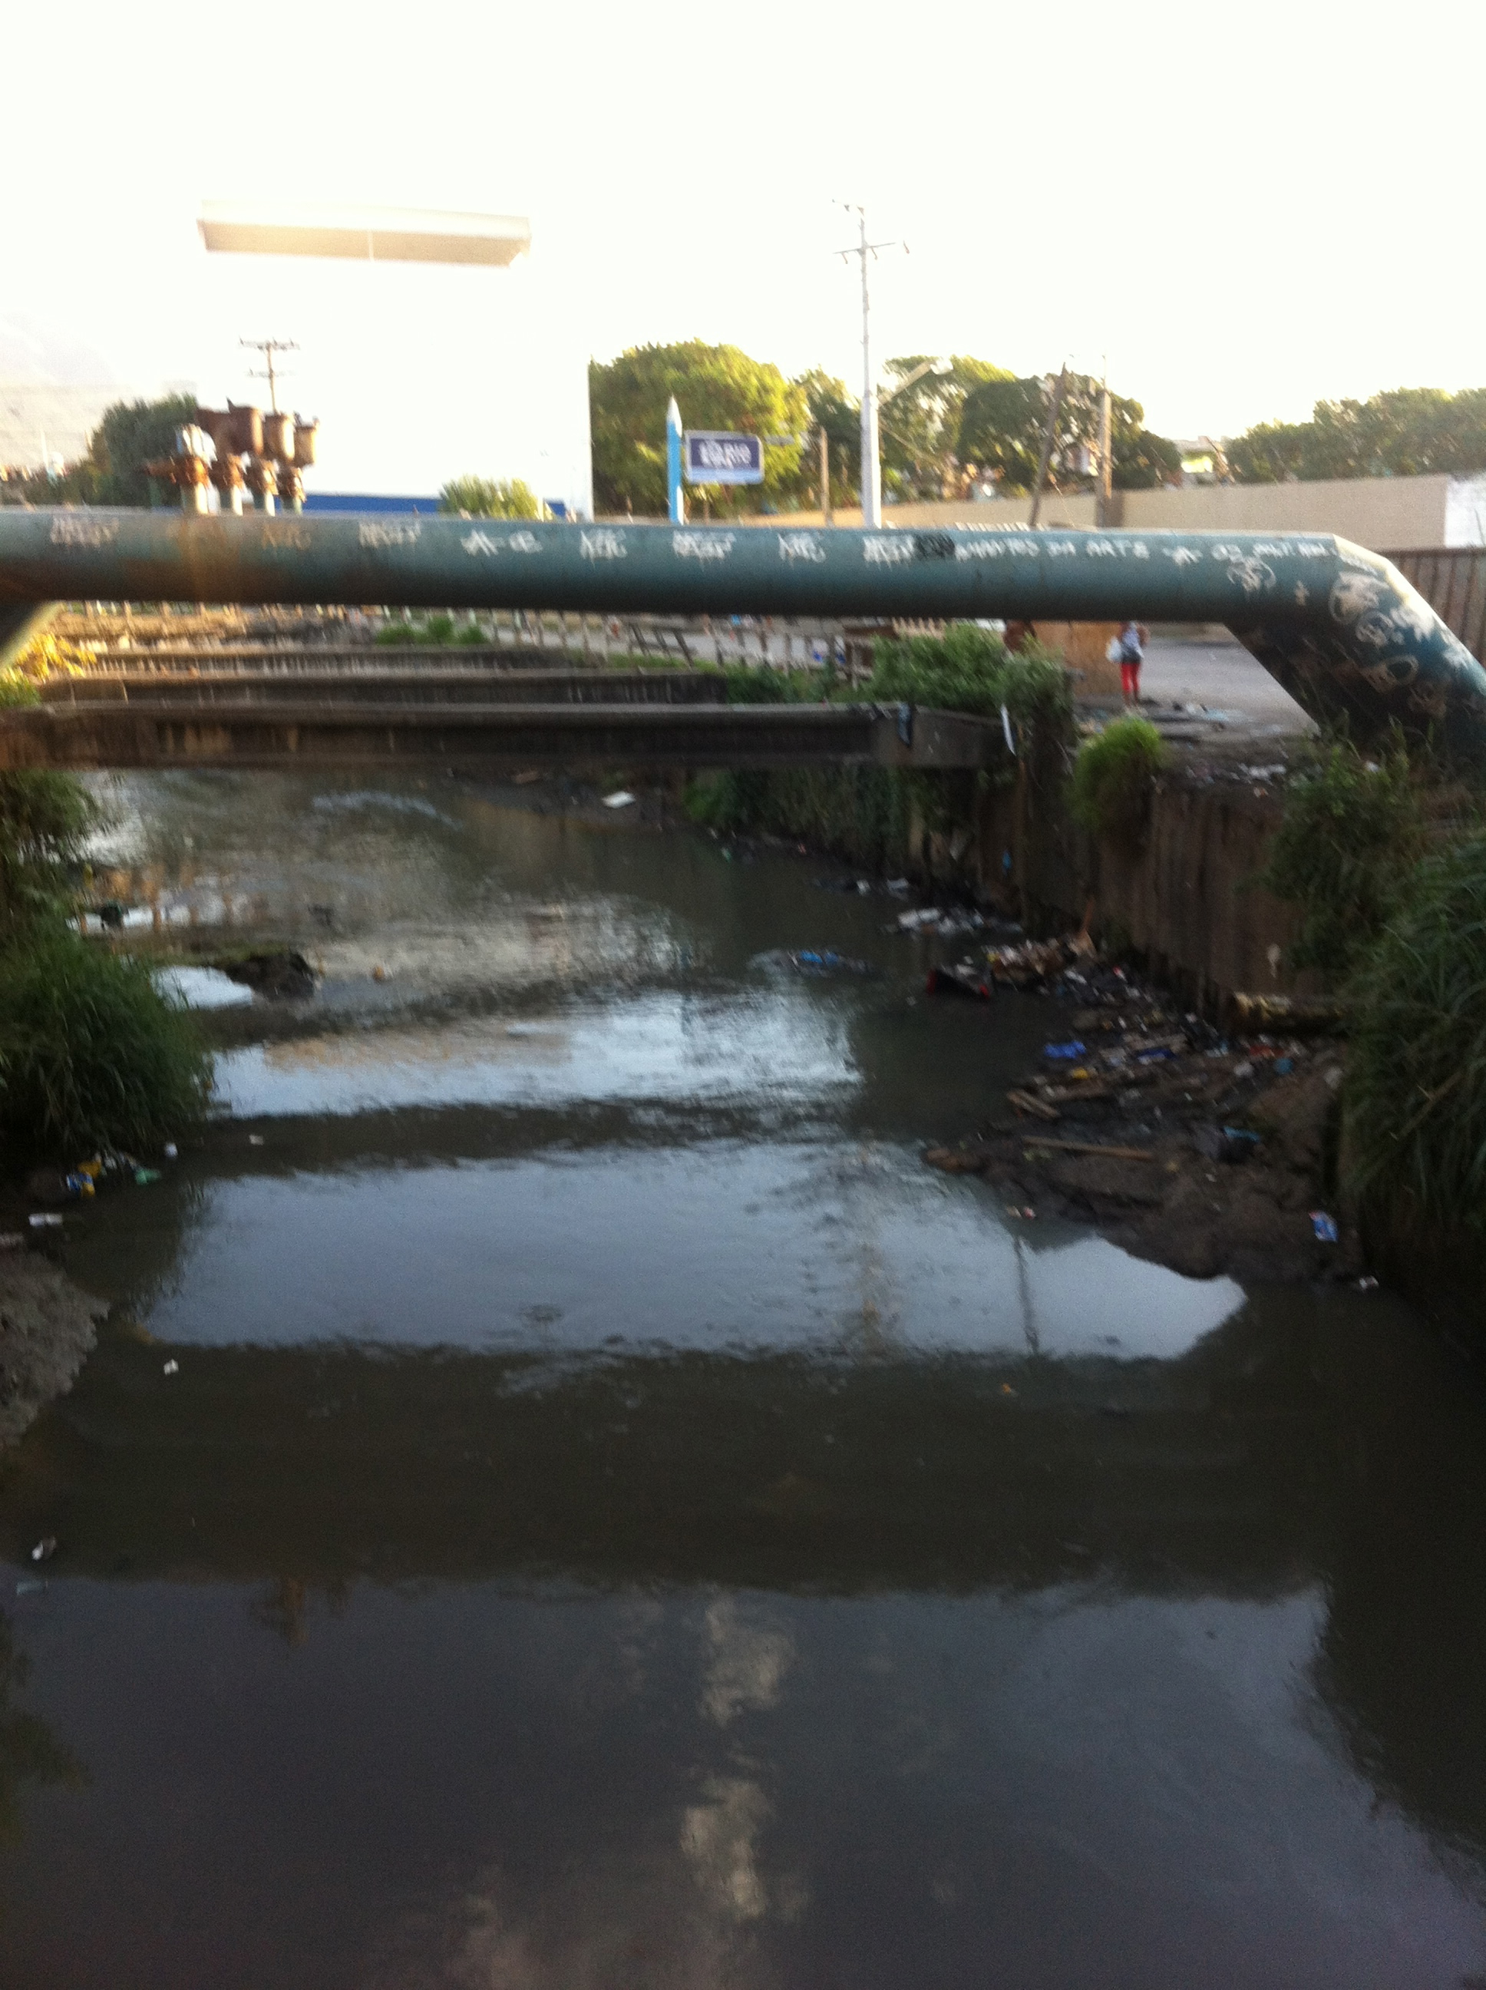
Figure 15- Entrance to Jacarézinho: One can see the meager sanitation the in Jacaré canal when walking down the path form Av. Dom Hélder Câmara. To the right (not visible in picture) is where the usual crowds of people, young and old, sleep and use drugs in during the daytime. Sometimes one will see people showering with the canal water in the broad daylight
It was the first day of Term 10’s civil construction-training course, and I was there to observe the course, which followed the structure of Table 4. Beginning with the first material (topic) about Personal Image. Luzia, the psychologist and research guide for this project, taught this course plus an additional two other topics throughout the week. A gentle and kind woman, Luzia was a favorite of many participants due to the participatory manner in which she taught her subjects.

The course began with an exercise where the participants had to answer the question, “who am I?” by drawing a picture of themselves. Afterwards they were asked to share with the picture with the rest of class. During this time one of the participants said that he is a “bischo” (animal). Another person was so nervous when presented his picture that he could barley stutter a response. He mumbled that he is a, “hard-working and humble man.” Conversely, most of the other participant had no problems communicating. The majority of the men stated their aspirations to “vencer” (succeed) in life and drew thought-provoking pictures of themselves.

During this time one the participants said in regards to his current unemployed situation, “It is chato (annoying) to wake up Monday morning with nothing to do.” Afterwards the class discussed the importance of proper communication, e.g. not using slang words, and networking.

The class was very participative, giving examples of personal experiences and partaking in the conversation spontaneously. Luzia talked about how they communicate to the people the outside of the classroom with the t-shirt that they wear during the course. She gave the example of a previous participant who she witnessed smoking marijuana nearby the NGO one day after he had left the course. The example was well received by the participants.

During the course, I glanced outside the window of the classroom at the slum community. A middle aged, nearly naked women staggered by the garbage filled canal that sits in front of the NGO. She conveyed the appearance of someone who had not slept for days and probably was a crack-cocaine user like the many others who surround the premises of the community day and night.

Next the participants played a game with balloons-filled with course jargon on the inside. After hitting the balloons in the air like beach balls, the participants popped the balloons and were asked to read the word on the piece of paper inside. The terms consisted of words like “marginality” and “carteira assinada” (social security benefits for Brazilian workers). The participants who popped a balloon were asked to read the term on the inside and explain their understanding of it.

As I glanced outside the classroom window again, a group of 5 UPP’s (pacifying police officers) walked by with their assault riffles in hand. The police officers usually stand at the main entrances of the community and around the two bases located in the community. At this point I did not think about why they were walking around the NGO until the subsequent events that occurred in the afternoon.

After lunchtime another mediator introduced the next topic, safety at the workplace. Ironically, the class was dismissed early for fear that everyone’s safety was in jeopardy due a shooting that happened in the community. Marcos, the community leader who manages Rio de Paz, escorted a group of us to the outside of the community in order to assure that we would not get caught in the confusão (chaos) happening outside.

The next day the course resumed as if nothing happened the day before, as most of the community members are accustomed to similar situations on a frequent basis. This day of the course was strictly on civil construction. Helymar, the course mediator, addressed the need to adapt with the new technology implemented in the CC field today. By approaching each topic addressed with real life situations, Helymar added life values to his talk about the CC field.

For example, he explained how the more time a worker waste at a jobsite, the less the entire company benefits (including the wasting of materials). He showed how CC worker not only benefits the company but also themselves with interactive dialogues were the participants asked questions and volunteered to engage in examples given by the mediator. He also talked about the importance of not trash littering by gracefully alluding to a participant whom he witnessed throw their disposable coffee cups in the canal outside the NGO that morning. The advice was well received by the participants.

The session was finalized by demonstrating the importance of planning ahead. By mentioning illustrations of people who build their homes in the favelas, an example that all could lucidly see by looking outside the classroom window, he demonstrated how many people build without planning, e.g. making a blueprint. During this time it appeared that many participants underwent the light bulb moment where they realized how planning ahead is constructive not only in the CC field but in everyday life.

They discussed how making a plan could lead to a better overall effort in constructing a home. Helymar explained that by making a plan the bedrooms of the house can be constructed in an area of the home less exposed to the sun throughout the duration of the day. In turn, the room will not only take less time to cool down, but will also produce a significant cost cut on the energy bill. The class concluded by examining the hierarchy of jobs in the CC field. The mediator encouraged the participants that though they maybe starting at the bottom of the totem pole, the opportunities for promotion in the field are many.
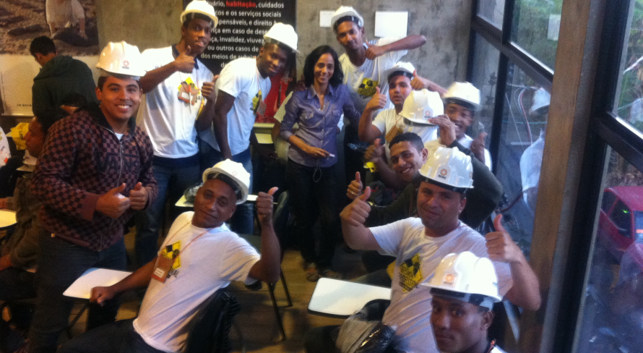
Figure 16- Term 10: The image displays some of the participants from Term 10 and Luzia (center) in the classroom at Rio de Paz.
The following day’s course consisted the topics on how to properly interact with others in the workplace and about proper etiquette in the workplace. The participants also received a small sum of money to pay for transportation to the jobsite and to SECONCI for the final day’s endeavors. There were also given a “ciesta basica”, a food hamper that includes the basic essentials for about a month. A daughter of one of the participant’s, who was no more than ten years old, attended a few classes throughout the week. The father later told me that he had eleven children.

The next day the first half of the course was conducted at one of PDG’s job-sites near Jacarézinho. During this time, the safety technician’s from PGD spent extra time going over safety at the workplace, since participants had to leave the course early during this portion of the course on Monday. One of the technicians made note of the dreadful statistics regarding safety in the CC filed in Brazil and commented on the 7 workers who died in the process of preparing the stadia for the World Cup.

He also mentioned that the civil construction sector produces the second most deaths annually in Brazil. The reason for so many accidents, he explained, was due to the fact that so many workers operate under the “Jeito Brasileiro” (the Brazilian way). People are often in a rush to get things done and do not properly use safety equipment. The safety technician also talked about how Brazilian culture often does not tend to plan ahead and how this lack of planning leads to a lackadaisical work environment. The participants were very attentive and interactive during this time at the worksite, especially during the safety talk, which lasted for the majority of the visit.

Another safety technical described the dangers of drinking on the worksite and gave an example of a worker that she had to fire after giving him numerous chances regarding this matter. The technicians also talked about injuries that often occur due to improperly picking up heavy materials. The importance of protection from over exposure to the sun and getting a physical, which is required by most construction companies, including PDG, was discussed during this time.

After a tour around the worksite, the participants were introduced to an Inspiring worker who shared his experience with the group. After working many years as a servante, the lowest position in the trade, he decided to participate in a course that helped him get promoted. He now drives a Ford Fusion, a car with the starting price of $BRL 98,000 (app. $USD44, 000) and a substantial indicator of success. The visit was completed by a final discourse encouraging the participants to enter into the “growing” CC field.

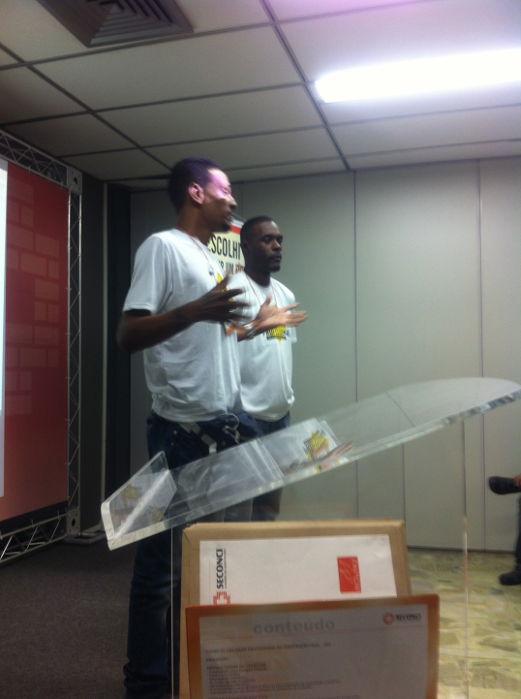

Figure 17- Term 10 Graduation: The image displays two participants from Term 10 expressing their gratitude and what they learned throughout the course of the week.

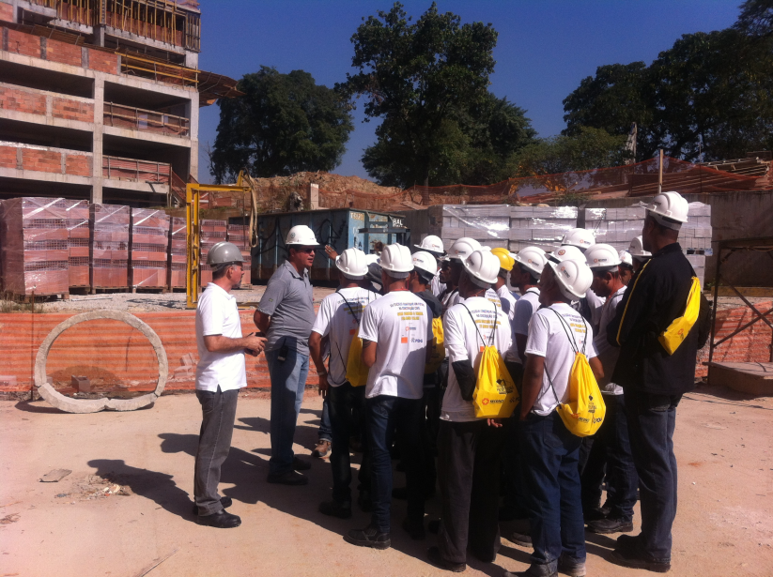

Figure 18- Construction Site Visit: The image displays Term 10’s visit to a PDG jobsite during the course of the week. Helymar (left) was the guide from the course who gave instruction as well along with some of the safety technicians from PDG.

On the last day of the course the participants seemed very excited and motivated to get working in the civil construction field. This was evident from the people I spoke to on this day, especially the people that interviewed. I also notice that towards the end of the week a lot of the participants started to dress nicer and even got haircuts. During the first half of the day the participants had their final topic at the NGO with Luzia where they did their course reflections (see Figure 20). During this time they were asked to draw or write about who they were before starting the course, during the course and who they are now after having nearly completed the course. The majority of the participant demonstrated significant transformations produced by the course in their reflections.

After lunch, the participants traveled together to SECONCI for one last lecture regarding the prevention of drug and alcohol abuse. Another physiologist led the conversation about drug and alcohol prevention. This was her first time mediating during the week, and although she was rather dry, the majority of the participants seemed to be very interested in the topic. From the ten participants that I collected data from in this term, approximately half of them admitted that they abused or used drugs and alcohol in the past, which may be the reason why so many seemed to be fascinated on the matter. Next, the participants underwent an individual exit interview with one of the staff members from SECONCI where they were given feed back on their overall participation throughout the week. The last section of the course was the “formatura” (graduation).

The graduation ceremony was quite animated and emotional. During this time two of the staff from SECONCI gave some words of encouragement. They then asked a volunteer lawyer at Rio de Paz and me to share some words. Nevertheless, the most inspirational part of the event was when two the participants voluntarily shared their thoughts with the group. One of the middle aged participant, talked about how the course had given him another opportunity in life saying, “God has taken me, like many others, from the den of lions.” Both of these participants expressed their gratitude and amiably explained some of the ways that the course has helped them vencer. After the ceremony I conducted my interviews with the sample section (Group 1) from this term.

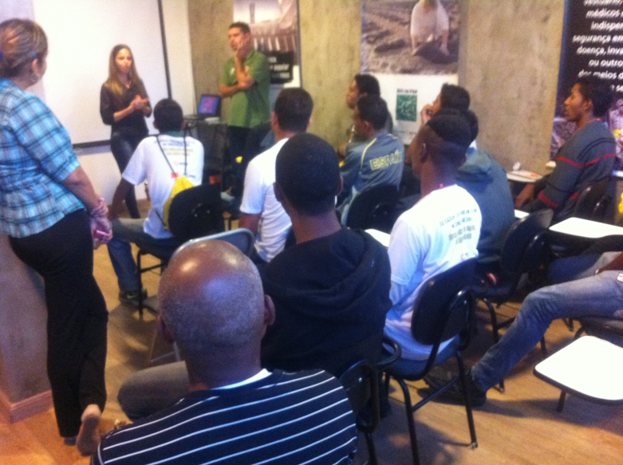

Figure 19- Classroom Time: A lawyer who volunteers at the NGO talked to Term 10 about the importance of knowing constitutional rights and expressed the willingness to help people who were in need of legal assistance.

Participant Stories

The stories shared during this research project are far and wide. With that said, one of the younger participants from Term 10 shared about how he started working in CC field with his father at the age of 12. His mother passed when he was still an infant and he father died when he turned 15 years old. Since his grandmother could not afford to support him and his other three sisters he was forced to support himself with the small salary that he earned as an informal construction worker. Now, at the age of 22, he recently married and his wife is expecting their first child. He said that he decided to take the course because he wants to become a “professional” in the civil construction trade and to continue climbing in the trade. It was interesting that both participants had the required documents to work with when visiting the construction site.

Two brothers from Term 10, one 36 and the 31 years old, participated in the course in order to seek an alternative to livelihood to the trafficking of drugs. The younger brother did not know how to read and write. However, he was the one that seemed most motivated to work and to mudar (change) his life. During the initial selection process he shared a little bit about his past life as a trafficker and revealed a bullet wound on his abdomen. Both had prior experience working in construction and demonstrated high participatory levels throughout the course. Furthermore, the two seemed to be much more in their element during the visit to the construction site, as opposed to in the classroom.

Another story from Term 10 includes a 25 years old professional soccer player. , He wanted to take the course in order to have a “backup plan” since he plays for a small club in Rio and is already consider an “older” athlete in the trade. He also mentioned that he would make more money working in the construction sector than he is currently making as a professional soccer player. After starting the course with his cousin, however, only he was able to continue on because his cousin did not have the proper documentation to work in the CC field. He was very well behaved and disciplined throughout the week.

A participant from Term 8 (Group 2) informed me that he had been working with a construction company for a couple of months but stopped because the company was backlogged on their payroll. He said he wanted to take the course because CC is an area that is growing and was unemployed at the time. He is currently enrolled in a free carpentry course because he wanted to keep growing in the area and it was the only course offered at night, allowing him to work during the day. He mentioned that he plans to do another course that he has to pay for afterwards in order to keep on growing in the field.

A participant from Term 2 (Group 2) expressed that he wanted to take the course in order to have more opportunities to work in the CC field. Even tough he 58 years old retired and does not need to work for financial reasons, be he said that he prefers to work rather than doing nothing at home. He worked for most of his life as a garbage collector but enjoys construction work and wants to keep learning and growing as a worker for as long as he can. He mentioned that he has had one interview since completing the course last year, however, the company called him afterwards only to inform him that they would call he “later” when a position is available. He has yet to work in the field since completing of the course.

Another participant from Term 8 (Group 2) decided to take the course because he is in regime aberto, a program that allows jail inmates to work outside of the jail compound during the day from Monday through Friday. The inmates have to return to the jail during the nighttime. He said that the course helped him a lot, especially in regards to his self-esteem because came out of the jail feeling like “scum.” He mentioned that most impactful part of the course for him was the part that addressed safety in the workplace because he lost a friend to a work related accident during the time he was taking the course.

After the course he has not worked in the field because Rio de Paz offered him a position as a paid volunteer coordinating projects in the jail. Upon obtaining this function he has brought about ten other inmates to do the civil construction-training course at Rio de Paz. He has also refused four offers to work in the CC field because he enjoy the current job that he is doing, even though he would make more money as a CC worker.

A participant from Term 5 (Group 2) mentioned that he was given an opportunity to work in the field immediately upon completion of the course but was not able to work because he did not pass the vision portion of the pre-work physical. He wanted to take the course because he was unemployed and the CC field is an emergent market. He is working in another field but is going to get surgery on his eyes and start a course to be a safety technician in August. The most impactful aspect of the course was the visit to the jobsite because it was what made him realize that he wanted to be a safety technician.

One participant from Term 10 (Group 3) mentioned to me during the course that he worked at an upscale restaurant in Ipanema on the weekends as a valet driver. At 43 years old, he has informal experience working as a mason and has worked many other jobs. He wanted to take the course in order to better his life by pursuing a career in civil construction. He started working on in the CC field on July 1, 2014 and mentioned that the course has helped him a lot when he is at work. It also gave him confidence during the job interview for this job and helped him know how to dress and act during interview. He said that he wants to do another course to be a “machines operator” and keep growing in field.

VI. Data Analysis

“God has taken me, like many others, from the den of lions.”

During the data analysis, five emergent themes were developed in regards to the information collected from the participant samples. The themes address a variety of topics mentioned by the participants and research guides in relation the social impacts of the training course, with a special emphasis is placed on the topics mentions by participants during the data collection processes.

Data Themes

Personal Image

Many of the participants mentioned that the course taught them how to “behave”. This included allusions of the importance on one’s physical appearance and they way that one express themselves with other. Most participant made statements such as “one’s demeanor is very important” when asked what the most important thing that the learned in regards to personal image.

Numerous participants mentioned that they learned about the importance of ones personal appearance during this portion of the course. An interesting comment made during this time was that the first impression is that one that lasts. Many also mentioned the way that one dresses is extremely important, especially during a job interview.

Participants also frequently mentioned the importance of knowing how to behave according to ones environment. People mentioned examples such as not goofing around with friends in the workplace and treating others with respect. A few acknowledged the workplace is a like a team or a family and therefore everyone is to be respected regardless of differences. Others mentioned that proper communication is important and slang should not be used in the workplace.

Safety & Health

A majority of participants stated that it is important to always use the appropriate safety equipment (EPI’s) at the workplace. One participant mentioned how this topic was the most impactful feature of the course because he lost a friend to a work related accident during the time of the course. Another described how the visit to the jobsite was very impactful because he realized that he wanted to pursue a career as a safety technician because it is jobs that help others be safe at the workplace.

Many others mentioned that safety and health are “fundamental for good development”. Acknowledging that this matter involved not only ones personal health and safety but also the wellbeing of others at the jobsite. Therefore attention to detail is an essential aspect of ensuring safety at the workplace and helps to prevent accidents from occurring. By taking care of one’s own health and safety you also consider the health and safety of others at the workplace.

Other people mentioned the significance of health in the pursuit of safety at the workplace. One person mentioned the importance of being up to date on their immunizations. Most other noted that health and safety are interrelated matters that produce both personal and communal benefits for the construction workers and for the construction companies.

Self-Confidence

Just about every participant that I interviewed at some point mentioned their gratitude and aspirations to grow in the CC field. Many were overwrought by the simple fact that they were deemed “worthy” to be given a free training course. Others also shared their astonishment that the people from the course actually took the time on the final day to give them individual feedback. Almost everyone described how that they really enjoyed classes with Luzia, the psychologist.

One person said that the most impactful part of the course for them was all of the sessions with Luzia because of the energy that she put into teaching. He went on to say that you could tell that she is doing what she loves. Another participant said that Luzia’s class was the most important to him because it was the first course on Monday morning and it set the tone for the rest of the course. Others said things like the matters she taught are important because they are relevant for everyday life.

Other participants described how the topic on education and citizenship was the most impactful to them because it taught them a lot about the rights and duties that I have but do not currently implement. For example people stated that they have that a lot have rights and duties to fulfill, in and out of the workplace. Some mentioned specific rights that they have as workers in the CC field.

In regards to the individual feedback time many mentioned that they were surprised that the people from SECONCI actually took the time to do given them individual consideration on their progressions throughout the week. When asked about what they learned during this time, some cited specific areas of growth identified during this time. Some mentioned that they were very encouraged that a company from “outside” would believe and invest in the people of the favela.

Other described how they felt respected that the people took the time to listen and give attention. One participant who had recently been released from a four-year sentence in jail explained how this time helped him understand that he is on “the right track”. He expressed how it taught him that can accomplish things, after having worked extremely hard to complete the weeklong course.

When asked why they wanted to participant in the course many responded that wanted to learn about CC and build a career in the field. However, some opened their hearts and shared their story and struggles as under qualified and marginalized workers. When asked about their aspirations after having completed the course many used poignant adjectives like: satisfied, accomplished, optimistic, happy, confident and hopeful. Other mentioned that they are looking forward to work in the CC field.

Quality

Many participants expressed their desire to continue to study and growing once placed in the CC field. The majority of them described this “growth” as a two-part process. One of personal growth and the other as the construction company grows, which occurs simultaneously. When asked why people wanted to work in the CC field, many described it as an opportunity for employment in an area that is growing. Other mentions that though many enter the field as a “servant”, that it is just an entry-level position that presents other opportunities to grow in the future.

This idea of the CC field as an area of growth was focused mostly on the opportunities to grow in ones career. Some also mentioned that Rio de Janeiro is place where a lot of construction work is happening due to the mega-event happening. Others mentioned that importance of doing work of high quality in order to avoid double work and the wasting of materials.

When asked how the most impactful thing learned during the course in regards to “quality”, many answered that it is about dignity. That is, it is about being a good professional and constantly to growing as the company one works for simultaneously grows. One participant responded that he learned that he could do anything, if he puts his mind to it.

Many others responded that quality is about teamwork. That is, because no one works in the CC field along, nothing can be accomplished individually. Others said that CC work is a reciprocal effort because one has to work well with other workmates in order to complete any task. This requires for one to get along well with their co-workers. A participant said that the CC field is a business that gives you a good quality of life, referring to the good salary entry position workers earn.

In regards to the prevention of drug and alcohol abuse many participants stated that neither should be used at the work place for various reasons. Most referred the matter as a safety hazard for all people in the work place. Others mentioned that it would be counter productive at the workplace. One participant compared using drugs or alcohol in the workplace as “throwing away” the investment that the company has given you.

One participant from Group 2 agreed that they should not be used at the workplace and admitted that a lot of people do so. Another person compared the preservation of his body and connected to the production and quality of work that he is able to produce. He said that using drugs and alcohol keeps his body from performing well.

Another participant Group 2 who is a life-long resident of Jacarézinho claimed that he did not take a course about this matter because it is the very reality that he witnesses, alluding to many examples of friends that had destroyed their lived by becoming addicted to crack. He later stated that it was good to have this topic in the course because it allowed for others to talk about their experiences involving the matter, giving everyone the opportunity talk about their experiences and share different perspectives.

Preparation for Interview and Work Life

During conversation on this topic many made mention of the following matters: how to effectively prepare for a job interview, skills that they learned for working the CC field and/or specific duties of the servante. Those who had prior work experience mention that the topics were a helpful reminder. Some who had with formal and informal work experience in the CC field made note that there is a lot of new technology in the field that makes the trade easier and safer.

The majority of participants involved in this research project mentioned that the course taught them how to successfully prepare for a job interview. This involved suitable personal appearance such as being properly dressed and well groomed. It also included respectable communication during the interview process. A lot of participants said that they learned that they should not use slang during the interview time. Responses also persisted of people saying that they learned how to use proper bodily language, avoiding using hands to communicate as much a possible.

Participants from Group 2 and Group 3 also mentioned that it gave them the confidence to be interviewed by knowing what to say during this time. Others mentioned that they leaned that it is important to maintained proper posture, demonstrating attentiveness and respect to the interviewer. One participant gave an example of an interview that he went where a group of gentlemen waiting to be interviewed were obnoxiously talking loud in a derogatory manner about shooting people. He used this situation as an example of what not to do in the process of a job interview.

In regards to practical skills learned for working in the CC field, many mentioned that they learned the importance of not goofing off with others at the workplace. This included the understanding that CC companies are like a team or a family where not everyone is the same but everyone deserves to be respected. Other made note of the fact they will be at times be asked to do new tasks to grant the opportunity to learn a new skill. Many others also mentioned the important of safety and ethics in the workplace. One participant stated, “I learned that I could be a constructor; it is going to be cool to look back one day and see what I constructed, maybe my own house, God willing.”

When asked what is the most impactful concept learned in the course about the role of the servant, the entry position in the CC field, many cited that it is a position that requires great adaptably and team work. The majority also noted that it is a “starting” position with many opportunities to grow in the future. Others celebrated the importance of the role in regards to the overall productivity of the construction project, even though it may seem as the lowliest position in the hierarchy of the trade. Some made referenced to a video observed during the course that explained how the position has evolved over the past ten years and is an honorable occupation nowadays.

Summary

The results of this study demonstrate the various impacts experienced by the participants the civil construction-training course in Jacarézinho. It is a project that is granting many people who have been secluded from society and the workforce due to the violence and other illegal mattes that happen in and around the community. For some, as stated by many during the research process, the completion of this training course is the only diploma that they have ever received.

It is acknowledged that this portion of the work will not do justice to the complexity of each participant’s story. However, the objective is to give a brief insight to sample selection of people involved in this work, which includes participants from Group 1, Group 2 and Group 3. These stories are from some of the participants of who contributed to the raw date of this research project.
(Participant Term 10, personal communication, June 6 2014).

