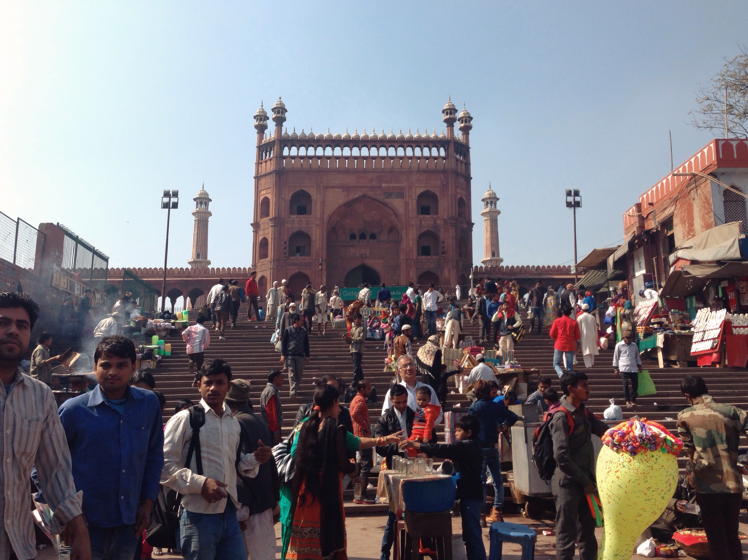

Literacy and Transformation: Contextualizing Literacy Education for Homeless Women in Delhi, India

Emily Echevarria
Azusa Pacific University
Research Project TUL670B
Supervisor: Dr Viv Grigg

Abstract

In partnership with Delhi House Society and the women of the night shelter in Meena Bazaar, this participatory action research was conducted in an effort to develop a culturally accessible method of adult literacy education for homeless women. Educators such as Laubach and Freire have pioneered adult literacy programs that seek to cultivate personal and community transformation in addition to functional literacy. Such predecessors have accomplished valuable work; however, to be effective in India, educational design must be contextualized to the specifics of the community.

Through secondary scholarly research, key-informant interviews with homeless women in Delhi, and observations of current adult literacy interventions on site, this research aims to capture emergent themes useful for designing adult literacy education. Interviews with women identify valuable cultural themes and patterns that can direct the content of literacy education programs for homeless women. Findings identify common themes among the women at the shelter: rural to urban migration; common life milestones such as child marriage, abuse, abandonment, and motherhood; transactional faith in Allah, discontent with shelter conditions; and hope for their children’s futures.

As a result of this study, Delhi House Society will be able to engage the identified real world context with a three-tiered literacy education program, focusing on practical survival and skill-related literacy. Research will contribute to the body of knowledge in this field, and culminated in a five-page booklet of principles for contextual literacy education formation for Delhi House Society to use as they seek community transformation in Meena Bazaar.

Acknowledgements

To my family, who has championed every effort I’ve pursued. Your unending loving support has made all of this possible.

To Dr. Grigg and Dr. Thom Wolf, thank you for your counsel, both academic and otherwise. I am honored to have such distinguished and faithful advisors to challenge and encourage me.

To Valerie Alms, Heidi Rico, and Sean Magaña thank you for your unending support and friendship. I could not have asked for better friends-become-family to walk through the slums of Delhi with. To Jacob Graham, thank you for your tireless support, encouragement, and care, even across oceans and continents.

To the staff and leadership at Delhi House Society, thank you for the demanding, valuable work you do. It has been an honor to walk alongside you, learn from you, and in some small way participate in your efforts. You are sowing love.

To the ladies at Meena Bazaar, thank you. For welcoming me in, for sharing your time and stories, for teaching me about resilience in the face of incredible hardship.

Above all, thanks be to God, who in His mercy is continually transforming and renewing us. To Him be the glory.

Table of Contents

Chapter 1
Introduction ………………………………………….. 5
Methodology………………………………………….. 6

Chapter 2
Literature Review……………………………….....… 13
Community Context ………………………………… 18

Chapter 3
Research Findings……………………………………. 20
Stories…………………………………………. 20
Emergent Themes…………………………….. 39

Chapter 4
Analysis……………………………………………….. 45

Chapter 5
Recommendations for Program Design…………….. 47
Organizational Feedback …………………………… 51

Chapter 6
Conclusion…………………………………………… 52
Works Cited………………………………………….. 53
Appendix…………………………………………...… 55

Introduction

As the world trends towards an urban configuration, many rural poor individuals gravitate towards city centers seeking opportunities not available in the village. As of July 2014, 54% of the world lives in urban centers. Delhi, India finds itself as one of the most populated of those urban centers, with a population of 25 million and growing (UN, 2014).

In India, the homeless commonly contribute to larger society. The majority of Delhi’s homeless are employed and contribute to the city in profound, yet low-paying ways. In fact, Sharhri Adhikar Manch: Begharon Ke Saath, a community organization comprised of and for the homeless, prefers to refer to the homeless as “City Makers” (Suryanarayan, 5). Homelessness in Delhi can refer to a variety of living situations. The Supreme Court Commissioners in the Right to Food case (2012) have defined homeless people as:

“Persons who do not have a house, either self-owned or rented, but instead –
- Live and sleep at pavements, parks, railway stations, bus stations and places of worship, outside shops and factories, at constructions sites, under bridges, in hume pipes and so on;
- Sepend their nights at night shelters, transit homes, short stay homes, beggars’ homes {jails} and childrens’ homes;
- Live in temporary structures without full walls and roof, such as, under plastic sheet, tarpaulins or thatch roofs on pavements, parks, nallah beds and other common spaces.” (Supreme Court Commissioners, 4).

The women who live in Urdu Park in Meena Bazaar are homeless, illiterate and unemployed aside from the begging they do outside of the Jama Masjid mosque. Delhi House Society is beginning literacy education for the women of Meena Bazaar. In addition to the wealth of practical benefits that stem from literacy, such as the ability to navigate the city, avoid getting cheated with official documents, and catch the right bus, studies have linked literacy among women with lower birth rates. Beyond the benefits of literacy as an end to itself, there is a wealth of research that regards adult literacy education as a powerful tool for transformation. Paulo Freire and Frank Laubach’s experiences as adult educators speak to this potential in adult education. Literacy education can be a powerful vehicle for discussion of community and life issues. This study will seek to understand the perspectives and educational experiences of Meena Bazaar’s women to shape an educational design that engages voices both from Islam and Christian texts to cultivate ethical values and transformation among Delhi’s homeless population.

Methodology

Participatory Action Research

Participatory action research (PAR) is a democratic approach developed upon the action research model created by Kurt Lewin, which holds great potential for the discovery and implementation of an empowering, critical literacy education program. (Gray 2014) In Lewin’s conceptualization, the research process is cyclical, progressing through steps of “planning, action, and observing and evaluating the effects of that action.” (2014, Location 8630) Often, these steps occur simultaneously; planning a project, a team may actually begin to implement it, and monitor the progress to make changes as needed. (2014, Location 8641) PAR has been heavily influenced by the work of Paulo Freire, in that “it seeks to empower learners to take responsibility for their learning.” (Gray 2014, Location 4776) Freire discusses the integrated, critically engaged person as “subject” – one who acts upon their context, exerts agency, and creates in the social world surrounding them. In contrast, the adaptive person becomes a passive object, one who adapts to the conditions prescribed to them. (Freire 2013, p. 4) PAR seeks to include individuals in the research context as active contributors who provide their perspectives, share their hopes and desires for the future, and engage in interventions on their own behalf.

PAR is a process of creating, discovering, and recreating, which fits well with researching most effective program design for literacy education. Within PAR, there are no research subjects; everyone involved in the research is a participant and co-researcher. (2014, Location 8889) While the researcher does extract themes, analyze, and synthesize data, community members are active participants in research that will feed back into their community. As Fordham et. al. observe, “If the views of insiders are not taken into account, it is unlikely that the outsider will design a [literacy] program that can achieve lasting results.” (1995, p. 7) Through diverse methods of data collection, including interviews, observations, diaries, and audio recordings, participatory action researchers invite the community in to create and inform interventions for themselves. Within the context of contextualized adult literacy educational design, PAR will assist in the discovery of educational design approaches that fit into the community’s own worldview, while discovering spaces to expand worldview with transformational lesson content.

Variables

Understanding the women’s sociocultural contexts is crucial if an accessible, effective educational design is to be discovered. National culture (Indian), religious culture (Muslim), and socio-economic culture (homeless) shape women’s roles, life experiences, and worldviews. Understanding the culture of Meena Bazaar means understanding these women’s location at the intersection of these three cultures. It is this understanding that will be paramount in understanding effective practical strategies for education, and valuable themes to tie in. This is a tangled web to unravel and operationalize, so interview questions have been strategically designed to evoke responses about their perceived roles, opportunities, and limitations as a woman in society, reasons that they are in favor or opposition of a literacy education program, and the role of God in their lives. The responses to these questions have been shaped by the influencing three cultural spheres the ladies belong to.

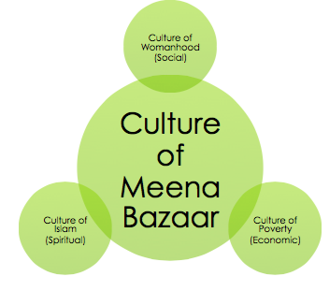
Figure 1: Intersecting cultures found in Meena Bazaar.

Prior educational attainment does matter, and it is pertinent to this research to discover what level of education they reached and why they withdrew from education. However, that is not the primary variable this study is concerned with. The primary concern is capturing cultural worldview dynamics, such as the felt roles and limitations of women, and the role of Allah in their lives. Understanding who they view God to be, and how they understand God views them provides for the creation of a curriculum that empowers the participants as valuable children of God with a purpose in this world.

Independent Variables: cultural values, prior educational experience
Dependent Variable: contextual and engaging literacy education design

Research Question

How can adult literacy educational design be contextualized to facilitate learning and transformational dialogue among homeless women in Delhi?

Community Relevance

This research contributes to the current initiatives Delhi House Society is pursuing in the Meena Bazaar Rain Basera. Delhi House Society currently oversees a learning center at Urdu Park that provides free education for the children who stay in the shelters with their mothers. Women from the community have expressed a desire to learn how to read, and Delhi House Society staff has expressed a need for consistent, systematic approaches to education on the site. Part of Delhi House Society’s mission is to see the lives of poor communities “transformed economically, physically, emotionally, socially and spiritually, and walking in the fullness of life as purposed by God.” The intentions behind this research are in line with that vision, and it is the researcher’s hope that research outputs will assist Delhi House Society in their mission to do the transformational work of the Kingdom in Meena Bazaar.

Action-Reflection Theological Framework

Ideally, the resulting adult literacy program will be an embodiment of a transformational conversation, as one of its goals is to create a space for discussion of real-life concerns and ethical/spiritual responses. Through understanding the realities and roles of the women of Meena Bazaar (city conversation), the researcher will identify appropriate ethical and spiritual themes from Muslim and Christian voices to incorporate in the resulting educational design (theological conversation). Ideally, then Delhi House Society will be able to engage the identified real world context with identified themes and principles from Christianity and Islam through the venue of literacy education. Research will identify themes that should be incorporated, but it is anticipated that they will be within the realm of the love and Fatherhood of God, and how that shapes lifestyle.

Assumptions or Presuppositions

In this research, there is the assumption that women want or could use an additional purpose within literacy education. Literacy education is a felt need that has been vocalized by a number of women, though it cannot be assumed that every lady in the community is equally invested. Realistically, the researcher cannot expect to understand the ladies’ entire cultural framework. However, it is assumed that valuable themes will surface that can be addressed and engaged with wisdom from Holy Scripture. The researcher is also assuming that the women would also be willing to partake in community-based discussion.

Population and Locations

Participants in this study were homeless women between 20 and 45 years of age, approximately, living in or around the Rain Basera shelters in Delhi. The participants were either illiterate or semi-literate, as both candidates have valuable input for determining what design and cultural factors contribute to effective education of homeless women. The researcher had an existing relationship with Delhi House Society, which is working in Meena Bazaar and has a good relationship with this community of women. Contact for research was made through community visits and meetings with eligible research participants there.

Methods

Secondary information collection consisted of review of the pertinent scholarly literature. Primary information collection hinged primarily on observation, and one-on-one semi-structured interviews with 14 women residing in the Rain Basera. Observation included casual conversations with women and children on the site, and Delhi House Society staff. The secondary data collected provides information on some technical considerations of adult education design, while interviews with the women from the Rain Basera inform the discussion on cultural and content elements in adult literacy design.

The researcher kept field notes on her observations in the current trial literacy classes, and used an audio recording device (once participant consent is secured) to record participant interviews. A translator appropriately trained in ethical research practices assisted with the interviews. Each interview was between 20 and 45 minutes in duration. A preliminary list of interview questions can be found in the Appendix.

After data collection, the researcher will use methodological triangulation to demonstrate validity “by analyzing a research question from multiple perspectives.” (Guidon, Diehl, and McDonald, 2011, p. 1) Analyzing co-existing themes that emerge from the various data collection methods can indicate patterns and re-enforce the truth and accuracy of the study’s findings. (Guidon, Diehl, and McDonald, 2011, p. 1) She will locate pertinent emergent themes from the various data collected, including secondary scholarly research, key informant interviews with community members and adult education experts, and on-site observations at Meena Bazaar.

Data, therefore, will be reflective of a variety of angles on the topic of contextualized literacy education for the homeless. Scholarly literature will engage the academic discussion on contextual literacy education for empowerment, while local educators will speak to practical methods of adult education, and homeless women’s experiences will illuminate the realities of their context.

Each piece contributes to the resulting knowledge: the theoretical, the practical, and the content. Through implementing methodological triangulation from various data sources, the researcher will analyze findings on important cultural elements to be considered when constructing appropriate transformational adult literacy education design.

Research Guides and Assistants

All interviews with participants were conducted in Hindi. While the researcher can speak conversational Hindi, an interpreter was required to truly communicate and capture everything that is said during the interviews. Shallu Rai, a Hindi interpreter, assisted with translation, both on-site and post-interview for review. While she did not undergo CITI Program Training for conducting research with human subjects, the researcher conducted an abbreviated 1-2 hour course with her concerning such topics as privacy, confidentiality, beneficence, justice, and respect of persons. She conducted interview translation with remarkable sensitivity and accuracy.

The researcher’s limited knowledge of Hindi was sufficient for gauging participants’ compliance, concern, or distress, so she attentively supervised the interviews to ensure participants’ comfort. Considering the length and intensity of the interviews, Ms. Rai has been appropriately compensated.

Ethical Considerations

An important ethical issue to consider in research with human subjects is the issue of risk. The researcher is committed to protecting all participants within the research process in whatever ways are appropriate. No research subjects’ names or identifying information that may put them at risk will be used in the study. All participants will be given aliases, and identifying information will be changed. All interviews will be entirely voluntary, and while reviewing the informed consent document, participants will be notified of their freedom to leave the study without penalty.

Because of the researcher’s relationship with Delhi House Society, and NGO that provides services for the residents of Meena Bazaar and their children, potential participants could have assumed that they were required to comply in this interview process. However, the informed consent document dispelled any illusions that participation might be mandatory and could affect the services they receive. The researcher and translator ascertained that a participant thoroughly understood that participation in the study was voluntary, and provided them with the opportunity to exit the study at any time.

It is the responsibility of the researcher to minimize risk for trauma of any sort to participants in the study. This study was low risk, and the only potential risk the researcher could imagine would be if the participant had experienced some trauma that resurfaced during the interview. The risk of distress in these interviews was no higher than what could be expected during any conversation about personal experiences and cultural attitudes. If participants had experienced such distress, however, there are on-going resources that are available to them. Mohini Pandey, a counselor affiliated with Delhi House Society, is willing to provide counseling to any participants who might require this service.

Permissions

The researcher received approval from Azusa Pacific University’s Institutional Review Board (IRB) to conduct this research. The IRB has found this research project to be ethically sound, posing minimal risk to the participants in the community. Within India, the researcher has received approval from Keshav Dutt Pandey, the Team Leader and Executive Director of Delhi House Society to engage in this research. In addition, she received an endorsement from Dr. Shaik Mujibur Rehman, Associate Professor at Jamia Millia Islamia Central University, New Delhi that affirms the culturally sensitive nature of the study’s administration.

Research Products and Action Outcomes

This research was conducted with the intention of ending in action and program implementation. Program implementation may occur at a later date, but this research will leave Delhi House Society staff and community members with a presentation of the findings in July 2015, as well as a 5-page booklet that outlines principles, cultural themes to integrate, and a variety of methods to do so. It will be intended for use when constructing a literacy education program for the homeless women of this community. It is the researcher’s hope that research will directly benefit the participating population by assisting in the design and implementation of a contextualized literacy education program that is usable and effective. The nature and format of this program will hinge upon research findings.

Community Benefits

This research is intended to benefit the community directly. While they received no financial compensation, participants were able to provide input for the design of a literacy education program in which they will be able to enroll. Benefits from this study will include a body of information for Delhi House Society’s use. It is intended for them to create and implement a Hindi literacy program for homeless urban poor, and to use as a resource about the context of the site for a variety of interventions. The community will potentially benefit from DHS’s active use of the research to design and implement a literacy education program based off of the study’s findings and recommendations. This program would be tailored to the context and needs of the community, with the intention of partnering with the shelter residents in the journey towards literacy and empowerment.

Literature Review

Protestant Missionaries’ Literacy Legacy
Traditionally, religion has had a major influence on the literacy of it’s adherents in India and abroad – whether it’s been increased literacy among Muslims and Christians, thanks to madrasas and the doctrine of Sola Scriptura, or suppressed literacy among Hindus at the hands of the limiting caste system. Pandita Ramabai mourned the oppressive Brahmatical system of Hindu education, that not only discouraged education for girls, but actually prohibited it. In her studies of Hindu scriptures, she found many contradictions but only a few consistencies, in which the scriptures agreed that women and low caste individuals had no right to read the Vedas. As a rare Hindu educated woman of her time, Ramabai was disgusted by what she found, stating that, “the woman has no right to study the Vedas and Vedanta, and without knowing them, no one can know the Brahma. Without knowing Brahma, no one can get liberation; therefore, no woman as a woman can get liberation, that is, Moksha.” (Ramabai, Loc. 130) Ramabai went on to say that the same rules apply to low-caste Hindus, who “must not study the Veda”. Anyone of low caste who breaks this rule is subject to violent punishment, including the filling of their ears with liquefied lead or the pouring of scalding hot liquor down their throats. (2013, Loc. 130)

Historically, Protestant Christianity has promoted universal literacy so that all have the ability to read the Bible on their own. The foundational Protestant principle of “Sola Scriptura”, affirms that “one can understand God’s word only by reading the Bible.” (Mantovanelli 2013, p. 2) In line with this principle, missionaries to India have emphasized literacy education in India, specifically amongst disadvantaged groups such as women and low-castes. (Mantovanelli 2013, p. 3) In his study on the long-term relationship between populations’ exposure to Protestant missions and contemporary variances in literacy outcomes across India, Mantovanelli finds that places with a historical missionary presence have strong a positive association with the total populations’ literacy rate. Increased literacy extends to even those who did not adopt the missionaries’ religion. (2013, p. 3-4) In this way, entire cultures have been transformed. Entire populations have been changed by the voice of Christ communicated through education, even if they do not claim Jesus as their own.
For example, the Welsh Presbyterian missionaries to the Khasi hills of Meghalaya, India left the tribes with an enduring legacy of literacy, rooted in their commitments to Christ and to education. After developing a written script for the dissemination of scripture in the 19th century, the missionaries embarked on literacy education campaigns for both men and women. (Corwin 1980) As Natarajan writes:
Missionary work, mainly Christian, has wrought beneficial changes in Khasi society. Education, improved health, dispelling of ignorance and unfounded superstitions and fears, inculcation of rationality of outlook, and economic changes have resulted. (Natarajan 1977, p. 151-152)
In line with the principle of “universal literacy”, Protestant missionaries have specifically promoted education for the poor and marginalized low castes. Viewing caste itself as a major injustice, Protestant missions have promoted education as “an invaluable weapon in the fight against caste.” (Mantovelli 2013, p. 23) Likely a result of Protestant interventions, Protestant dalits (untouchables in the caste system) generally have a higher level of literacy than non-Protestants of the same caste. (Massey 2007) Through faith-motivated education initiatives in India, cultures have been shaped and changed, and the traditionally disempowered have been empowered.

Laubach and Freire: Literacy with a Purpose
Literacy education among the uneducated urban poor has great potential for individual empowerment, as well as for community transformation. Frank Laubach’s world-renowned literacy training movement, which resulted in the widely-used “Each One Teach One” Program, is informed by compassion and aims to equip students with practical literacy capacity and the transformational message of Christ. Laubach focused on evangelism through literacy education among the Muslims of Dansalan, Philippines. Through respecting their religion and actively seeking to learn the “religion, culture, and language of the Maranao Muslims” out of love for them, Laubach found a favorable environment within which to minister. (Gowing, 1983, p. 60) He attended disussions with community leaders at the mosque, he read the Koran with them, and engaged the entire community in discussion about faith and truth. (Laubach, 1960)
Literacy education provided valuable training to this largely illiterate Muslim population that had historically been hostile towards outsiders. As Gowing says, for Laubach, “Literacy provided the means not just to approach them but to approach them as one who wanted to share the love of Jesus Christ with them.” (1983, p. 61) However, his literacy campaign cannot be fairly accused of existing only to pursue an agenda of conversion to Christianity. After one year with the community, Laubach (1960) wrote that none of Moros had been baptized, but that nearly all in the community had become their friends. (p. 38-39) Regardless of their faith alignment, Laubauch pursued in literacy education, believing that it was God’s work for the people of Maranao.
For Laubach, the literacy education methods hinged upon keywords, which contained as many sounds as possible from the target language. These keywords did not necessarily need to mean anything particularly important; they only needed to contain richness of sounds. When developing a keyword curriculum for the Moros of Maranao to learn to read their language, Laubauch wrote that he gathered some locals to help him identify keywords that contained all twelve consonants of the Maranaw language. (Laubach 1960, p. 30) These keywords were developed into charts to assist students as they learned to read.
Before he could teach the people of Maranao, Laubach saw the importance of understanding their language, worldview, and faith. Large bodies of literature espouse the value of contextualized education. For example, Freire’s approach to education provides a helpful theoretical framework for education that is rooted in a community’s cultural context and stirs new consciousnesses to encourage engagement with community transformation. In his native Brazil, Freire launched “culture circles”, rather than the passive term, “schools” through adult literacy classes, in which “illiterate adults were invited to participate in a process of critical reflection on the social conditions in which they found themselves.” (Roberts, p. 75). This Freireian adult literacy involved cultural evaluation of the social situation of the illiterate adults and formation of appropriate materials and agendas to match the context. (Freire 2013, p. 40; Roberts, p. 76) The adult participants’ input was central to Freire’s approach: generative words emerged from the community’s own experiences, and teaching was dialogue-based, not lecture. This democratic method of adult literacy education is firmly rooted in community experience, and looks towards individual empowerment and community transformation through the vehicle of education. Such an approach has potential application into other spheres of consciousness and resulting community transformation.
Traditionally, Freirian “popular education” stands upon the recognition that “human beings are meant to be free, work collectively, and seek justice; that human beings have agency and are capable of transforming the world…” (Choules 2007, p. 163) Freire’s model was inspired by Marxist notions of conflict and power struggle, though it has great potential to inspire non-Marxist interventions.

Contextualized
As Freire’s educational vision was distinctly contextual for Brazil, contextual and cultural issues must be considered when implementing it elsewhere in the world. According to Choules (2007), wholesale adoption of Freire’s “popular education” approach without considering the context of the implementation location can cause significant problems for social change education. (2007, p. 160) While she wrote regarding difficulties translating Freirian critical education from Latin America to countries such as America and Australia, similar contextual adaptations must be considered when pursuing application for critical education approaches in India.
When studying educational design for any population, socio-cultural context is a foremost concern. One’s socio-cultural context shapes worldview, assigns meaning to objects and ideas, and provides each individual with a sense location in the world. Vygotskyian sociocultural theory is based on “the concept that human activities take place in cultural contexts, are mediated by language and other symbol systems, and can best be understood when investigated in their historical development.” (John-Steiner & Mahn, 1996, p. 191)

As human activities, learning and education also occur in cultural context, and along with knowledge, are inextricably tied with that specific context. (Alfred 2002) Students have grown and developed within specific cultural worlds, and it is an educator’s role to seek to understand those cultural worlds. Fordham, Holland, and Millican (1995) write that “literacy can be a transforming experience. But… any programme has to be firmly embedded in its time and place.” (1995, p. 5) Educators should also seek to understand how students “interpret who they are in relation to others, and how they have learned to process, interpret, and encode their worlds.” (Alfred 2002) Without this understanding, the educational efforts may be nothing but rote memorization, devoid of opportunity for application, and without effect on the heart.

In an Indian context, culture and religion are one and the same. The speech, dress, language, and worldview vary greatly in the Indian subcontinent among Hindus, Muslims, Christians, and Sikhs. On the ground, the practice of Islam often looks quite different from the Orthodox Islam that the West learns about. After spending 25 years in Pakistan, Merlin Inniger writes, “the practice of Islam among the common people differs widely from the ‘ideal’ Islam that is preached in many mosques and explained in books.” (Inniger 1979) Popular Islam in South Asia often involves devotion to saints, amulets, and superstitious practices to ward off the evil eye. None of these elements are found in orthodox Islam, yet their centrality in Indian Muslims’ lives is paramount. Often, the Sufi tradition is seen as a link between Hinduism and Islam, and its tradition is carried through traditional poetry and songs, accessible for even the illiterate. (Eaton 1974)

Culture of Homelessness

As a subset within Indian Muslim culture, the homeless exist within subculture, a culture of homelessness. The culture of homelessness carries with it several consistent themes that impact how the homeless experience and deal with the world around them.

Based off his studies of Puerto Rican families in Puerto Rico and in New York, Oscar Lewis (1966) writes of the culture of poverty, a style of life that “transcends national boundaries and regional and rural-urban differences within nations. Wherever it occurs, its practitioners exhibit remarkable similarity in the structure of their families, in interpersonal relations, in spending habits, in their value systems and in their orientation in time.” (Lewis, p. 21) He identified some 70 traits consistent within the global culture of poverty. (1966, p. 21) These themes are wide-ranging, and can be categorized into four dimensions: “the relationship between the subculture and the larger society; the nature of the slum community; the nature of the family, and the attitudes, values and character structure of the individual.” (1996, p. 21) Some common themes in communities that Lewis studied were disengagement of the poor with major societal institutions, usually at the hands of poverty, discrimination, fear, suspicion, and apathy. Chronic unemployment, low wages, lack of property and savings, as well as distrust for institutions such as the government or the police are common in the midst of a culture of poverty. (1966, p. 21)

Considering that Lewis’s “culture of poverty” typically applies to Western cultures based upon nuclear family structure and the beliefs that upward mobility is possible and the poor are at fault for their own personal inadequacy, it does not apply perfectly to the culture of homelessness in India. (Lewis 1966, p. 21) However, it indicates that poverty indeed affects culture, and even creates new cultures. Tripathi (2014) suggests that that understanding and documenting “the various causes and cultures of homelessness by incorporating the lived experiences and worldviews of the homeless” can be a valuable tool in forming appropriate interventions. (p. 34) Homelessness is both an objective reality, one of living without traditional housing, as well as a subjective reality of one’s experiences with homelessness. (2014, p. 37) This means that in addition to homelessness being the living situation of this community, it also impacts the ways they see the world and interact with it. Tripathi suggests that understanding the subjective perspective of homeless individuals and communities can assist in effective action research and program development.

Combined, these voices from the literature point towards a space to further investigate contextualized literacy education for the homeless in India that also contributes to personal and community transformation. The following study will attempt to engage at the intersection of these areas of scholarship, to contribute to the knowledge regarding appropriate transformational literacy education interventions for homeless women in Delhi.

Context Description

Urdu Park – Meena Bazaar

In the open dusty rectangular park that unrolls in front of Jama Masjid sit two blue rectangular structures, shelters erected by the Delhi Urban Shelter Improvement Board (DUSIB). The site hugs Meena Bazaar, a day market outside of the mosque’s east gate that daily fills with vendors and beggars, earning their day’s wages. Aside from the government-provided rain baseras, the park expanse is bare. During the day, families can be found sitting under trees, while children play cricket, gilliballi, and climb on cycle rickshaws that dot the dusty space. Drug and alcohol abuse are rampant in the surrounding areas. Children as young as twelve-years-old stumble around bleary-eyed, intoxicated from sniffing vulcanizing cement. Fortunately, the government has provided this women’s shelter with portable bathing areas, toilets, and a stovetop for cooking food – facilities that many shelters in the city do not have access to. However, the ladies staying in this shelter still want for clean water. Currently, they only have access to dirty water that they must filter through makeshift filtration techniques, including leaving the water in sunlight and straining it through cloth. This results in frequent illness for the ladies and their children. Fortunately, the government has provided the shelter with toilet and bathing areas, facilities that other shelters lack.

One of the two buildings on the site hosts the learning center, run by Delhi House Society. Five days a week, children from the shelter can come and learn basic reading, writing, math, and general knowledge, such as colors, shapes, and days of the week. While the learning center is not officially a school, it provides an opportunity to learn for children who cannot go to school because they must beg for their families. It also acts as a launching pad for children to enroll in school. Learning center staff members have been central in enrolling several of the shelters’ children in local government schools and hostels.

This night shelter caters exclusively to women and their children, and is a site burning with need for Jesus’ holistic transformation. Many women who stay at the shelter have toxic, abusive relationships with their husbands, or have no relationships with their husbands at all. The stories are horrific: child marriage, infidelity and divorce, fraudulent land theft, suicide, abuse, miscarriages. The common experience with men is fraught with pain and neglect. Without committed, working husbands, the Indian family system collapses and leaves the women with the brunt of caring for the children, cooking food, and earning enough money for survival. Without parent’s supervision, children are exposed to many influences, many of them destructive. Since the women here cannot depend on a husband to provide for their families, women here are desperate to provide the best they can. However, illiteracy and lack of marketable skills pose significant stumbling blocks in the search for decently paying work.

Three months before this study, a teacher from the Delhi House Society learning center began literacy classes with the women from the shelter. Two days a week, the teacher brings notepads, pens, and chalkboards to class. Eight or nine women attend class, where the teacher covers basic literacy skills, such as writing one’s name in Hindi and English, as well as basic math skills. At the time of the interviews, topics covered in these literacy classes have been writing one’s name in Hindi and English, and for some women, basic numeracy and simple mathematics. The woman who teaches them has a relationship with them, tracks their progress, and seeks to cater the lessons to the appropriate level of literacy.

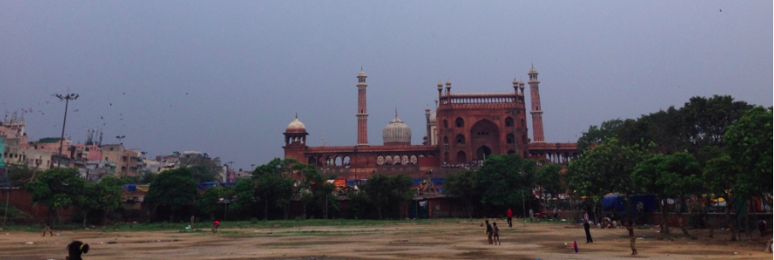

Stories
“I have told you everything, whatever was in my heart.” - Shabnam

Over the course of a month, I sat with 14 homeless women who are staying at the Meena Bazaar shelter to listen to their stories and hear about their perspectives. Unfortunately, the sample size was smaller than desired because most of the women at the shelter beg and the study occurred during the Muslim season of Ramadan, where Muslims are to give generously to the poor. The following case study record is not exhaustive, but provides the accounts of a small sample of the ladies interviewed. Their interviews are shared here because they illustrate well the typical experiences of Delhi’s homeless women that I sat with.

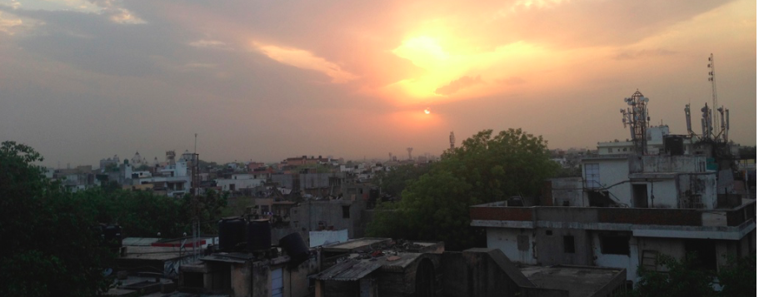

Aisha

While sitting together on a wood and fiber charpai, 35-year-old Aisha shared the story of her life. She was born in a village near Lucknow, Uttar Pradesh in a Muslim family of laborers and farmers. However, when she was young, her mother and father passed away, and she was left in the care of her three elder brothers. Rather than sending her to school, her brothers left the housework in her care. Aisha spent her childhood dusting, cooking food, and working in the field harvesting crops. She recounts never having dreamt about her future, saying, “I just always stayed in the house, so what could I possibly have dreamt? I never thought, ‘I will study, I will do this.’”

Aisha remained in the home with her brothers until they arranged a marriage for her when she was 12-years-old. The marriage was not a happy one. Aisha remembers, “We were married for 10 years. He was not a good man. He had an affair and then he divorced me.” Her brothers took care of her again after the divorce, until she married again. She is currently with her second husband, who is the father of her four living children, her two children who died as infants, and the child she is unhappily pregnant with now. Aisha’s husband works hard as a garbage picker, earning 100 to 200 rupees a day to provide for his growing family. They came to Delhi from the village about six years ago, after her husband encountered some conflict with others in the village that compelled him to sell their small house and their property. At the time of the interview, Aisha had just returned from a visit to her village, which she much prefers to life at the shelter in Delhi. As she said, “I like my village better, but we don’t have a house there, so we have no place to live. My kids are growing up now, and the environment here in Delhi is not good for them. They can get addicted to drugs or they can run away with boys. Because of that, I’d prefer to be in my village.”

Since literacy classes began at the shelter, Aisha has been faithfully attending, learning to write her name and learning basic math, including multiplication. Aisha likes it when her teacher gives her homework, and expresses the satisfaction she feels when she completes the work assigned to her. She dreams of being able to confidently read and sign important documents on her children’s and husband’s behalf.

As difficult as it is for her family to make ends meet, Aisha desires the best for her children. She hopes to teach them to be honest, to study hard, and to live cleanly. She wants to set a good example for her children, knowing how much children learn from watching those around them. “I have never been to school,” she says, “but I have seen how people live, and I have learned to do roza. I’ve never been to school to learn Hindi or Urdu, but I’ve watched people and learned things.” Aisha worships Allah, and explained that she feels like she has an angel sitting on one shoulder and Satan sitting on the other shoulder. “The angel tells me to do good things, to be honest, to do namaz. But then Satan is sitting on the left side and tells me to do wrong things, like snatch things, steal things, or look at men in impure ways. I get good things from the angel and bad things from Satan.” Ultimately, she concludes, it’s her choice to choose which one of these voices she will obey. Aisha holds out hope that one day, Allah will see that she and her husband have lived honest, nice, hard-working lives and will reward them with a large amount of money.

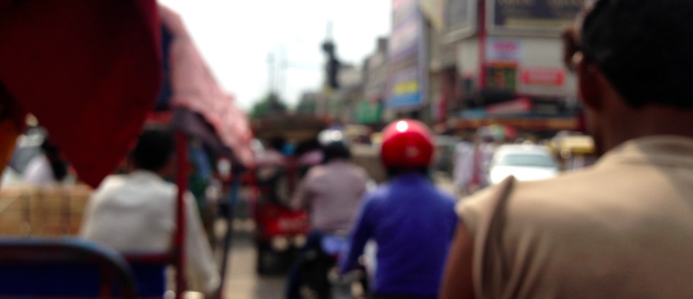

Roshni

When Roshni was about 19 years old, her parents arranged for her to get married. They found her a boy in her home state of Bihar, whose family had property, gave him the dowry of a cycle and a goat, and married her off. They had no idea he would be an abusive drug addict. “It turned out that he wasn’t nice – he was beating me and at one point, he even tried to set me on fire,” she recounts with a straight, non-expressive countenance. Roshni tells of times her husband stabbed her, took her money, and beat her so badly she miscarried a baby.

At 30-years-old, Roshni is a mother of three children, is currently pregnant, and has suffered a miscarriage and the deaths of two infant daughters. She and her kids came to Delhi from Bihar two years ago to escape her abusive husband. Since arriving in Delhi, Delhi House Society staff has assisted her in enrolling her ten-year-old daughter in a hostel in Okhla, where she can study safely. Her seven-year-old daughter and four-year-old son stay with her at the shelter.

While all of Roshni’s brothers and sisters are in school studying, she herself never attended formal school. Instead, she studied Urdu at the madrasa and can read and write Urdu, though she cannot read or write in Hindi. Roshni has been attending literacy classes since they have begun at the shelter, and can now write her name in Hindi. She expresses enjoyment at her newly developing skills, and also deep regret at never having gone to school in the village. During the interview, Roshni looked at me and said, “You have studied so much. I wish I had gotten to do something like that. I could have done so much with my life. When I look at you, I see that you have learned so many things. I would like that for myself. I could have read anything I wanted and could have done so many things that I haven’t done. I really want to learn.” She has determination to learn, and says that as long as the teacher continues teaching at the shelter, she’ll continue learning.

Currently, Roshni does not have a job, though she and staff members from Delhi House Society are looking for a job for her. While she’s unhappy that she has not encountered any work, her costs of living are lower than some other people’s in the area, since she doesn’t have any addictions to feed. For now, she is earning small amounts of money through begging, which provides just enough money for laundry soap and food. Her husband continues to disturb her. Several months ago, he came to Delhi and found Roshni at the shelter. After beating and abusing her, he took her 4-year-old son away, and currently has him in Bihar.
Regarding the future, Roshni is planning on undergoing female sterilization surgery after she delivers her baby. In the past, her husband has forbidden her from doing this procedure. She says, “He has told me before, ‘If you get the operation, I’ll leave you.’ But this time, I’ll go through with it, because he is an addict and not a good man.” While methods of birth control are against traditional Muslim beliefs, Roshni practices her faith. She says that she believes in Allah because her future is uncertain; she fears and worships Allah so that he will care for her children after she dies. In fact, her children are a large part of her faith. Roshni reads the Quran in Urdu and prays to Allah so that he will take care of her eldest daughter, who died as an infant, in the afterlife.

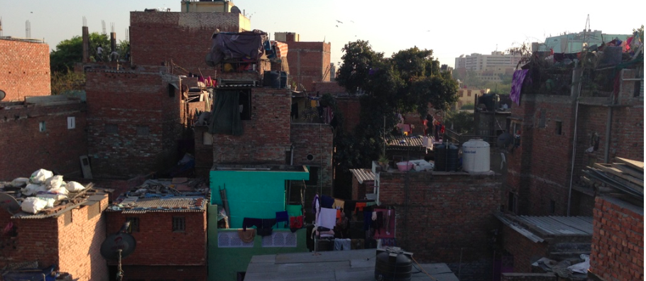

Fahima

Vibrant and articulate 30-year-old Fahima was born in Delhi to a mother from West Bengal and a father from Bihar. She has three sisters, all of whom beg asking people to place money on what she as a “holy green sheet”. Her one brother is a drug addict. When Fahima was young, she and her siblings all used to beg with her blind mother to earn money for their families. She and her siblings never went to school, largely because there were no facilities available for the education of children who begged. “Now, people are coming here [to the shelter] and teaching our children. In my time, no one was doing this.” She and her siblings were never encouraged to dream about their future. “My parents never encouraged us to study. They used to get drunk all the time. My mother was blind, and my father was always drunk, so there was no one to take care of us,” Fahima remembers.

When she was 15 or 16 years old, Fahima fell in love and got married. She now has three children, ages 7, 3, and 7 months. Watching after her children keeps her days busy, while her husband works to earn money for the family. Her husband has found work on the city’s buses as a ticket-taker, though work has not been stable lately. He earns about 200 rupees a day, which she adamantly asserts is not enough to support her family of five.

Fahima has been attending the literacy classes run at the shelter. Of all of the ladies at the shelter, she is one of the most enthusiastic about learning to read and write. “I like that I am learning! If I knew how to read, I could have done so much and gotten a good job. My husband studied to 10th standard, so he can do so many things. I could have gotten a job if I had studied. And now, studying, it is nice.” In addition to her wishes for having a job, Fahima wishes she knew how to read so she could teach her daughter. Her daughter is a slow learner, and cannot always stay up to speed with her class. Fahima mourns that if she had learned how to read, she would have been able to provide academic support for her daughter. She feels she lacks knowledge, and that this affects her ability to parent.

“There was an incident once with my husband, where he asked our eldest daughter to write his name. But she couldn’t write it. Another girl came and wrote his name. He got angry at me, saying things like, ‘You haven’t taught your kids! If you had ever learned something, then you could teach your children something!’ He got really angry about it. I really want my daughter to study.”

Fahima finds several obstacles to her own personal studies at the shelter. First, classes only meet twice a week. Her ambitious mind and spirit would like to have class every day of the week, though she believes she is the only one at the shelter who feels like that. “Two days a week is not enough. With classes two days a week, it does not get into my head. There is too much time to forget what we have learned.” Contrarily, Fahima feels that the ladies at the shelter do not have enough time to commit to literacy classes. She feels the pressures of her responsibility to her children, especially when they disturb her during class.
After everything, Fahima holds on tightly to hope for her childrens’ futures. She engages them in conversations about what they want for their own lives, and shared that her daughter wants to be a police officer, even though Fahima’s husband wants her to be an engineer. “My husband has big dreams for them,” she says.

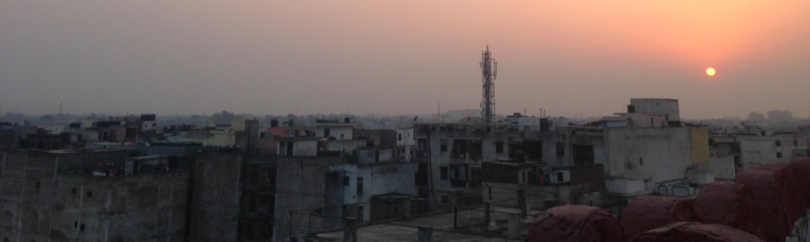

Farhannah

After finding a shady spot under a generous tree on the shelter grounds, Farhannah sat and her 3-year-old daughter climbed onto her mother’s lap for a lice check. As she carefully, delicately, lovingly removed the small insects, Farhannah shared about her life experiences.

35-year-old Farhannah was born in a village in Bihar in a family with 8 siblings. As a child, she never attended an official school, but studied at a friend’s house when she was young for three or four years. During that time, she learned how to read Urdu and basic Hindi, though she has since forgotten how to write. To this day, she still remembers many of the reading basics she learned then. Farhannah got married in Bihar and had eight children. Her oldest child is an 18-year-old daughter who is married and is living in Bihar, and her youngest child is 6-months-old. While she has many children, only the three youngest ones are living with her at the shelter.

Farhannah’s husband used to work in a shoe factory in Delhi. He then moved back to the village to pull a rickshaw there before returning to Delhi again. At that point, he became addicted to drugs and took up work as a rag picker. Farhannah recalls,“He never wanted us to come here to Delhi. He kept us in the village when he was working here in Delhi.”Eventually, her husband returned to the village, where there was a property dispute between him and his brothers. In the stress of the dispute, he hanged himself, leaving Farhannah as a widow. After he died, her brothers-in-law finalized the land snatching. “Even after he died,” she remembers, “I didn’t get anything. No land, nothing. All the money, everything, was taken. They never gave me anything. My family wouldn’t have duped me if I knew how to read and write better.” Without any land, property, or security, Farhannah made the trek to Delhi. Since arriving in the nation’s capital four years ago, Farhannah has made ends meet by begging. She goes to Jama Masjid and a local temple to beg, through which she makes 100 rupees a day, without exception. Because the amount of money is so small, she also goes to the gurudwara for meals. At the time of the interview, it was Ramadan, which is typically a time where Muslims are encouraged to be generous towards the poor, resulting in an increase to 200 to 300 rupees a day.

Growing up in a Muslim family, Farhannah considers herself Muslim, though she says that she believes in all gods, Muslim and Hindu. According to Farhannah, “Humans were the ones who created “Allah” and “Bhagwan”, but in reality, there is only one God. I believe in all gods, because all gods are one.” While she says she cannot say what God is like, she knows he is good and right. “All things are done by his will, not man’s will,” she says, “so we trust in him.” Farhannah believes that Allah asks them to do righteous work and to follow the right path. Because she can read Urdu, Farhannah likes to go to Jama Masjid to read the Quran. She sees a direct correlation in her life between performing her duty to Allah and the ease and success of her life. “Right now, I’m not reading the Quran, so everything is going bad. When I read the Quran, I feel like there is hope that Allah will do good things. If I keep on reading the Quran, Allah is good to me. But right now, I am not reading the Quran, so things are not going well. When I read the Quran, Allah listens to my prayers. When I read the Quran and I do namaz and roza and everything, everything goes well.”

Farhannah has big dreams for her children. She says it’s important for children to learn how to read and write, as well as to do household work. She hopes to enroll her children in a hostel so that they can further their education can invest in their futures. Farhannah hopes that one day, her children will “be somebody”in the world.

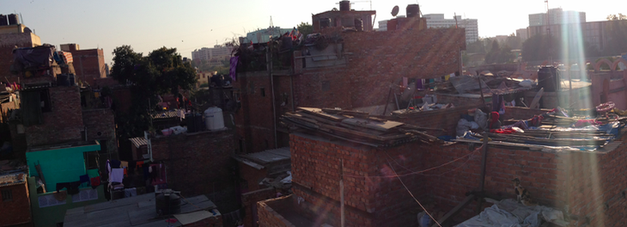

Safiya

Safiya, age 40, was born in a village in Bihar and came to Delhi 16 years ago. The daughter of farmers, she spent her childhood caring for her siblings, taking care of their home, and preparing food while her parents worked in the fields. “I always wanted to go to school but my parents never allowed me because I had to do the household work,” she explained. When Safiya was about 12 or 13-years-old, her parents married her off. After she got married, Safiya’s husband began drinking heavily. Even when he earned money, he spent all of his money on drinking. At that point, all of the responsibility for caring for her family of three daughters and one son fell to Safiya. Someone in the village told the family that if they moved to Delhi, he would stop his drinking. Hopeful at the prospect of anything that would turn around his habit, Safiya and her family moved to the nation’s capital. However, she found that when they arrived in Delhi, the urban setting influenced his behavior in the opposite direction. “But when we came to Delhi, his drinking only got worse. He started drinking more, and began taking drugs and beating me. So I had no other choice than to go and beg for my children’s sake. The situation got worse coming here,” Safiya remembers

Upon arriving in Delhi, Safiya and her family settled in a jhuggi jhopri colony across the Yamuna River. Then, about 10 or 12 years ago, the entire settlement was demolished and cleaned out. At that point, Safiya’s family moved to another area of town, where she tried to rent a room. About six years ago, her husband became very ill with a respiratory condition, and he passed away. Without any income at all from her husband, she could only afford to pay for her family’s food expenses with her meager salary of 2,000 rupees a month. Unable to pay the full amount of rent, Safiya came to stay in the shelter at Meena Bazaar. Unlike some of the other ladies at the shelter, she enjoys staying there. According to her, there is a sense of community at the site. She prefers it to the village, saying, “Now, when I go to the village, I don’t like it because I am so used to Delhi life.” She enjoys sitting with other women from the site and talking late into the night. Yes, ladies sometimes fight about their children, she explained, but all in all, they are there to support each other. Safiya has been taking literacy classes at the shelter, and is greatly enjoying them. “Classes are going well!” she says. “[The teacher] taught me how to write my name. Before I didn’t know how to read or write, but now I’m learning. I learned to write my name, but I have not yet learned how to read.” Safiya says that the biggest motivation for her to learn to read is to be able to navigate her way around the city. “If I go out, I need to be able to tell what bus to take and where it is going. It’s really convenient if I know how to read, and I won’t have to ask anyone. ”

“There’s so much tension in my mind and many problems in my life. My son doesn’t want to study, my daughter is always fighting. This gives me tension. And Eid is coming, so I have to get new clothes for my kids for the festival. There are many things that I have to think about. There are so many things and problems in my life. I used to be much fatter than I am now, but now I have been worrying so much that I have become skinny. I have become so weak from anxiety. I have been worrying so much, and I haven’t been able to sleep. Sometimes, I can’t sleep because I am worrying so much. All of these worries are for my children, especially for my son.”

Rather than espousing hope for her children’s future, Safiya feels great anxiety. The problem is not a lack of available facilities for her children’s progress and growth – the issue is her 13-year-old son’s lack of motivation. While he is intelligent, he has no drive and has been getting into fights. Regarding her son, she says, “I just worry so much about my son. I’m always telling him to go study or to do some work, but he doesn’t do anything. I worry a lot about him. Sometimes, I try to talk to him and tell him to take a job or something, but he doesn’t do it. He doesn’t do anything. He doesn’t want to do anything. My heart is always beating really fast. If he would go to school, half of my tension would be gone.” At the hands of her anxiety, Safiya has experienced weight loss, difficulty sleeping, and quickened heartbeat. She of all people in her son’s life knows the value of an education. Safiya says, “If I had studied, I would have become someone. So I want my kids to study.”

Tabassum

Tabassum, 20-years-old and bright-eyed, came to Delhi from her family’s village in Bihar when she was very young. Her mother, a widow, had decided to come to the city to earn money by selling socks.

When Tabassum was young, she attended school at a hostel for boys and girls. Recalling her days at the hostel brought a smile to her face, and she excitedly explained what life was like when she was in school. “We stayed there, slept there, ate there, studied there. They served us all kinds of food. They even made us pizza!” Tabassum stayed at the hostel until she was in 3rd standard. Her mother came to the hostel and told the school she was signing her daughter out for a holiday. “One day, my mom came and took me out of the hostel. She said it was for a holiday, but it wasn’t – she pulled me out of school. And then, after that, I got married. My mother took me to the village, and I got married. After that, I did not study any more. I was 14 years old when I got married.” Some people had been telling Tabassum’s mother that because her daughter was tall and looked like an adult, it was time she got married. Tabassum laments her mother’s decision to cease her education for marriage, and blames the decision on her mother’s own lack of education. “My mother could not read. If my mother were literate, this would not have happened to us. She would have sent us to good schools. She was not educated; that’s why this happened to us,” Tabassum explained.

Since getting married, Tabassum has had one daughter, one son, and been abandoned by her husband. He left her, and married someone else from the village. Tabassum says that she does not think about him often; she is too busy caring for her children and earning money for them through begging. Although she began to learn how to read during her time at the hostel, she has since forgotten all that she’s learned, and has since begun to take classes offered at the shelter through Delhi House Society. While Tabassum enjoys learning during these classes, she explains that it can be difficult to attend regularly. “I don’t have anyone who would take care of my kids, and I have to earn money to provide for my family and feed them. I’m always taking care of them; so I do not have time for literacy class. I have to go beg. So I don’t have time for all these things.” She usually either goes to the mosque to beg, or she goes to people’s homes, singing and asking for money.

Tabassum expresses a deep commitment to her children, saying that she works hard to provide them with anything they want or need. She wants her children to study, and says that when they are old enough, she will send them to a good hostel so that they can get a good education and eventually find someone good to marry. “It is difficult to find a good life partner without education,” she explains. “If you are educated, you will be able to find a good husband or wife.”

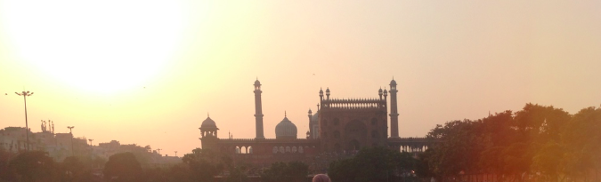
Shabnam

Shabnam, the 20-year-old daughter of Safiya, who is also at the Meena Bazaar shelter, came to Delhi 16 years ago when her mother was trying everything possible to get her father to quit drinking. Just as Safiya shared, the urban environment became the setting for the opposite effect to take hold. “We came here to Delhi, and he started drinking more. He drank too much, his mind went bad, and then he died,” Shabnam shared. Before he died, he was abusive to his family, did not provide financially, and used all of the family’s money to feed his addiction. Her mother did some housework sweeping when she was younger, but it was not enough to allow for Shabnam to be able to attend school. While her mother was working and her father was drunk, she was left to care for her siblings. When she was 13-years-old, Shabnam got married. She had two children, a son and a daughter, before her husband left her a year and a half ago. He wanted to go to the village for his sister’s wedding, but Shabnam resisted because of the financial strain of both of them attending the wedding. She told him to go, and he went, promising he’d return in three weeks. He never came back. He never gave a reason for his leaving, and Shabnam said, “I don’t know why he left me, didi.”

Since her husband has left, Shabnam must care for her two young children and earn money for their survival through begging, from which she earns about 100 to 200 rupees a day. After her bad experience with marriage, she speculates that she’ll never get married again. “What’s the point of getting married when they will not take care of my children?” she asks. “Even if I wanted to get married again, the men around this area are not nice. They’ll get married for a day or two, have their fun, and leave. So there’s no point in getting married. When [my children] get older, I’ll find a job and work.” Currently, she and her children go out to the mosque every day to beg, and she occasionally brings local shopkeepers chai for 10 or 20 rupees. Without literacy and with young children, these are some of the only options available to her. While she and her children usually stay in the shelter, she stayed outside at the time of the interview. During Ramadan, they must stay outside, Shabnam explains, because they must beg until late at night during the holy season, after the shelter gates are closed at 11:00 or 11:30 pm.

Shabnam has attended Delhi House Society’s literacy classes about three times, though it is difficult for her to attend regularly. She says that her children are always around her needing her attention, which makes it difficult to pay attention in class. She reflects, “I always think about how I should be educated. But in reality, I cannot do that because of my kids. They will be trying to teach us here in class, but then my kids start to cry and I have to take care of them. I always wanted to study, but I cannot.” Additionally, she feels that she is a slow learner, which makes it difficult to progress academically. She has learned how to write her name in these classes, and says that it would help the ladies to learn if literacy classes were to occur every day. As it is, twice a week, Shabnam says it is too easy to forget about what they have learned. Although she believes she is a slow learner in academic matters, Shabnam has great confidence in her abilities to learn skills for survival quickly. When her children get older, she would like to do any kind of work, such as, “housework, like sweeping, doing dishes and chores in people’s homes, cleaning and pressing clothes, selling vegetables, or running a shop.” While these are diverse occupation options to enter into, she confidently says, “I’ve been working and doing things since my childhood, so I can learn to do any job pretty quickly.”

Shabnam reports feeling like Allah takes care of them, and that’s how they survive. As Shabnam explains, “We ask him, ‘If you’ll do this for us, we’ll be good and read the Quran and all.’ Once he grants us our wish, we pray to him and we thank him.” Regarding her hopes for the future, Shabnam says that she would like for her children to have a different fate than what she’s experienced. She hopes that when they become old enough, that they will attend school, study well, and one day “become somebody”. Ideally, she would like for her son to become a mechanic and avoid the common occupations of Meena Bazaar, such as rickshaw pulling. She also hopes to find her husband to ask for her children’s inheritance that they rightfully deserve.

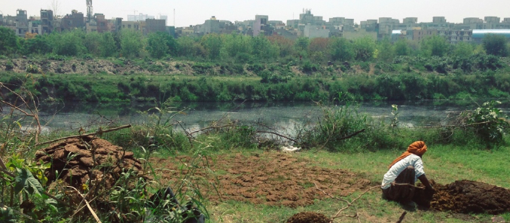
Maryam
Maryam and her daughter, Ruksana, have only recently come to the shelter from their hometown that is just outside of Delhi. She suspects that she is between 22 and 25 years old, though her voter ID places her at 26 years old. When Maryam was young, her mother and father gave her away to family members. She was adopted by her uncle and aunt, and lived in an abusive environment. As Maryam states, “I lived in fear.” Even though she was adopted in, she felt she was never truly cared for. “When my adoptive family began having children of their own,” she says, “they stopped taking care of me.” Every once in a while, she attended school, though she reports that she learned very little. Maryam can read a write a little bit, but she admits that her skills are insufficient due to her limited schooling.
Eleven years ago, her adoptive parents married her off to her first husband. It was an abusive relationship, which spurred her on to get a divorce. Then, eight years ago, she entered into her second marriage with the husband who would be the father of her daughter. Again, it was a relationship marked by abuse, both by the husband and his family towards Maryam and Ruksana. “Because of this [abuse],” Maryam says, “we left them, I got a divorce, and we came here.” Someone had given her some money to support herself, but her husband kept it all. She and her daughter came to Meena Bazaar with nothing, searching for work so they could sustain themselves.

Maryam and Ruksana had been in Meena Bazaar for two to four weeks, and originally came to Old Delhi in search of work, which Maryam had yet to find. She abhors the idea of begging, saying that she doesn’t feel good about it. “The whole thing where they send children out to beg with their hands out, asking for money… It really doesn’t sit well with me, didi.” Desperate for work, she is crying out to Allah for help and asking everyone she can for opportunities. While earning money would be a priority anywhere, Maryam feels this need acutely in Delhi, which she describes as “very expensive”, considering that just one cup of chai is 10 rupees. She complains about the shelter environment, where people are, “not nice” and take drugs. Maryam feels that the best situation would be for her to find work in someone’s house, where she and her daughter could live, eat, and work in the home. Such a work situation would provide enough stability for her daughter to attend school consistently, rectifying the current gap in her education from moving away from her old school. Although Maryam admits that literacy classes would be nice so she could augment her small literacy capability, she feels that she does not have time to commit to such classes. It is quite clear that her primary objective at this point is to obtain work.

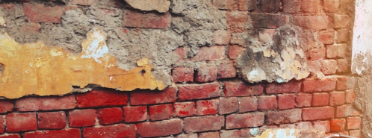

Jyoti

When Jyoti was a child, her parents moved to Delhi from Punjab. The opened a restaurant, and sent their three sons and one daughter to school. However, when Jyoti was eight or ten years old, they withdrew their children from school after a teacher beat one of her brothers. “I was quite intelligent,” she remembers. As a child, Jyoti’s parents had difficulties managing her. “I was very naughty, stubborn, and spoiled,” she remembers. “Nobody dared to say anything to me, because I used to get angry very easily.” As a result, she wasn’t disciplined and didn’t contribute to household or restaurant work.

Jyoti’s mother passed away, an experience she remembers bitterly. After her death, more responsibility fell on Jyoti’s shoulders. She began doing her mother’s duties, taking care of her brothers, and doing housework in someone’s home to earn money. “When my mother was alive,” Jyoti recalls, “I was living a really good life. But once she died, I had to wake up to reality. Now, I know the value of a mother. Now, I know what sorrow is.” Eventually, Jyoti got married in a love marriage, and had three daughters, who are now ten, five, and two years old. At the time of the interview, she was nine months pregnant, due to give birth in two or three days. She still has contact with her husband, who lives just outside of the shelter. “He works as a rickshaw wallah and gives us money to take care of ourselves.”

Jyoti regrets withdrawing from school now. As she said, “I wish I had studied. I always regret it. Anybody could do the jobs I’m qualified for, but if I had studied, I could have gotten a better job.” She explained that since she never completed school, her employment prospects were significantly limited.

Jyoti has been attending literacy classes at the shelter since they began, and she is a determined learner. Sitting on the floor in any one position for a period of time is difficult for her this late in the pregnancy, but she deals with the discomfort. “I lean against the wall and do what I can. I try very hard. And I’ve learned a lot! The teacher tells that I’m very intelligent. I’m learning everything very quickly.” Jyoti has learned how to write her own name, her husband’s name, and her children’s name. She feels great pride that she no longer needs to sign documents with her thumbprint. “I go to my kids’ school, and they ask me if I’d like to put my thumbprint down or sign. And now I can tell them, ‘Sign.’ It’s a good feeling to be able to tell them I’d like to sign.”

Jyoti summed up her life experience well, in a way that captures the sentiments and experiences of many of the women she shares shelter with:

“It’s been a rough life. There has been so much pain and so many things I’ve learned. My mother died and I got married alone. There are no guarantees in life. I believe in Allah, and he will take care of me. When I have any problems, I talk to Allah and he listens to me. I don’t know what will happen in the future, but he will take care of me.”

Emergent Themes

The stories these women bravely shared have been thoroughly reviewed and coded for commonly emerging themes. The themes outlined before were among the most commonly appearing themes that the ladies mentioned in their life stories and cultural reflections. The most common themes have been compiled and analyzed below.

The Culture of Meena Bazaar

Based upon the interviews, a number of worldview, cultural, and life-experience themes emerged. The ladies at Meena Bazaar:

- Experience or are influenced by a rural-to-urban migration
- Feel negatively about the shelter environment
- Share certain lifecycle milestones such as child marriage, abuse, abandonment, and forced independence
- View Allah as an unknowable provider influenced by human deeds
- Hold on to hope for the future in the lives of their children.

Rural-to-Urban Migration

First and foremost, it appears that the need for literacy among homeless women is an urban phenomenon. As they or their parents arrive in the city, many village economy skills do not translate to marketable skills in the urban economy. The livelihoods they could depend on in the village fall flat in Delhi’s sprawling urban metropolis. Largely coming from backgrounds as farmers or laborers, these rural-to-urban migrants find that their skills do not fit into the urban system. The jobs that they are qualified for, such as rag picking, rickshaw pulling, and begging do not pay enough to support a family in the increasingly expensive capital. Farhannah explains that the 100 rupees she earns a day is not enough to support her family in Delhi. Things are more expensive than in the village, meaning that money does not go as far.

Navigating the urban space provides additional challenges. In the rural setting, paths are known, and knowledge of the village’s spatial layout is passed down orally and learned through experience. In urban centers, however, rural migrants are faced with the challenges of using public transportation that weaves through an infinitely complex matrix of roads, bridges, and alleyways. As many of these ladies mentioned, lack of education and illiteracy leave them dependent on strangers as they maneuver their ways around the city on Delhi’s public bus system. Catching the correct bus requires literacy and numeracy to read the bus’s destination. Without literacy and numeracy, bus-takers are rendered dependent upon strangers who may or may not provide correct information to those who need it. Roshni explained, “My daughter is studying at a hostel in Okhla, and I have to meet her. I don’t know how to read numbers and Hindi, so I have to ask people to know which bus I should take. I wish I didn’t have to ask people, I wish I just knew and could read it for myself. I want to learn more so that I don’t need anyone’s help. Once I learn, I can do it all for myself.” Safiya shared similar sentiments, as she said, “I really want to learn how to read, because if I go out, I need to be able to tell what bus to take and where it is going. It’s really convenient if I know how to read, and I won’t have to ask anyone.” The ability to read bus stands, street signs, and metro maps would decrease their sense of vulnerability, empowering the ladies to navigate the city they have chosen as their home.

The Shelter Environment

Women also commented on the undesirable nature of the environment at Meena Bazaar. As they live in a place surrounded by drug use, begging, and abuse, they desire safer and cleaner places to live for themselves. The environment seems to include the location, facilities, and residents at Meena Bazaar. Based on her experiences, Farhannah describes the conditions of the urban environment. “Here in Delhi, there is nothing good for us. Everywhere we go, there are people drinking and smoking and doing drugs. It’s not a good environment in Delhi.” Maryam, who had just arrived at the shelter two to four weeks prior to the environment, also expressed discontentment with the environment at the shelter: “This whole area’s environment is not nice. I don’t know of any other place I could go, but this place is not nice.”

Similarly, Aisha shared discontent with the environment at the shelter. She says, “My kids are growing up now, and the environment here in Delhi is not good for them. They can get addicted to drugs or they can run away with boys. So for these reasons, I would prefer to be in my village, but we don’t have a house there so we had to come back here.” These particular

Life Cycle Milestones

Every respondent shared that they have experienced certain life cycle milestones. Every woman interviewed at the shelter has fulfilled the Indian cultural expectations of women to get married and to have children. Unfortunately, the institution of marriage, which typically exists in part to support women by providing financial security, has not been favorable for these women. Experiencing abandonment and lack of support, many ladies at Meena Bazaar find that those they have been told to depend upon are not dependable.

Early marriage is common among the ladies at the shelter. From Fahima who was 15 or 16 years old, Safiya who was 12 or 13, or Saida who was 10 at the time of marriage, child marriage seems to be a common experience among the women at the shelter. Child marriage is the result of several factors, including cultural norms, lack of education, and financial instability. If a girl’s a family cannot reasonably provide for her anymore, it pushes her into another man’s house for his family to care for her. Among the women at the shelter, marriage has happened at a very young age. Tabassum regrets her mother’s decision to get her married at the young age of 14. She said, “I don’t know what they were thinking when they got me married. They just married me off. If it were in my hand, I wouldn’t have done it that way. I wouldn’t have gotten married. I would have waited.”

While some of the ladies responded that their husbands are helping support them financially, a more common story was one of abandonment and lack of financial provision within their marriages. Farhannah, whose husband committed suicide, mourned the difficulties of providing for her family by herself. Then she added, “But, you know, he never gave me money even when he was alive. He always spent his money on gambling, drugs, or drinking. He never took care of me or my family.” Similarly, Safiya’s husband spent all the family’s money on alcohol, leaving her with the responsibilities of household work and breadwinning. Providing for their families in both financial and caretaking capacities takes its toll on the women. After having been at the shelter for a year, Tabassum shared, “Life is tough here for women. But we just take care of our kids, we take care of ourselves, we try not to depend on anybody else, but it’s tough.” She laments that the men who stay around the shelter are not good, and put them at risk for being robbed and molested.

Coming from poor families trapped in generational poverty, many of these women were required to work at an early age. Fahima, who was required to beg for her family’s survival, and forfeited her childhood schooling. Aisha never attended school because her brothers needed her to work around the house and assist in harvesting the fields.

What Allah Requires

Islam among the women at the shelter is distinctly Indian, and shares much in common with Hinduism. It could be described as being closer to folk Islam than orthodox Islam. Few of the respondents described Allah as relational in any way, and every respondent mentioned earning Allah’s favor through their works. The spirituality at the shelter is behavioral, action-based, merit-driven and uncertain.

Many of the ladies were unable to articulate and define Allah’s character. Descriptions of Allah characterize him as a deity responding transactionally to humans’ efforts. The ladies see Allah’s responsiveness to their prayers as directed correlated to their level of obedience in fulfilling their duties of religious observance. Aisha, for instance, explains what Allah thinks about her and what he requires of her.

“When Allah looks at me, he just says to be honest, to be nice. My husband goes and works very hard, and so one day Allah will see this and will give him lots of money. We will have lots of money and will be able to buy a house and we will give some of the money to charity. So one day, Allah will help me. Hindu people give charity, they give to the mandir, they give food, they give money, they do all the good things on Saturdays. And why do they do all these good things? Because God will see their good works and he will bless them. That’s why people do it; that’s why people do good things.“

Fahima echoes the giving nature of Allah, when she says, “Everyone says to pray to Allah and he will answer your dreams and prayers. Everyone says that, so I think it must be true that he gives things. Whatever I ask in my heart before Allah, he does it. Whatever I ask Allah for, he gives me through my husband.” Similarly, Jyoti reports asking Allah for work for her husband and food to eat for the children at the shelter.

Interestingly, this group of Muslim women have implemented the Hindu idea of all gods being one in the same. Time and time again, women stated, “Hum ekki hain” – We are all one, implying that we all worship the same god. As Shabnam shared, “We worship Allah. We believe in all gods: Allah, Bhagwan, all gods. We don’t believe in a separation. We don’t hate others for what they believe. We just believe in everything. Our blood is all the same. We are all one. “ Farhannah believes that the distinctions between Allah and Bhagwan were created by humans, and that there is only one god that humans cannot truly understand. Jyoti expresses the same perspective: “I believe in everything. I believe in one god. The names for god are all different, but I believe in god: Bhagwan and Allah.” Similarly, Safiya stated that there is no difference between Allah and Bhagwan. “They are all the same to me,” she said. When asked what the Divine was like, women commonly responded by saying that humans can never truly know what god is like, but that they know he is right (“sahi hai”) and they can trust him. Maryam expresses deep uncertainty of the nature of Allah, yet asserts, “Whatever Allah will do, He will do for good.”

While the ladies did not quickly establish an exclusive connection to the Muslim name Allah, they were quick to refer to Muslim cultural and religious practices of roza (fasting) and namaz (prayer). Engaging in these practices seem to be an indicator of a good Muslim. The practices of namaz and roza, used to show devotion to Allah, become transactional practices used to earn Allah’s favor. Roshni shares her experience with prayer and fasting: “When I do namaz, everything goes well. When I do namaz and pray, my health and everything with my body is fine and healthy. But when I don’t do namaz and don’t do those things, things are bad. So I try to be holy. When ladies here fight and swear at each other, I tell them to not do these things and to not use bad words. I tell them to do good things, and Allah will take care of you. “

Honesty, as well, is held in high esteem. The second most common desire for their children was that they would grow up to be honest. When Tabassum shared what Allah requires of her, she said, “Tabassum – “He asks us to do namaz, to be honest, to not steal, to not rob people.” Additionally, she shared a story about a time in the market when a man’s wallet was hanging from his pocket. “Two thieves were behind him, coming after him. And I told him, ‘Bhaiya, please, take care of your money.’I always do things like that, because Allah is always watching us, so we must be very honest.”

Hopes and Children

There is some sense of hope among the women in Meena Bazaar – if not for themselves, then for their children. They have dreams for their children, sometimes based off of their own regrets, and sometimes based upon observed methods of progressing financially in the world. The women’s hopes for their children speak to what they believe is possible, and what they hold as valuable in the world. They are practical hopes for their children to be functional, respectable members of society. While the ladies in Meena Bazaar have many similarities with each other, there’s only one thing every respondent stated: their primary hope for their children is that they study. Roshni explained, “I have a very difficult life, and I don’t want my kids to go through what I have been through. So studying, so they can get a good job with something like computers, I’d like for them to learn skills, like sewing or computer work.” Fahima recalls a difficult childhood of begging, under the care of parents from the village who never fostered the sense of hope for their children. Now, as an adult who has grown up in the urban setting, she encourages her children to dream for their futures. Fahima understands the handicap of illiteracy in the city, and she encourages her children to study well and dream big.

Their responses that reflect a value for childhood education run contrary to a major misperception among the Indian public, that the uneducated do not understand the value of education; In fact, this group of uneducated women has a firm grasp on the importance of education. Some of the most common desires for their children include the desire for their children to study, to get a good job, to be honest and polite, and to care for them in their old age. Learning from decisions that their own parents made for their lives, the ladies of Meena Bazaar seem committed to providing their children with a different future. Several women shared that they would not marry their daughters off early; rather, they would allow them to make the decision to get married for themselves.

Contribution of Cultural Themes to Literacy Design
Homeless women in Delhi are among the city’s most vulnerable, routinely facing exploitation and violence at the hands of their families, the public and law enforcement, and lack accessible legal and governmental protection. (Shahri Adhikar Manch: The women of Meena Bazaar are apex of vulnerability in this demographic. As widowed, abandoned, poor, Muslim women, they have status and hierarchy working against them. However, they do have agency, and know that there is hope. Unlike Oscar Lewis’s (1966) “culture of poverty”, which is characterized by fatalism,
Fordham, Holland, and Milican write that in order for literacy from any program to be considered “functional”, program formation must involve their input. “People know why and when they need literacy,” Fordham et. al. write. “Programmes should be designed with them – and where possible, by them.” (1995, p. 14) Based off of the data collected from interviews, the following is an analysis as to how this information can be used to shape and guide the literacy program at Meena Bazaar.
Throughout interviews with the women at the Meena Bazaar homeless shelter, it became apparent that the primary need for literacy is to lessen their vulnerability and to connect them with the city through education. Based off of the data, two major forms of vulnerability that can be addressed through literacy education are transportation and employment.
Limitations
The ladies at the site have varying levels of willingness to interact with each other, and according to Delhi House Society staff, group discussion-based interventions have not been successful in the past. Currently, there is such a degree of distrust and conflict among the ladies in the community, that participation in group conversation would be limited. The Freireian model of “culture circles” require community and group participation in the discussion, which is outside of what most participants are willing to do at this point. Additionally, time constraints and family responsibilities mean that ladies do not want to be present in a classroom setting for longer than is beneficial for them. For these reasons, Freire’s “culture circles” would not be a good fit. Regarding spiritual and worldview components of a literacy program, a group discussion format is not ideal.

Regarding family responsibilities, childcare availability is a major consideration. Lack of childcare during literacy classes, and the necessity to earn money were the two most common reasons that ladies said attending literacy classes was difficult or impossible.
Opportunities
However, Freire’s concept of generative words to assist in literacy education holds great value. Using phonemically rich words that hold practical and cultural value for the learning population, an educator can engage learners in word recognition and phonetic decoding skills. Specifically, women have shared that literacy regarding skills and transportation would be of great practical value for their lives. The instructor could utilize words from these realms as keywords (Laubach, 1960) or generative words (Freire, 2013). Pertinent words from these realms with great phonemic richness and practical, cultural value could be utilized for word recognition and a template for learning corresponding sounds.
Additionally, ladies who are interested in literacy classes at the site have expressed that two days as week, as classes have been scheduled since their introduction, are not sufficient to meet their learning needs. Fahima, who is a particularly motivated learn, has said, “They are only teaching us two days a week. I think there should be regularly occurring teaching. Two days a week is not enough. With two days a week, it does not get into my head. There is too much time to forget what we have learned.” Similarly, Shabnam complained that she is a slow learner and needs for the class to meet every day if she is to remember what she has learned. “Once in a week is not enough to learn and remember what we’ve learned. Sometimes, we forget whatever has been taught to us,” she said.

Literacy education tailored to the felt needs of the participants could provide the women of Meena Bazaar with empowerment, increased autonomy, marketable skills, and the ability to better support their children in their own education.

Recommendations for Program Design

Based off of this research, it appears that the women at the shelter are in need of practical literacy skills quickly. As often the sole earners in their households, they do not have much time to spend sitting in a classroom. Therefore, it is my recommendation that Delhi House Society implement several level-based curriculum for the ladies of Meena Bazaar. Such a curriculum would allow the ladies to acquire the skills they need quickly, while piquing their interest and motivation to continue learning. This model would utilize the “relief-rehabilitation-development” paradigm, shifted into the realm of education. Often, development workers employ this model to conceptualizing appropriate development interventions depending on the severity of a situation and the realistic capacity of those within the affected community. For a literacy program, such a paradigm might be helpfully translated into “survival”, “skilled”, and “self-sufficient” literacy skill acquisition. Such terms will need to be defined based off of the literacy program’s context, which in this case, is the reality of the ladies in Meena Bazaar.

Knowles (1980) states that adult education must take into consideration several key assumptions, including that adults are motivated to learn, orient their learning based off of real world experience, need to direct their own learning, and deepen in individual difference with age. Engaging the ladies’ needs and desires in an accessible format holds great promise for gains in the field of literacy.

Survival Literacy

For the women in Meena Bazaar, basic survival literacy skills will mean a heavy emphasis on environmental print-based literacy. This is one realm where literacy can practically reduce one aspect of vulnerability that homeless women face. In interviews, women repeatedly made mention of their desire to read bus signs, street signs, and other tools to navigate around the urban space. Practical literacy of signs and public writing, also known as environmental print, has high practical survival value. Studies show that adult learners use memory for word recognition, while children rely more on phonetic (National Centre of Literacy and Numeracy for Adults, 2013, p. 1). Word recognition skill development for common words in the urban environment appears to be a practical step towards achieving their goals.

Research supports that beginning with environmental print-focused literacy education builds confidence in the learners as they see immediate real-world application of the classroom material. (National Centre of Literacy and Numeracy for Adults, 2013). Seeing that the time and effort they exert in the classroom have real-world payoff, adult learners are more apt to persevere in their studies.

Some topics within the realm of Survival Literacy would be:

- Reading and writing names (own and names of family members)
- Reading and writing one’s address
- Reading names of often-used bus lines
- Reading signs for businesses frequented (chemist, ration shop, etc.)

Words within these realms can be used as phonemic templates to demonstrate the usage of a variety of written vowels and consonants. Such an approach falls in line with Freire’s (2013) criteria for generative words: that they phonemically rich, of appropriate phonetic difficulty, and pragmatic and practical in tone. (p. 47) Additionally, he suggests that to engage the learners, the words chosen should be culturally significant. As example, the “Uttam Nagar” bus line could be a template to learn the “U”, “T”, “M”, “N”, “G”, and “R” consonants. Fortunately, Hindi is phonetically consistent, meaning that there is one sound for each letter. This phonetic consistency lends itself well to such phonemic segmentation. As the incorporated words should be based off of the individual learners’ experiences and learning needs,

Skills Literacy

The next portion of literacy education would equip women with knowledge to partake in income-generating work. Many of the women interviewed lamented their lack of education because it has kept them from being able to secure a job. Although they have skills to engage in rag-picking and cleaning homes, these jobs either provide little money, keep them away from their children, or require connections. Equipping women with literacy to assist them with finding work

The Skills Literacy portion of the program should immediately provide the following skills:

- Basic numeracy and math for business (addition, subtraction, multiplication, division)
- Basic stitching skills.
- Ability to follow recipes.

Self-Sufficient Literacy

This next step would only be developed as ladies desire or need further literacy skills. Beyond the basic topics covered in Survival and Skills literacy, some ladies have expressed deeper literacy needs. The ladies have been learning to write their names, a significant step towards literacy, and symbolically empowering. They are now able to sign documents, and to see their own name in writing, and to take pride in holding a pen in their hand rather than having ink smeared on their thumb. However, further literacy is required if they are to avoid being duped; the ability to read documents that one is signing is of utmost importance.

For example, Farhannah shared that she feels a need for deeper literacy to be able to read contracts and legal documents. As she said, “It’s nice to know how to read because then, if someone gives me something to sign, I can read it first before signing. If I can read, then nobody can dupe me. My family wouldn’t have cheated me if I knew how to read and write better.” Jyoti would like to be able to read so that she can play a part in teaching her children literacy skills. Individuals vary on their ultimate literacy goals; Conversation with individual women can uncover further literacy needs.

Discussion Topics

While a fully Freirian curriculum does not seem to be the best fit for this context, there is absolutely space to incorporate transformational conversations into the literacy program. The teacher should be a transformed person herself, building relationships with the ladies of the shelter, and getting to know not only their educational progress, but their hearts. She has an opportunity to get to know the ladies in a one-on-one capacity, and such intentional relationships are relatively new phenomena to these ladies. She should engage the women in conversation throughout the classes, and share the transformational message and actions of Jesus. As one staff member from Sewa Ashram stated, this community is sensitive and crucial, and the mission of Delhi House Society is to serve people regardless of caste or creed. This is true, and the teacher should be respectful. She should also recognize the transformational potential of Jesus to touch this community in holistic Kingdom transformation.

As learners progress to pursue more advanced types of literacy, the teacher/facilitator should incorporate various theme words that pertain to the ladies’ life experiences. Based off of common experiences in the ladies’ lives, this literacy program should include keywords and discussions that revolve around the following themes:

- Identity as child of God: personal value, and the value of others.
- God as caring, loving Father, unlike the men they’ve known.
- Biblical principles for ethical entrepreneurship and business (weights and scales, etc.)
- Agency to affect the world around them as co-creators with Christ.

Figure 2: Three-tiered approach to contextualized literacy for Meena Bazaar

While the proposed model may facilitate empowerment, true transformation will only come to Meena Bazaar through Jesus. Education and skills development can alleviate the day-to-day practical and financial stresses of these ladies, but they have deeper trauma that only the Spirit of the Lord can fully heal. Literacy education can be a jumping-off point for transformation to occur, but the ability to read itself does not indicate transformation. As the instructor builds relationships with the ladies, she has a profound opportunity to pour into them. It is my recommendation that the teacher or facilitator of Meena Bazaar’s literacy classes would be a transformed person herself, interested in listening to the women and walking through life with them in solidarity. This process may not be quick or easy, but sharing life and encouraging the ladies towards their goals provides the instructor an opportunity to share Jesus’ transforming life with the women at Meena Bazaar.

Recommendations for Further Research

Future researchers should investigate the effectiveness of such a program as it is implemented. Additionally, future research should focus on ideal learning format for homeless women in Delhi. Group learning does not seem well received at the shelter, and education as a method of community building would be a particularly interesting study.

Organizational Feedback

On July 23rd, 2015, these research findings and program recommendations were presented to Delhi House Society leadership, staff, and community members at Sewa Ashram in Narela, India. While most of the staff present were not “hands-on” personnel at the Meena Bazaar site, they listened intently and asked thoughtful questions. One senior staff member inquired about the effectiveness of current literacy interventions, asking if the women were responding to the classes. “Are they really improving?” he asked. Mr. Faniel Singh, who oversees activities at the Meena Bazaar site proudly bore testimony to the women’s learning abilities. He told of taking ten women and their children from the shelter to register for school. The principal handed them the admission forms, and only two of the ten women needed to sign with their thumbs – the rest wrote their names. “I felt very, very proud when I saw that these women were writing their names,” he reported.

Another community member expressed the importance of the teacher as a guide, saying that, “there is a difference between teacher and student.” Additionally, he said that people without an educational background should learn from teachers and facilitators who can nurture their learning process, catering to each learner’s capacity and required speed.

One staff member from Delhi House Society voiced concerns over the idea of sharing the Good News with the ladies through these classes. He was concerned that the program design in question was focused on proselytizing among “a crucial community” where people are “very aggressive about their personal beliefs.” This revealed the need for clearer articulation regarding the transformative portion of literacy education. The goal is not to pressure anyone towards conversion; it is to be salt and light, sharing the hope of Jesus, the One who transforms.

Unfortunately, the woman who has been teaching in Meena Bazaar was unable to attend the final presentation. She will receive a pamphlet outlining the proposed program and methods for teaching, and will be encouraged to use them by her supervisor.

Conclusion: Literacy and Transformation

Based off of scholarly literature and interviews with homeless women living at the Meena Bazaar shelter, it appears that it would be appropriate to tailor literacy education to the specific felt needs of the women. Economic strain and family responsibilities shape the need for a literacy program that provides practical literacy skills quickly and efficiently.

The women at the shelter also have similar life experiences of rural-to-urban migration, abuse, child marriage, and motherhood, similar views of Allah, negative feelings about the shelter environment, and enduring hope for the futures of their children. These themes can be helpful in shaping a literacy program that is accessible and useful for the ladies. It is recommended that Delhi House Society consider the implementation of a three-tier program approach to literacy that involves focus on Survival Literacy, Skills Literacy, and Self-Sufficient Literacy.

If Delhi House Society continues to seriously invest time and resources in literacy education for the women of Meena Bazaar, it could open doors to employment, empowerment, and potentially transformation for participants.

Works Cited
Akker, J. J., Gravemeijer, K., McKenney, S., & Nieveen, N. (Eds.). (2006). Educational design research. London, UK: Routledge.

Alfred, M. V. (2002). The promise of Sociocultural Theory in democratizing adult education. In Learning and sociocultural contexts: Implications for adults, community, and workplace education (pp. 3-13). San Francisco, CA: Jossey-Bass.
Brown, R. E. (1971). How dialogue can be used to witness to Muslims. Evangelism and Missions Information Service (EMIS). Retrieved from www.emqonline.com.
Choules, K. (2007). Social change education: Context matters. Adult Education Quarterly, 57(2), 159-176. doi: 10.1177/0741713606293912.

Corwin, E. (1980). Bury my heart in the Khasi Hills. Evangelism and Missions Information Service (EMIS). Retrieved from www.emqonline.com.
Eaton, R. M. (1974). Sufi folk literature and the sxpansion of Indian Islam. History of Religions, 14(2), 117-127. doi:10.1086/462718.
Freire, P. (2013). Education for critical consciousness. Bloomsbury Academic: London.
Fordham, P., Holland, D., & Millican, J. (1995). Adult literacy: A handbook for development workers. Oxfam: Oxford, UK.

Gowing, P. G. (1983). The legacy of Frank Charles Laubach. International Bulletin of Missionary Research, 58-62. Retrieved from internationalbulletin.org.
Gray, D. E. (2014). Doing research in the real world, 3rd edition. SAGE: Los Angeles, CA.
Inniger, M. W. (1979). Getting to know their heart hunger is key to reaching Muslims.Evangelism and Missions Information Service (EMIS). Retrieved from www.emqonline.com

John-Steiner, V., & Mahn, H. (1996). Sociocultural approaches to learning and development: A Vygotskian framework. Educational Psychologist, 31(3/4), 191-206. doi:10.1207/s15326985ep3103&4_4
Knowles, M. (1980). The modern practice of adult education: from pedagogy to andragogy. N.Y.: Cambridge.
Laubach, F. C. (1960). Thirty years with the silent billion: Adventuring in literacy. Westwood, NJ: Fleming H. Revell.
Lewis, O. (1966). The culture of poverty. Scientific American, 215(4), 19-25.
Mantovanelli, F. (2013). The Protestant legacy: Missions and literacy in India. Available at SSRN 2413170.
Massey, S. (2007). Christian Missionaries in India. Delhi, India: Sumit Enterprises.

Natarajan, N. (1977). The missionary among the Khasis. New Delhi: Sterling Publishers.

National Centre of Literacy and Numeracy for Adults. (2013). “Read with understanding: Environmental Print.” Tertirary Education Commission: New Zealand.

Ramabai, P. (2013). Pandita Ramabai (Eternal Light Biographies Book 1). Eternal Light Books: India.

Roberts, P. (2000). Education, literacy, and humanization: Exploring the work of Paulo Freire. Westport, CT: Bergin & Garvey.

Schlitz, M. M., Vieten, C., & Miller, E. M. (2010). Worldview transformation and the development of social consciousness. Journal of Consciousness Studies, 17(7-8), 18-36.

Tripathi, A. (2014). Understanding the problem of homelessness: A case for using habitus as a tool. The Journal of Development Practice, 1, 33-37.

Appendix
Interview Questions
1.How old are you?
2. Are you married? How long have you been married? What work does your husband do?
3. Do you have any children? How old are they?
4. Where are you from? What brought you to Delhi? To Meena Bazaar? How do you feel about life here?
5. Did you attend school? How many years did you go to school for? What was your experience at school like? Why did you leave? How did you feel about it?
7. What do people think about education for boys and for girls?
8. How do you worship Allah? What is Allah like? What does Allah think about you?
9. Would you want to participate in literacy education? Why or why not?
10. In what situations do you feel like you need to be able to read?
11. If you had a daughter, what three hopes would you have for her life?
12. What is life like for women here? What are your responsibilities?

A term meaning ravine or gully, often referring to polluted and unsanitary sewage canals.
For more information on Delhi House Society, see delhihouse.org.
Ancient holy Hindu Scriptures.
The largest mosque in India, built between 1654 and 1656 by Shajahan, the famous Mughal ruler who built the Taj Mahal.
Hindi term for “night shelter”.
A common game among children in Delhi, involving using a stick as a bat to bounce a ball or stone off the ground and hit it.
Meaning, “four legs”, a charpai is a common cot-type piece of furniture.
Approximately $3.13 and $4.69 USD, respectively.
According to the definition provided by “Cities of Delhi” through the Center for Policy Research India, a jhuggi jhopri cluster is a “non-notified ‘squatter settlement’ in Delhi. Most are on public ‘lands occupied and built upon without the permission of the landowning agency’. From http://citiesofdelhi.cprindia.org/glossary/
Respectful Hindi term meaning “older sister”.
Approximately $1.56 and $3.13 USD.
Black tea with milk, sugar, and spices.
$0.16 and $0.32 USD, respectively, at the time of the interview.
Approximately $0.16 USD.
Term for someone who pulls cycle rickshaws for a living.
In India, it is typical for illiterate individuals to sign documents with their thumbprints.
About $1.56 USD at the time of the interview.
Hindu temple.

