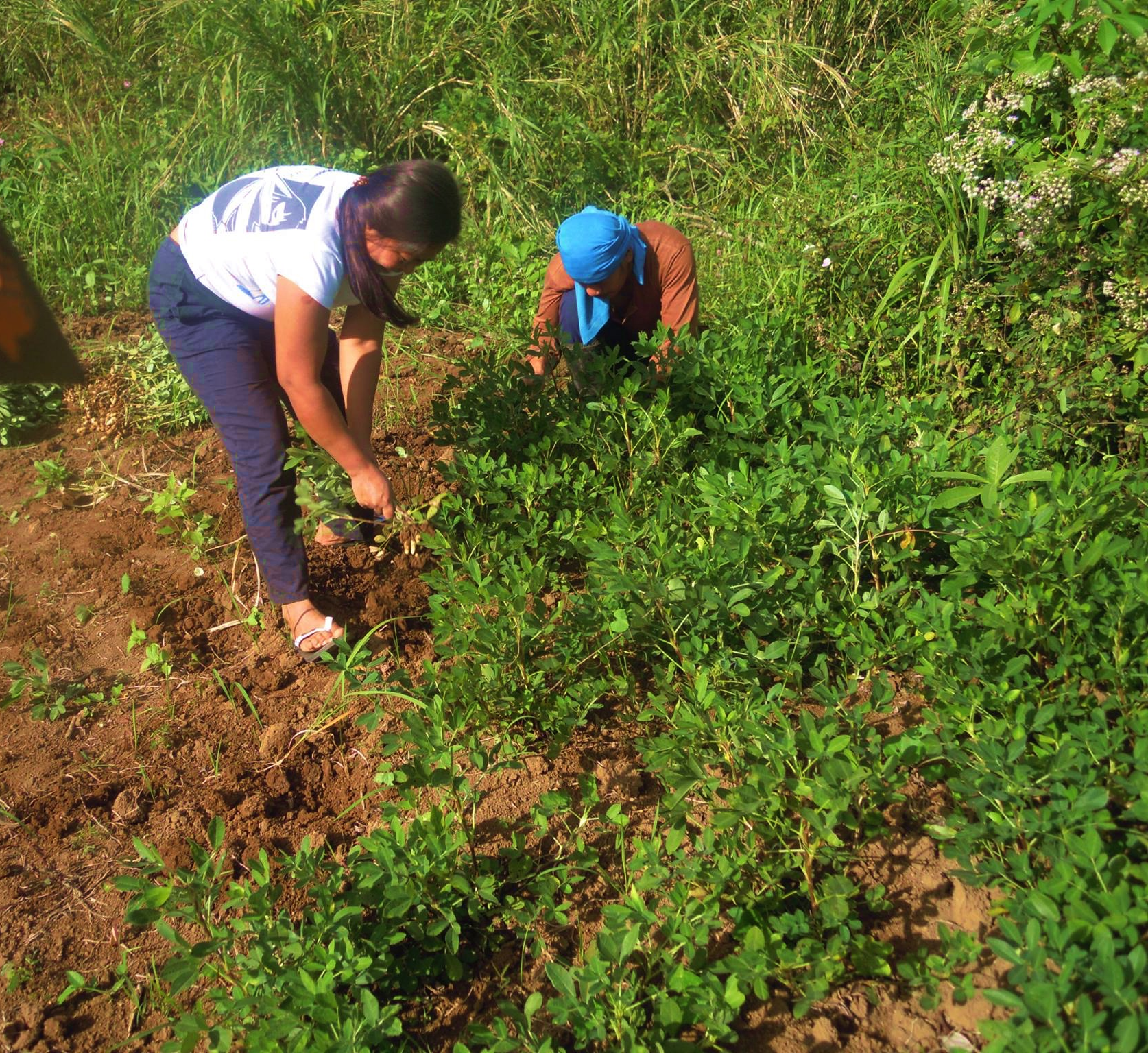
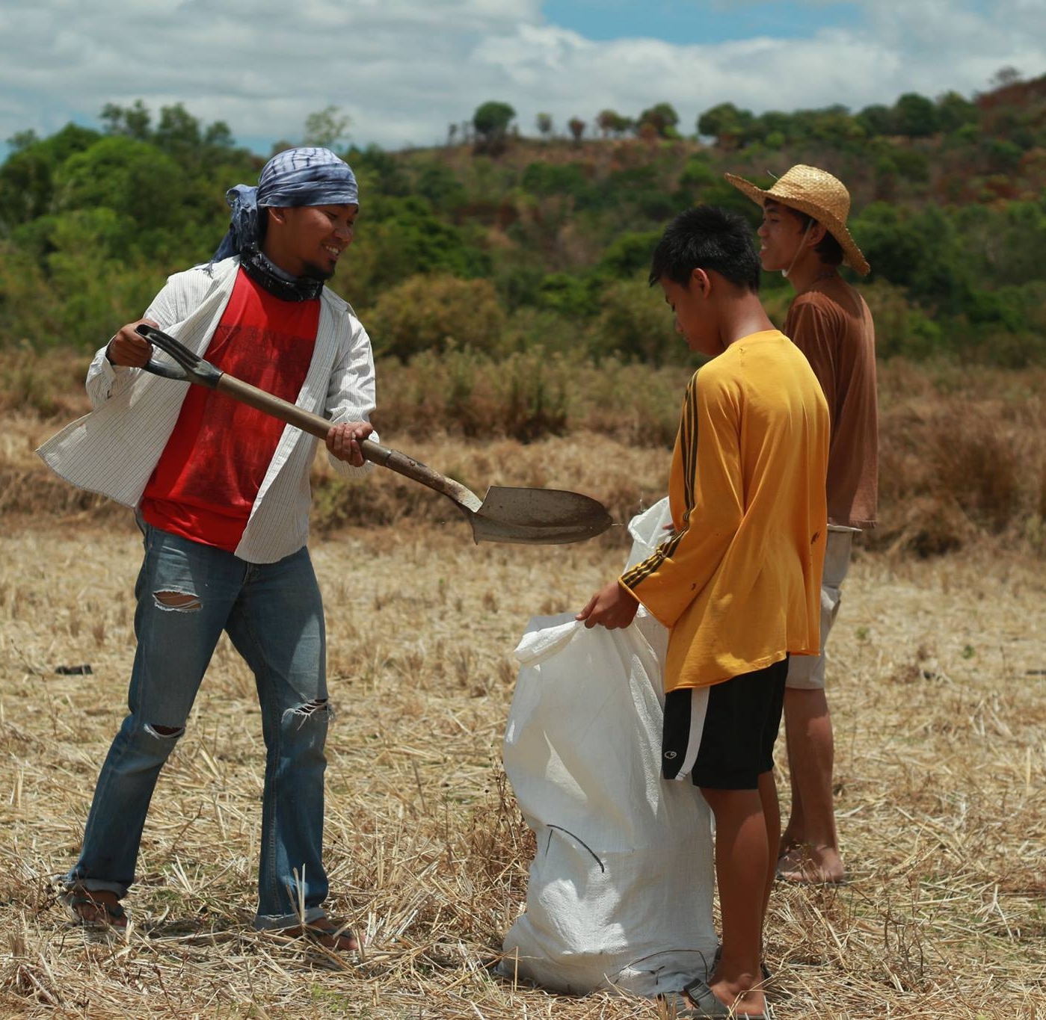

Reconnecting with the Land:
An Exploratory Study on the Impacts of Sakahang Lilok on Environmental Stewardship among the Urban Poor

Research Project
submitted as partial requirement for TUL670B
Amanda Tam
M.A. Transformational Urban Leadership
Azusa Pacific University
Advisor: Dr. Viv Grigg, Ph.D.

Acknowledgements

Thank you to Dr. Grigg and my fellow MATUL classmates for sharing your wisdom and hearts with me,

my dear family and friends for all of your love and support in this journey,

the wonderful Filipinos I have met during my time in the Philippines,

and God, the Creator of all things beautiful.

ABSTRACT

This grounded theological research assesses the effects of Sakahang Lilok on the perspectives, behaviors, and theologies of urban poor Christian Filipinos on environmental stewardship.

Sakahang Lilok is a farm in Rizal, Philippines run by Lilok Foundation and is a common retreat site for churches and ministries from Metro Manila. Sakahang Lilok aims to provide visitors from the city with a tranquil place to rest, while also educating them on how to better care for the land and God’s creation.

The data for this study was collected from fifteen individuals from six different communities who previously spent time at the farm and three locals who are knowledgeable on environmental and urban poor issues in the Filipino context. The findings of this research will assist Lilok Foundation and other similar organizations to better understand how to teach urban poor communities about the theological and practical significance and value of caring for the land.

TABLE OF CONTENTS

CHAPTER 1: Introduction 5

CHAPTER 2: Literature Review 10
Environmental Stewardship for the Poor 10
Significance of Land and Creation
Reconnecting People and Land 11
Mobilizing the People 11
Research Approach 13

CHAPTER 3: Methodology 15

CHAPTER 4: Research Findings 17

CHAPTER 5: Analysis 32

Conclusion 37

Works Cited 38

Appendix A: Interview Questions 40

Appendix B: Map of Sakahang Lilok 41

Appendix C: Pictures of Sakahang Lilok 42

CHAPTER 1 INTRODUCTION
"We need to see, with the eyes of faith, the beauty of God's saving plan, the link between the natural environment and the dignity of the human person."

-Pope Francis, Manila, Philippines, January 2015

As you travel towards the provincial area where Sakahang Lilok is located, a few hours east of the hustle and bustle of Metro Manila, you can immediately sense the change in the atmosphere. There are fewer vehicles on the road, buildings and homes are further apart from each other, and the air is significantly cleaner and crisper. Trees and greenery are abundant and line the narrow roads, not all of which are paved. It’s refreshing and calming to be removed from the chaos of the city. You feel much more at peace amidst the simplicity of the more natural environment.

In April of 2007, Lilok Foundation purchased the 1.4 hectares of land in Tanay, Rizal that would become known as Sakahang Lilok (Lilok Farm in Tagalog). Although it had been used and visited by friends, churches, and groups associated with Lilok Foundation in the building and development process, it was officially complete and open for guests in 2011. Since then, Sakahang Lilok has been hosting churches and ministries from Metro Manila for retreats and camps at their site, providing a quiet, peaceful place to rest and learn, while showing them the beauty of God’s creation and teaching them how to care for it well.

THE ISSUE
The need to care for the environment has become more of a mainstream issue across the globe due to emerging awareness of the effects of climate change. Even in the Philippines, plastic bags cost a fee in cities like Quezon City, Metro Manila, and the mega malls publicize their use of solar energy and concern for Mother Earth. Issues such as air pollution and waste management are key issues in Metro Manila and affect the urban poor at large. Mucky, trash-filled rivers and smoggy, grey skies are daily sights in Metro Manila, and they negatively affect the quality of life for the urban poor who often live in undesirable locations that are exposed to environmental hazards. Urban poor communities suffer the most from negative environmental conditions

POINT OF INTEREST
The Lord God took the man and put him in the garden of Eden to work it and take care of it.
Genesis 2:15 (NIV)

I am passionate about seeing God’s creation cared for well because it glorifies God to do so and because when we care for the environment, it in turn cares for us. I received my undergraduate degree in Environmental Studies and although I am currently studying about grassroots community development, the significance and effects of caring for the earth continues to be a prominent subject matter that interests me. In the Bible, God calls us to care for His creation and to steward what we’ve been given well. God intended for His creation to glorify Him, and it wounds Him to see it destroyed and abused; the land has more value than for mere human utility as God’s character is reflected in the existence of creation. For this research project, I am interested in exploring how urban poor Filipinos view and practice environmental stewardship after attending a retreat farm that emphasizes minimal human impact on the environment.

RESEARCH QUESTION
How do the experiences of urban poor Filipino Christians at Sakahang Lilok affect their perspectives and practices of environmental stewardship?

This research question may seem rather small in focus, but using urban poor experiences from Sakahang Lilok provides indicators in the examination and analysis of the practices and values of urban poor individuals in caring for the environment. I am curious to see if their experiences at Sakahang Lilok affected these practices and values, and to explore why or why not there were changes. The length of time available to conduct and analyze the research is limited, but I believe that it will be possible to achieve within the time frame. Accessing the communities of the informants to interview them may be somewhat challenging if they are difficult to find, but I will seek the assistance of my translator, a long-time resident of Metro Manila. Lilok Foundation will provide me with the contact information of communities, churches, and individuals who have attended Sakahang Lilok.

There are many questions that arise when it comes to discussing environmental stewardships and the urban poor – Is it a luxury for urban poor individuals to personally care for the environment when they are primarily focused on surviving in the present? Do the urban poor think about sustainability and the long-term effects of current environmental concerns? How do environmental issues affect them personally? There is a great deal of research about the effects of environmental hazards and disasters that are exacerbated by extreme amounts of pollution and unsanctioned production of waste, but there is little research about environmental management practices among the poor and how they can be involved.

VARIABLES
The independent variable in this research study is Sakahang Lilok, the Lilok farm in Rizal, Philippines where the research participants have spent time. Sakahang Lilok’s educational programs, activities, and staff have shaped the experiences of the dependent variable. The dependent variables are the values, perspectives, theology of the group of urban poor individuals who have previously stayed at Sakahang Lilok.

POPULATION
The population in question is Christian Filipinos from urban poor backgrounds who have previously visited Sakahang Lilok for a retreat or other similar event. Some of the individuals were contacted through Lilok Foundation’s provision of their contact information, while other research participants were individuals recommended to me through word of mouth. I met with most informants in their communities, as this was the most convenient for them.

COMMUNITY RELEVANCE & BENEFITS
Environmental concerns have been a pressing issue since the rise of urbanization, and more people continue to move to the city, causing increased demand for limited resources. We are deeply connected with our physical and natural environment and it is also important that we care for the things that God loves. Lilok Foundation has said that they have not yet had research conducted specifically about their Sakahang Lilok program and would be interested in learning more about how sustainability can be taught and encouraged among urban poor individuals. Lilok strongly values caring for the land because the land cares for us.

This research will contribute to a greater body of knowledge about the subject matter- urban poor values and practices regarding environmental stewardship. Sakahang Lilok’s outreach and educational programs can also be structured and designed to better serve and educate the urban poor population. The research seeks to deepen understandings about how environmental stewardship benefits urban poor stewards. Hasan et al. (2005) argue that local poor populations should be in tandem with local governments in order to manage urban environments in a pro-poor manner; there should be greater inclusion of poor groups in environmental governance. This research hopes to encourage further discussion as to how the poor can be more involved in environmental issues in their local communities. The poor are the ones who suffer the most from environmental issues and it’s important that they recognize their role in environmental management.

THEOLOGICAL FRAMEWORK
In the scriptures, it is clear that nature and all of God’s creation are intended to glorify Him in their existence. In the passage Psalm 19:1-6, David writes of how the sky is not able to physically speak, yet it reveals the magnificence and artistry of God’s character. All elements of the natural world, from the plants and trees to the birds and fish of the land and sea, worship God in their existence because they are evidence of the almighty, living God.

“The heavens declare the glory of God;
the skies proclaim the work of his hands.
² Day after day they pour forth speech;
night after night they reveal knowledge.
³ They have no speech, they use no words;
no sound is heard from them.
⁴ Yet their voice^{[b]} goes out into all the earth,
their words to the ends of the world.
In the heavens God has pitched a tent for the sun.
⁵ It is like a bridegroom coming out of his chamber,
like a champion rejoicing to run his course.
⁶ It rises at one end of the heavens
and makes its circuit to the other;
nothing is deprived of its warmth.”
Psalm 19:1-6

The Kingdom of God, which Jesus speaks of during His time on the earth, involves shalom- reconciliation of all things. Not only is there restoration between man and God, but also between man and the environment, the created order. Figure 1 below depicts this relationship. Urban poor dwellers are often distanced from a natural environment as they live in “concrete jungles,” where they see few signs of wildlife or greenery due to how densely populated many slum communities are in the city. The gospel of Jesus Christ is holistic and although the salvation of people’s souls is significant, it does not ignore addressing the redemption of the created order.

“With all wisdom and understanding, he made known to us the mystery of his will according to his good pleasure, which he purposed in Christ, to be put into effect when the times reach their fulfillment—to bring unity to all things in heaven and on earth under Christ.” (Ephesians 1:8-10)

Reconciliation

Fig. 1. The Kingdom of God involves reconciliation and restoration of relationships between God, people, and environment.

BIASES & ASSUMPTIONS
I did have some presumptions at the beginning of this study as I have lived in an informal settlement in Metro Manila for more than a year and have made opinions based on my personal observations and experiences. One presumption I have is that environmental consciousness is not a priority or concern for most urban poor individuals because they are focused on day-to-day survival instead of longer-term sustainability.
As a middle class individual who grew up in the United States, I may have a limited perception of what environmental stewardship looks like due to being raised in a different cultural and socioeconomic context. In addition, my religious background as a Christian and personal belief that it is an important biblical mandate to care for the environment because it honors God is a bias.
I have structured some of the interview questions to be more open ended to minimize the effects of my biases on the responses of the research participants.

ETHICAL CONSIDERATIONS
Environmental stewardship is not a very sensitive discussion topic in my opinion, but the issue is still connected with the personal values of urban poor individuals. As a Westerner, I treated each interview with care and respect. I ensured that I respected each informant as a human being with valuable information to share, and not just a source of information for a research project.

Each interviewee was informed about my thesis topic and my intentions with the information that they share. Each interviewee’s confidentiality will be maintained after the interview. No research participant was required to answer any interview questions they were uncomfortable answering. The identities of the interviewees have been coded in this study in order to maintain their anonymity.

CHAPTER 2 LITERATURE
Why should humanity value itself as more than a small part of the one great unit of creation? And what creature of all that the Lord has taken the pains to make is not essential to the completeness of that unit - the cosmos? The universe would be incomplete without humans; but it would also be incomplete without the smallest transmicroscopic creature that dwells beyond our conceitful eyes and knowledge.

-John Muir

ENVIRONMENTAL STEWARDSHIP FOR THE POOR
Caring for the environment and other social justice issues have recently become more popular, yet it has been a Biblical mandate since the start of creation to care for the earth. It is well known that the Bible calls Christians to care for their neighbor, but environmental stewardship is often seen to be separate and of lesser importance. Environmental issues are serious though, as Mastaler (2011) addresses the gravity of global climate change because the effects upon the poor are the greatest. Mastaler quotes, “It will be the global poor who will face the most devastating effects of global climate change induced largely by the global affluent and it will be the poorest regions of the world with the least amount of resources to mitigate those effects” (2011, p.66). Mastaler’s statement poses the argument that the global poor are the ones who suffer the most due to environmental damage, yet the ones responsible for the damage are the affluent.

According to Mastaler (2011) and Hart (2008), it is necessary to develop a theology that gives a preferential option for the poor and socially marginalized, as we seek to link economics with ecology and equalize the realities of the poor and affluent. It is unjust that both the poor and the earth are suffering due to current economic and ecological realities. Local environments are deteriorating due to the conditions of poverty, and will continue to degrade alongside the standard of human living (Mastaler, 2011, p.76). Although most environmental issues outside of Metro Manila are related to the degradation of natural resources such as forests and fishing grounds (start of the production chain), the environmental concerns in the urbanizing cities are related to disposal of waste (end of the production chain) (Broad and Cavanaugh, 1993, p.24). Urbanization continues at a rapid rate as more people are moving from rural to urban areas, in hopes of better lives, yet this has resulted in some detrimental effects upon the Lord’s creation.

In recent decades, the rate of individuals living in urban areas has increased to over 50 percent and continues to grow alongside the mega-cities of today (Jeppesen et al, 2006). A number of environmental injustices occur from this process- polluted air, trash-filled rivers, and cramped, squalid living situations for informal settlers. Living areas are becoming congested and cities are overcrowding as masses of people continue to migrate to the hubs of their respective countries. As urbanization continues, poor populations are also increasing in urban areas. Hasan (2005) states that the development of urban areas has led to greater inequality in society between rich and poor. These inequalities have resulted in a number of social problems such as issues in waste management, sanitation, and health that affect the poorest of the poor in urbanized areas.

Viv Grigg (1988) reasons that Christians must seek economic and social justice because godliness involves bringing righteousness into urbanization. Urbanization is a process that is rapidly continuing with no signs of stopping in the future, meaning that more people will be forced to live in crowded, inhumane conditions if they are not in the minority who are able to secure a decent job. Boff and Elizondo state that the poor are the victims of the rich who consume much less, but are forced to live in unhealthy conditions, pollute land and water, and do other such activities in order to survive (1995). Social injustice causes the poor to contribute to environmental injustice because of the hand that they are dealt by the wealthier. The poor are trapped in a world where they are both cause and effect of environmental injustice (Mastaler, 2011).

SIGNIFICANCE OF LAND & CREATION
Mastaler (2011) argues that faith communities need to be accountable for the environmental injustice that is hurting both the poor and the land. Brueggemann (2002) states that land is a central theme of the biblical faith and should be seen as interconnected with people’s lives. The land is much more than the physical dirt, as it is connected with security, joy, and prosperity (Brueggemann, 2002). God intended for us to view creation with a much bigger lens than mere utility. In the Old Testament, Israel is gifted with land and this is a sign of God fulfilling his promises (Brueggemann, 2002). Brueggemann (2002) adds that the gift of land comes with responsibility, as in Luke 12:48 it states, “Everyone to whom much is given, of him will much be required.” Land should be viewed with reverence and thus managed well because it is representative of a blessed gift from the Lord.

It is important that creation is stewarded well for the sake of sustainability and future generations. Brueggemann says that in biblical history, the land was not cared for effectively under the care of the judges, as they only appeared in times of crisis, and this was not effective because the land needed more disciplined care and attention (2002, Kindle Locations 1227-1232). The next form of management was kingship and Brueggemann asserts, “Israel reflected on the nature of kingship that was appropriate to the land, recognizing early that a legitimate form of management must be consistent with the character of the land as gift” (Kindle Locations 1242-1243). The concept of land as gift is significant to Brueggemann (2002) because of how the land is managed and perceived; he specifies that the land is to be like an entrusted gift, not one that is personally possessed. When a gift is entrusted to an individual, it is used in a resourceful manner, the recipient conscientious of how it is used and preserved. The land should not be seen as something just to be used for our personal security, but an entity that honors God as we wisely manage it.

Heath A. Thomas (2011) states that Isaiah called for people to appropriately use land for and in the Kingdom of God. According to Thomas (2011), Christians cannot view the kingdom of God merely as a place on earth where humans live under God’s reign, but it is significant to view the land as part of eternity. Earth is not just a place, but also an area of our lives in which we are called to be obedient to the Lord. As previously mentioned by Brueggemann, Thomas asserts that Israel knew that she was in relationship with God, his land, and his people (2011, p. 192); Israel knew that her purpose was to glorify God and demonstrate God’s grace. Isaiah 5:8-10 also describes Isaiah’s prophetic vision of land development and that the greedy rich will have luxurious estates that are built at the expense of the poor (Thomas, 2011, p. 195). This is evidence of how the land and creation can be exploited. Bookless (2008) adds that the biblical gospel is not just about individual salvation but healing and restoration of all relationships- between God, people, and creation, and thus there should be right relationships between all of created order. As we pursue the Kingdom of God, there should be healing between all of creation. Environmental stewardship honors the relationship between man and creation.

RECONNECTING PEOPLE AND LAND
Pretty (2002) reasons, “There are many dangers in the persistent dualism that separates humans from nature. It appears to suggest that we can be objective and independent observers, rather than part of the system and inevitably bound up in it. Everything we know about the world, we know because we interact with it, or it with us” (p.12). Pretty (2002) says that people are intertwined with the environment and the land, whether they are aware of it or not. Our lives are bound up in the environment and todays urban societies seem to have resulted in a disconnection between people and the natural world, yet Pretty (2002) argues that there needs to be reconnections between the two in order to pursue a more sustainable future.

MOBILIZING THE PEOPLE
Hasan et al (2005) argue that the urban poor need to be included in managing the environment, as they are a valuable resource and are often not consulted, but there is great potential if local governments seek out their expertise. Hasan et al (2005) contend that the urban poor are valuable partners in caring for the land because they are motivated in securing their personal wellbeing, they have ground level knowledge about the issues at hand, and are valuable resources in the community due to their habituation in the area (p.8). Although the poor may be disregarded in concerns regarding environmental management because they may not have formal schooling, they are wise and knowledgeable of the matters that affect their loved ones and communities.

Broad and Cavanaugh (1993) claim that it is necessary to increase the capacities of Filipinos so that they can better manage their resources for lasting sustainability. They state that the Philippines’ sustainable-development movement includes NGOs, spontaneous citizens’ formations, environmental organizations, and mass-based people’s organizations (1993, p.133-136). Although Broad and Cavanaugh’s research is not very recent, their arguments still remain true today. They state that environmental issues in the Philippines require developmental responses that involve mobilizing citizens to pursue sustainability in the country (1993, p.18-19). Metro Manila, the urban area of the Philippines, is a congested and packed urban ecosystem where waste management is a key environmental issue. Trash clogs drains, is burned in places without regular waste collection, contributing to air pollution, and is dumped in improper places, which can contaminate water supplies (Tseng and Lin, 2009). Although it is important to address the role of larger forces, such as government, in environmental stewardship, it is important that individuals are involved in this movement too. A sense of responsibility among the Filipino people, who are so proud of their country and resiliency, can result in momentous positive effects upon the environment.

Mihaylov and Perkins (2015) explore how environmental psychology can be utilized to encourage individuals and communities to respond to environmental issues. Mihaylov and Perkins argue that the local level of activism is powerful because it involves a place of shared identity, the everyday lives and networks of community residents, and is conscious of state and corporate forces that may have opposing interests (2015, p.127). The authors state that within a spatial area, there is a strong sense of trust and community among institutions and people and so it is beneficial to do grassroots activism among communities. Environmental discourse emerges when community members are aware of the discrimination the community is facing, consciousness of power inequality, and/or the expectation of the participatory-democratic decision-making process as a form of change (Mihaylov and Perkins, 2015, p.135-136). Sparking discourse among a community is a complex phenomenon and requires strong relationships between members and local institutions.

Schlosberg (2004) states that there are three significant components in addressing environmental justice issues at the community level; these include: equality in the environmental risk of all people groups, acknowledging the diversity of all individuals and their respective experiences in marginalized communities, and involvement in the political process in attaining environmental justice. Schlosberg claims that achieving justice involves recognition and participation, as “justice includes a dimension of participation on environmental and other issues – participation by those at the short end of distributional inequity, and participation by those suffering” (2004, p.526). Participation is a significant aspect of the justice attainment process.

RESEARCH APPROACH
Jeppesen et al (2006) state, “By addressing the household (social and cultural values), the industry (motivations for particular practices) and the management of the system (public and/or private) the potential technical and normative solutions can be assessed in their practical context” (p.29). Jeppesen et al suggest that by better understanding the household preferences, practices, and priorities of community members, potential conventional and ecological solutions that are culturally appropriate and economically viable can be explored (2006).

Jeppesen et al’s recommendations to start at the ground level helped provide the basis of the methodology my research project in hoping to better understand the attitudes and customs of the urban poor when it comes to environmental stewardship and management. The practicality of Jeppesen et al’s suggestions seem more effective in the long run as the people who are the most affected can be empowered through education and take ownership of the condition of the places that they live in.

Our upbringing affects the way people view the world. Johnson (2014) says that since our worldviews are shaped by these factors, it is important to understand creation in light of how God views it because our other identities such as culture and spirituality can negatively skew our perspectives. Although in the secular world, it is common to view the world in a dualistic manner, the sustenance of creation is integrated with how God intended for humans to live under his governance (Johnson, 2014). Johnson emphasizes the importance of viewing the world through the lens of God, seeking to understand humanity and nature in God’s eyes and not our own biased ones. Members of urban poor churches and ministries typically frequent the Sakahang Lilok; thus, most research participants will be of the Christian faith. It is important to remember in this project analysis that culture and faith have greatly affected the participants’ perceptions and practices. These elements are important to consider when analyzing what hinders or promotes environmental stewardship and seeing if this parallels the biblical mandate to care for the earth.

CHAPTER 3 METHODOLOGY
The ecological teaching of the Bible is simply inescapable: God made the world because He wanted it made. He thinks the world is good, and He loves it. It is His world; He has never relinquished title to it. And He has never revoked the conditions, bearing on His gift to us of the use of it, that oblige us to take excellent care of it.

-Wendell Berry, What Are People For?

I conducted individual interviews with 15 individuals, male and female, primarily between the ages of 16 to 24, but also a few older individuals. These interviews sought to gain insight into their personal values and practices on environmental care and how their visits to Sakahang Lilok affected them. The interviews were structured, as I had a prepared list of questions to ask the research participants. These ten interview questions can be found in Appendix A.

RESEARCH GUIDE AND ASSISTANTS
Doris Risare, a bilingual local missionary and resident from my community, assisted me with this research. She accompanied me on several of my trips to the communities where I traveled to interview the informants. She also assisted me in the translations of the recorded responses of the informants to ensure the most accurate understanding of the research informants’ responses. I am conversationally proficient in Tagalog, but am not fluent when it comes to deeper discussion such as the conducted interviews for this study.

VALIDITY
To ensure validity of this research, I attempted to select a varied sample of research participants to certify that the interviewee’s responses were representative of the population of individuals who have spent time at Sakahang Lilok. I interviewed a range of ages and both genders in order to get a diverse sample of individuals from urban poor communities. Some interview questions were more open ended, while others were more structured so that the interview responses can be analyzed accurately.
In addition to interviewing the individuals who have spent time at the farm, I have interviewed three local experts on issues related to environmentalism and the urban poor in the Filipino context in order to better understand the dynamics and details of environmental issues in Metro Manila and the work of creating paradigm shifts among the urban poor.

LIMITATIONS
I had hoped to have an evenly mixed group of research participants - approximately half female, half male, and half younger, and half older – yet the majority of the visitors to Sakahang Lilok were youth. Most of the research participants referred to me were young males and so more than half of the interviewed individuals are male, resulting in an imbalanced sample in terms of gender and age.

Due to my lack of Tagalog fluency, I was unable to understand the entirety of the interviews until my research assistant helped me translate them. Having better fluency would have allowed me to dig deeper and ask the interviewees to elaborate on issues in which they did not go into detail.

OUTCOMES
This research will be submitted as part of the requirements for completing my master’s degree in Transformational Urban Leadership (MATUL). The responses of the interviewees from the research project will be used to better understand the values and practices of urban poor individual regarding environmental stewardship. Lilok Foundation will be able to use this research to further develop Sakahang Lilok’s educational programs to teach others about how creation care fits into part of holistic discipleship.

CHAPTER 4 RESEARCH FINDINGS
The earth is the Lord’s and all that is in it, the world, and those who live in it.
-Psalms 24:1

The interviews for this research focused on seven areas of discussion related to environmental stewardship, discipleship, and experience. In this study I sought to explore the research participants’ current perspectives and practices regarding caring for the environment and how their experience at Sakahang Lilok impacted them. Appendix A may be referenced for the questions that guided the interviews with the research participants.

Primary Interview Focuses
- Personal environmental theologies
- Prevailing environmental issues present in their communities
- Opinions on fellow Filipinos caring for the earth
- Experience at Sakahang Lilok
- Lessons learned from their time spent at Sakahang Lilok
- Paradigm shifts, if any
- Current practices of environmental stewardship

INTRODUCTION
Environmental stewardship among the poor…does it matter?

As I went about this research project, I considered the realities and contexts of the urban poor in relation to environmental stewardship. Coming from a very different background, I’m aware that my perspectives towards many issues are quite different due to my social reality. When I asked Dr. Nitschke, a knowledgeable individual on urban poor issues and former resident of a slum community in the Philippines, for his thoughts regarding environmental stewardship as a challenge among the poor, he stated, “Environmental protection is a luxury of the rich because the poor, they have to survive. All their energy and all their effort is occupied with survival. So to think about the environment as a companion, something that’s worth protecting has somehow disappeared.” According to Dr. Nitschke, the environment is no longer a friend or an entity to be in relationship with, but it merely becomes a resource that is to be used, and this can make environmental stewardship a challenge for this particular population.
Is it wrong to ask the poor to practice environmental stewardship when they have so many other priorities?

On the other hand, when I questioned Kuya Joshua if he thought that asking the urban poor to think sustainably about the earth was impractical or a luxury, he stated, “Sustainability should not be seen as a mentality of luxury because they can afford to live their way. The farm seeks to help people think more deeply about consumption. There are composting toilets at the farm, and there is a zero plastic rule so we do not contribute to the landfill. These actions are a small drop in the bucket, but they make a difference.” Kuya Joshua believes that everyone, rich and poor, should be conscious of their actions and its effects on the earth.

Dr. Nitschke and Kuya Joshua’s responses are not entirely contrary, yet Dr. Nitschke highlights the challenge proposed in encouraging environmental stewardship among the urban poor, while Kuya Joshua’s statement affirms the idea that all are to honor the Lord in caring for the earth. These ideas were significant to consider as I went about the research process.

I. ENVIRONMENTAL THEOLOGIES
After asking for a basic introduction of the interviewee, I began each interview by asking the interviewee’s thoughts on how God views the environment. Since all research participants identified as Christian and went to Sakahang Lilok for the purposes of a church or ministry event, it was expected that they would have some theologies regarding the environment - some opinions and beliefs about God’s views on His creation. As theology is the study of the nature of God, it is expected that the environmental theologies of the research participants would affect their personal behaviors and practices regarding creation care; theologies can provide insight as to what people choose to make a priority in their life. Although many of the research participants gave brief answers about God’s perception of the environment, I hoped that these responses would provide more insight and understanding into how and why they did or did not actively practice environmental stewardship in their communities.

Overall, the interviewees’ responses to this question were positive, as everyone recognized that nature and the environment are of great importance to God because He created them. Several of the research participants specifically indicated that God created nature before He created people in order to provide for the needs of people; they recognized God’s provision for people through his creation of nature and the resources it offers. According to Informant G, nature is seen as the source of life, as it is what “gives us life, oxygen, and fresh air”, while Informant D shared that, “all the materials that people need come from nature…all the things we see in the world today are part of nature”. Research participants recognized that God created nature in order to be used to meet human needs, and that nature was more than just a nice place to visit, but that it was the source of all human necessities.

Another theme of the informants’ theologies was the reflection of God’s character in nature. Informants noted that God’s creation reminded them of God’s compassion and love for people as creation was intended to provide Informants also stated that they saw God’s beauty in the beauty of nature. Informant P shared:
When I see the plants, soil, horizon, birds, and the sees, I see it as a symbol of God’s love towards us. It symbolizes God’s generosity and thoughtfulness. In Genesis, He has prepared everything before creating [people]. For me, nature is a reminder that there is a generous God who provides. Nature reminds us not just to take care of our families, but all the created beings, even the rats and the cockroaches. I feel that they provide balance to our environment.

Informant P acknowledged that he was reminded of qualities of God’s character, such as loving and generous, when he is able to see different elements of nature; he reflected that nature is also a symbol of God’s provision for people. Informant K said that the environment is “God’s reflection, [it shows] how beautiful God is, how artistic He is. My view is that His creation is to show the world how compassionate He is. Nature is where people get their livelihood; in nature He is showcasing His provision and His power to give, to provide for humanity’s needs.” Like Informant P, Informant K shared that nature is demonstrative of God as compassionate and giving. God is seen as extremely loving because of how he cares for and sustains the nature according to Informant J. He stated, “If one is depressed, he will just look at that tree, and he would think if this tree has life, how much more is he that God values much more than that tree. Nature can really inspire and us and that is why we really should take care of them.”
“If one is depressed, he will just look at that tree, and he would think if this tree has life, how much more is he that God values much more than that tree.”
–Informant J

God’s delight in His creation of nature was referenced a few times in the interviews. Several of the research participants said that nature was sacred and that God was pleased with the nature that He created. Similar to this idea, informant M stated that perhaps God was upset with people for the way they treat the earth- “I think He is disgusted because He created the Earth beautiful and then people destroy it. They don’t throw their garbage properly, they cut the trees…perhaps he’s disgusted.” Informant M’s statement about God’s deep concern with how people care for creation and treat His gift to humanity.

A person’s theology on particular issues such as environmentalism can reveal a lot about their heart, explain the basis for their actions, and reveal what they choose to prioritize or be intentional about. Having the informants begin their interviews by sharing their views on God’s perception of nature and the environment was significant because having a clearer understanding of the other responses that were shared in their interviews. While some research informants appeared to have a deeper appreciation for nature than others, the key themes that emerged from the interviews involved the demonstration of God’s generosity and provision through nature and God’s delight in His creation. For the informants who merely said that God created nature in order to provide for human needs, their theology regarding the natural environment could potentially be labeled as utilitarian instead of having intrinsic value.

II. PREVAILING ENVIRONMENTAL ISSUES
All fifteen of the research participants and the three local experts agreed that Metro Manila had numerous environmental issues that needed to be addressed. As previously mentioned, it is difficult to avoid seeing environmental concerns in most areas of the city. Urban poor communities and their surrounding areas in particular tend to be extra dirty and polluted; there is evident pollution of land, water, and sky in these communities. I wanted to hear the research participants share what issues they were aware of and what their perspectives were. In developing a concern for the earth and its well-being, an awareness of environmental issues is essential. If there is no awareness of environmental concerns in your community and city, it’s understandable that there is no sense of urgency or need to address issues related to conservation and stewardship.

According to most of the informants, improper disposal of trash is one of the biggest issues, as there are massive amounts of garbage that are created each day by the millions of residents of Metro Manila. Many of the interviewees said that they often see people casually litter by throwing their snack and candy wrappers on the floor, as it is rare to see public trashcans in their communities or cities. Informant D shared that the government does not know where to dispose all of the trash because so much is being created. Informant O lives in close proximity to the country’s largest garbage dump, and stated, “There are many [environmental issues], because we are here in Payatas, so there all kinds of issues...When you hear of Payatas, you know it’s about garbage. You will see nature gradually perishing.” Informant O is aware of the gradual degradation of the environment in his community and how there appears to be minimal awareness or concern about the condition of the environment. Everyone creates trash in some shape or form in their daily lives, and in places like Metro Manila that have an extremely high population density, proper disposal is a concern that needs to be addressed by community residents and local governments alike.
Environmental Issues in communities in Metro Manila (from the interviews):
- Improper disposal of garbage
- Polluted bodies of water
- Polluted air
- Lack of plant life & greenery
- Flooding due to clogged drainage systems or deforestation
- Quarrying of mountains

Most bodies of water in or near urban poor communities in Metro Manila are a murky grey or brown color, and are usually full of trash. Informant E shared that the river in his community is extremely polluted, and said that the river is so dirty that many of the fishes have floated to the top, likely because the contaminated water poisoned them. In addition, Informant C shared about the polluted water where he lives and said that there was a cigarette factory near his community that disposed of their residue, which led to the deaths of fish, causing a really bad smell in the community. Informant M also shared about a creek near his community where residents regularly dump their trash; the trash resurfaces and returns to the community during rainy season when there are typhoons according to Informant M. Based on the interview responses, cleanliness of local water bodies is an environmental issue that needs to be attended to; maintaining sanitary creeks and rivers also appears to be correlated with proper trash disposal.

It can be challenging to enforce proper environmental practices without a proper system and set of regulations encouraging people to do their part. Informant P believes that there is a need for more organization when it comes to stewarding the earth as he said, “We don’t have an organized system of throwing our garbage, no proper place to dispose of it. The government and the community leaders, they should remind us where to put and throw our garbage.” He raises an important issue of the need for the presence of a structured system in order to facilitate people’s contribution in making the community a more pleasing and safe place to live. All around Metro Manila, there are signs stating, “Do not litter”, yet people usually do not abide by these laws and neither are they enforced.

Most of the interviewees not only listed environmental issues that they saw in their communities and in Metro Manila, but also linked the issue with their respective negative effects, such as health or other environmental hazards. Informant N made an astute observation about the flooding in her community that has been caused by the cutting down of trees, resulting in no plant life to absorb the copious amounts of rain water during the Philippines’ long rainy season. Several other informants also mentioned that the improper disposal of garbage often leads to flooding when there are heavy rains as the trash clogs drainage systems; the research informants were aware that littering was not only unsightly and a potential health hazard, but had additional consequences in the community. Informant B was also able to make the connection between environmental concerns like air pollution and other external costs that may not always be blatant. He shared that it seems that people need to “buy” fresh air nowadays by spending money to go to a remote province away from the city, as all the smoke and smog have affected the breathing and lungs of city residents like himself. The interview responses demonstrate recognition of the causes and effects of different environmental issues.

When Informant A was asked about environmental issues in his urban poor community in comparison to middle class subdivisions in the Philippines, he said that there is a vast difference and this can be attributed to space. He shared,
If I walk in a middle or upper class subdivision, they still have trees there. You can see that a family owns a very big portion of space that they can afford to put trees and other green there. Where in the urban poor communities, a family only has up to 6 square meters of space and that’s like five to six people in one family. In my area, there’s like 5000 families in a very small portion of space. It’s actually in the middle of a middle class subdivision…You can see the difference of space and difference in population…there is more green and it’s cleaner in the middle class areas because there’s more space and less people. There’s less green in the urban poor areas because there’s more people and very little space. And there are more people so there’s more trash.

Informant A’s response addresses a very significant cause of the environmental concerns of urban poor communities and Metro Manila as a whole. The city of Manila has the highest population density in the world and it is a characteristic of the city that cannot be changed; people move from the provinces to the city in hopes of more opportunities, resulting in crowded conditions and exacerbated environmental problems. Community members should recognize that each of their actions contributes to either the problem or the solution.

III. THOUGHTS ON FILIPINOS CARING FOR THE EARTH
I was interested in the interviewees’ thoughts on their fellow Filipinos and caring for the environment. I was wondering if they thought that Filipinos should do more in terms of environmental stewardship or if it wasn’t that important for more people to take more action. Research informants were also asked if they had any ideas or suggestions as to how their fellow Filipinos could better care for the earth.

Overall, the key theme that emerged from the interviews was that when Filipinos care for the environment, they are in turn caring for themselves and their communities.
“We Filipinos should take care of the environment because this is our security.”
-Informant D

For example, Informant D shared:
We Filipinos should take care of the environment because this is our security. When the environment is clean, people will not get diseases. Like the pollution, especially here in Manila, in the air, lung cancer is one fatal disease, and it does not have a cure. The garbage that is clogging the waterways, it causes floods, and stagnant water causes dengue fever that kills a number of Filipinos because of the negligence of many…if there are no people, nature will continue to exist, but with out nature, people will die.

Informant D’s statement indicates that Filipinos taking further steps to manage the earth well is important because the way it is currently being managed is negatively affecting them.

Related to the concept of the deep interconnectedness between the welfare of people and the welfare of the environment, is the idea of preservation of the environment for the sake of future generations. Several informants such as Informant H stressed the importance of being forward-thinking. Informant H shared that if Filipinos do not take care of the environment now, then in due time, “the next generation will not see it or benefit from it.” Informant H added that she has seen how heavy logging of the forests has led to landslides and flooding due to water that comes down from the mountains and this leads to tragedies in communities living in the lowlands. She states that the way Filipinos are utilizing natural resources today directly affects current and future generations.

In addition to noting how management of the environment correlates with personal health, other interviewees said that the environment is the source of many livelihoods and essential resources. Informant L said, “Of course [Filipinos should better care for the environment], if the environment is ruined, where will we get our provisions?,” while Informant M shared, “yes, we should take care of our environment because this is where get our minerals, food, and medicine that helps our bodies. We should cooperate in managing the disposal of our garbage. We should learn to plant trees, not just benefit from it.” Informant K said, “The Philippines number one source of livelihood is really nature. Before there were companies, we only relied on nature. Nature is one big factor in the livelihoods of the Filipino people.”

Informant A believes that environmental education and awareness are needed to encourage Filipinos to better care for the environment. He said that once more Filipinos are educated about the effects of environmental destruction, and then they will realize the strong need to protect it. Informant O also indicated that greater self-discipline is needed in order for Filipinos be more intentional with environmental stewardship. He said that if more Filipinos do not have self-discipline, then the conditions of the earth will continue to degrade until there is nothing left; he believes that caring for the earth needs to begin in the home, where a love for nature should be fostered and developed, and then this can be demonstrated to others in the community. Relevant and applicable environmental education and awareness can lead to more active participation in urban poor communities, and this will be further discussed in the analysis section of this paper.

All informants affirmed the necessity for their fellow countrymen to steward the country’s resources because not only does doing so honor the Lord, but because it also in turn benefits them. The idea of caring for the Earth in order to care for ourselves and our future involves broader awareness as well as forward thinking, but can be revolutionary if widely taught and discussed in urban poor communities. It was wonderful to hear the interviewees share their thoughts on the need for collective participation in environmental stewardship, while also connecting caring for the earth with a number of significant ideas and happenings in their communities and country.

IV. EXPERIENCE AT SAKAHANG LILOK
Kuya Joshua, one of the head coordinators of Sakahang Lilok, says that the experiences at Sakahang Lilok are very influential in increasing awareness of the significance of creation care. He said, “Sakahang Lilok seeks to help people experience creation in a new way. Few words are needed as you can see it with your own eyes. Just like how music is heard, creation is seen with the eyes. Nature depicts the beauty and glory of God…[At Sakahang Lilok] we don’t teach doctrines, but have bibiliodramas (interactive bible studies) and experiential activities. We believe that it is up to the people to develop the theology that they believe in.” Kuya Joshua believes that once city dwellers are able to experience the beauty and splendor of being in a natural, organic environment, they will create their own theologies regarding creation care. He also added, “It is important to give questions, to let people think instead of giving them answers and telling them what to believe or think. We need to realize that we aren’t disconnected or superior to the rest of God’s creation.” Sakahang Lilok’s method of teaching about creation care is experiential, as guests are not told what to believe, but are given the power to decide what they believe regarding God’s creation based on their personal experience and interactions with nature while staying at the farm.
“Sakahang Lilok seeks to help people experience creation in a new way…just like how music is heard, creation is seen with the eyes.”
-Kuya Joshua, head coordinator at SL

Dr. Nitschke shared with me about how there is a disconnection between the urban poor and a natural environment:
You will see that the habitat of the rich, the first class subdivisions, there are lots of green, gardens, and trees, while the habitat of the urban poor is completely stripped of greenery. There is almost nothing. So that means you live in a habitat where you have almost no contact, almost no visibility of the natural world. It’s not there. It’s gone. And even if a creek or little river goes through the slum, it is severely polluted. There is actually not life in it as well. Daily contact with other creatures except for humans are very limited…And of course if you are disconnected from creation, your awareness or concern for creation cannot develop.

Dr. Nitschke’s comments about the minimal interaction between urban poor individuals and a non-manmade environment support Kuya Joshua’s emphasis on experiential learning. In Metro Manila, urban poor communities tend to be concrete jungles as numerous homes are squeezed into a small area of space; the high population density and living conditions make it difficult to grow plants and develop gardens which can foster a sense of appreciation for nature.
“[When] you live in a habitat where you have almost no contact, almost no visibility of the natural world... you are disconnected from creation, your awareness or concern for creation cannot develop.”
-Dr. Peter Nitschke

One of the most commonly shared about experiences from the farm in the interviews is the unique toilet situation there. Sakahang Lilok emphasizes that there is a zero-waste policy at their site and this even applies to the toilets. At Sakahang Lilok, the toilet is referred to as a composting toilet, or “CT”, instead of the typically referenced, comfort room (CR). Using the toilet in the Philippines, especially in urban poor communities, traditionally involves water to cleanse oneself after using the toilet, but the CT at Sakahang Lilok only involves the use of tissue. Informant H shared about her experience,
It was my first time to see a toilet like that. At first, it was uncomfortable to use it because we don’t usually have [a toilet] like that in the city. I also had a realization when they explained to us that the waste I thought I’m making is useless and can’t be used. But I saw that they are using [our human waste] there as fertilizer and then I conditioned myself to see that my waste was indeed my “contribution” or as they called it there, ambag (contribution in Tagalog).

She shared that most of her companions during the trip could not comfortably adjust to the different style of toilet, but that it was important to change the way you think so that one’s personal impact on the earth would be minimized. She learned that instead of just utilizing the environment as a resource, she too could contribute back. Informant L added the details that during his experience at Sakahang Lilok, he learned that “human waste is the number one source of element that can be used as a fertilizer. After 6 months, human waste does not smell anymore.” Related to the interview responses about the Composting Toilet at the Lilok farm, Informant B also shared that he could tell that the people at the farm loved nature, even in the act of bathing; the farm conserves rainwater by collecting and storing rainwater for use at the showers and sinks.

Returning back to the basics of simple living was a new, but positive experience for many of the informants when they visited. A few informants shared that their experience at Sakahang Lilok was very unique as they ate many simple foods that did not typically eat in Manila, such as meals with no meats and lots of vegetables. They pointed out that the prepared foods for the meals did not have Magic Sarap (a commonly used MSG-based seasoning). Informant O said that during his time at Sakahang Lilok,
You can feel that you are a part of nature. Life there is simple, there is no electricity, you have to conserve water, which one should really be mindful of…whenever I’m there, I feel the love for nature even more. It’s like you are really contributing to it and it’s like your life is connected to nature. Whenever I’m there, I realize that we are nothing without nature and we need nature more than it needs us.

Informant O has had the opportunity to go to Sakahang Lilok multiple times and it appears that each visit reconnects the individual back to creation. Informant K also said that his experience being immersed in a natural environment while at the farm was unforgettable. He shared, “The experience of seeing the beautiful view of the mountains where you are at the “octagon” (structure) is unforgettable. Nature is indeed beautiful. And then the sounds the animals and the insects were making, it’s not often that you hear those. It’s only the sound of the vehicles [in the city], but back there, even the rustling of the leaves you can hear, and I really treasure those experiences.” Informant H also said that Sakahang Lilok was a place where she could be “in communion with the Lord because of the peace it brings.” Informant H also said that during her stay, “the sound of the birds and the cicadas were the only sounds [they] hear, there were no radios or sounds you can hear in the city.”
“Whenever I’m there, I realize that we are nothing without nature and we need nature more than it needs us.”
-Informant O

The area where Sakahang Lilok is located is very spacious and homes are not directly side by side like they are in the urban poor communities in the city, but there are somewhat distant from each other as an abundance of trees, plants, and grasses fill up the spaces between the homes. Informant D made an observation about the housing arrangements of the neighbors and residents of the farm. He said, “I saw that it was really like a forest, neighbors are far from each other, like a mountain away from each other. They said that your neighbors are your security because they don’t have fences or walls around them, so it’s good to know that you are safe, that your neighbors will not harm you.” In addition to learning that the environment is our security, as Informant D previously mentioned, he also learned about how people can be our security. Instead of fearing if one of our neighbors will break into our homes and steal our personal belongings, there is a strong sense of trust and camaraderie between neighbors in the Sakahang Lilok’s vicinity.
“One gets tired of living in a noisy place, and so I long for a place like that here [in Manila]…whenever I get tired of living here, I want to go on a vacation in a place like that.”
-Informant L

The ability to rest at Sakahang Lilok because of the serene and tranquil environment was another common theme among the interviews. Informant L said, “One gets tired of living in a noisy place, and so I long for a place like that here [in Manila]…whenever I get tired of living here, I want to go on a vacation in a place like that.” Informant M shared a similar sentiment of not wanting to return to the city and said, “We told ourselves, we don’t want to go back home. It’s so nice there, the food is fresh, no MSG, everything is natural and the air is so clean, it feels so good and it’s cool during the evenings. It really feels so nice.” Informant F mentioned, “I love it there because I can relax and just take everything slowly.” The nature of the city is noisy and chaotic, but the interviewees’ experiences at Sakahang Lilok allowed them to take a breather and enjoy a simpler way of life away from the city. The ability to rest and enjoy silence can be connected with spiritual reconnection, which was mentioned by a few of the research informants. Informant J shared, “I appreciate God showing me His creation during my time there, and how I can take care of it. During my stay there, I told myself, it would be so nice to live in that place, so peaceful, and one can have a clear mind. The only sounds you can hear are the sounds of insects, and it’s like God is speaking to you in those circumstances.” Interviewees did not comment about wishing there was Internet or better cell phone service, but were able to appreciate nature in all its glory because of the secluded nature of the farm. It was apparent from the responses that the conditions of the city were exhausting and unpleasant.

V. LESSONS LEARNED
In addition to experience, I was interested in hearing about what new lessons and information the visitors acquired after their time at Sakahang Lilok. Did they learn anything new? What knowledge did they take home with them in addition to their personal experiences? Education is often an essential component in the transformation process and retaining new information about why environmental stewardship is important and honoring to God is critical in bringing about lasting change in the individual and community at large.

According to Informant B, he learned to think more from the perspective of nature. He shared, “Somebody at Lilok asked us, “What if trees can talk, what would they tell you, what would their reaction to you be like?” You were the ones commissioned to enrich them yet you are the ones consuming and destroying them. And I said to myself, “Yeah, what if trees could talk?” He also added, ”We just do what makes us happy, we don’t think about nature and how we are hurting her.” Informant B learned to think beyond his personal needs and wants, and learned to view environment as an entity that should be respected. He also said that he is more aware of the need to care, protect, and enrich nature so it can flourish, which will honor God since His creation will be restored. Informant L also said that during his stay, they were taught to huge trees, love nature, and thank them for providing for people. He said he learned to talk to nature and to value it more deeply. The shift from a focus on self to an understanding of one’s impact on the environment is monumental. In a reality where one’s focus is mainly on daily living and survival, this newfound knowledge can be really influential.
“Somebody at Lilok asked us, ‘What if trees can talk, what would they tell you, what would their reaction to you be like?’…And I said to myself, ‘Yeah, what if trees could talk?’”
-Informant B

On the other hand, Informant D learned more about the value of each and every living thing, and how God has a purpose for all things, big and small. He said, “They (the workers at Sakahang Lilok) said we should not kill the insects because they are part of the ecosystem. They play a role in this world. All insects, ants, cockroaches, all of them, they play a part to balance the earth. Humans, nature, insects, and trees, they provide a balance to the earth.” Informant D has gained a deeper appreciation of all aspects of God’s creation and is aware that they all contribute to the balance and harmony of the earth, which helps him to see the bigger picture that God sees.

Informant G said that Sakahang Lilok is “the only place I’ve seen or been to that shows how to really care for nature.” Informant G also stated that she learned why it is so important to be intentional about caring for nature in daily life. Visitors at the farm are shown a sustainable model of living, and they learn why it’s important to be aware that a different way of living is possible. The ability to see in person what sustainable living tangibly looks like enables one to apply certain aspects of the practices and structures of Sakahang Lilok back in one’s home community if he or she makes the effort to do so. Informant J also shared that during his time at Sakahang Lilok, “They taught us the discipline of accountability and self-discipline…one [lesson] you can transfer to your community and church.” Informant J’s statement about being more accountable and disciplined when it comes to personal actions is important as taking individual responsibility for the consequences of your actions, whether or not you are directly impacted by the effects of them. Both Informant G and J’s responses involve passing on the knowledge that has been gained and creating movements and positive change elsewhere, although it is up to them to be proactive about applying this newly gained information in their communities.

Informant A gained a new theology regarding the relationship between God, man, and environment from Kuya Joshua. He stated,
[Kuya Joshua] provided us with a theology about the connection of God, man, and creation where it’s like a triangle. God at top, then man, then creation. There are three lines, one line is relationship, another line is stewardship. The connection of man and creation is stewardship, and then ownership is the other line. Sin broke this line, but Jesus redeemed that. But most churches only emphasize the relationship. He gave a theology that advocates that he also redeemed the stewardship in bringing back the ownership [of creation] to God.
The theology that Informant A shared has been diagrammed in Figure 2. The diagram of the theology demonstrating the nature of the relationships between God, man, and creation, which was shared with Informant A, parallels with the Kingdom of God diagram that is discussed in the “Theological Framework” section in the first chapter.
Fig. 2: A diagram of the theology that was shared with Informant A
GOD
- - - - - - - - - Relationship - - - - - - - - -
- - - - -
- - - -
p - - - - -
MAN
CREATION
- - - - - - - -Stewardship- - - - - -
- - - - - - - - -Ownership - - - - - - - - -

Informant P also discussed the restoration of creation as something he learned during his time at Sakahang Lilok; he said, “The environment is part of the body of Christ. Creation is not just people. I believe that when God returns, He will restore everything, not just us, but also the Earth, seas, birds, heaven, and earth. A holistic view of the Kingdom of God is not often recognized in churches, as stated by Informant A, yet his recognition of this issue is important in developing a more comprehensive theology that goes beyond man and his relationship with God.

VI. PARADIGM SHIFTS
After noting the different lessons that the Sakahang Lilok visitors learned, I wanted to know if it changed the way that they thought about the environment and environmental issues. Learning new information is one thing, yet adjusting the way that you think and view the world is another. Research participants were asked if their visits affected the way they currently view creation and the environment, in order to determine if there were any paradigm shifts they had acquired and maintained since their visit. I wanted to survey the research participants to see if one or two visits to Sakahang Lilok could affect one’s perspectives.

The idea of living simply is stressed at Sakahang Lilok. As the nature of life in the city is chaotic and seems to encourage busyness, Sakahang Lilok seeks to encourage its visitors to return back to the basics. When interviewing Kuya Joshua, he told me that Sakahang Lilok wants to encourage people to live a simple lifestyle. He told me, “Is the goal of life to be blessed? No, it is about learning to simplify. Creation care and living simply go together. There are no locks for the rooms at the farm; we should not be hoarding material things.” Related to the issue of living simply and not merely being a consumer of material things, Informant A reflected, “Back here in Manila, I’m caught in this consumerist culture…everything I use, eat, wear, I buy all of them. I don’t produce them. I work, I make money, and it’s all I care about. And if I have money then I can buy. I don’t care where my food and clothes really come from. I keep on consuming and consuming, but I’m not doing any steps to provide my own food or replace the food by planting.” Informant A was challenged to think more broadly about his role in a consumerist society that encourages people to buy more and newer things.
“Back here in Manila, I’m caught in this consumerist culture…everything I use, eat, wear, I buy all of them. I don’t produce them…I keep on consuming and consuming, but I’m not doing any steps to provide my own food or replace the food by planting.”
-Informant A

Sakahang Lilok’s model of sustainability also challenged individuals like Informant H to think about living more simply as she says that had the opportunity to pick fruit from the fruit bearing trees and eat it and see how Sakahang Lilok grows their much of their own food. On the other hand, Informant H raises the issue of living the same way in the city. She said, “We don’t have space to plant now, as it is all cemented roads. So if there is a chance to live in a place like [Sakahang Lilok], it would be so great. Fresh air, and fresh food, especially fruits and vegetables.” She raises an important issue that should be addressed- the challenges of replicating the Sakahang Lilok model in urban poor communities in Metro Manila, which have limited space and resources.

Informant E was challenged to think about each and every of his actions, even the small ones. He said that at Sakahang Lilok, he “saw the impact of valuing even little things; little or big, they give importance to it…[he] was amazed by how they treated nature and the environment…they plant, and even in their products they don’t use chemicals.” This shift in thinking from, “My actions are so small, therefore they don’t make a difference” to “I have the power to make a difference, even if it may seem insignificant” is powerless.

Informant D said Sakahang Lilok helped him to view the environment with a different lens. He shared,
I really saw how God wants me to see nature. When we are looking forward 30-50 years from now, what will happen to Earth? I think, by then, Earth would be devastated If we continue to be like this, if we continue to neglect nature, if we continue not to care, what will left of the Earth 30 years from now? I’m thinking, if people don’t think like that, I need to do my part to care for and protect nature while I’m still living in this world.
Informant D raises the important idea of forward thinking, and says that he has learned to think about the future impacts of his actions.

Interviewees such as Informant K shared that they realized how important nature and the environment are to the Lord and thus that there is great importance in caring for it. Informant K said that his thinking changed after his visit, and that he “saw the need to protect [nature] because it showcases God’s holiness, and so we need to protect it and care for it, so we can preserve and see the beauty of God’s creation.”
“When you see a beautiful place like that, you want to preserve its beauty, its freshness.”
-Informant M
Interviewees such as Informant K were encouraged to understand why creation care should be a priority for Christians such as themselves. Informant M also felt motivated to better care for the earth due to the beauty of Sakahang Lilok, as he said, “When you see a beautiful place like that, you want to preserve its beauty, its freshness. It all begins with you.” Informant M’s comment about the desire to preserve what is lovely and precious ties in with the idea of reconnecting people back with a natural environment after there has been a disconnection due to the conditions of the city, especially of the urban poor communities.

A couple of the research informants said that their thinking did not change because they were already aware of the importance of creation care, but they still learned new lessons from the farm about how to better care for the earth.

VII. CURRENT BEHAVIOR & PRACTICES
During my interview with Kuya Joshua, he told me, “Big changes in society come from small actions.” Kuya Joshua strongly believes in the power of the individual, and that no act is too small to make a difference. After asking research participants about new knowledge they had gained and if there were any shifts in their thinking towards environmental stewardship, I wanted to know if and how they put
Informant D | At our house, we have plants there that we care for.
Informant O | I don’t burn my trash and I segregate, biodegradable and non-biodegradable. It saddens me though that I exert effort to segregate but the garbage collector still combines them.
Informant F | We are stewards of God’s beautiful creation, and so I always practice the “leave no trace” principles.
Informant A | I reduce my food consumption, I do my best to live as simply as I can…I plan to start a few farm by collecting some bottles and putting some soil in them to plant. I would also like to start composting so I can reduce my trash.
Informant H | Here we have a recycling program, separating waste from biodegradable to non-biodegradable. I also joined a tree-planting program in a watershed in Bulacan…It’s a waste to see trees without replenishing it.

this all into practice. As education creates more awareness about pertinent issues and how these issues affect others and the world around them, the subsequent step is engagement. The seventh area of discussion in the interviews was how they were currently intentional about being environmental stewards.
Fig. 4: Quotes from informants about the various ways they actively practice environmental stewardship since their time at Sakahang Lilok
Informant B | The simple act of not littering, I know I can help through this act. By doing simple things we can help. I’m not saying that we focus on these [small acts] alone, but whatever ideas you can think of to help to take care of nature, you should do it.
Informant M | I try to throw my garbage in the proper place. And whenever I go out with my fiends, I tell them to pick up they litter they throw however far they left it. I tell them to keep their litter with them until they find a garbage bin.
Informant G | For example, the biscuit wrapper, I don’t throw it on the ground if there is no garbage bin, I will just put it in my bag for the meantime.
Fig. 3: Quotes from several of the informants who shared about properly disposing of their trash since their visit to Sakahang Lilok
When the research participants were asked if they currently practiced caring for the earth and what their personal practices were, the most commonly cited practice of environmental stewardship among the interviewees was the proper disposal of trash. Although disposing of snack wrappers may seem like a small, inconsequential act, Dr. Nitschke reminded me, “If you think about the whole city, [there] are thousands of tons of trash that get thrown into the river. Of course, you only observe the little plastic, and a person may think that they are just throwing their plastic, but there are ten thousands of people throwing their trash. The dimension of this is enormous.” Figure __ below features a few of the responses from the interviews regarding being more intentional about the proper disposal of garbage after their time at Sakahang Lilok.

Informant E shared about serving as a role model in his community. He said, “I initiated a community service program. As a youth, I wanted to be a role model for the community. When people saw that we cleaned up the whole community, they were encouraged, because we were cleaning not just our own surroundings, but the whole community, and when they saw this, they were embarrassed so they started cleaning up too.” Informant P also seeks
to share with youth about creation care. In addition to doing his best to conserve water when possible, he stated, “I taught my youth group how important nature is to us. I share with them the things that I’ve learned at Sakahang Lilok. I told them that God can also be found in nature, not just
in people; we can see and feel Him through nature.” Informant K says that he teaches his students to care for nature because this is a part of the world that God created; he says that his options are limited since he doesn’t have a nature to care for, but he still has the ability to teach. He quoted, “In a city like this, what nature are we talking about? It’s like there is no nature here to protect.”

Informant N says that she too encourages her neighbors and friends to clean their surroundings, but also added, “We don’t wait for the authorities to tell us to do so because this is for our own good and for our health sake.” She mentions that it is important for the community to take ownership of its own health and cleanliness, as opposed to waiting for someone else to do the work. She practices accountability when it comes to her personal actions and encourages others to do the same. Informant B also shared a sentiment as he said, “We were the reason why this happened, let’s all help return the environment to its natural state.” Taking ownership and responsibility is an important characteristic of transformational change in a community; it fuels the motivation behind environmental stewardship, as opposed to feeling as if caring for the earth is an obligation. Informant J said that participates in any activity or event that helps the environment because he seeks to be an instrument of the Lord whenever possible, and that we are not merely recipients of God’s blessings.

CHAPTER 5 ANALYSIS

“You cannot protect the environment unless you empower people, you inform them, and you help them understand that these resources are their own, that they must protect them.”

-Wangari Maathai

This chapter of the thesis reviews prominent themes from the collected data and focuses on how Sakahang Lilok is encouraging urban poor Filipinos to think more deeply about their role in caring for the land. The findings of this research study are examined and connected back with the original research question: How do the experiences of urban poor Filipino Christians at Sakahang Lilok affect their perspectives and practices of environmental stewardship?

POWER OF PRESENCE
Being immersed in the more peaceful atmosphere of the province while at Sakahang Lilok was impactful for the research informants. Their experiences at the farm were more than just refreshing times away from the city, but these times of immersion in natural environment in comparison to the one they are accustomed to in Metro Manila were very significant. Being physically present among trees and other greenery reminded them of God as Creator and Provider, and how the environment glorifies God in its magnificence. Sakahang Lilok provides urban poor individuals with the opportunity to experience a new way of living, as well as a new and unique way to experience God. These impacts are meaningful, especially for those who were born and raised in Metro Manila and have not yet had the opportunity to be exposed to nature in this manner.

Jules Pretty (2002) states that our “connection with the land is philosophical, spiritual, and physical…[we] need to seek a new path towards sustainability [so we can] adapt, evolve, and new connections will be established” (p.11). Pretty (2002) states that a holistic relationship with the land involves the mind, body, and soul; she says that sustainability can only be achieved if the environment is seen as something to be in relationship with. The research findings showed that the participants’ visits to the farm were influential in encouraging them to think more deeply about caring for the earth and honoring God through their environmental stewardship. Interviewees commented on the beauty of Sakahang Lilok and expressed a desire to return. The experiential nature of the teachings that the urban poor visitors gain when they go to the farm is powerful.

Being told that it is important to care for the environment is vastly different than being present in God’s natural creation and seeing why it needs to be sustained. When one is amongst a natural environment, one has the ability to see and experience the splendor of God’s creation and understand why it is important to love and preserve it. Being in more natural environments as opposed to man-made creates more opportunities to foster a love for the natural created order because you spend more time being immersed and surrounded by the entity that you are trying to develop a relationship with.

SEEING THE BIG PICTURE
Having lived in an urban poor community in the Philippines for the past year and a half, I am aware that many urban poor individuals are focused on day-to-day survival. They purchase items such as shampoo, toothpaste, and laundry soap in tiny plastic sachets because they are focused on purchasing what they presently need for the day and are not thinking of long-term convenience and cost efficacy. The realities of the poor affect their thinking and worldview, as they prioritize the particular items in their lives that prolong their subsistence.

In the interview responses, no one mentioned that they felt powerless in caring for the earth. Instead, research participants said that because of their visit to the Lilok farm, they became more aware of how necessary it is to maintain the health of the earth, as the wellbeing of the environment affects the wellbeing of people. The relationship between people and other aspects of creation can be a mutual one if people treat the environment with respect and care. The research participants’ visits to Sakahang Lilok encouraged them to think beyond their personal realm, to strive to view the environment how God views it.

Almost all of the research participants stated in some manner that it was important to manage the earth well because the future of the environment would affect people, and that by preserving resources now, future generations would be secure. Although I had presumed that most of the research participants would not discuss the future because they would be focused on daily living and needs, many of the interviewees’ responses addressed the issue of environmental preservation for the future. The contrast between places such as Sakahang Lilok and the urban poor communities in Metro Manila reveal how dramatic the environmental degradation is, and how much has changed in recent years due to urbanization. The opportunity to see this great contrast is a large reminder of what once was and what could potentially be restored.

EARTH CARE AS DISCIPLESHIP
Kuya Joshua says that environmental stewardship is part of holistic discipleship. He shared that Sakahang Lilok wants to help Christians think more about the bigger picture. Kuya Joshua added that without Christ, there is no hope in the broken world that we live in. The current environmental conditions of the earth are alarming and it can be easy to fall into despair because of the gravity of the situation due to reports and news of large-scale phenomena such as global warming.

Discipleship requires that followers of Christ honor and love God in all things. This too applies to caring for His creation. All the research informants admitted that they were aware that the environment was of importance to God because He created it. The research participants discussed developing a better understanding of how harming the earth wounds the spirit of God too due to their experiences.

Research informants were encouraged to love and care for the environment while at Sakahang Lilok, but no one mentioned receiving any accountability or follow up from any church or ministry leadership upon their return to their communities. There needs to be increased awareness and discussion of environmental discipleship in the church in order for there to be greater lasting effects from experiences such as visits to Sakahang Lilok.

ROLE OF CULTURE
Filipino culture revolves around the group, as the culture focuses on maintaining harmony among the group members. Although this was not discussed in the interviews in an attempt to be culturally sensitive as an outsider, I thought that cultural values were important to consider when thinking about why more people did not actively practice environmental management, and why habits such as littering were so common.

Dr. Nitschke shared about the concept of sakop and said that it could potentially be something to be considered when seeking to foster a sense of creation care in urban poor communities in Metro Manila. He said:
Actually, Dr. Melba Maggay, she spoke on the principal of sakop. People are very good at taking care of their own sakop, their own thing that belongs to them. Even if you go to the houses in many slums, their homes are neat and tidy. But people don’t care about what’s happening outside their sakop. Maybe people need to see that what’s outside your sakop also influences your impact. You cannot say, “okay, I will clean my own house, but the rivers are polluted and it’s not my problem.” If it’s a cultural thing, I don’t know. If it is, it somehow needs to be addressed. I think the gospel is also about changing culture. Maybe people need to work on seeing that everything is interconnected. If they cut down the forest, it will affect me because there will be floods and drought and stuff like that. So people should think about this and do something about it.
Dr. Nitschke’s comments about sakop in Filipino culture were intriguing, and perhaps this concept needs to be addressed. At times, living out the gospel can involve changing or speaking into particular aspects of culture that may not always be positive.

A STEP FORWARD, HOWEVER SMALL, IS A STEP
Even though the realities of the urban poor require them to focus more about their personal livelihoods on a shorter-term basis in comparison to the middle or upper classes, the responses from the research participants demonstrated that engaging in environmental stewardship is possible among the urban poor. Although the poor may not be able to afford purchase pricier organic personal care and cleaning products, everyone can be more accountable for and intentional about their personal actions.
We ourselves feel that what we are doing is just a drop in the ocean. But the ocean would be less because of that missing drop.
-Mother Teresa

As mentioned earlier, many of the interviewees said that they no longer littered because of their awareness of the importance of proper garbage disposal. As you go about the city, there are massive amounts of stray litter and it’s important to recognize that this was not caused by one person, but by many. Every positive step in the right direction, however small the step may seem, is a step towards cleaner communities. Sakahang Lilok

MODEL FOR ACTION & ENGAGEMENT
I propose a basic two-step process that can be utilized by organizations such as Sakahang Lilok in order to reconnect more urban poor individuals with the environment and encourage them to engage in creation care.

The first step of the process begins with reconnection with the natural environment, which in this case is the personal experience the individual has as at Sakahang Lilok. Immersion in a natural environment begins the process of greater awareness and concern for the environment. Before engaging in discussion and conversations regarding the biblical basis of environmental stewardship and practical engagement with environmental issues, the first aspect of the process is the experience. Experiential learning is powerful. Being able to create one’s own thoughts and judgments regarding an issue is empowering for an individual. This initial process leads to increased awareness about the beauty of the environment and environmental issue, as well as the development of relationship between man and environment.

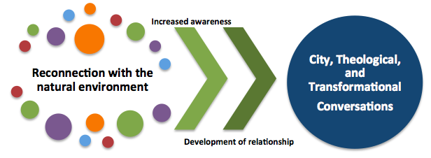
Fig. 5: This diagram depicts the first of a 2-step process in reconnecting the urban poor with the environment.

The second step of the process involves multiple conversations about the issues, which leads to engagement. The second half of the process of engagement can be paralleled with Grigg’s (2000) transformational conversations approach. Grigg (2000) states that theology involves both diachronic conversations (over multiple generations) and synchronic conversations (one time, across cultures) (p.22), thus the transformational conversations process can be applied to the issue of environmental stewardship among the urban poor.

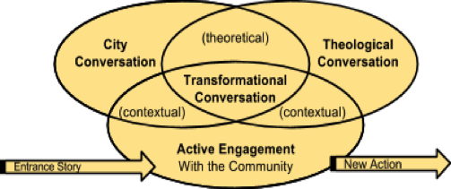

Fig. 6: The Transformational Conversations research process (Grigg and Gard, 2013)

This second process begins with a discussion of current environmental issues in the individual’s community, such as a polluted river or improperly disposed of garbage. After recognizing the current issues in the community that need to be addressed, this will lead to a discussion as to why God cares about these issues. The theological conversations simply involve conversations about what the bible has to say about environmental stewardship, utilizing passages such as Genesis 1 where God specifically states that each and every aspect of His creation is good. Then, as the two conversations intersect, urban poor individuals learn about how to practically go about caring for their community and for the land. This ultimately leads to engagement and putting newfound knowledge into action.

Fig. 7: This diagram features the various stages of creating conversations, which lead to engagement (part 2 of 2)

CONCLUSION

This research study discovered that Sakahang Lilok is creating important conversations among the urban poor about environmental stewardship. The experience to a natural environment in the province has a profound effect upon the thinking and awareness of the urban poor when it comes to caring for God’s creation. Research participants had very positive things to say about their time at the Lilok farm and state that they were positively influenced by their time there.

Research participants expressed a positive change in and awareness of their behaviors since visiting the farm. Although these positive steps may appear minor, they are honoring to the Lord and moving towards the right direction. Gaining a deeper theology and knowledge of how God cares for the land and all that dwells on it remained with urban poor visitors to Sakahang Lilok, yet what creation care looks like once translated to urban poor communities is still an area that needs to be explored. One significant question that I was unable to address is, “What can be expected from urban poor individuals that is realistic and practical for their personal realities and contexts?” However, the awareness that was developed while Sakahang Lilok is a wonderful starting point for further discussion and engagement.

As this study researched environmental perspectives and practices of the urban poor as impacted by visits to Sakahang Lilok, yet there were no interviews with a group of Christian urban poor Filipinos who had not been to the farm or interviews with the same individuals, but before their experiences at the farm. This would be an interesting topic of research for a future study, and hopefully this study is just the beginning of the conversation of the issue of environmental stewardship for the poor.

Questions that still need to be addressed and further researched:
- How does environmental stewardship practically translate to urban poor communities in Metro Manila?

- How does Filipino culture affect the practices of caring for the earth?

- How can creation care be discussed more often in the church?

- How can a better infrastructure be developed by local governments to encourage better environmental management?

References

Boff, L., Elizondo, V. (1995). “Ecology and Poverty: Cry of the Earth, Cry of the Poor.” Ecology and Poverty. Concilium. SCM Press. Longon.
Bookless, D. (2008). Christian Mission and Environmental Issues: An Evangelical Reflection. Mission Studies. 37-52.

Broad, R., Cavanaugh, J. (1993). Plundering Paradise: The Struggle for the Environment in the Philippines. London: University of California Press, Ltd.

Brueggemann, W. (2002). The Land: Place as Gift, Promise, and Challenge in Biblical Faith. Minneapolis, MN: Augsburg Fortress.

Grigg, V. (1988). Biblical reflections on land and land rights: biblical frameworks for poor peoples' theologies. Auckland, N.Z: Urban Leadership Foundation.

Grigg, V. (2000). Transformational conversations. The Spirit of Christ and the Postmodern City. Auckland: Urban Leadership Foundation. Pp. 20-32.

Hart, J. (2008). The preferential option for the poor: The poor of the planet and the planet of the poor: Ecological ethics and economic liberation. University of St. Thomas Law Journal.

Hasan, H., Patel, S., Satterthwaite, D. (2005). How to meet the Millennium Development Goals (MDGs) in Urban Areas. Environment and Urbanisation, 17 (1), 3-19.

Jeppesen, S., Andersen, J., & Madsen, P. (2006). Urban Environmental Management in Developing Countries - Land Use, Environmental Health and Pollution Management - A Review. University of Copenhagen, Denmark. 1-47.

Johnson, T.K. (2014). Faith and reason active in love: The ethics of creation care. Evangelical Review of Theology, 38(4), 292-306.

Mastaler, J. S. (2011). “A case study on climate change and its effects on the global poor.” Worldviews. 65-87.

Mihaylov, N., & Perkins, D. (2015). Local Environmental Grassroots Activism: Contributions from Environmental Psychology, Sociology and Politics. Behavioral Sciences, 5, 121-153. 1(2).

Pretty, J.N. (2002). Agri-Culture reconnecting people, land, and nature. London: Earthscan Publications.

Snyder, H.A. (2012). Salvation means creation healed: Creation, cross, kingdom and mission. William Carey International Development Journal.

Schlosberg, D. (2004). Reconceiving Environmental Justice: Global Movements and Political Theories. Environ. Polit.13, 517–540.

Thomas, H.A. (2011). Building house to house (Isaiah 5:8): Theological reflection on land development and creation care. Bulletin for Biblical Research. 21 (2), 189-212.

Tseng, M., Lin, Y.H. (2009). Application of fuzzy DEMATEL to develop a cause and effect model of municipal solid waste management in Metro Manila. Environmental Monitoring and Assessment. 158 (1-4). 519-533.

APPENDIX A: Interview Questions

1. Please provide a basic introduction of yourself – age, schooling, community, etc.

2. How do you think God views the environment/creation? Please explain.

3. Are there any environmental issues in your community? In your city?

4. Do you think Filipinos should take better care of the environment? If so, how?

5. When did you go to Sakahang Lilok? Why did you spend time at Sakahang Lilok?

6. Can you tell me about your experience at the farm?

7. What did you learn at Sakahang Lilok? Were there specific lessons or programs teaching you about creation care?

8. After your time at Sakahang Lilok, do you think differently about the environment?

9. Did being in a more natural environment have an effect upon you?

10. Do you try to be more intentional about caring for the environment? Why or why not? If so, can you provide examples?

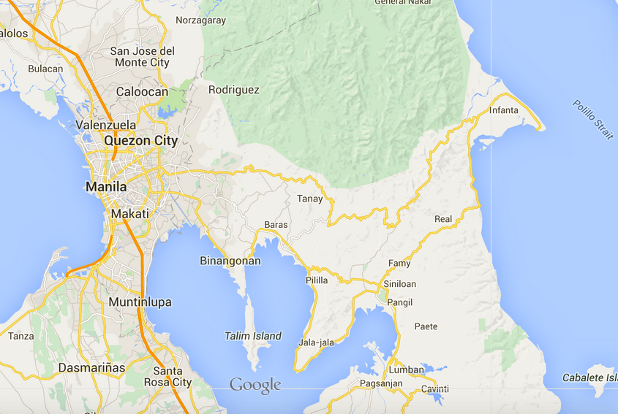
APPENDIX B: Map of Sakahang Lilok

APPENDIX C: Photographs of Sakahang Lilok
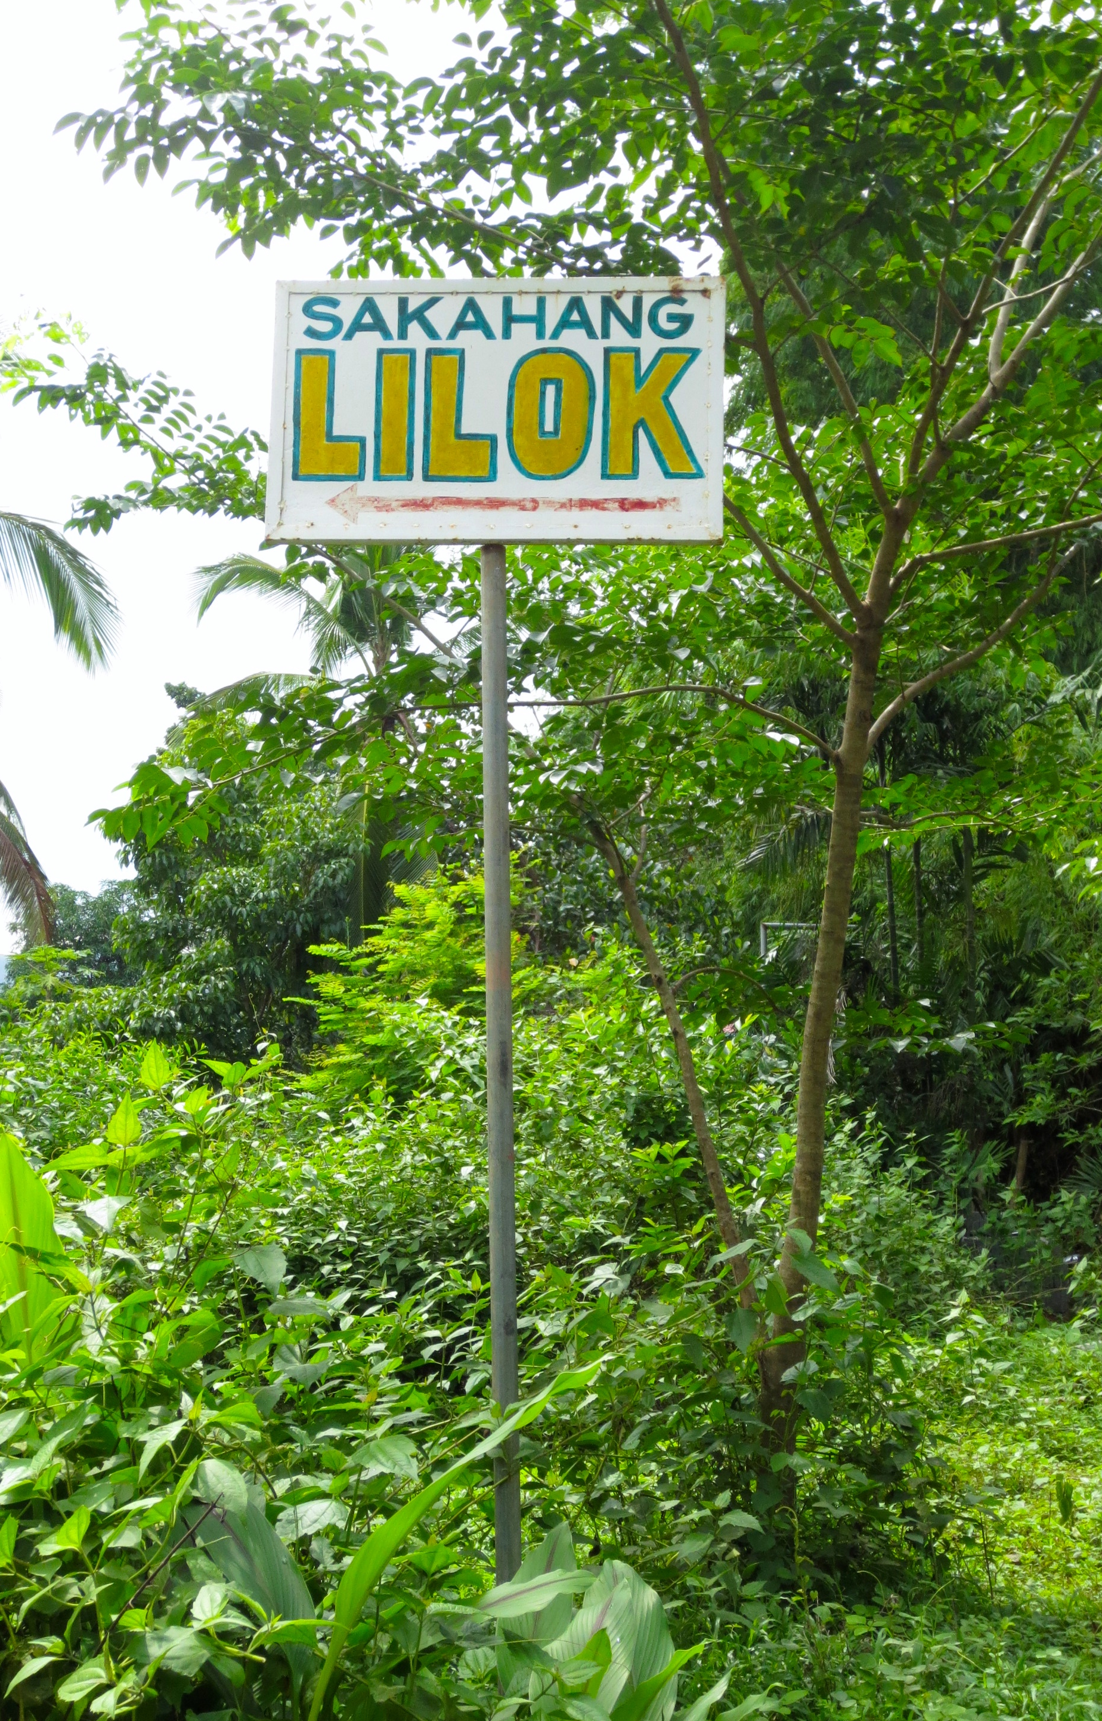
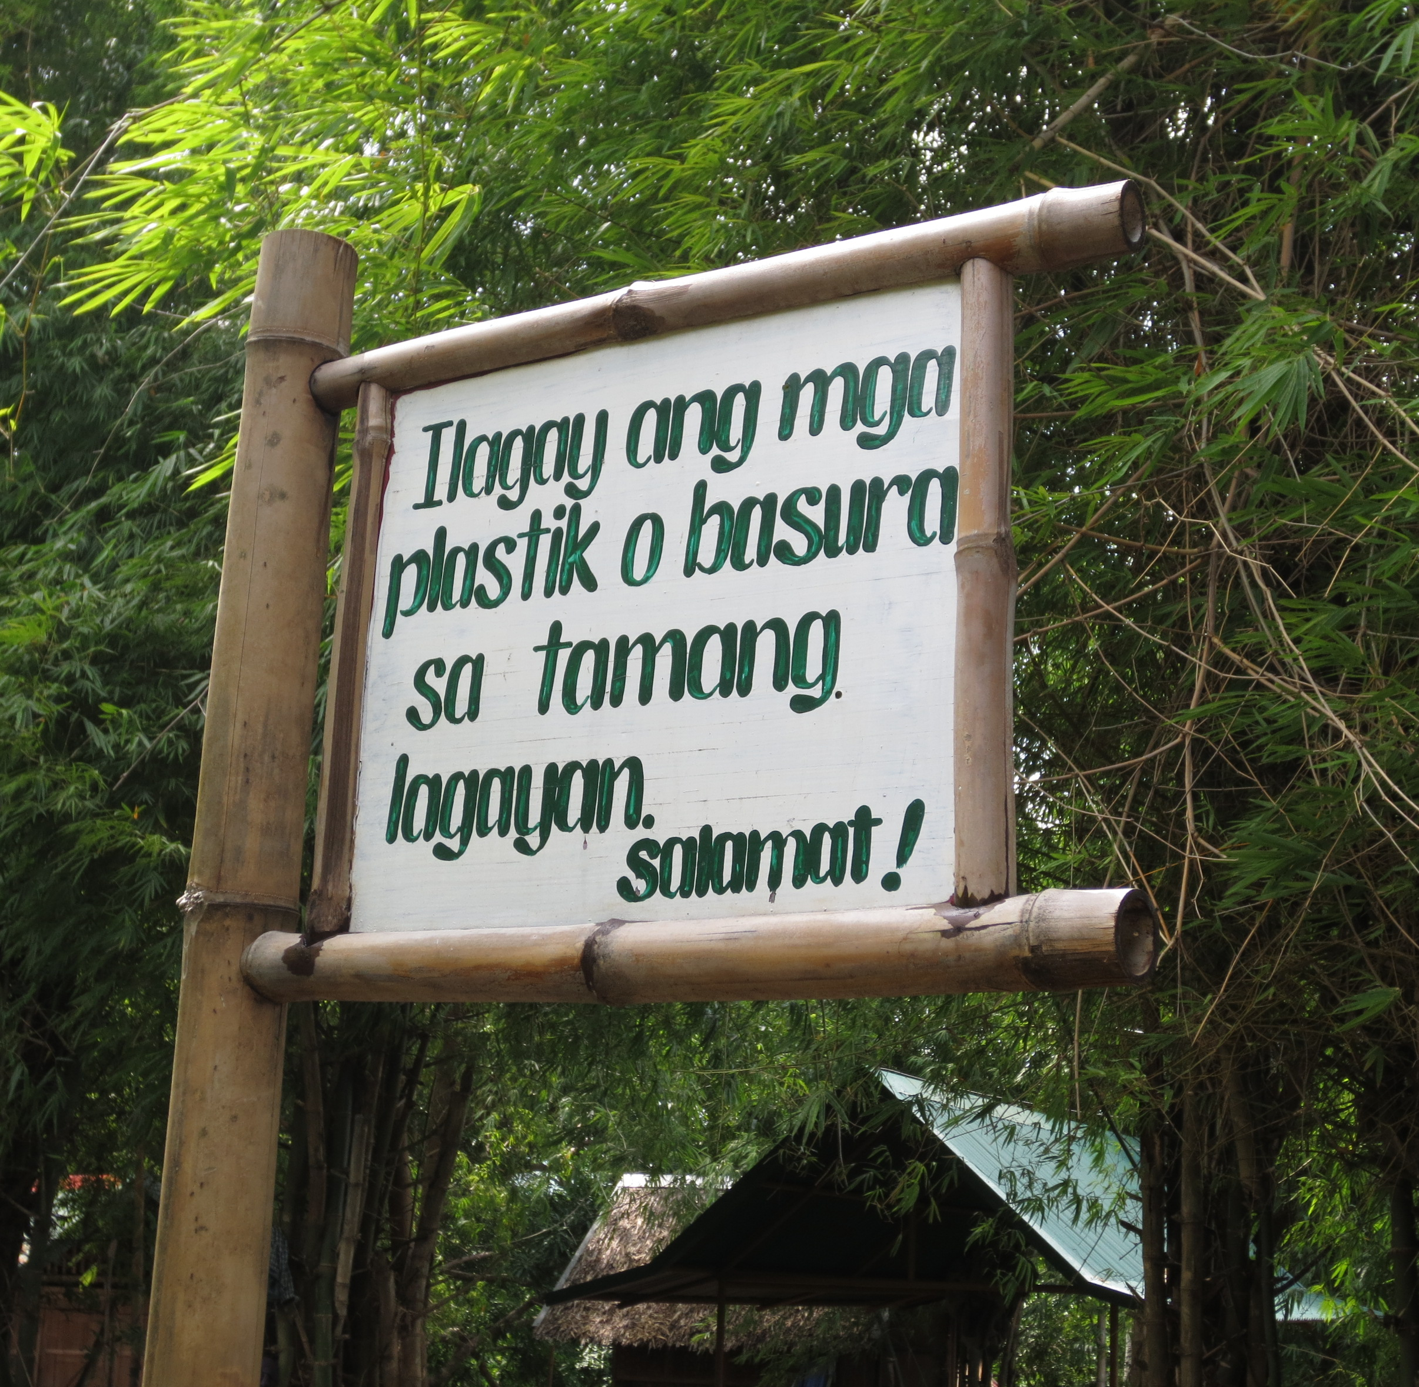
Photo 2: “Put plastics or trash in the correct place. Thank you!"
Photo 1: Sign right before arrival to Sakahang Lilok

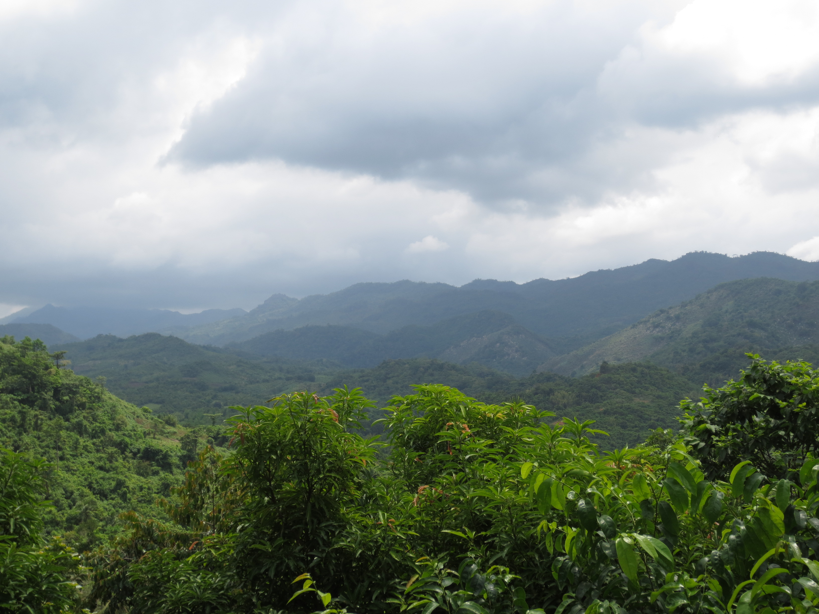

Photo 3: The view from the “octagon”
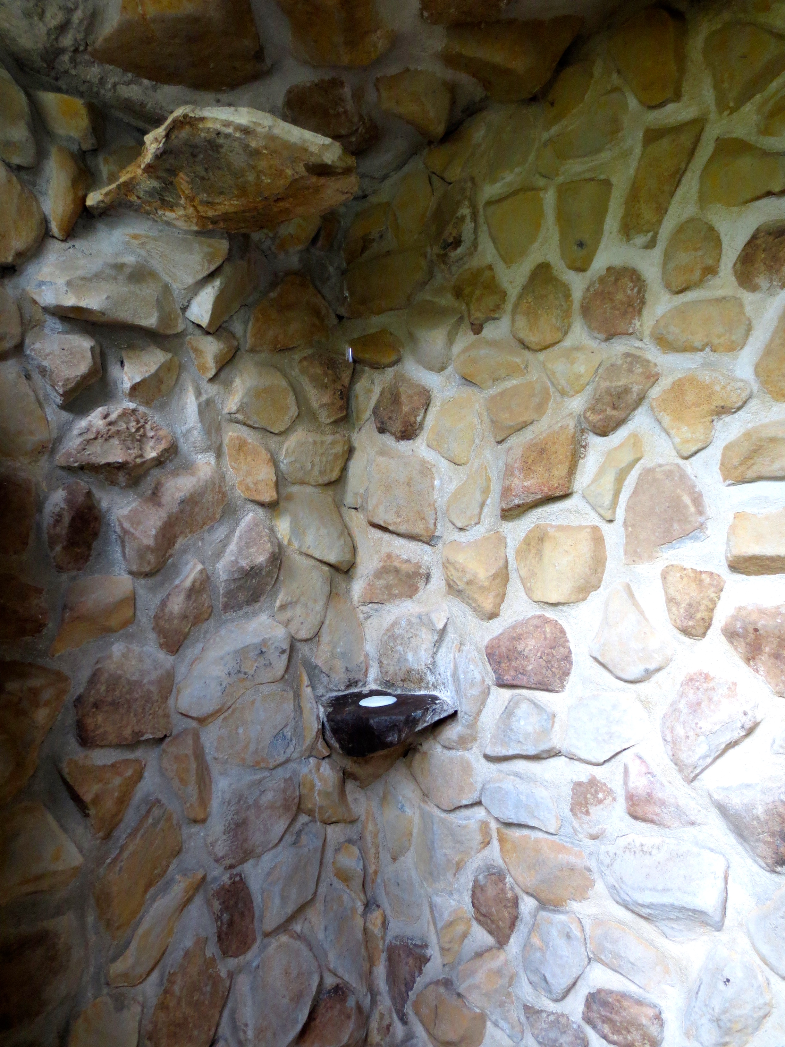
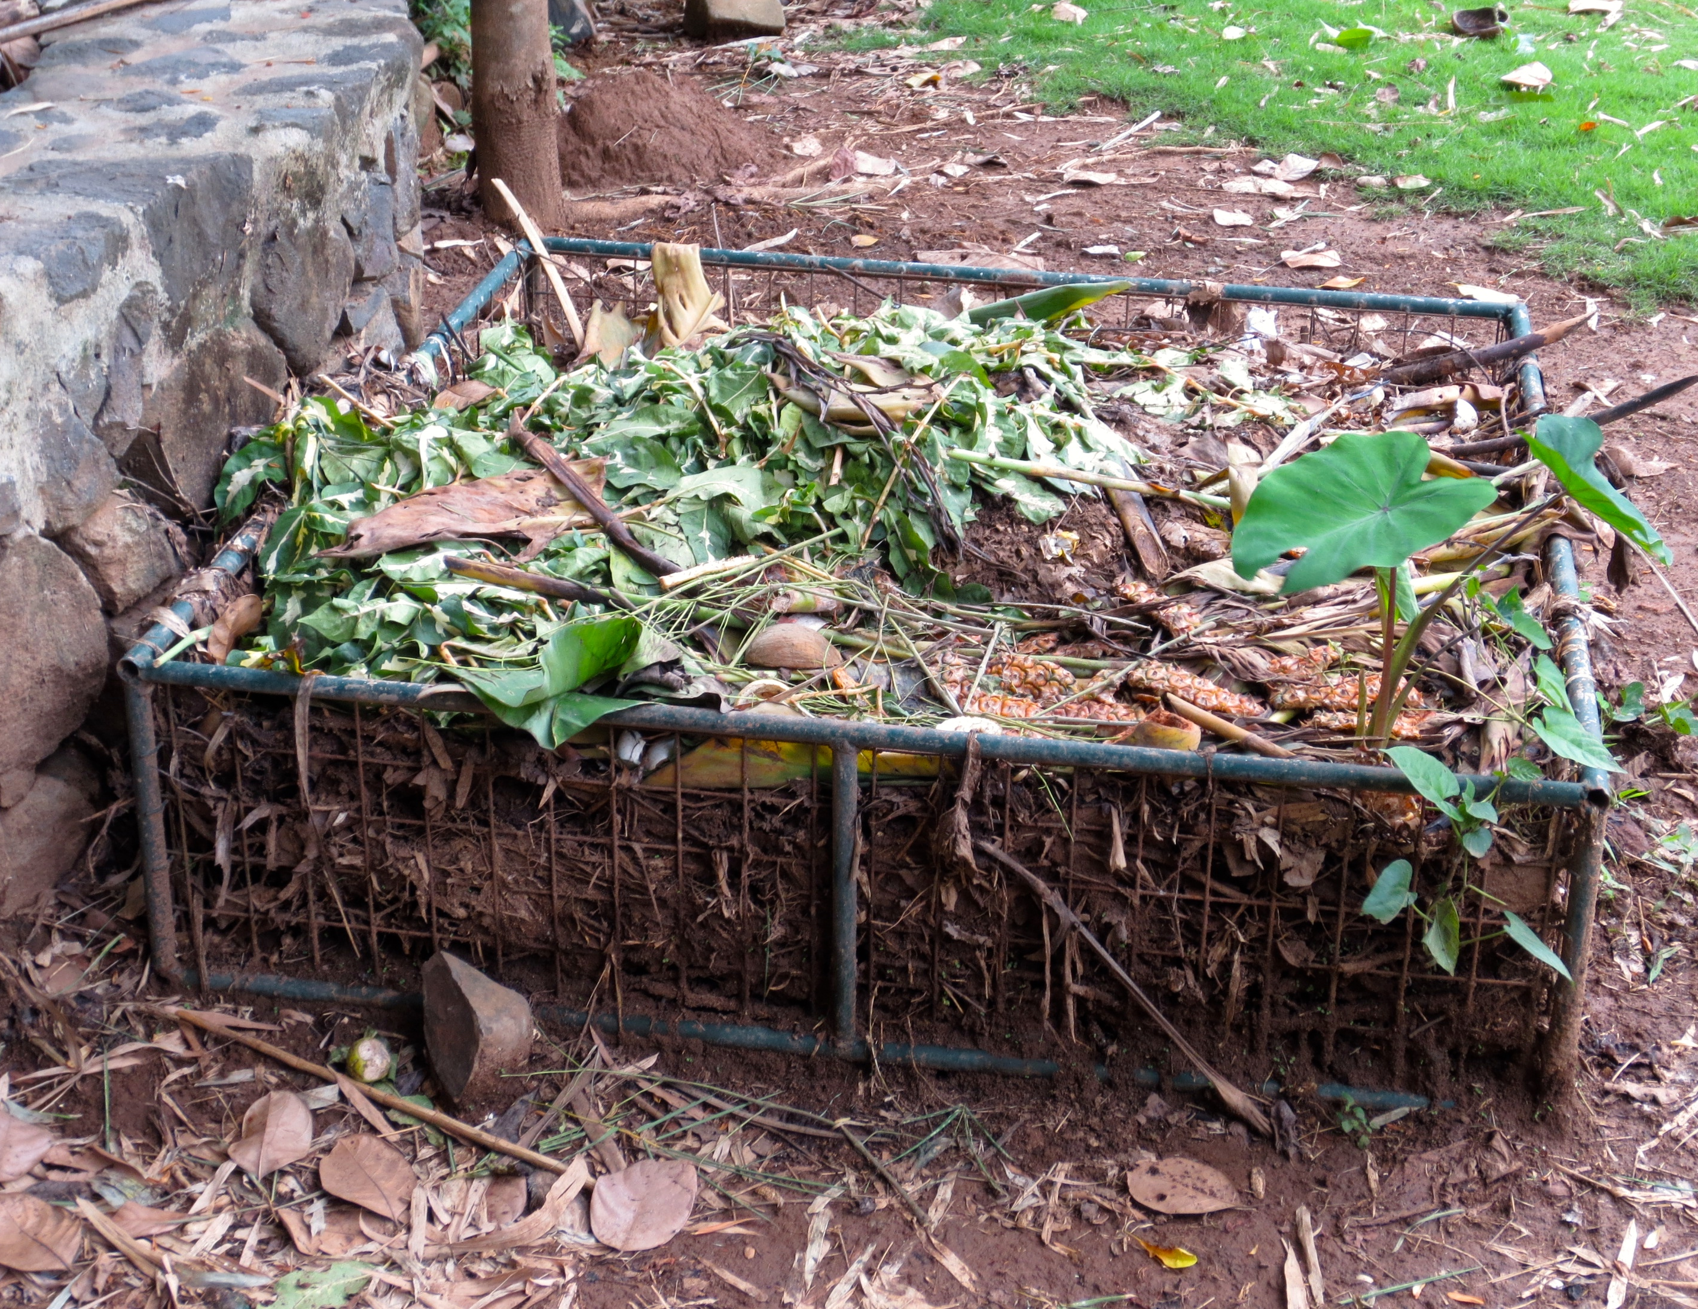
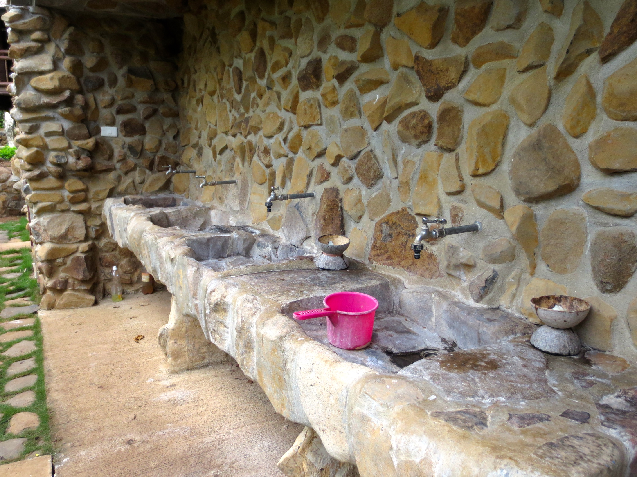
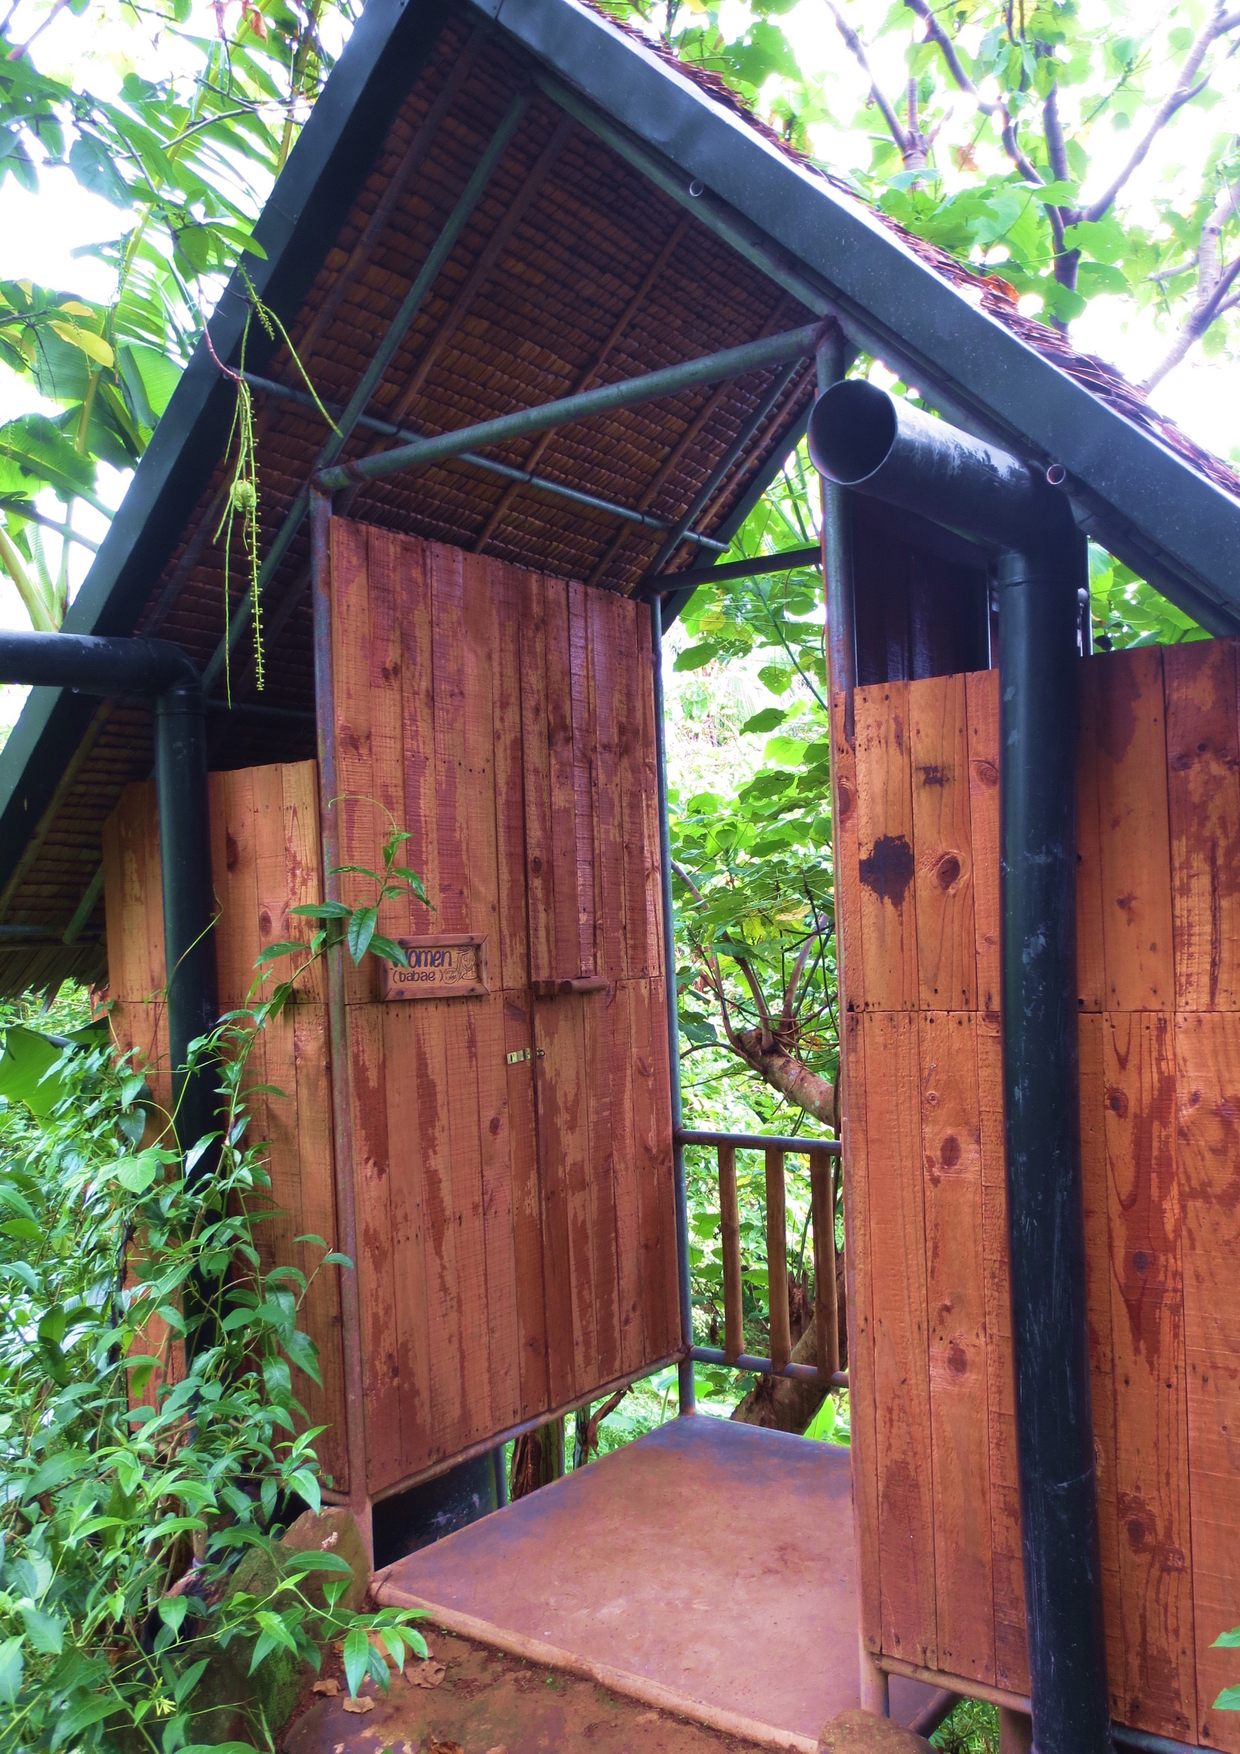
Photo 7: Shrubbery and branches being composted
Photo 5: The showers at SL use water from a deep well
Photo 4: One of the composting toilets
Photo 6: The sinks, which are accompanied by biodegradable soap and coconut shell soap dishes
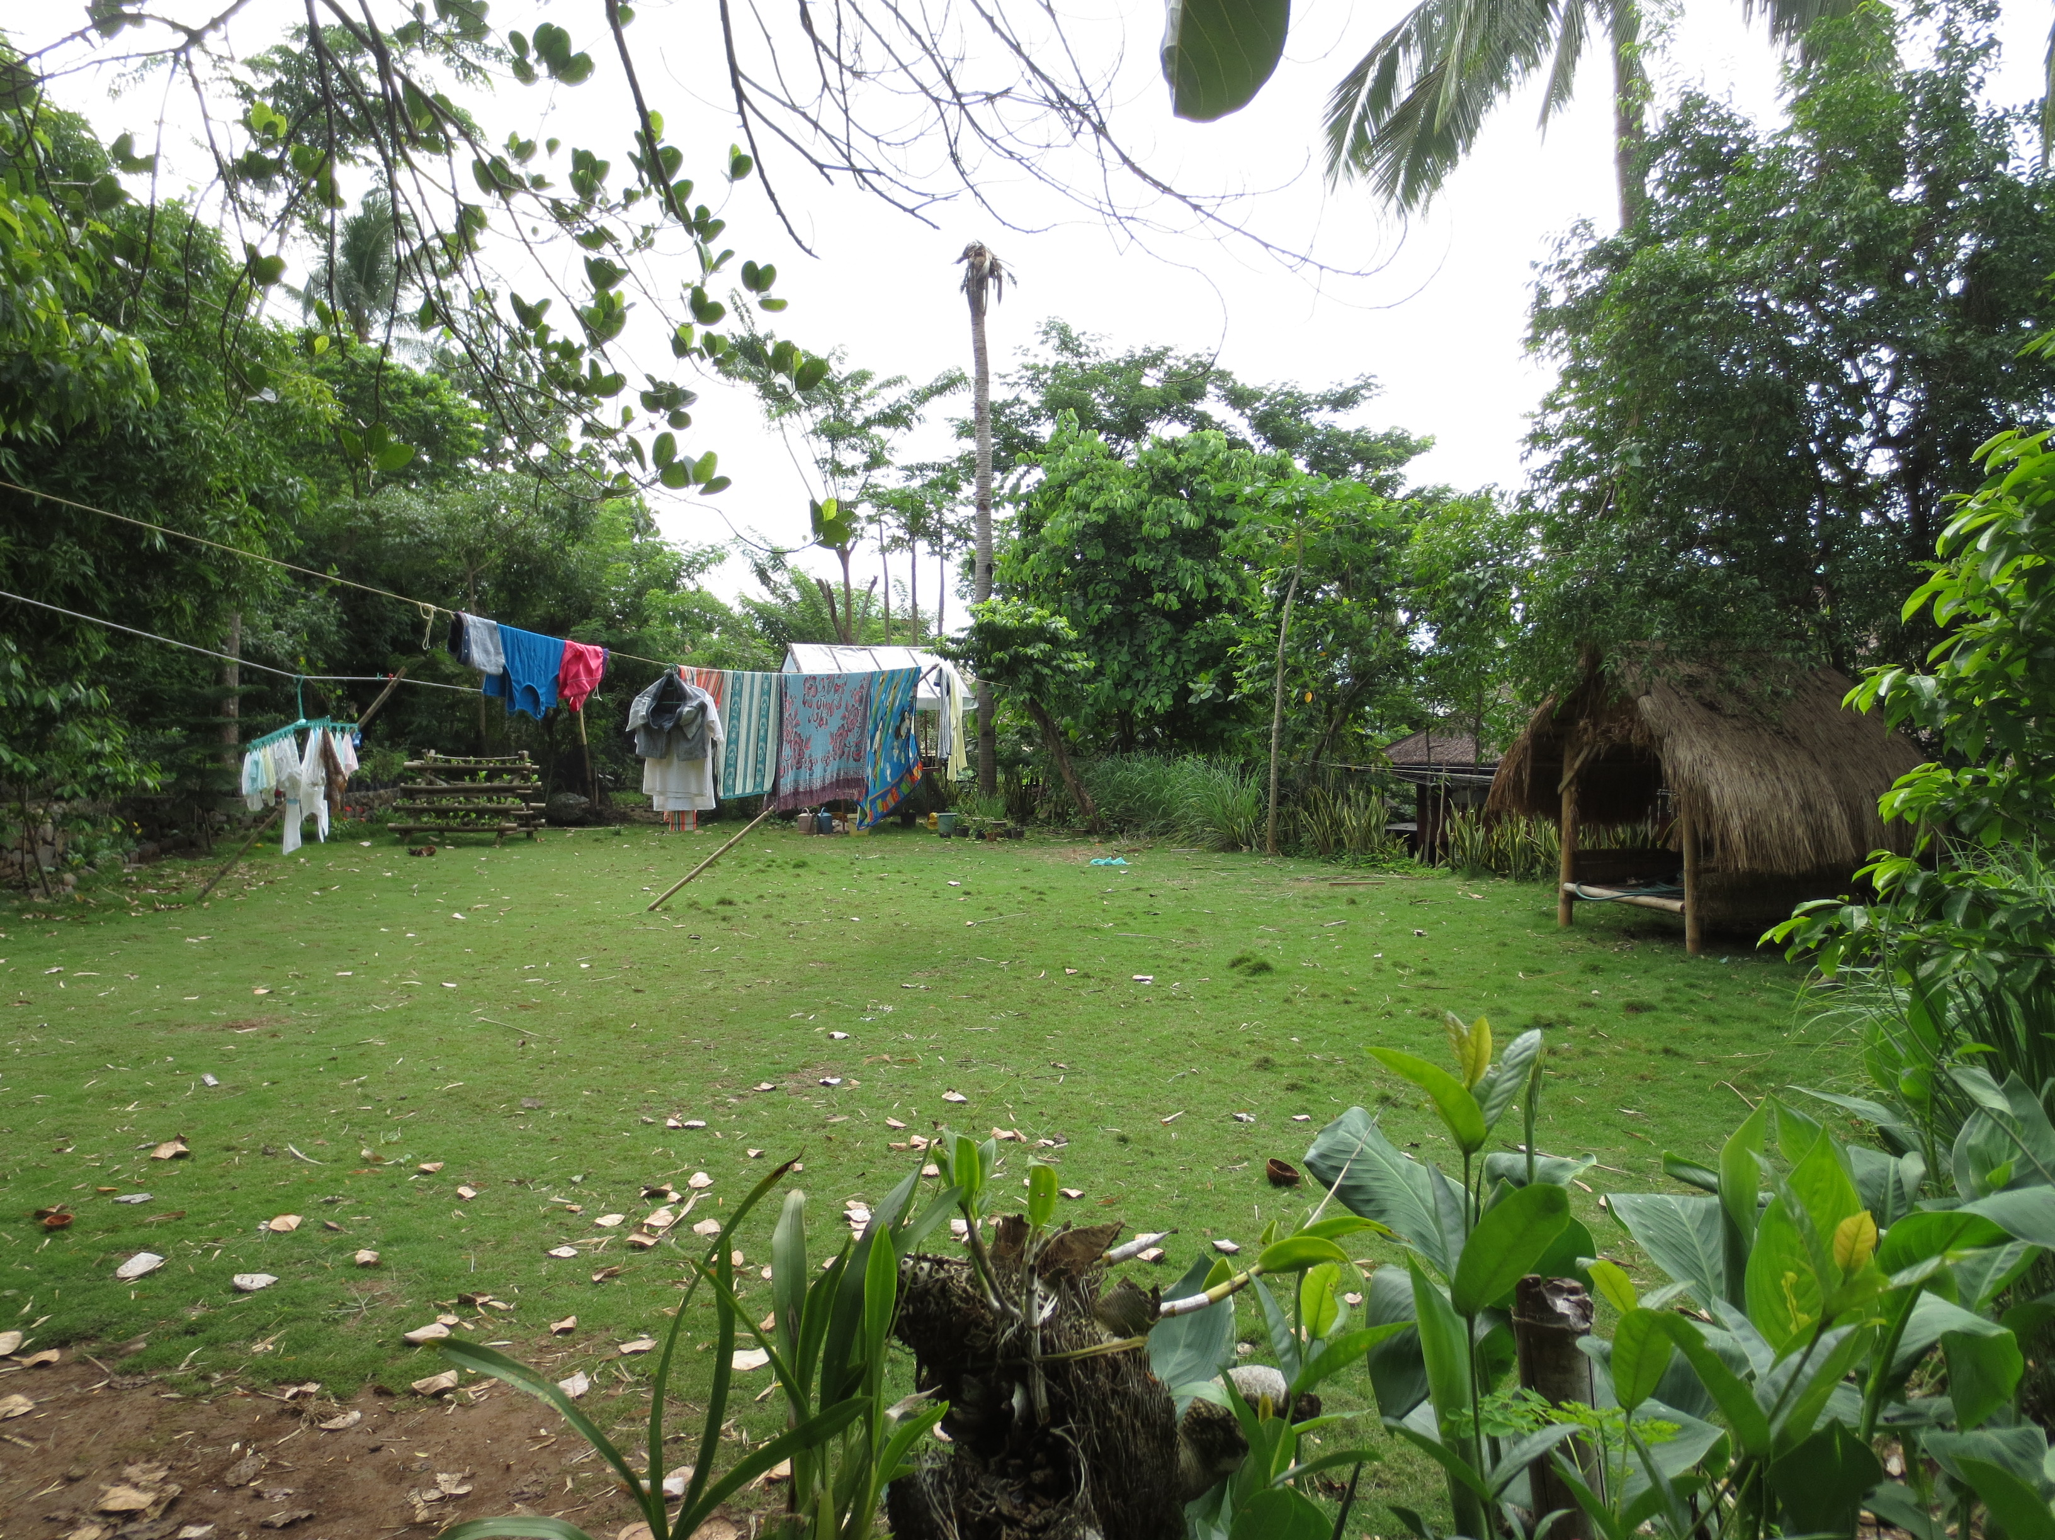
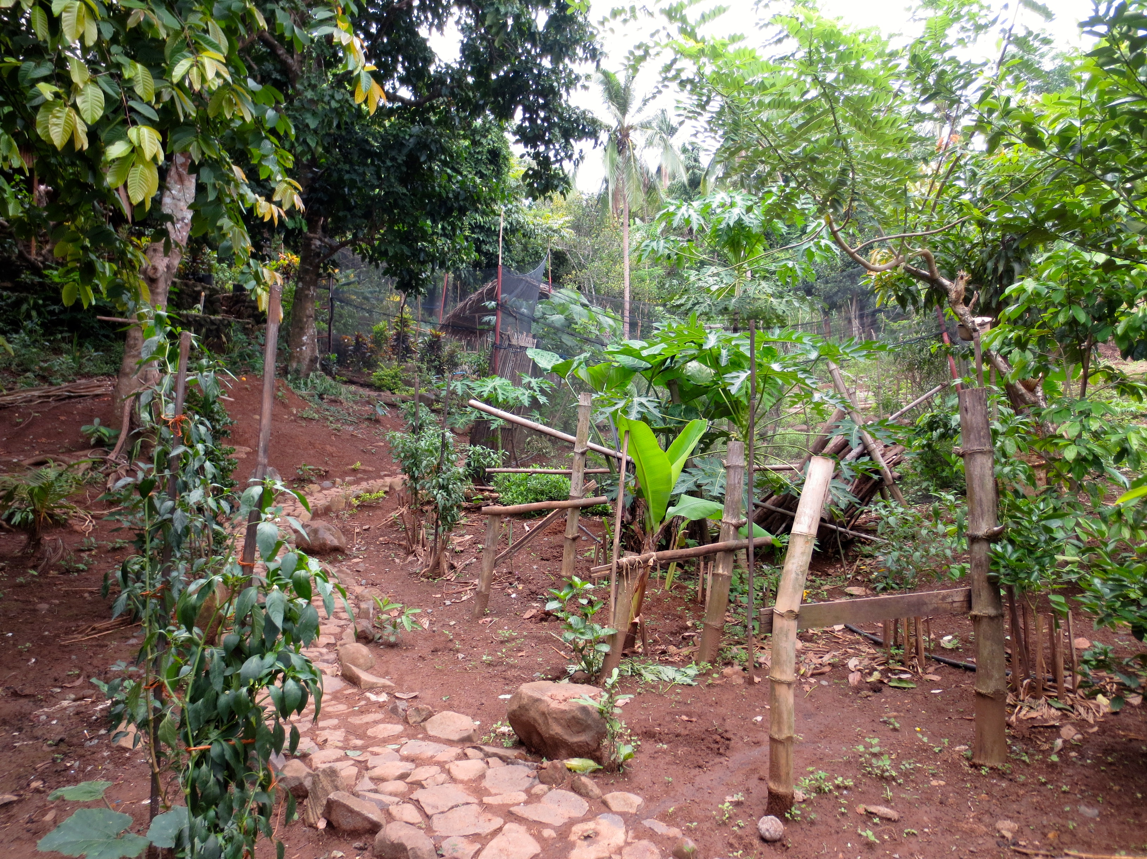
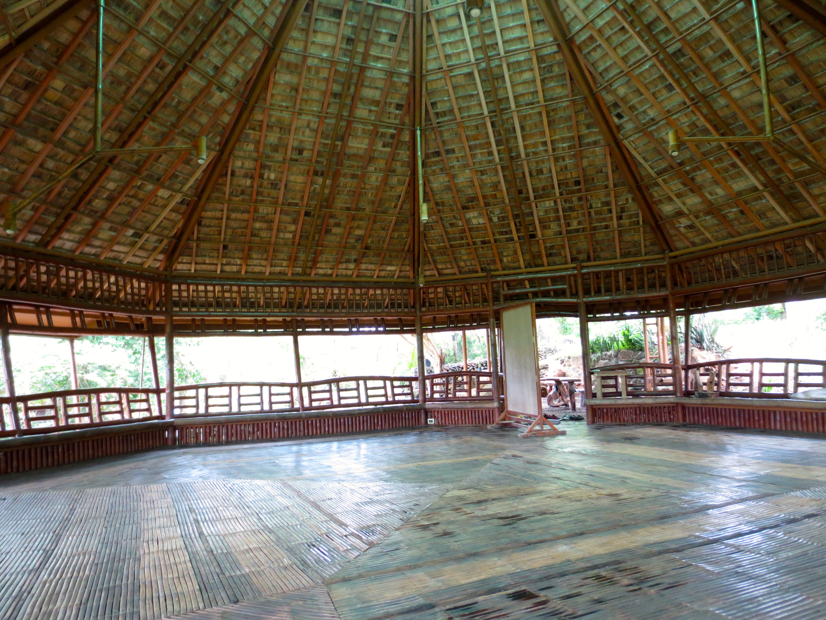
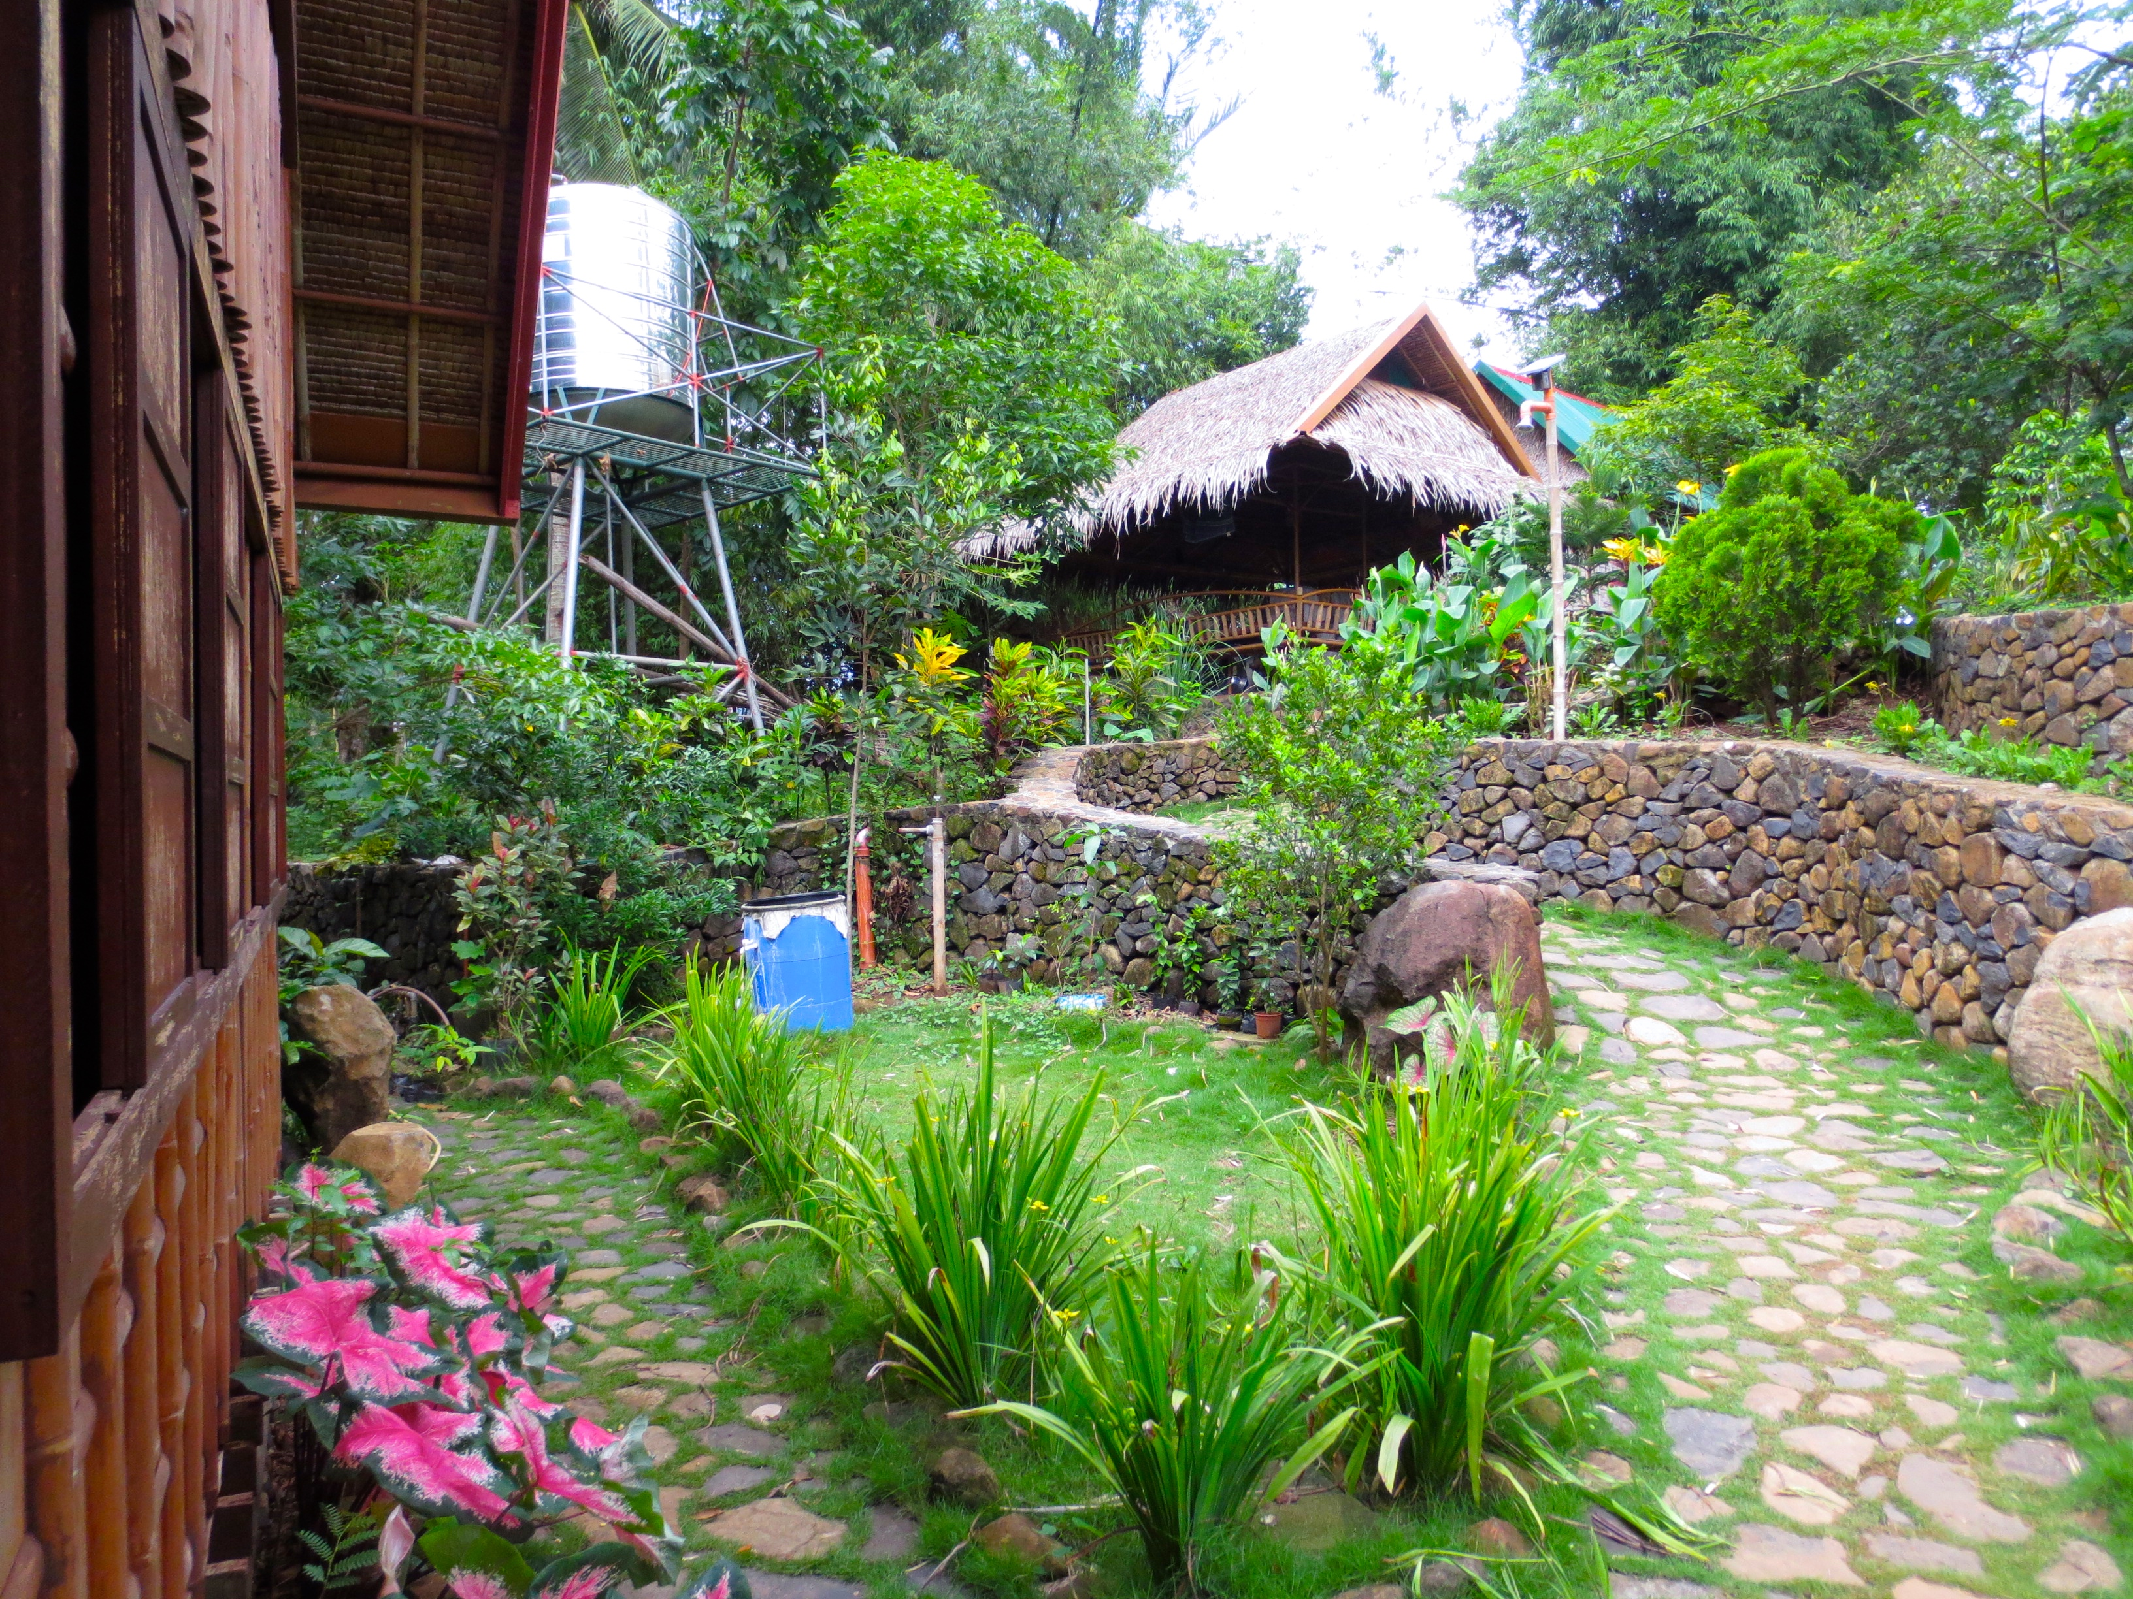
Photo 11: A large open area near Sakahang Lilok’s entrance
Photo 10: A walkway lined by some plants
Photo 8: The view from outside the indoor dining area
Photo 9: The "octagon" where large group activities are held

