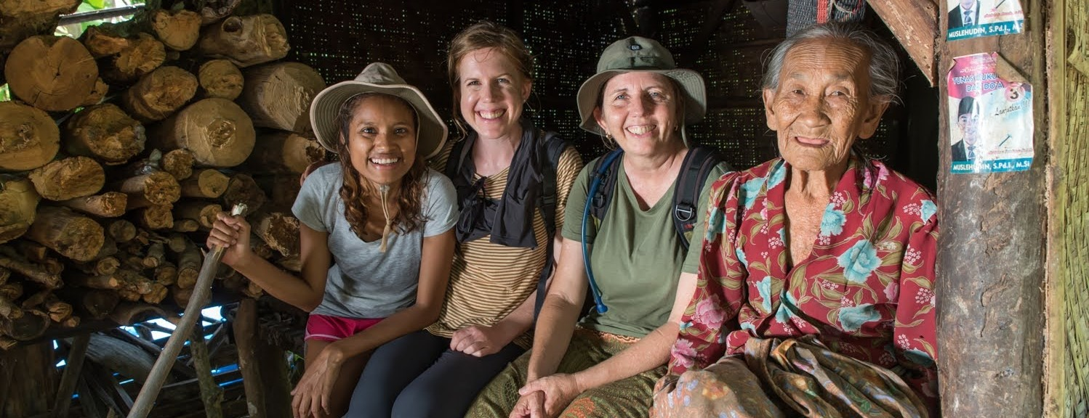

**Themes in Discerning Female Apostles**

Edward Jack

Master of Arts in Transformational Urban Leadership

William Carey International University

TUL 675: Integrative Community Research Project

Dr Peter Nitschke

September 2023

**Ponder**

“I couldn’t have left the others and come up to you alone, how could I? Don’t look at me like that… oh well, I suppose I *could*. Yes, and it wouldn’t have been alone, I know, not if I was with you. But what would be the good?”

Aslan said nothing.

“You mean,” said Lucy rather faintly, “that it would have turned out all right – somehow? But how? Please, Aslan! Am I not to know?

Quite suddenly she sat up. “I’m sorry, Aslan,” she said.

“I’m ready now.”

“Now you are a lioness,” said Aslan. “And now all Narnia will be renewed.”

“Go and wake the others and tell them to follow. If they will not, then you at least must follow me alone.”

Prince Caspian

CS Lewis (1998, Chapter 10)

The Lord announces the Word and the women who proclaim it are a mighty throng: Kings and armies flee in haste; the women, at home, divide the plunder.

Psalm 68: 11-12 TNIV

**Acknowledgements**

*For Asha, my lover and fellow warrior.*

*You always believed.*

*For my kids who pay the price.*

*For the daughters, found and yet unfound, rise up!*

**Abstract**

From a background as a long-term movement-catalyst among Unreached People Groups, I long to see movements established around the world. It seems logical that if an apostle, whether female or male, is leading a movement we can expect success. Apostles are gifted by God to get the job done. This raises the question: how do we multiply apostles to finish the Great Commission?

I have a long-term interest in female apostles. Thus, my thesis topic is “Themes in discerning female apostles”. Theological and historical research supports their existence. Few people since New Testament times have dared to use the title apostle, especially women. Yet many men and women have been apostolic – working to complete the Great Commission.

This thesis begins with a literature review that deals primarily with the validity of Junia as a woman and an apostle. I then discuss some theology and missiology relevant to the topic of discerning and growing female apostles. I surveyed leaders in my mission organization. I interviewed six apostolic women and five apostolic men to hear their stories which revealed many themes. Most were expected. Some themes stood out and raised my awareness of broader issues which impact my own praxis in discerning and training female apostles.

My research culminated in forty-one themes across three categories in discerning female apostles. These I distilled further to eighteen indicators. These can be utilised as an analytical tool evaluating the stories of potential women apostles. It’s simple. If a female’s story is highlighted, underscored and marked with these themes (perhaps the more the better, but not necessarily so) it could well be that she is a budding apostle. Interestingly the research revealed that the themes are generic for females and males.

*Keywords*: female apostle, discerning, bias, identifiers, Continuist, journey, themes, movements

**Table of Contents**

**Title page 1**

**Ponder 2**

**Acknowledgements 3**

**Abstract 4**

**Chapter 1: Introduction of the Problem: A lack of apostles 6**

**Chapter 2: Review of Literature 9**

**Chapter 3. Theological and Missiological Framework 21**

**Chapter 4: Research Methodology 32**

**Chapter 5: Description of the Findings and Analysis of the Data 35**

**Chapter 6: Conclusion and Recommendations 65**

**Bibliography 73**

**Annexes 78**

* 1. **Collations of data**
  2. **Ethics Approval**
  3. **Questions for interviews, surveys, and the community focus group**
  4. **Communication back to the community and Partner Organization**
  5. **Discovery Bible Studies on Growing Apostles**
  6. **Questions for Interview or a Written Application Using the Themes**
  7. **An exegesis of 1Tim 2:11-15**

**Chapter 1**

**Introduction to the Problem**

**A Lack of Apostles**

This study lays a foundation for further discussion and research regarding the problem of a lack of apostles, particularly female apostles, on the mission field. I come from Pentecostal, Continuist heritage. My mission organisation is mildly charismatic. We accept that Ephesians 4:11-13

11So Christ himself gave the apostles, the prophets, the evangelists, the pastors and teachers, 12to equip his people for works of service, so that the body of Christ may be built up 13until we all reach unity in the faith and in the knowledge of the Son of God and become mature, attaining to the whole measure of the fulness of Christ.

is relevant for today, that God still provides apostles for the benefit of the Church and the world.

Even though my organisation has numerous apostles they are not given titles. We focus on function, fulfilling the Great Commission.

The need for apostles now is even greater than the first century. World population is over eight billion. In my country of service alone there are two hundred and thirty mostly Muslim Unreached People Groups and ten megacities. Some of these remain unengaged.

What kind of person mentioned in the Bible is most likely to create a movement? The answer is clear, right? An apostle! But where are the apostles? How do we grow them? Or identify them? Charismatic churches generally pay lip service to apostles. There are precious few if any programs that intentionally discern, recruit, train and mentor apostles.

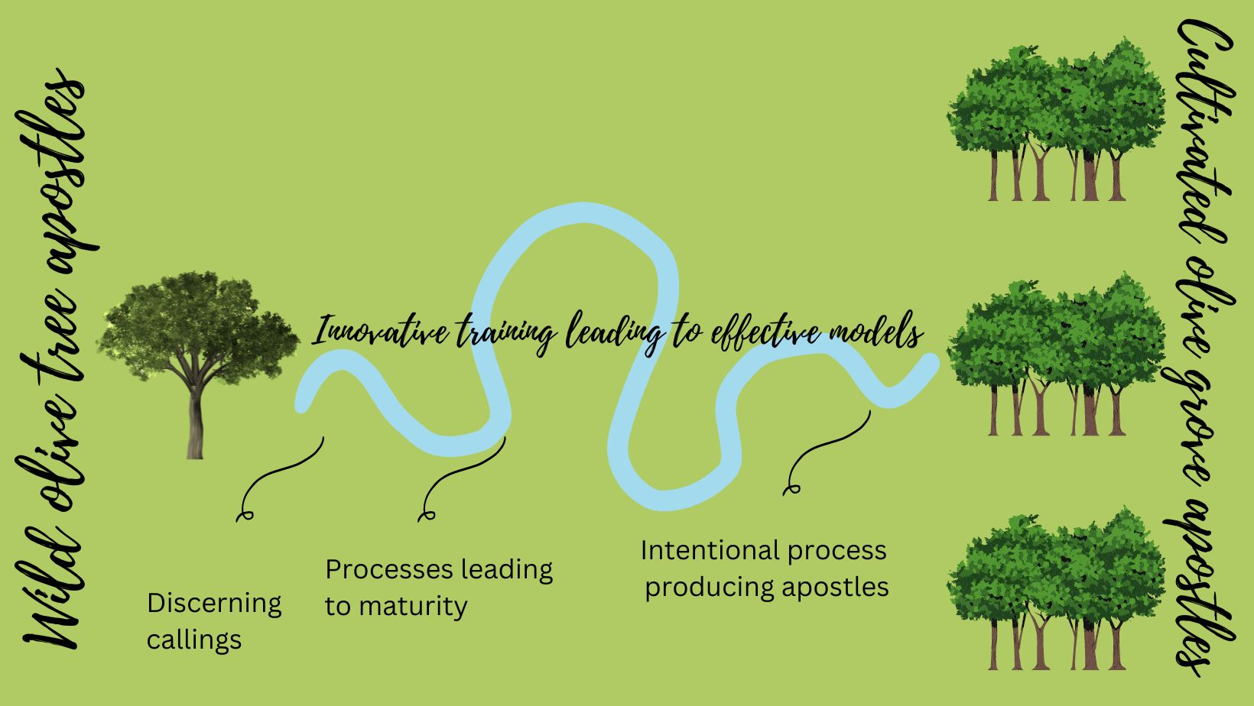

**Diagram 1: Cultivated Olive Grove Apostles**

Diagram 1 envisions the development of an intentional process or pathway leading to groves of cultivated apostles. Apostles would be discerned as with Jesus and Paul. Then they could be grown. One initial hypothesis based on experience as I come to the study is that most present-day, genuine apostles are what I call wild olive tree apostles. In my country-of-origin birds have spread non-native olive trees so that they appear to come up randomly. Similarly, these apostles appear randomly. They grow through the “school of life” or the “school of hard knocks”. I assume that many more people are gifted as an apostle than we presently admit – the sheer size of the Great Commission task in this generation requires me to believe this.

In contrast, Jesus and Paul were intentional about discerning, recruiting, training and mentoring apostles. Like them, my background which informs this study is to seek to intentionally grow groves of cultivated olive tree apostles. This will happen when the Church undertakes worthy experiments and good research to find models for growing apostles. This leads to the identification of the first phase in growing a grove of cultivated olive tree apostles which is discerning them. That is the focus of this thesis.

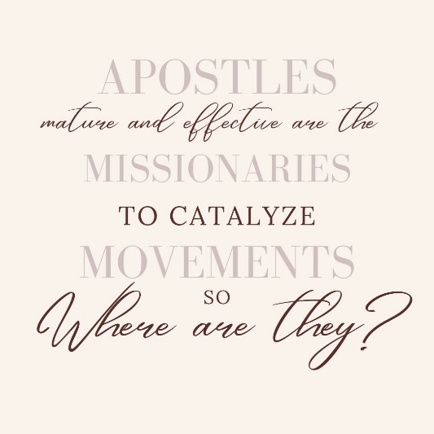Why discern female apostles rather than identify them? Identifying a mature female apostle is a relatively simple task. Defining “apostle” and seeing who meets the definition is an easy beginning to identifying. Discernment is broader than identification. It is a broader and deeper process – particularly if one is looking at teenagers and late bloomers with whom the calling of God may not be initially obvious.

Why focus on female apostles? The majority of missionaries are women. They proclaim the good news, disciple new believers, establish churches or catalyse movements of churches. If we can discern female apostles early in life, it will impact recruiting and training. If they are discerned later in life these female apostles can be honoured, further supported and encouraged to grow more apostles.

There is a question of appropriateness which remains unresolved. Should a fifty-something White Anglo-Saxon Protestant male dare to write about discerning female apostles? The answer in the academic context is probably no. Yet in the reality and pragmatism of field people I have received only encouragement and gratitude from women for beginning explorations regarding this topic. My good reputation among apostolic women has cleared the path before me.

My purpose with this exploratory study is to lay a foundation for further research. While there are quite a few sources regarding the nature of apostles and apostolic ministry, there are fewer regarding discerning and training them. There are fewer still about female apostles among Unreached People Groups.

The study is in the domain of constructivist action-reflection research. It is framed towards identifying pathways to begin to intentionally discern, grow, train and release large numbers of (female) apostles into the mission field.

This research will reveal themes in the discernment process. And these themes may open doors to developing tools for the early discernment of female apostles. Early discernment could then be followed up by appropriate training and mentoring – speeding up the process towards world changing fruitfulness.

This is my thesis: **Female** (definition: biological) **apostles** (definition: movement-catalyst, miracle worker, church planter, structure builder, DNA carrier) can be **discerned** (definition: ascertained, recognized, apprehended, perceived, understood) through self-identification, testing, surveys and growth of a cluster of themes within the context of an apostolic team. This thesis is based upon my observations when training female movement-catalysts in the field. My explorations begin with a literature review which deals with the subsidiary questions.

**Chapter 2**

**Review of Literature**

**Triangulation**

This literature review has a specific trajectory defined by four subsidiary questions. What is an apostle? I will define apostle from the available literature. Are female apostles biblically valid? I will validate the existence of female apostles as biblical from the available literature. What is the evidence for and description of apostolic women in history? With a clear definition of apostle and an understanding that women may be apostles I will then seek to triangulate truth with historical examples of women working apostolically. If someone’s life and ministry correspond with the definition of an apostle, it is likely they are one. What does a literature review reveal about discerning female apostles? Some themes, but not all. I expect that surveys of my mission leaders and interviews with apostolic women and men will triangulate and support the literature as well as add more wisdom to the research.

**What is an apostle?**

Prinz states "An apostolic leader is defined as someone who takes the Good News to a previously unreached people group. It is the modern equivalent of the biblical term apostle (ἀπόστολος; Brown 1975), someone who is sent by the church cross-culturally to take the Good News where it is not yet (Johnson 2011:69). Among frontier missiologists in recent years, a return to the usage of the biblical term apostle or apostolic leader has occurred (Murphy 1976; Greene 1984; Griffiths 1985; Fraser 1987; Caldwell 1992; Miley 2003; Sinclair 2005; Johnson 2011; Dent 2011)" (Prinze, Appendix A, paragraph 6).

Dent points out that in Greek missionary and apostle are synonymous terms: “Due to a quirk of linguistic history, the adoption of these two words into English resulted in our having both apostle and missionary, etymologically similar words originally used to translate each other” (2019, Ch 1, para6).

Resane (2016) summarises Wagner’s (2012) definition of apostles and their tasking. “They lay foundations for social transformation and give direction to the church. They cast vision and formulate the mission for the church. Each of the five offices is uniquely located in the church for cultural transformation, for as far as Wagner is concerned, Christ’s mandate to the church is both evangelistic and cultural. According to Wagner, the apostles possess a spiritual gift, assignment or a call, extraordinary character, followers and a vision. He furthermore attests that apostles are characterised by activities such as receiving revelation, casting a vision, giving birth (pioneering), imparting blessings to others, governing by setting systems in order, teaching, sending off, finishing God’s project or season to desired conclusion, leading the church in spiritual warfare, aligning generations, and finally equipping. All these apostolic characteristics and functions are common in Wagner’s books, especially in *Apostles Today*” (Resane p4).

In defining “apostle,” it seems that many are fixated on the authority of the apostle. CBMW’s articles refers to “authoritative female apostle” (2014, p1) and “governing authority” (2014, p1). Even Wagner’s definition of apostle emphasizes authority making it ecclesiastical authority – authority to rule. Caldwell quotes Wagner “regarding the gift of apostle, Wagner defines it as ‘the special ability that God gives to certain members of the Body of Christ which enables them to assume and exercise general leadership over a number of churches with an extraordinary authority in spiritual matters that is spontaneously recognized and appreciated by those churches’” (1992, p104). Sadly, I agree with Dent that “Wagner’s position is biblically indefensible, missiologically confusing, and tragically influential” (2019, Ch 1, para 54).

What of this emphasis on apostolic authority? Frankly, an over emphasis on apostolic authority is not biblical and can have terrible consequences. It seems narcissistic Protestant leaders take the apostle title as a justification to rule. Caldwell offers a biblical view of apostleship as an antidote to this overemphasis on authority. “Jesus is the incarnational model for those who are sent (John 17:18, 20:21). Just what did Jesus model? Jesus had such humility he was able to renounce his status, his independence and community. In this way he was truly able to identify with people” (1992, p159).

Many contemporary pro-apostle writers emphasize apostolic function instead of authority. Griffiths (1995, p164) says “The gift of an apostle maybe more generally applied to what we think of today as pioneer missionaries, since the word indicates someone who is being sent, with a view to initiating a work, or planting a church”. Caldwell offers a similar definition “The spiritual gift of apostleship is a very necessary gift for today’s Church. As a gift it is given to individual Christians as God wills. The gift will be verified in the lives of these individuals as they spread the Gospel and plant churches cross-culturally, both overseas and at home. In this sense, apostleship is a very individualized gift. All Christians do not possess the specific gift of missionary apostle” (1992, pp129-130). Livingstone (n.d., p14) chimes in: “…the gift of an apostle-a leader who can motivate and help others to break new ground, persevering until national brethren will take responsibility for the church-planting effort. I call this person the team leader”.

I have recently written (2022) about apostles. Apostles are Kingdom pioneers: “Jesus was an apostle (Hebrews 3:1). The Greek Apostolos (ἀπόστολος) means “one sent forth”. Sent by whom? Sent by God, of course! Some Bibles translate the word “apostle” in Hebrews as pioneer. What did Jesus pioneer? Among his achievements are, a New Covenant of the Spirit, salvation through his blood and a new structure for his service: apostles. Apostles are made to be sent to the nations and pioneer the Kingdom in new areas and new ways” (2022, pp115-116). He clarifies the primary role of the apostle - movement catalyst - church planter: “Pioneering, that is, establishing kingdom beachhead communities among the unreached and among the poor” (2022, p86).

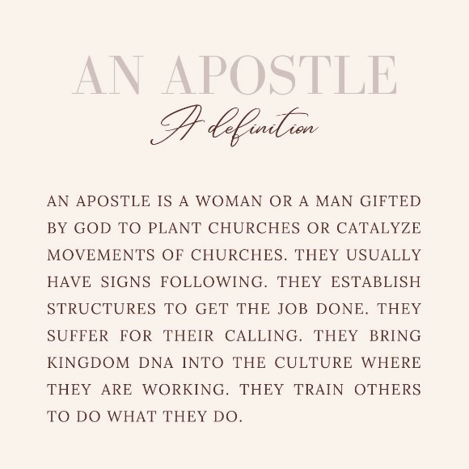My book underlines the foundation laying work of the apostle. Primarily the apostle is focussed on church planting. “The apostle is a social entrepreneur. She pioneers new church structures, structures that suit the needs of the people at the time” (2022, p128). This foundation is not a pietistic gospel, it is holistic. The gospel is salt, light and yeast. It is designed to bring change to all areas of existence. Apostles lay foundations for future generations to grow on.

Apostles will seek to work among the unreached. They establish church planting and social change movements though training. They have a heart for the poor” (Jack, p134). Social change follows the life, example and teaching of apostles. “Apostles establish beachhead communities of disciples and provide DNA for the redemption of social structures” (Jack, p141). This is the Kingdom DNA referred to in the definition below.

Buckner et al thoughtfully adds to understanding what apostles do: “The functions of the apostle within the church are as such: training the church, instructing and guiding leaders, and setting the church right for order and doctrine” (2016, Ch 10, para 6).

**A Definition for This Thesis**

Authors provide various definitions of apostle, the best of which emphasize function not authority. For this thesis I define apostle as follows: *An apostle is a woman or man gifted by God to plant churches or catalyze movements of churches. They usually have signs following. They establish structures to get the job done. They bring Kingdom DNA into the culture where they are working. They train others to do what they do.*

**Are Female Apostles Biblical?**

As I read the literature regarding female apostles, I realized that assumptions and presuppositions play a significant role in biblical interpretation of this topic. Epp notes “…once the notion of ‘apostle’ is broached, it is discovered that the description as a prominent apostle and the identification as a woman, for some at least, can no longer coexist” (2005, Ch 11, para 3). She is referring to assumptions and bias that translators bring to the text. Barr is blunt with her opinion that “the problem wasn’t a lack of biblical and historical evidence for women to serve as leaders along with men in the church. The problem was male clergy who undermined the evidence” (2022, p97).

Hamilton summarizes the intense debate around Junia’s apostleship. He notes well that the “… dispute regarding Junia can be separated into four different categories: The Name-Gender Debate, The Syntax-Grammar Debate, The Rhetoric-Context Debate, and the Apostleship Debate. Any author attempting a thorough discussion of the subject should address all four levels” (2022, p5). Sadly, Hamilton missed the historical debate. Epp deals with the name-gender and historical debate convincingly.

Epp’s seminal work on the apostle Junia defends biblical female apostleship. The name-gender debate is over whether the Greek name “Ἰουνίαν” in Romans 16:7 is referring to a man or a woman. The difficulty is that the original texts did not add accents. These came centuries later. With the accents came the use of a male variant, Junias. And scholarship “resulting ultimately in a sex change by translation” (Bernadette Brooten, 1997 as cited in Epp, Ch 8, para 8) has “with rare exceptions” come only this century (Epp, 2005, para 7).

Epp could not find one attestation to the male form Junias in anywhere New Testament era literature. There are hundreds of historical documents using Junia or it’s variant Julia.

Epp quotes Cervin to explain that “lunias as a masculine name does not occur in any extant Greek or Latin document of the NT milieu” (1994 as cited in Epp 2005, Ch 5, para 3).

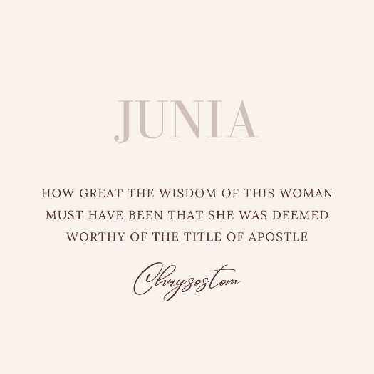Hutson summarises the case. “Some translators have stumbled over a technical ambiguity (created by the lack of punctuation and accent marks in ancient manuscripts) to render this as a man's name, ‘Junias.’ Nevertheless, Lampe has shown conclusively that no such man's name existed in antiquity (even as a nickname for ‘Junianus’ or some such) and that Paul is referring to a woman named - Junia. In other words, to insist that Junia was a man is to insist on ‘a boy named Sue.’ It makes more sense to understand Andronicus and Junia as a missionary team similar to Aquila and Priscilla” (2012, p3).

The Church Fathers attest that Junia was both a woman and an apostle. In the historical debate Epp explains that Chrysostom, Jerome, Theodoret, John Damascene, Peter Abelard and Peter Lombard “assume that the partner of Andronicus is a woman by the name of Junia” (Epp, Foreward, para 6). Chrysostom gives his stamp of approval: “how great the wisdom of this woman must have been that she was deemed worthy of the title of apostle” (Epp, Foreward, para 6).

Damsteegt (2000) and CBMW (2014), however, bring up Ephiphanius who from the fourth century “mentions that Junias was a man who became bishop of Apameia of Syria” (CBMW, 2014, p6). CBMW accepts the source. Damsteegt suggests the Ephiphanius source is “spurious” and “a late attempt to masculinize what had originally been feminine.” (2000, p133). Complementarian Burer is more cautious *and transparent:* “However, Epiphanius’s testimony here ought not to be weighed too heavily, for he calls Prisca in the previous sentence a man, too!” (Burer and Wallace, p77).

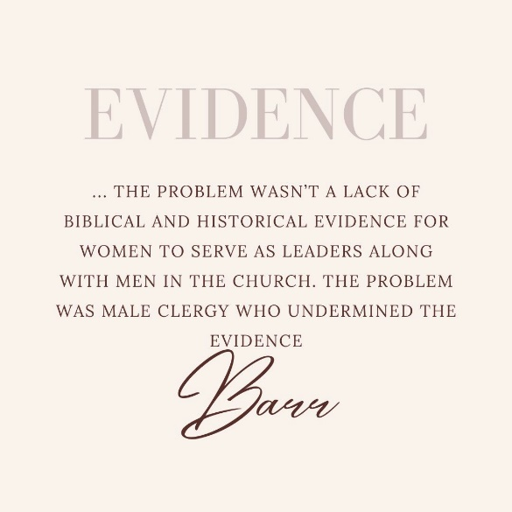Why do Burer and Wallace, as well as CBMW seemingly ignore one thousand two hundred years of church tradition and not accept that Junia is a female apostle? Is it purely sound exegesis driving this? I fear not. It seems that assumptions and bias, the impact of the Complementarian narrative, is behind this. Barr is eloquent: “Biblical womanhood is Christian patriarchy” (2022, p216). It appears to be an attempt “to write women’s leadership out of Christian history” (Barr, p186).

The apostleship debate is about what is meant by “apostles” in Romans 16:7. Were Andronicus and Junia well known among the apostles or were they outstanding apostles? Did Paul mean that they were apostles like him or something else? Hutson adds to the confusion, saying “given that Paul names so many women teachers and evangelists, it is not difficult to imagine that Andronicus and Junia were an evangelistic team, in which case the word ‘apostle’ appears here in its generic sense of ‘missionary’ (as in Acts 14:4, 14) without reference to the Twelve of the gospels (2012, p3). CBMW relegates them to messengers between churches (2014, p9). Earlier, quoting Dent (2019, Ch 1, para 6), I noted that missionary and apostle are from the same root word. Hutson has missed the point.

Proponents of present-day female apostles are supportive of Junia as an apostle. Dent chimes in that Andronicus and Junia, a “couple serving as missionaries was a twist on Jesus’ method of sending out pairs but provided some advantages to reaching families and households. So, apparently a woman was considered an apostle by Paul and the early church” (2019, Ch 2, para 53).

I had to examine my own assumptions about the female apostle, Junia. Am I merely reading into Scripture what my Australian egalitarian culture, swimming in a leftist-feminist sea predisposes me to see? No! I have concluded that my convictions supporting contemporary female apostles are biblically based. These convictions are built upon my study of Scripture, my grasp of the Trinity, identity in Sonship and the priesthood of all believers (more on these in Chapter 3) and upon my understanding of Jesus and the freedom he offers. It is both logical and sensical that Jesus would still provide female apostles.

**What of Apostolic Women in History?**

Since the resurrection women have proclaimed Christ and served in mission. Mary first proclaimed the resurrection to the apostles. Junia was a contemporary apostle with Paul.

7Greet Andronicus and Junia, my fellow Jews who have been in prison with me. They are outstanding among the apostles, and they were in Christ before I was (Romans 16:7, NIV).

Scholarship has unearthed a plethora of women in ministry, even apostolic ministry, around the planet. Barr (2021, p87) notes “the problem wasn’t a lack of biblical and historical evidence for women to serve as leaders along with men in the church. The problem was male clergy who undermined the evidence”. Barr provides as evidence several popular church history texts which leave most women out all together or “present a masculine narrative of church history that minimizes female leadership” (2021, p98).

My intention in this section then is to remind all that women historically have had roles in apostolic leadership. It is important to note that many of these women had men try to limit or even prevent their ministries. Barr notes that “God’s calling on women’s lives never seems justification for women to preach; they have to justify their right based on their historical context of patriarchy” (2021, p170).

As a sampling, Dora Yu, Peace Wang and Ruth Lee were Chinese pioneers last century. They preached, discipled, planted churches. Ministry became more complicated as they worked “within the constraints of what was then considered appropriate for women” (Dzubinski and Stasson p33). They are remembered as ‘helpers’ who ‘assisted’ the male leaders even though ‘coworkers’ (Dzubinski and Stasson, p33). Lee and Wang died in a communist prison.

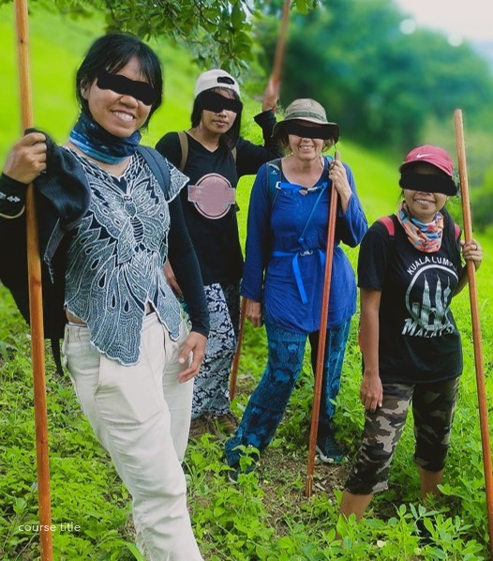Lilias Trotter and Maude Cary were apostolic missionaries to Muslims in North Africa. Trotter served in Algeria and Cary in Morocco. Trotter was a painter and writer. Trotter led an apostolic Mission Band of thirty workers including men. Cary pioneered with a team that was mostly women. “More women were openly defying their cultural mores and coming out for Bible teaching” (Tucker, p252).

Jackie Pullinger is outstanding among female apostles. Pullinger chose to minister incarnationally with criminals, drug users and the urban poor in Hong Kong. “My mission was to help the Walled City people to understand who Christ was” (Pullinger & Quicke, 2007, p45). Her book outlines the initial years of struggle and sacrifice in her ministry. Not once does she use the term apostle regarding herself. Yet her life speaks loudly. Planting churches, establishing drug rehabilitation, training leaders. Signs and wonders follow the ministry.

The Morris twins stand out as apostolic church planters. “As apostolic harvest church planters, Mothers Reatha Morris Herndon and Leatha Morris Chapman Tucker illustrate the power of church planters being freed from the work of pastoring and discipling (even if this was not their choice). Together they are credited with planting some 75 churches in many of the major metropolitan areas of the United States. The women church planters of COGIC are arguably the single most important reason for the size and success of this denomination today” (Danielson, 2021, p61).

**Photo 2: Interviewee “Junia” and three budding apostles somewhere in Asia**

Lotte Moon evangelized in rural China (Tucker, 2004, p296). She desired “perfect equality” (Tucker, 2004, p303) regarding doing pioneering gospel proclamation rather than being relegated to secretarial and teaching roles. “Despite local opposition, she established a church” and had “baptized more than a thousand converts” in Pingtu making it the biggest Southern Baptist work in China (Tucker, 2001, p 297). Moon also trained new missionaries.

Nowadays Moon’s organization’s websites emphasize Moon’s mobilization and fundraising efforts. It still uses her household name to raise money for missions. It describes Moon as “a bold woman of action and radical obedience who shared Christ with her beloved Chinese to the end” (IMB Store, 2023). Her achievements are not listed. Her successful church planting is not mentioned. But there is a recipe for her tea cake (IMB, 2023) which takes up a significant portion of the page. This seems evidence of obfuscation of the history of women in leadership to support the Complementarian narrative referred to by Barr.

In the 1800’s, Ellen Mason met the criteria for apostolic worker. Mrs Mason had a supernatural calling to serve God in Burma. Over time her work developed. “First, she started a school for girls, particularly for Karen girls, to fill a growing demand for teachers in the hills. Secondly, she trained Burmese, Karen and Shan Bible-women to evangelise adult women at home”. She “recruited Bible readers of the different languages represented in Toungoo, to go into the homes and explain the gospel to women while the children learned at school” (Womak, 2008, p544).

Sharon Portfield was unexpectedly called to the jungles of Thailand and Myanmar from suburban California (Porterfield and Wellman, 2023). She has not personally planted any churches but has been an outside catalyst for several who have. She has discipled many people. She has also worked to establish a Christian School and a Bible School to benefit the Karen *ethne*. Porterfield has suffered much because of her calling – any number of tropical diseases, vehicle accidents and even living with Internally Displaced Persons.

**Literature Concerning Discerning Apostles?**

In a personal email Dent wrote: “I believe that apostle is a calling and may include multiple spiritual giftings and personalities.   Even though called by God, some may have been twisted by non-biblical models or outside funding.   You may not be able to redeem them back to the work of apostles.  Things to look for in a potential apostle –

* They are not satisfied with long-term pastoral ministry or even lay involvement in church.
* Some may be suspect to older churches because they like lost people too much!
* Have a strong sense of local responsibility for outreach, not dependent on outsiders.
* Often testify that they knew immediately that everyone should know the gospel the first time they heard.
* Think big, not just local like a pastor – talk about the district, the country, the people group.
* Are certain of their calling, even if they do not have a word for it.
* Faithful in evangelism and discipleship (see below).
* They see beyond what they can do and empower others to serve effectively”.

(Dent, personal communication, 2023)

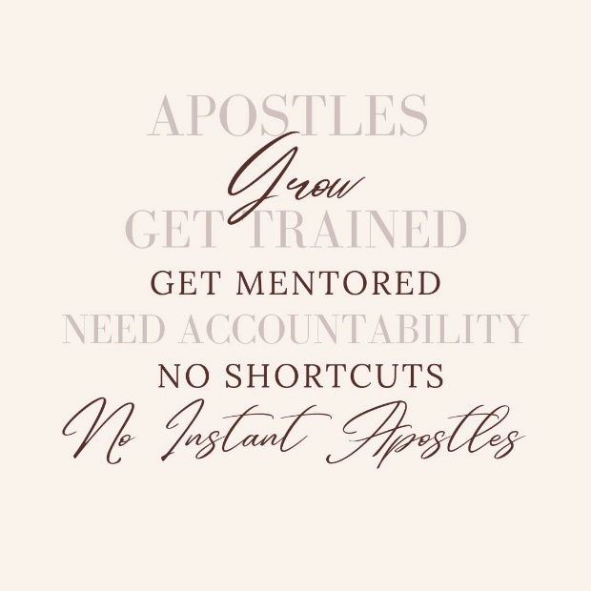In a personal email Buckner asserted: “As mentioned previously, Divine mandates of five-fold offices and functions doesn’t eradicate basic principles required of all believers. (Authentic) Female apostles are discernible by the fruit they bear. They will walk uprightly before God and His people. Whether budding or mature, there will be fruit/evidence. Holy Spirit will bear witness to who they are. The Body will be able to discern them, as they have been able to do with any others that are assigned to the Body of Christ. The distinction made isn’t that they are female, but that they are walking according to the will of God” (Bucker, personal communication, 2023).

Naiker gives three qualifications for an apostle. “First, an apostle had to have seen the Lord and been an eyewitness of Christ’s resurrection (Acts 1:22; 22:14; 1 Corinthians 9:1). Second, an apostle had to be specifically selected by the Lord or the Holy Spirit. Third, an apostle was invested with miraculous power to the extent that he could perform miracles” (2008, p9-10). Dent applies seeing the Lord only as a specific criterion for the replacement of Judas. It is not clear if Barnabas, Timothy, Silvanus, Andronicus or Junia ever saw the Lord.

Women and men grow into effective apostles. There were several years between Paul’s Damascus Road experience in Acts 9 until he was recognised as an apostle after release from Antioch in Acts 13. Apostle Anna Randall notes: “From the time of my official call from God concerning the apostleship to my actual commissioning service was a period of nine years.” (Buckner, 2016, Ch 1, para 15). It takes time.

Vermont, perhaps wisely, sidesteps the female apostle debate completely. She assumes women will be involved in catalysing ministry to Muslims and “highlights the need to envision, train and mentor Expatriate Married Female Missionaries (EMFM) to play key roles in Muslim Majority Communities (MMC). In addition, mission organisations need to prioritise reaching the women of Islam and inspire EMFMs to take an active role in ministry in MMCs” (2020, p4). Without training them it is unlikely that apostles will be effective.

Hansung Kim notes that Korean church planters in her research would just wing it. “Somehow their passion for church planting met with faith in God and religious optimism and not with education that would provide principles and methods on the practical level. I was intrigued that most of the interviewees did not have formal or nonformal learning opportunities before they launched their church planting ministry.” (2009, p11). Apostles grow and grow through training and mentoring. “These skills don’t magically appear in apostles, nor anyone else for that matter” (Jack, 2022, p165).

In earlier writing I devised an Apostle Growth Spectrum (2022, p118). God gifted apostles grow through several stages till they are mature. They do not magically appear, mature and authoritative. Before Paul was released as an apostle, he was among those who pioneer working with Arabs (Gal 1:17). Jesus designated The Twelve as apostles early, it seems. They were unreleased apostles until Pentecost. Designated apostle Judas stole money (John 12:6) and betrayed Jesus. Immature apostle Peter stopped eating with the Gentiles in Galatia (Gal 2:11). Mature apostles like Paul make a whole province their mission field and reaped a harvest.

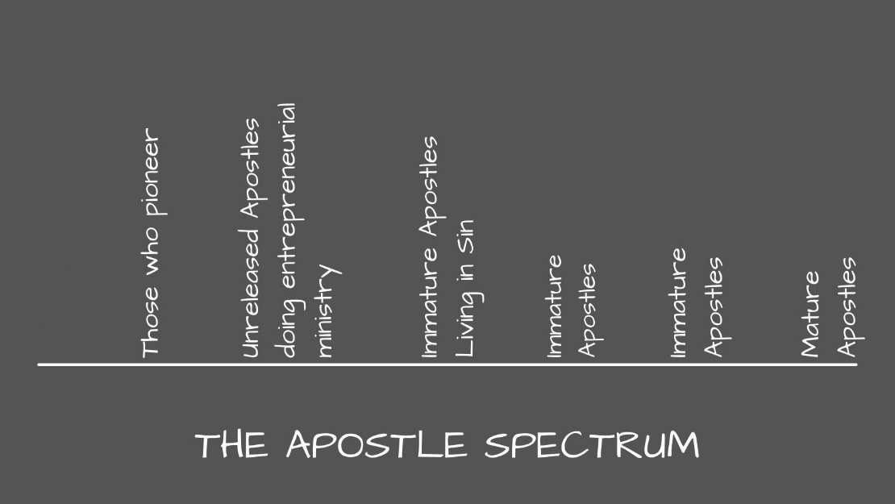

**Diagram 2: Apostle Growth Spectrum (Jack, p118)**

Pateman in a personal email wrote “… everything is a process! You might be called but *calling* and *appointment* are two different things. It’s easy to disqualify yourself. The progress is the same, whether male or female… We go from glory to glory. We don’t just step into a position. Remember the position of an apostle carries a lot of weight. You can’t be a child and a father at the same time. You grow up within the church structure, showing yourself faithful, learning how to serve, putting others before yourself. Remember apostolic gifts lift up others, not oneself. As we lay our life down - God raises us up” (Pateman, personal communication, 2023).

Mimms describes the giftings needed for the Strategy Coordinator which “[m]any identify as apostolic” (2023, p19). This role is also sometimes called Team Strategy Leader or Outside Catalyst. The giftings for this role “include casting vision, networking, creativity, and developing a residential team” (2023, p19).

Parks describes the type of people who become movement catalysts. They are passionate, humble and with large vision. Interestingly, “when we asked a group of movement-catalysts how they identified which of their new trainees would become effective…The consistent answer was that *we have no idea*” (Parks, p42). So far there seems to be no guaranteed identifiers for success.

Caldwell assists his readers to discern apostleship with some simple questions. I summarize them as follows: Are they involved in an E-2 or E-3 cross-cultural ministry with unreached peoples such as international student work? Do they feel called by God to such a ministry? Do they have a keen interest in people from different cultures? Do they display a particular aptitude for learning another language? Do they want to be directly involved in planting cross-cultural churches and doing cross cultural evangelism (1992, pp114-115)?

Jack (2022) provides numerous suggestions for discerning apostles along his growth spectrum. They come from his observations in apostolic ministry. Budding apostles may only have a clear call, or lots of ideas about ministry. They can be annoying. They take risks leading and pioneer *something*. Therefore, they are entrepreneurial. They are willing and faithful. They are best trained in a prophetic company model (like Jesus trained The Twelve). They are keen on evangelism. They pioneer churches, intentional jubilee structures and train others to do so.

Prinze’s (2022) recent seminal work potentially provides the many clues in discerning apostles, whether male or female. His research verified leadership traits and competencies found in the most successful eighty percent of Church Planting Movement catalysts (apostles) in his research group.

|  |  |  |
| --- | --- | --- |
| * Emotional stability * Adaptability * Tangible love * Drive to achieve * Desire to excel * Fervent intercession * Evangelistic zeal * Confidence in locals * Perpetual learning * Intelligence | * Complex thinking * Innovation * Movement knowledge * Sociability * Effective communication * Boldness * Discipling others | * Coaching others * Partnering * Influencing beliefs * Challenging assumptions * Personal consideration for others |

**Diagram 3: A summary of Prinze’s list of research verified leadership traits and competencies found in the top eighty percent of apostles - Movement Catalysts (Prinze, 2022, Ch 4).**

These are the traits and competencies of a mature apostle. How can Prinze’s findings be reverse engineered to assist with the discernment of female (and male) apostles? Prinze’s research plunges us into to the gifting, inherited or learned behaviour discussion. Romans 11:29, “for God’s gifts and his call are irrevocable,” indicates that giftings are given by God according to his will and sovereignty. How many traits and competencies are inherited? How many can be learned? How does one apply this knowledge to the annoying teen in the youth group and with authority proclaim them a budding apostle?

I distilled the explicitly expressed traits and competencies in budding and mature apostles in the research above. **See Diagram 4.** There is a significant spread of results. Explicitly agreed upon traits are limited. Pioneering churches, risk taking, training others, keen on evangelism, a clear call and in process to maturity are the only points of explicit agreement. And not all authors agree on these. No coherent pattern is visible.

|  |  |  |  |  |  |  |  |  |
| --- | --- | --- | --- | --- | --- | --- | --- | --- |
| **Author/ trait** | **Dent** | **Buckner** | **Pateman** | **Caldwell** | **Prinze** | **Jack** | **Mimms** | **Parks** |
| Entrepreneurial |  |  |  |  |  | x |  |  |
| Pioneer churches |  |  |  | x |  | x |  |  |
| Risk taker |  |  |  |  | x | x |  |  |
| Kingdom structures made |  |  |  |  |  | x | x |  |
| Train others to do same | x |  |  |  | x | x |  |  |
| Keen on evangelism |  |  |  |  | x | x |  |  |
| Clear calling | x |  |  | x |  | x |  |  |
| Willing and faithful |  |  |  |  |  | x |  |  |
| Involved in cross-cultural ministry |  |  |  | x |  |  |  |  |
| Interest in other cultures |  |  |  | x |  |  |  |  |
| Aptitude for language learning |  |  |  | x |  |  |  |  |
| Already involved in planting churches |  |  |  | x |  |  |  |  |
| Long to front line church plant |  |  |  | x |  |  |  | x |
| Interested in cross-cultural evangelism |  |  |  | x |  |  |  |  |
| Currently involved in cross-cultural ministry |  |  |  | x |  |  |  |  |
| Process to maturity |  |  | x |  |  | x |  |  |
| Discernible fruit…seen by the Body |  | x |  |  |  |  |  |  |
| Walking in the will of God |  | x |  |  |  |  |  |  |
| Dissatisfied with status quo of ministry | x |  |  |  |  |  |  |  |
| Love the lost | x |  |  |  |  |  |  | x |
| Sense of responsibility | x |  |  |  |  |  |  | x |
| Macro view | x |  |  |  |  |  |  |  |
| Casting vision |  |  |  |  |  |  | x | x |
| Networking |  |  |  |  |  |  | x |  |
| Humble |  |  |  |  |  |  |  | x |

**Diagram 4: Explicitly stated identifiers of budding and mature apostles in the literature and communications with authors.**

There would be a better correlation between results if implied results could be included. For example, Prinze’s first trait is emotional stability. I assume that all authors’ comments would implicitly support this trait in an apostle. Similarly, Prinze clearly does assume the movement catalyst is planting churches, but it is not explicitly mentioned in his traits and competencies.

***Closing statements***

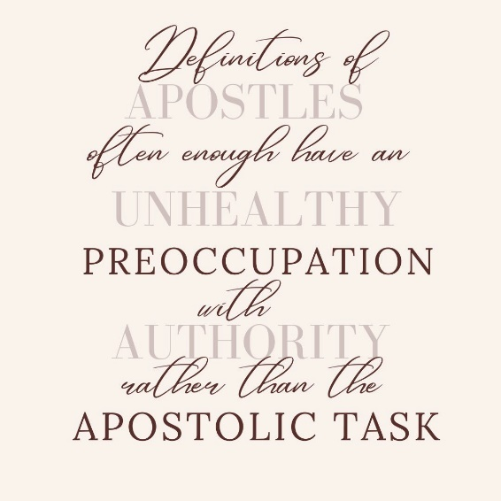I could not find literature that specifically dealt with discernment of apostleship – in males or females. Much further research is necessary if seeking early discernment of female apostles.

Prinze’s study could prove helpful if it could be reverse engineered to assist in finding budding apostles. Could this be cross referenced with personal histories, temperament, personality types and personal understanding of calling to create a test or descriptor? *Insyallah*, my planned interviews with apostolic women and men as well as the surveys of leaders in my mission organisation will be more fruitful and conclusive regarding themes in discerning female apostles.

In Scripture Junia was both female and an apostle. The full ramifications of this theological debate are in process. Significant support for female apostles comes from this study. Bias has played a part in the interpretation of Romans 16:7 – perhaps on both sides of the argument. The above discourse has demonstrated the rationale supporting the argument for Junia as a female apostle. As a logical consequence, I seek to discern (the focus of this research), recruit, train, send and serve female apostles.

Women have been doing apostolic – apostle like – ministry since the first century. Mason, Moon, The Twins and Porterfield are examples of women who have worked apostolically in the last two hundred years. Clearly there are many more. If someone is apostolic, does it mean they are an apostle? No. Hence there needs to be discernment.

The literature provides some clues, traits, and competencies regarding themes in discerning female apostles. Some of the authors and contributors to my research were in explicit agreement on a few identifiers. There was no unanimous agreement. My theological and missiological framework provides a further relevant understanding of women in leadership. It also provides the beginnings of a model to discern and grow female apostles.

**Chapter 3**

**Theological and Missiological Framework**

**Relevant Theological Input**

**The Doctrines of Men**

It seems the biggest hindrances to women in ministry of any kind is Christian men and the doctrines of men. Barr notes “God’s calling on women’s lives never seems justification enough for women to preach; they have to justify their right based on their historical context of patriarchy” (Barr, p170). It’s not just about men not supporting women. It’s men forming a scrum to keep women out.

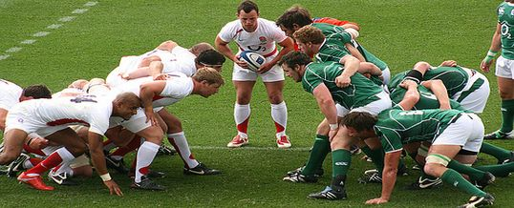

**Photo 2: Team Junia battles is out with Team Conservative (i.pinimg, 2023)**

***The Trinity places women in ministry***

“In the beginning, God” opens my line of theological argument. Above, Epp more than adequately establishes precedent for the scriptural and historical female apostle, Junia. Barr makes very clear that throughout history women have taken the lead in preaching and church planting – even in denominations that no longer allow them to do these things.

“In the beginning, God” means that all discussion about the nature of men and women, *imago Dei*, must begin with the nature of God, the Trinity. How does the Trinity function? The Trinity, Father, Son, and Holy Spirit have a love relationship. They communicate with each other. They submit to each other. One does not dominate the others. One does not take a subordinate role to the others. They are all God, all the time.

Humanity is made *imago Dei*. Men and women were created equal as *imago Dei*. “…created he them” (KJV Gen 1:27). There was no subordinate role, just as in the relationship between the Trinity. Both, “them,” were commanded to (NIV, Gen 1:28):

a. be fruitful

b. increase in number

c. fill the earth

d. subdue the earth

e. rule

Osborn concurs: “… we are equal and that we each have ability, we have dominion, we have authority, and we have prosperity or property rights because God created man and woman and blessed them both. He told them both to be fruitful and multiply. He told them both to subdue the earth. He told them both to have dominion or authority, and both were given the right of choice” (Glorius Church, 2017, 5:15). This is the original plan.

Then Eve was deceived, and Adam rebelled. It’s important to note here that “he will rule over you” (NIV, Gen 3:16) is an outcome, a consequence of sin, NOT an express command from God. If culturally women have become subordinate since The Fall this was not the plan and design, “natural order” of God.

**Complementarians.** I was blissfully unaware of the Egalitarian-Complementarian debate until relatively recently. I lived in an Australian bush town and then moved to a Southeast Asian Muslim community. Following the brilliant (Egalitarian leaning) teaching of the Osborn’s (Glorius Church, 2017) about marriage I never stood in my wife’s way in ministry and have worked intentionally to push her forward in her calling as an apostle.

Reading Barr’s experience of living in a Complementarian community shocked me. It sounded much like the Muslim culture where I have served for fifteen years. The “cult of domesticity” (Barr, p159) is disturbing. That women are being blocked out of ministry through poor exegesis of 1 Timothy 2:11-15 is infuriating. In my book A Guide for Growing Prophets I give a solid exegesis of these typically poorly handled verses. A copy is in Annex 5.

***Sons of God***. Williams takes another tact in defending women in the fivefold ministry Ephesians 4 ascension gifts and in ministry in general. Williams (2022, p49) declares: “Justification by faith, therefore creates a spiritual equality among believers (all are ‘sons of God’). This has far-reaching implications for the social equality of believers (that all are one in the Spirit) and the functional equality of believers (that all are gifted and anointed and empowered by the same Spirit).” God sovereignly chooses and empowers his sons of both sexes to fulfil the great commission, “with the ability to have spiritual authority over men” (Williams, p92).

***David’s sensical argument.*** In interview, David, a South Asian pastor and church planter, told me he faces many issues because he empowers his wife in ministry. He quipped: “And I would always question the logic of having an uneducated, untamed, [male] wild animal stand at the pulpit and scream out things that make you cringe, where you have such sober, mature women who could actually do a job that would be one hundred times better than that. Why aren't they utilized? So that was my question that really made me start thinking on these lines, and that pushed me to explore the Word of God…” (David, p5). It just doesn’t make sense to exclude women from the work of God.

**A Missiological Framework**

My assumption is that if I understand how apostles grow (which includes discerning them) I could extrapolate themes in discerning female apostles. Jesus set up a structure, a garden if you will, to grow his grove of olive tree apostles. What model works? This next section investigates and articulates a model for growing apostles. And from that model I will extrapolate themes in discerning female apostles.

**Observing Jesus**

Jesus grew a grove of cultivated olive tree apostles. How did he do that? How can we emulate that? Jesus took logical steps to discern and grow his apostles. Please note Diagram 5, and read it from the bottom upwards.

i] He chose people to follow him. “Come, follow me” (Mark1:17). On what basis did he choose them? The Bible doesn’t say explicitly. Yet Jesus had just been fasting in the wilderness for forty days. I assume he prayed about choosing the disciples. There are quite a few gaps in the story.

ii] In choosing to follow Jesus the disciples demonstrated that they were a. willing, and as time went by, they were seen to be b. faithful. Clearly, Jesus had more than just twelve men and women from the beginning of his ministry – Joseph and Matthias had been there from the beginning (Acts 1:21-23). It is sensical that Jesus would observe his disciples. Perhaps he looked into the future to read and apply The Ideal Team Player (Lencioni, 2016). Who was psychologically healthy? Who demonstrated leadership?

iii] Jesus then chose The Twelve in (TNIV) Mark 3:13-15.

13Jesus went up on a mountainside and called to him those he wanted, and they came to him. 14He appointed twelve – designating them apostles – that they might be with him and that he might send them out to preach 15and to have authority to drive out demons.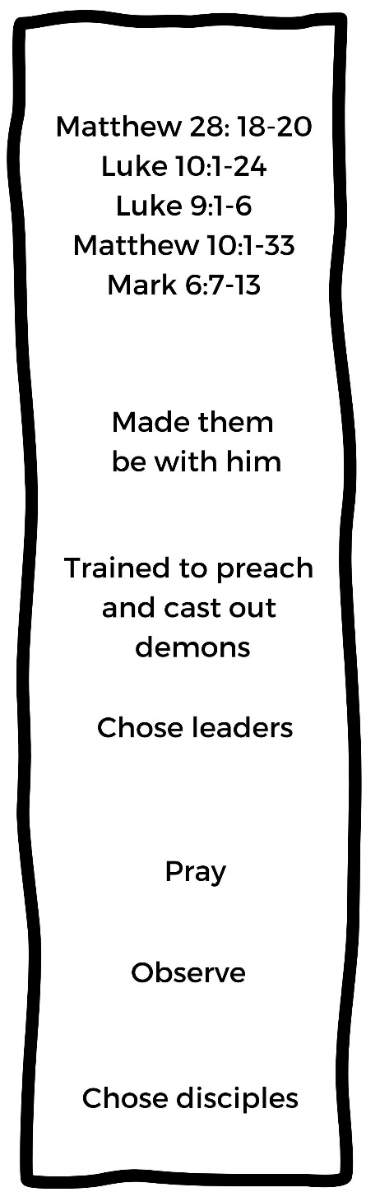

What was the initial task of The Twelve here?

**Diagram 5: Jesus’ Model for Discerning and Growing Apostles**

a] To be with him. They got to know him. They discussed everything with him. They experienced his love and embrace.

b] To be sent out to preach and drive out demons. Jesus gave a simple job description for the designated apostles – get sent, preach and cast out demons. What to preach? Just copy Jesus. How to cast out demons? Just copy Jesus.

c] Jesus’ training incrementally set the apostles on a trajectory for international catalytic ministry. In Mark 6:7-13 Jesus sent them out with a limited task and instructions. In Matthew 10 and Luke 9 he sends them again to get more experience. In Luke 10:1 Jesus “appointed seventy-two others” to the preaching task. Seventy is a multiple of twelve. Did Jesus send The Twelve, still two by two, and give them some leadership responsibility in this task? It makes sense that he would if we see that Jesus intention is leading the apostles to launch as international catalysts.

***Beginning Discernment***

The discernment of female apostles falls into the missiological category of leadership selection and development. The Bible provides some excellent examples of leadership selection and the processes used. Jesus selected the apostles. The apostles selected the deacons. Paul selected Timothy and Silas. What kind of process will work in discerning female apostles?

**Diagram 6 Foundation Stone 1: Psychologically Healthy**

I mentioned earlier that I was surprised when I read in Prinze (2022, Ch 4, para 8) that emotional stability was the first trait in movement catalysts. Why surprised? Surprised because for me, at least, emotional health is assumed in a leader. I extrapolated that trait further and named it Psychologically Healthy. One cannot assume that every apostle is in a good state of mental health. Psychological health, emotional stability, then seems like a firm foundation to build upon with any leadership discernment process including for female apostles.

The place to grow discern and grow female apostles in an apostolic team. (More on this later in Chapter 6). Jesus selected his disciples to join him, follow him and join his team. Back in the day recruiting to my area in Southeast Asia was challenging. As a result my bar was spectacularly low. I wish I had read Lencioni’s The Ideal Team Player (2021).

Lencioni provides three simple but powerful criteria for choosing the ideal team player. The prospective team player must demonstrate that they are i] humble. They have a realistic opinion of themselves and cooperate well with others. They must demonstrate that they are ii] hungry. Hungry for good results that the team is focused on. And they must be iii] smart. Smart refers to being people-smart, being able to work with all kinds of people. I call being an ideal team player Foundation Stone Two. Together I see that the two foundation stones form what I will call Foundational Good Character.

**Diagram 7: Foundation Stone 2: The Ideal team Player**

**Leadership.** Female apostles, like all ascension ministries, are leadership roles. Webber (2014) a Christian ministry leadership training specialist provides two keys in discerning potential leaders. These keys are i] thinking and ii] acting.

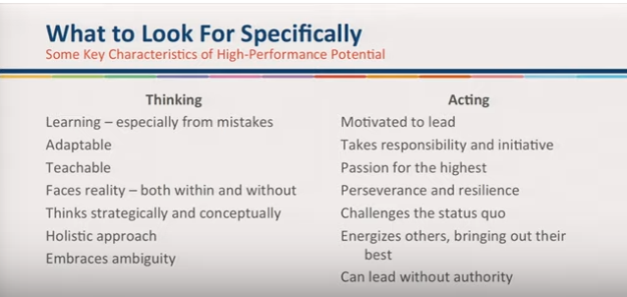

**Diagram 8: Some Key Characteristics of High Performance Leaders (Webber, 2104, 33:20)**

The thinking leader can work through the difficulties and complexities of ministry. The acting leader puts effective thinking into practice. Interestingly a healthy number of these and other leader identifiers are recommended by those surveyed and interviewed as apostolic identifiers. Webber marks these merely as foundational leader qualities. Consequently, I add Foundation Stone Three, that is, demonstrated leadership.

**Diagram 9: Foundation Stone 3: Demonstrated Leadership: Thinking and Acting**

**The Four Seasons chart.**I stated earlier that research on discerning and growing apostles is almost non-existent. Grigg’s Four Season’s Chart (2004, p 174) is therefore a useful model. In fact, it is the only model I could find that outlines Christian spiritual growth from birth to fruitful maturity. Grigg extrapolates three stages of spiritual growth in Christians from 1 John 2:12-14. These stages take place as the believer grows through four seasons: Security, Commitment, Quality and Calling.

12I am writing to you, dear children, because your sins have been forgiven on account of his name. 13I am writing to you, fathers, because you know him who is from the beginning. I am writing to you, young men, because you have overcome the evil one. 14I write to you, dear children, because you know the Father. I write to you, fathers, because you know him who is from the beginning. I write to you, young men, because you are strong, and the word of God lives in you, and you have overcome the evil one.

Grigg extrapolates from these verses that believers *ideally* pass through a little children stage, a young man stage and a father stage. To be more inclusive I rename these the child, youth and parent stages. The child is dependent upon others to nurture it. The youth has a level of independence and strength. Mature youth can reproduce. Parents do parenting, fathering and mothering of the youth and children.

**Diagram 10: Grigg’s Four Seasons Chart (2004, p 174)**

The Security Season covers the little children stage. Basic formation is covered: Accepting the Father’s love, turning from sin, growing in grace, inner healing.

Commitment Season brings the believer to commitment in the things they have learned. They maintain discipline in their faith and discipleship and don’t waver.

In the Quality Season the believer takes on ministry tasks and grows in and through them. They grow disciples.

In the Calling Season the believer follows the calling they have received to fullness. New ministries grow from them. They Father and Mother disciples.

In theory converts become mature believers, effective in their callings in six to nine years. There could be functioning female apostles in that time! This is not just an idealistic dream diagram. It is research based and comes from Grigg’s training with the Navigators (Grigg, personal communication, 2023). It is a good starting point for planning and praying.

***First integration.*** My focus in this research is to find themes in discerning female apostles. To assist in this task I integrate the above models as shown in Diagram 11, below. First, we look to the foundation stones, upon which the female apostle’s life will be built. Is a foundation of psychological health demonstrated? Are Ideal Team Player traits clearly in place? Are they humble, hungry and smart? Are they demonstrating leadership? Are they thinking and acting?

Each potential female apostle will require individual discernment regarding their growth. At this stage of my study I am feeling like an architect adding line upon line, brick upon brick. Why so? Adding the foundation stones to Grigg’s Four Seasons Chart gives greater clarity for using the model. Knowing Grigg, those stones are already implied. Articulating the implied and the assumed seems to be one of the major themes in discerning female apostles. To discern them and train them we need clarity and intentionality.

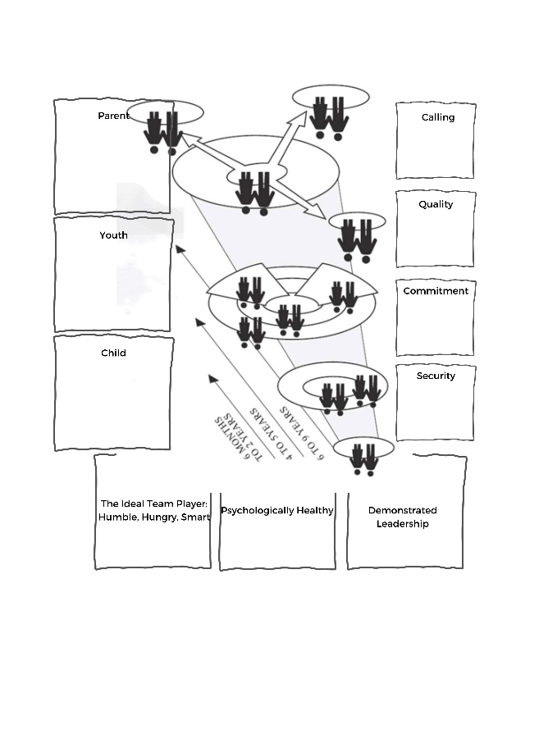

There are limitations in a one size fits all model. Clearly age and maturity will impact the reliability of the chart. And so will temperament. The 14-year-old female believer may be psychologically healthy. But how can I measure Ideal Team Player and leadership traits for that age? They may still be in Grigg’s Security Stage.

**Diagram 11: Grigg’s Four Season’s Chart, Adapted**

***A brief case study.***Meet Al. I met her when she cold-contacted me on Messenger, selling dog meat curry to pay for her Bible School. She was 23.A nominal Christian, she left her isolated village to seek work in a major tourist area. On the ferry she met a woman who offered to help her to do a theology degree.



Al came to saving faith in her first year of study. Al grew up with a stable family. She is choleric in temperament and a natural leader. She was very humble and a very good team player. Her foundations were strong.

Al was sent to the west of our nation where she served in a large city. The team training and strategy were simple: read 35 chapters of the Bible every day then go talk to people about Jesus. (Sadly, I’m serious.) Al was faithful to this unorthodox model at personal cost. *Alhamdulillah*, Covid rescued her and landed her in a six-month internship with us. Within three months she was boldly sharing the good news, running Discovery Bible Studies as well as performing significant signs and wonders.



**Diagram 12: Al’s Four Season’s Chart**

And now several years later Al is assistant team leader focussing on an animist UPG. I discern she has grown from Commitment significantly into Quality. She is growing through the youth phase. Diagram 12’s red lines indicate levels of growth, arrows indicating growth.

***Some reflection.*** Grigg’s model with my adaptations can assist with discernment of female apostles. Reflecting on my days as an Australian Army Cadets trainer I served with several girls who at 16 demonstrated that they were in the Quality Stage after four years in the context of the program. Those high functioning girls give me hope of getting young female apostles to the field early. Fancy that! As a consequence of my research over the last three weeks I have placed two talented fifteen-year-old girls in my recruiting funnel. That upcoming gap year internship could prove very fruitful.

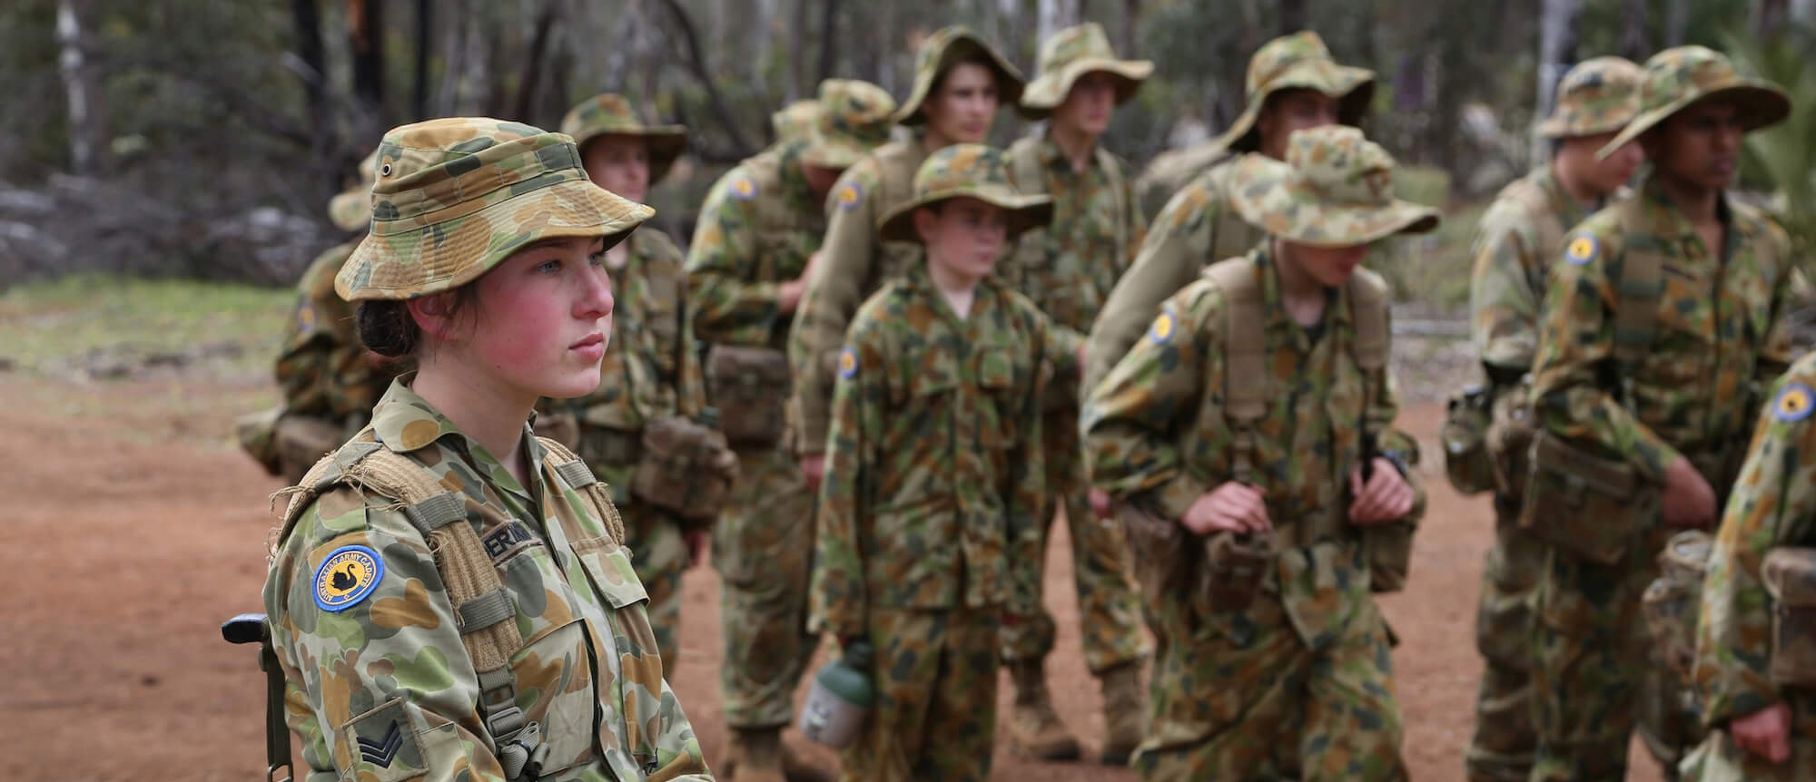

**Diagram 13: Sixteen and a Warrior (Shepherd, 2016)**

***Our experiments: ineffective to effective.*** At the time of writing, I have been serving in my Southeast Asian country of service for fifteen years. Our goal has been to establish Church Planting Movements in this part of the nation and in others. I came from a middle school teaching background. My wife and I were already fluent in the language when we arrived on the field, one of the advantages of being a late bloomer. When we started, we did not know how to do what we wanted to do.

***Classroom type training.*** We recruited a national team. We admitted we didn’t know what we were doing but were clear about what we wanted. I had caught a significant fear of persecution from Muslims (which, for the record has never happened). I gladly infected my team mates with that fear. It took me years to overcome that fear and also to develop a natural Jack-Way to share the good news.

We trained in a classroom type environment and sent our team out to do the work. After five years of struggle all team members and I were ready to go and find real jobs. By the grace of God, Dr Bill Smith came and set us straight on how to do things well.

***Classic internships.*** We then started interning foreigners. Our organisation has an internship program that focuses on preparing future workers through giving them a good foundation in language and culture. It’s not a free labour program to help missionaries. We interned many with an added condition that they do our organisations 6-week pre-field course. At the end of the internship, we had people keen to serve but like us, because of us. Yet they were not effective movement catalysts, apostles ready to be unleashed on the world.

***A better way.*** Our nation of service closed its doors when the Covid-19 pandemic came. We were house bound for three months. We prayed and worshiped. We gardened. We cooked. And we watched The Chosen. God spoke to me in a dream about offering internships to young women. We declared our new vision was to “mobilize, recruit, train, send and serve movement catalysts to our nation’s many UPG and megacities”.

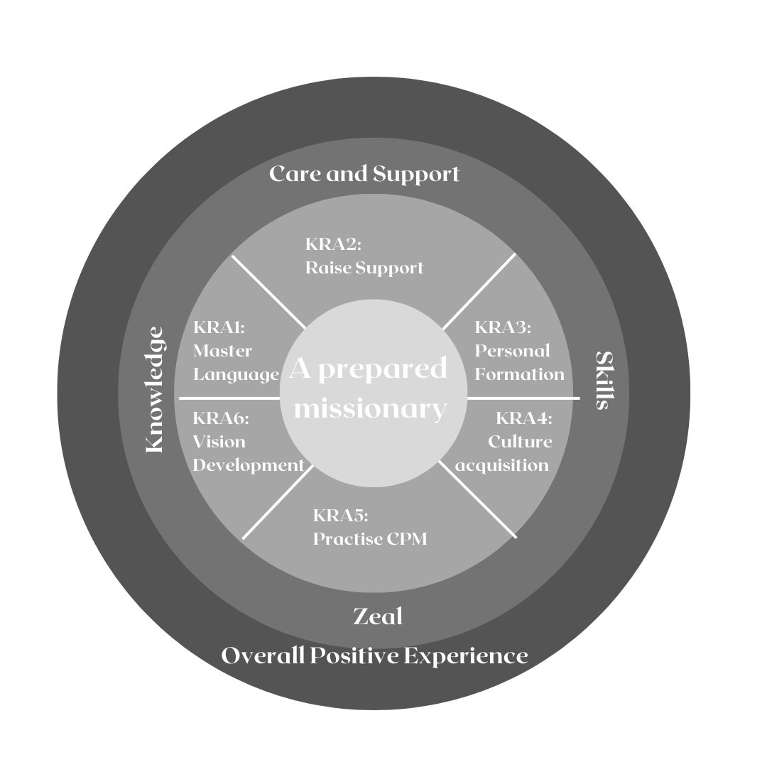We had known our first-round recruits for some time before the internship. Al is mentioned in the very brief case study, above. And Esther is one of those interviewed. Shekinah had long desired to work with the Muslim majority. We had known them for several years as women of quality.

**Diagram 14: Jack and Asha’s internship Key Results Areas**

My wife and I devised another way to intern people. Inspired by Jesus in the Chosen, we decided to follow Him and walk. We would spend Mondays and Fridays in town studying together. Then Tuesday till Friday we were living in a village or hiking through jungle and garden country. We lived and ate together and went with them and shared the good news with them. We walked around 150km together over six months.

And the training material? See Diagram 14. Personal formation, Culture acquisition, Practise CPM and Vision development were Key Result Areas (KRA). To us, at least, this is standard intern training.

We felt the focus on learning local language pushed our interns (who came from different ethnic backgrounds and languages) to live incarnationally. We have not yet learned to do this well, but we are on the way. Something worth doing well is worth doing poorly, *at first*.

Our Key Result Area of Support Raising is a multifaceted gem. *We have learned that an intern’s ability to raise financial support is directly related to gifting.* Every culture can amass reasons why fundraising is impossible in their context. But our interns do it over the term of the training. It indicates faith. Support raising quickly filters out those with poor motives and vain hopes.

After about three months there was significant growth in trust, mutual love and support as well as power in presenting the good news. Miracles started to occur. Esther prayed for a young girl’s ulcer which dried up overnight. This opened the door for a DBS group with a family. Al pulled a lame man off the ground in the name of Isa Al Masih. *Alhamdulillah*, he walked again.

After hiking several weeks searching for a person of peace without success our neighbour joined us by the campfire one night. We were prepared and did a story on Zacheus. She interrupted the DBS. “I know that story.” This Woman of Peace had watched the Jesus movie many times in many languages on the free-to-air satellite channel. She was ready for harvest. Within a few weeks she, her husband, father-in-law and neighbour were baptized as Shekinah followed through.

Upon completion of the internship all three women began working among UPG *alone*. They shared, followed up and now, several years later, have teams of their own and their ministries are successful. I have designated Shekinah, Al and Esther as apostles. Esther calls herself “a baby apostle”.

***Second integration.*** My model, an adaption of Grigg’s Four Seasons Chart, for discerning and growing apostles has developed significantly. Jesus’ model, on the left, was clearly effective in producing apostles. Mine (on the right) has got off to a good start with our internship discerning and producing some budding female apostles all under 30 years old.

My model was still incomplete. There was more to come. I complete this discussion in Chapter 5.

**Diagram 15: A Developing Model for Discerning and Growing Female Apostles based on Grigg’s (2004) Four Seasons Chart.**

**Chapter 4:**

**Research Methodology**

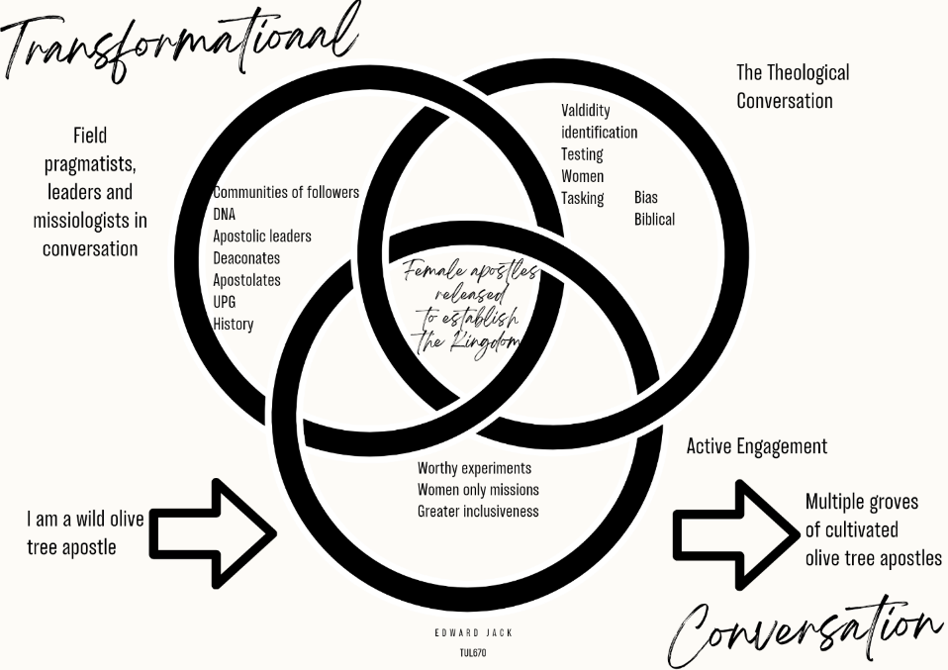

**Diagram 16: Jack’s Initial Transformational Conversation**

**The topic and the problem**

My topic is Themes in Discerning Female Apostles. I believe Unreached People Groups and megacities need to be reached with the Good News. Apostles are the most likely people to achieve that goal. The problem is multifaceted. How do we discern, mobilise, recruit, train, send and serve apostles to those UPG and megacities? How do I grow that grove of cultivated apostles? What is the process of growing an apostle so that I can extrapolate themes in discerning female apostles from it?

This thesis is limited to discussion about discerning female apostles. If we can discern them, we can mobilise, recruit, train, send and serve them. There appears to be few tools or articulated models available to discern female apostles. Bible exposition and history both support women as apostles. Why are there no intentional pathways for *any* apostles? What challenges do female apostles face that would stop them fulfilling their calling? How are male and female apostles similar and different? What are the action steps and progressions needed to produce that grove of cultivated olive tree apostles?

This thesis is intentionally an exploratory study that I expect will provide more questions than answers. Well thought through questions will be helpful in the journey to getting good answers and *insyallah* more apostles on the mission field.

My approach is qualitative research. I have interviewed eleven people whom I identified as living my definition of an apostle above. I interviewed five apostolic men and six apostolic women. The interviews covered a broad range of material. I wanted to hear their stories, hear their hearts and understand their journeys. What lessons could be learned from them to make the process of discernment and growth in the gifting clearer and more lucid?

This study is part of a broad transformational conversation that seeks to produce more apostles. The study wrestles with theology, missiology, my experience and experiments in discerning and growing apostles.

**The interviewed**

Some of the interviewed are friends and acquaintances, others mentors and one a virtual stranger. They all work apostolically, that is at the time of selection I identified that they met my definition of an apostle but I didn’t know if they identified as such. Some were from my organisation and some not. Most chose not to be identified for security reasons. I therefore gave them pseudonyms and obfuscated identifiers.

These are the interviewed given in order of age. The oldest is nearly 80, the youngest is 32. Dr Bill Smith: He is a world authority on CPM and a mentor to many. Dr Lorraine Dierck: A long term church planter in Thailand and a mentor to many. Dr Viv Grigg: Founder of the MATUL, church planter and mentor to many. Dr James Nyman: A DMM catalyst team leader with nearly thirty years of experience in Southeast Asia. Reina Nyman: A DMM catalyst and trainer of women with nearly thirty years of experience in Southeast Asia. Junia: A CPM catalyst, trainer of missionaries and catalysts with seventeen years of experience in Southeast Asia. Jehu: A DMM catalyst and catalyst trainer twenty-two years’ experience in Southeast Asia. Priscilla: A church planter with nearly twenty years’ experience in West Africa, now leading a missionary training school in the Philippines. David: A church planter with 30 years’ experience in the Middle East and South Asia. Dr Potima: A CPM catalyst with 16 years’ experience in South Asia and Southeast Asia. Esther: A CPM catalyst with two years’ experience in Southeast Asia.

***How I Used the Interviews***

I used the interviews to find major themes in discerning female apostles. I did the interviews and typed them up. I then read through them all to digest them again. Then I went through them again and again to look for common themes. In Chapter 5 I present my findings from the apostle’s stories in a thematic manner. I called these Themes in the Apostolic Journey.

I was blessed. How? I was given language for some processes and concepts which I intuitively held or practised but had not articulated. I concluded that there is a generic process in discerning and growing female and male apostles. God works beautifully in the individual to achieve his purpose.

***Surveys.*** I wanted to understand what people in my mission organization believe and practise in regard to discerning female apostles. To do this I sent out 101 surveys to my Mission Partners, leaders across the globe. Sadly, only twenty-eight responded.

Survey results were messy. By allowing respondents to answer in their own words I got a large amount of responses, data regarding discernment of female apostles. Mission Partners gave insightful input regarding their perceptions on the topic. Most of these results appear in Annex 1. There seem to be few consistent patterns of responses in regard to the topic.

I also collated information from eight authors in my literature review (See Diagram 4) and specific questions to the eleven interviewees (see Annex 1, Diagram 32a and 32b) regarding discerning female apostles. I listed them in a chart just like I did with data from the surveys. At first it appeared that individual sections of data would not reveal much at all. There was just such a variety of opinion and most of it was on topic, relevant and sensical. When all sections of data were collated together, it really took shape.

**Limitations and serendipitous findings.** There are several limitations in this research thesis. Unarticulated assumptions are by nature unarticulated, they are typically incomplete. And if my research through interview and survey has a major weakness it is that I don’t know what is underpinning all the answers people have given me. What have I missed? What have I read too much or not enough into? I will circle around to this point later in the thesis. Some answers were worded differently with similar meanings. Some were worded similarly with different meanings. When I put these into groups did I do it as the survey fillers would have wanted? If there is a method of guaranteeing perfect precision in filling in the charts it has, sadly, eluded me.

I see the results as very helpful and hopeful *but also messy*. Those interviewed and surveyed often answered in a specific way, not in a way that I was expecting. Some of the survey answers were quite odd. And last but not least, my survey pool is quite small with a total of 47 contributors. Twenty-eight were survey participants. There were eleven interviewees dealing with questions directly about discerning female apostles. Then there were eight authors whose points I took from their written works and or personal communication with them.

Not all those surveyed and interviewed put in much thought, planning and intentionality into the process. Consequently, answers may have just been off the cuff, not well thought through and perhaps not expressed well. That’s not at all a complaint, it’s just a reality. The flip side of the messiness is that some real gems came out as well. More on that in Chapter 5. The more experienced interviewees had more to contribute to the topic. Some of them have been thinking through similar questions for some time. These were very valuable conversations, giving me insight into God’s process in growing with these wild olive tree apostles as I heard and interacted with their stories. The biggest blessing for me personally from the research is that I was given language for a few of my own unarticulated assumptions and practices. This was very helpful.

**Chapter 5**

**Description of the Findings**

**and Analysis of the Data**

**The interviews**

**On Female Apostles**

It was a surprise, if not a shock, that all eleven apostolic workers interviewed *eventually* identified as apostles. It was also a great blessing to me that they all unequivocally supported the concept of female apostles as biblical. When I asked Jehu if he believed in female apostles, he was adamant and answered for all respondents “Of course I do. They’re in the Bible” (Jehu, p12).

***Themes in the Lives of Apostles, Female and Male***

These themes appear in a random order. They are not ranked in any way. The end of the interview section has a focus on themes that stood out throughout the interview process.

**Stories.** I wanted to capture the story aspect of this research. It is through narrative we can better understand the journey of the individual and God’s gift and calling working in them. Hence each theme is lengthy, giving the apostles’ perspective through quotes. There are many gems and much pain here.

Rather than report on the individual interview findings and make endless charts of potentially (to the reader) overwhelming data, I took a different route. I leapt into an immediate basic analysis of the interviews, the stories of living apostles, categorizing them into themes as they appeared. The effect is that we meet the apostles and many of their stories are heard. There is more to be gained from a story than a chart!

**Interviews with the apostles: Themes in the Apostolic Journey**

**A Growing Process**

All interviewees reported growing into apostleship. Jesus appeared to Saul on the Damascus Road and called him to be a witness, not an apostle. His apostleship was formally confirmed years later in Antioch. In between he served cross-culturally. Consequently, it seems logical that contemporary apostles should grow, like any other gifting. The traditional pastor, aged 24, directly out seminary is not the same woman at 57. Their experience has grown them significantly.

Upon repentance James “just automatically just started thinking how to reach people” (James, p1), “that’s been my passion and drive. I wasn’t thinking in terms of ‘is that apostolic or not’” (James, p1).

“God gave me very early on in my life the gift of prophecy and the ministry of a prophet” (David, p1), David recounted. Other gifts followed “with the ability to interpret the scriptures well” (David, p2). In moving to the Middle East and back to South Asia to plant churches David has matured.

Jehu describes his maturing process as “an unfolding revelation that there was something weird about me…” (Jehu, p1). Weird? He grew up in a Christian home “but I was the naughty kid” (Jehu, p1). At 15 or 16 he began “really following Christ” (Jehu, p1). He began to care about people, to share the gospel, and “also to care about people cross-culturally” (Jehu, p1). It wasn’t normal for him or those around him. He and a close friend were fervent prayers, they asked God for all the gifts of the Spirit. At around 20 he was affirmed (see the affirmation section, below) as having “the gift of apostleship” (Jehu, p2). This radically impacted Jehu’s world.

Bill’s story is similar to many in the group interviewed. Childhood salvation. A time in the military. A call to obedience and mission. Fourteen years church planting in Thailand. God then called Bill to a UPG in East Asia. Bill’s role changed: “I felt at that time I was being an apostle. I was called to an Unreached People group. I was doing everything possible to bring the gospel to them and to facilitate the gospel spreading through them” (Bill, p2)”.

Theoretically, Bill, in his eightieth year, is retired. Bill is a sage to many. “At this stage I’m identifying apostles, I’m training apostles, I’m facilitating and supporting them, creating structures for them” (Bill, p2-3). He has gone through phases of growth – growing apostle – church planter, apostle - strategic coordinator taking responsibility for a “segment of lostness” (Bill, p2) - apostle-mentor to other apostles. Lorraine, in her seventies, plays a similar role to many in Thailand.

Junia knew her calling and gifting intuitively. “I believed I was to be a missionary in Asia. And it just made sense to that that meant I was an apostle” (Junia, p2).

James’ pilgrimage story reads like many others in cross-cultural ministry. Campus work. Seminary. Perspectives. Apply for an organization. A providential meeting then launched him to his Southeast Asian nation of service. At this time “apostle” was not on his radar.

When talking to Viv about the growth process he stressed following The Voice. “I can’t talk of it, the apostolic, if I don’t talk about The Voice” (Viv, p2). He means the voice of God, if that is not clear, and the need to hear God in all aspects of life and ministry. Viv mentioned “the process where the prophetic moves to the apostolic” (Viv, p2). He spoke prophetically in New Zealand impacting a mission agency “their whole mission, structure and policy” (Viv, p2).

Viv named other factors in his growth. Mentoring played a role. Experimenting with evangelism also occurred. We discussed at length “foundations that have to be in place” (Viv, p7). Inner healing is necessary because “generally you can’t always tell people’s giftings because they are covered up by a whole lot of mess in their lives that needs to be undone” (Viv, p7).

Viv Grigg is the only interviewee to offer a clear theory (his Four Seasons Chart) in regard to growth into being an effective apostle. All the others pointed to a process, rather than instantaneous, “magical,” apostleship. Viv’s Four Seasons Chart was introduced in the literature review section of this thesis.

***Naming it***

All interviewed were very cautious in their answers when asked directly about apostleship. I defined apostle:

*An apostle is a woman or a man gifted by God to plant churches or catalyze movements of churches. They usually have signs following. They establish structures to get the job done. They bring Kingdom DNA into the culture where they are working. They train others to do what they do.*

Lorraine was quite decisive, perhaps even adamant. “I don’t feel that I’m an apostle, but I have an apostolic ministry”. Poor role models in her early life locked her out of identifying an apostle. Interestingly, she later noted “I went into the interview with a false perception of an apostle as a superstar; someone with an outstanding spiritual giftedness that resulted in movements of thousands of churches, and a person with celebrity status. I don’t identify with that at all. But after the conversation, I realized I had overlooked that the Bible refers to apostles as the foundation of the church – and the foundation is lowly and sitting on the ground. People named as apostles are usually not spectacular, praise-worthy superstars. The reason I would now dare to call myself an apostle is related to the God-given gifts of being able to do whatever is needed to initiate new churches and new ministries. As needed, I have evangelised, taught, encouraged, equipped other believers, administrated, served and given generously to birth new ministries. And somehow those churches and ministries have endured and multiplied” (Personal communication, 2023).

Similarly, James at first gave an unclear answer to the question about identifying as an apostle. “I think I am, but I don’t know. I don’t really identify myself that way” (James, p4). Like Lorraine, James took the “I just feel more comfortable with being apostolic” route (James, p4). Why so cautious? Cultural issues. James noted “I think there’s some baggage…attached to the word” (James, p4). He comes from the same “non-thing” pond as Reina and the use of the term is “weird” and “it feels sort of arrogant” (James, p4). The “non-thing” refers to James’ denominational background which was not extremely Cessationist nor anticharismatic. Spiritual gifts were not discussed. It was a “non-thing”.

Somehow, I did not ask Bill if he identified as an apostle during the interview. Bill cares little about titles, he’s all about being a person of action to get the job done. He accepted my definition of apostle above and broadened it further (more on that below). As I read over the interview afterward, I realised that I did not have a clear answer. I emailed for further clarification. Bill responded with his usual brief clarity: “I agree, go ahead and call me an apostle” (Personal communication, 2023).

Priscilla and her husband Aquilla grew in their understanding of apostleship over a twelve-year period of service in West Africa. “Later on in our ministry I did. I have recognised that ‘Oh, this is the gift of an apostle” (Priscilla, p4). Previous to this they identified as missionaries.

Junia recounts that “from the end of high school, just knowing God had called me as a missionary” (Junia, p1). When asked if she identifies as an apostle her answer was much like others interviewed: “These days I would identify as an apostle. I don’t necessarily share that with many people, however” (Junia, p1).

“Viv, do you identify as an apostle?” was my question. He joined all the others in giving a slow, deliberate and cautious answer. “Not publicly. I’m just a follower of Jesus and a servant of people. I’m not an apostle in the Catholic sense of having authority to command and demand…My authority is based on relationship to those I trained and led” (Viv, p1). Viv first identified as an apostle in his thirties while a student at Fuller Theological Seminary (Viv, p5).

Potima described how culture mitigated against openly identifying as an apostle: “British culture, Catholic background and female…and I think female would be the least of the three” (Potima, p3). She added: “…it sounds a bit pretentious to me” (Potima, p3). “So, I think previously I would have said, ‘I think I have apostolic gifting, but I would never have actually said that I am an apostle’” (Potima, p6). This young apostle has a doctorate. Her questions were as good as her comments. She echoed my own with “Can you call yourself an apostle when you haven’t done much yet?” (Potima, p3).

At the interview David was clear from the beginning: “I believe I am an apostle. I’m called for that kind of ministry” (David, p1). A transition period brought David’s apostleship to light. He had moved from South Asia to the Middle East. He was tentmaking and planted a church. Transitioning out after twelve years at the Lord’s command, reflecting on Paul’s life and practice made David realize that he too is an apostle.

“Do you identify as an apostle, Jehu?” was my question. His answer was a confident “I do” (Jehu, p7). He continued “I talk about I have the gift that no one else wants…I have the gift of apostleship. And then they start running?” (Jehu, p7).

**Affirmation.** Affirmation, and the lack thereof, was a common theme in my interviews. Affirmation has a powerful impact. Both Potima and Esther confessed that it was my pre-interview affirmation that made them accept that God had called them as apostles.

Junia felt affirmed by numerous helpful prophecies over the years. She received no direct affirmation as an apostle because she rarely discussed apostleship with anyone. “Then Cowboy Prophet laid hands on us several years ago and called us apostles. I think that was the first time anyone’s ever anointed us and sent us out as that” (Jehu, p2). It “confirmed what we already knew anyway, that we were apostles. And gave a greater courage to step out” (Jehu, p2).

Husbands play a significant role in affirmation. Reina, was in her “non-thing” pond with no affirmation. “I’d say honestly, I did not have anybody recognizing this in me and affirming this in me except for [my husband], along the way. [My husband] thought it was a strong gift of prophecy as well as apostolic gifting” (Reina, p6). Reina also noted that “when you find those apostolic gals you also find the men that affirmed them, because sometimes you need that covering in our circles to say ‘I see this’, ‘Yes. I think you should go after that’” (Reina, p6).

Similarly, James felt there wasn’t “any intentional development of us as apostles” (James, p5) in his early days on the field. At one point James journaled, “I think I am actually an apostle” (James, p6). He shared that with his mentor who responded, “I definitely affirm that in you” (James, p6). James had more confidence in the call after that. He explained regarding male-female apostleship, “I would actually say that in my organization that’s really affirmed” (James, p9). Good news!

At the time of Priscilla’s ministry in West Africa they were very isolated. She and Aquilla were intentional about “self-directed learning” (Priscilla, p7). She found affirmation in this learning. “I think one is Yonggi Cho’s teachings before when he said there were eighty percent women [leaders] in his church. That struck me a lot. And another one is reading and learning about prayer. That one really helped me in developing into an apostle” (Priscilla, p7).

Priscilla pointed out that her sending organization was always supportive. “They empower your calling” and “they’re coming alongside of us” (Priscilla, p9). She was not hindered in any way in ministry.

Esther’s success in only two years as a movement catalyst has caught the attention of many. Being an apostle was not part of Esther’s worldview until I suggested it may be her gifting. She observed: “…other people play a role in talking about it…and helped me to identify…” (Esther, p7). Esther summarized her feelings well: “Yeah, I feel like I’m still a baby. A baby apostle” (Esther, p8).

When I asked Viv about the role of affirmation he responded: “I see it as essential. It’s the mentor and the environments” together (Viv, p11). Interestingly Viv also added “But I would say my mentors never understood me, Jack” (Viv, p11) and “I never fit anywhere” (Viv, p12). Why? Because of the nature of the gifting and how it functions. Viv clarified further about affirmation, “…the apostolic need to find mentors who will affirm. That would be great, but probably unrealistic because wherever you go, you’re a threat. You’re creating new structures, wineskins. So probably young apostles need to figure that out as they go” (Viv p12).

One of the surprises for me doing these interviews was hearing that my affirmation had influenced Esther, Lorraine and Potima. Potima said “… you’re a part of that. I don’t think I would have owned the title unless you hadn’t been thinking about this and also said to me that you think I’m an apostle” (Potima, p1). Was it just my influence? A sudden whim on Potima’s part? No. She made that clear. “I think basically everything I was already planning to do and working towards seemed to fit. And then when you said ‘it looks like you’re an apostle’, I said Yeah, well, that probably makes sense” (Potima, p2).

Jehu, like Viv, mentioned having significant mentors along life’s way who affirmed him in ministry. Jehu was first affirmed as an apostle at age 20. “They affirmed me so strongly in that and it was such a shock. And then not only that, they invited me to join their team…Those were absolutely pivotal things” (Jehu, p2).

***Apostolic Environment.*** Viv, one of the heroes of my faith since my twenties, articulated my own practice and position nicely: “How do apostles form? I think they have to grow in an apostolic environment to lay the foundations” (Viv, p1). Viv’s descriptions of his life make him fit my ‘wild olive tree apostle’ model. He found his own way in many respects “Learning how not to do it…. we began to figure out…we began to figure out…We figured out…” (Vp1-2). Viv’s apostolic environment as a training ground is, I believe, a key to discerning female and male apostles.

David stressed the importance of growing in a team. He hypothesized that even a 15-year-old “could be released within a year’s time, not as a person functioning alone but in a team. Along with the team to start exploring and exercising their gifting” (David, p7). Articulating this point was helpful to me because apostles function in teams, but my archetypal-default position-authoritive apostle is a stand-alone cowboy, a Superman.

Junia has learned some powerful lessons in training budding apostles. Training, mentoring, and coaching should take place “not in a classroom. I’m talking get out on the field and do it together so that you can actually see how they do that” (Junia, p6). Over one of those internships Junia walked 150km with her three female *padawan*. All three are now doing apostolic work and two identify as apostles.

Esther comes from a Presbyterian background. She joined Junia’s internship and within six months was establishing Discovery Bible Studies. Signs and wonder began to occur. These days they are a regular and integral part of her pioneering. She reminisced about her “six-month internship where I learned about it in theory but also practice…I am seeing from the fruits, I am an apostle” (Esther, p9).

***Poor Definitions.*** I mentioned above how Lorraine could not identify as an apostle because it had been defined (as well as modeled, see below) poorly. Apostleship was “…it’s like shiny, sparkly, brilliant” (Lorraine, p7) and “very highly regarded and it was almost something that was out of reach of the ordinary person” (Lorraine, p1).

***Extending my Definition of Apostle.*** My definition of an apostle came from personal reading, reflection, and the influence of my broader studies in the MATUL. In no way do I claim it as divine revelation, but it seems very reasonable and helpful. Interviewing eleven apostles has been enriching at many levels. They added to my definition of an apostle and the apostle’s role.

James noted that “one of the things that resonates with me about the apostle is that it says they’re actually a Jack of all trades, but master of none” (James, p1). He added to this: “that probably describes me because I can do multiple things adequately but certainly none very great” (James, p1-2).

Bill clarified my definition and understanding of apostles. “[G]enuinely apostolic people either do something that hasn’t been done before or they do it in a place it hasn’t been done before” (Bill, p14).

Bill characterized apostles as not working from authority but from influence. “You’ve got to do it through influence. And God had equipped me through decades to influence people to what God wanted to do when I had no authority over them” (Bill, p8). This is quite a contrast to most archetypal paradigms about apostles. Bill noted that “apostles see beyond what they can personally do” (Bill, p13) - moving from ‘what can I do?’ to ‘what needs to be done?’

Bill added “part of an apostolic calling is calling the people of God together” (Bill, p9). Lorraine expressed a similar understanding. “[T]he problem that I have with this ‘am I an apostle or are you an apostle’ is that it focuses on that one person. But for me, it hasn’t been like that. It’s just been all those people always around me…” (Lorraine, p3). Jehu added to Bill and Lorraine’s wisdom. “…a big part of it is this thing of opening the ground for others ... apostleship, I think is listed first because it opens the way for everyone else” (Jehu, p7).

Interestingly Lorraine, James and Jehu all identified with Apostle Barnabas. Jehu explained about Barnabas. “…his most spectacular contribution… was actually turning Saul into Paul” (Jehu, p7). These older apostles, much like Bill, humbly work to see other apostles developed and grown. Jehu significantly added that “… creating leadership vacuums and helping others to fill them is huge, maybe one of the most crucial things about being an apostle” (Jehu, p7).

Interestingly, Jehu added to Bill’s strategy coordinator apostle concept. Quoting one of his professors, he called Paul a community organizer. “That’s what he was doing and everybody else was leading it on the grassroots level” (Jehu, p7).

Potima didn’t add to my definition of apostle. She seemed to long for clarity about the fivefold ministries “So it’s less intimidating” (Potima, p8) and particularly about apostles. A good definition (“you need to know what an apostle is” [Potima, p8]), that they are still functioning today: “if you don’t have that concept, then it’s very hard to see yourself as one” (Potima, p8). She suggested a list of their characteristics to make discernment accessible. “You need a list of characteristics and then just see if you can spot them” (Potima, p9). Well, yes, that’s why I’m researching this topic. One will be presented in Chapter 6.

Catalyzing became a significant undergirding theme in the interviews with apostles. Mission is God’s work. Viv remarked: “I tend to use the term ‘help catalyze’ rather than ‘I started’ ” (Viv, p5) a work.

***Overcoming Cultural Hurdles to be an Apostle.*** Others challenged Lorraine to see that she was apostolic or an apostle. Her response was always “No I’m not” (Lorraine, p6). For twenty years she was “just happy to think of myself as a missionary” (Lorraine, p6). She whined “Don’t call me an apostle because I don’t want that title, because I don’t see myself as a celebrity person” (Lorraine, p10).

Reina worked through her destructive experiences of Complementarianism. She had felt her position “similar to this Cousin [Muslim] thing of half value and no more” (Reina, p18). She’s philosophical and positive about it, however, as she believes “that the things that the Lord allowed in this process are ways to recognize where are the holes, where are the gaps, and helping women as well as men get equipped” (Reina, p19). In response Reina has developed a document of thirty questions to coach and guide people into movement friendly organizations.

Priscilla, like all interviewed, was cautious when talking about her gifting. The accumulated-historical-theological issues regarding apostles makes any apostolic claim seem spurious. Like Lorraine, “…we just say we operate in the apostolic gifting, we don’t call ourselves apostles” (Priscilla, p5). It’s a safe option.

Junia’s time in Pentecostal churches somehow damaged her confidence. “I believe[d] because I was a woman, I was less, I didn’t step out as much or take the front role as much as possibly I might have been able to” (Junia, p3). When her husband went into burn out Junia rose to the occasion and grew significantly.

Junia, like many interviewed, is aware of the cultural sensitivities of claiming apostleship. “I thought that being a woman had a lot do with me not expressing that I thought maybe I was an apostle. And later on, the need not to big note myself or to be humble in the eyes of the churches and supporters has also kept me from expressing any thoughts about being an apostle” (Junia, p4).

David and his wife had to break with their church rules and culture on their journey to apostleship. He reflected that “many things I learned…had to be dismantled, had to be broken down” (David, p5). One of these was his denomination’s view that missionaries must be celibate. Recently David and his wife have been pushing back on denominational rules blocking women in ministry.

***Sovereign Foundations.*** Looking back, Bill saw that he was uniquely prepared for the apostolic task. He “moved almost every year during my school years” (Bill, p7). This, with his time as a military officer helped him “[t]o be able to understand what it’s going to take and faithfully equip people to do hazardous, dangerous things, to grow the Kingdom of God” (Bill, p7).

Priscilla grew up Roman Catholic. She interpreted her dark-skinned hands dream through that lense at first. “I went to a Catholic university and so I got exposed to calling. So, I thought I was going to be a nun” (Priscilla, p1). After coming to Christ, she pursued “that calling until they introduced what we called an urban mission school…after that course and then I got the call. I got confirmation that I am going to be a missionary” (Priscilla, p1).

***Early Indicators.*** Potima saw fruit of apostleship well before believing that she is one. In high school, a Catholic school, at 13 or 14, she started and ran a Christian Union. She spoke at every school assembly.

Reina demonstrated healthy early indicators. She came to Christ at 16. “…and the Lord gave me a heart for my group of friends…. And, the Lord gave me a vision for the whole school” (Reina, p1). Similarly, while at college Reina was a very successful disciple maker: “if we’re seeing our sorority into four generations why wouldn’t we see the entire campus” (Reina, p1). Vision and action were strong. Jehu also started a student Christian group at high school (Jehu, p3).

Viv, however, did not seem overly impressed with early indicators such as those in Reina, Potima and Jehu. “It is usually only an indicator, Jack. There’s a lot of late bloomers in this business” (Viv, p10). I resemble that remark.

***Supernatural Signs Along the Way.*** Junia was encouraged on her journey through several prophecies. She reminisced: “I had a prophetic word given to me, a very long and detailed one, about Asia and the Father’s plan for me and my future husband” (Junia, p1).

Signs and wonders have not been an outstanding part of James’ ministry. He “was surprised we didn’t see more signs and wonders … it wasn’t for lack of effort” (James, p2). Yet along the way there have been some.

Priscilla had a dream which followed her from childhood. She dreamt that “I’m distributing food and those who are receiving it had dark skin toned hands. And this vision was very very vivid in my mind as I was growing up. So I had this perception in my mind that I think I’m going to do that…” (Priscilla, p1). Years later in her West African country of service Priscilla lived out the exact scenario of the dream. A further confirmation from God. Before leaving for West Africa Priscilla also participated in exorcisms and healing of the sick.

Reina’s evangelical background was not anti-signs and wonders, “it was just a non-thing”. She was “not swimming in the same pond where people are affirming that” (Reina, p2). Along the way there was a significant healing of a little girl after prayer, but signs and wonders were not a big part of her development.

Lorraine explained that God’s intervention empowered and publicly validated her calling. Her pastor was not excited about her moving to Thailand as a single female. He conspired, he admitted later, with a well-known visiting preacher to stop her leaving right at the service where she was to be prayed off. The visiting preacher began to pray, but the Holy Spirit fell on him, and instead of thwarting Lorraine’s plan he began to prophesy: “You are called, God is sending you out. He’s sending you out” (Lorraine, p2). In fact, the rest of that prophecy guided Lorraine through many years of ministry in Thailand.

Bill tells of directional experiences. He “had an experience with God. He dramatically said, leave Thailand and go to East Asia” (Bill, p1). And another time by chance he and his wife strolled into a church: “Somebody prophesied over Susan and I that we would become trainers and our disciples and trainees would be as numerous as the stars in the sky” (Bill, p2). This is not typical Southern Baptist guidance, I’m told.

Esther had a dream that was both powerful and pivotal. “I had a dream that confirmed my calling” (Ester, p1). Further confirmation came as “people in the village also had a dream about me coming back and visiting them” (Esther, p3). Then to confirm further “the people were actually asking for me to help them…” (Esther, p2) with a community development project.

Potima identified with the Apostle Paul from an early age. Growing up Charismatic Catholic she took Paul as her patron saint at confirmation. This was a sign along her way. Potima has seen a few miracles as well. Early in her ministry she healed a very sick woman. “So I broke the curse in the name of Jesus…She got up and walked out” (Potima, p2). Similarly, she ministered to a boy with epilepsy “And to this day, never had another fit, as far as I know” (Potima, p2).

Jehu has had his call shaped by hearing from God: “I get what Charismatics call a rhema” (Jehu, p5). And his ministry has always been very well supplied, “so much so that we actually asked a church to cut back on our support” (Jehu, p5). Miraculous interventions in regard to visas, a breech birth and many other events took place. “I’ve viewed this to be God’s hand in all this, affirming and constantly showing us that he is in it…” (Jehu, p5).

David recounted numerous signs and wonders along his journey. “Cancer healed completely, just over the phone” (David, p2), “lives transformed instantaneously” (David, p2).

***Seen Jesus.*** No interviewees have seen Jesus. For some authors like Naiker (2008) seeing Jesus is a requirement for apostleship. Not so for these apostles. None have seen Jesus with their physical eyes, but all have had numerous supernatural experiences of him, with him.

Priscilla probably has come the closest to seeing Jesus. She retells the time “I’m praying for harvesters…and I saw God, but I cannot see his face. I just see the side with a long white robe, and I laid my head on his shoulders, and he said, ‘We’ve got this, Priscilla!’. And then I saw multitudes. And it was a very special moment” (Priscilla, p3). Is this enough for the Must See Jesus people?

Esther has not seen Jesus at any time. Jehu’s response came with a smile “Oh, no. I would not say yes to that. I’d like to” (Jehu, p5). He mentioned a Muslim woman he knows who “had a dream of Jesus every night for years” (Jehu, p5) but he’s never had one of those, either. Likewise, Bill talked of many experiences of Jesus but not seeing him. “Unlike some people and unlike a lot of Muslims, Jesus doesn’t appear to me in a dream wearing white. But I hear from him” (Bill, p4).

Junia has had many experiences of Jesus but has not seen him. She said: “Personal revelations? All the time. I’m always hearing from him. But seeing him, no” (Junia, p2). Similarly, David reported “personal encounters with the Lord. I would say I haven’t seen him with my eyes” (David, p2). In discussing this David pointed out an “apostle is a person who has a close relationship with the Lord, and it can be in various ways” (David, p2), hence seeing the Lord should not “be a prescribed qualification for a person to be an apostle” (David, p2).

***Differences and Similarities Between Male and Female Apostles.*** Bill agreed with me that the call and function of an apostle, male or female, is generic. “It’s generic” he said (Bill p12).Bill noted that women and men lead differently: “I think women tend to lead more through influence. And men tend to lead much more through authority… Often women have influence because of relationship, because of zeal, because of passion…But they don’t exercise authority in the same way that men do” (Bill, p11).

David too theorized that “the call of an apostle is the same for both male and female” (David, p6). The outworking of that gifting “could be very different, too” (David, p6). Sex can determine entry point in ministry. In his context “male entry to homes becomes restricted” (David, p6) and women have much more freedom.

Junia noted that “it’s actually a bigger fight culturally for the woman to do apostolic things than the man” (Junia, p4). Interestingly, this cultural fight is with Christians, not with unbelievers. Lorraine too noted that female apostles will “have a harder row to hoe because there’ll be more rejection from church leaders” (Lorraine, p8). Junia also pointed out that “becoming acknowledged as an apostle may take longer for a woman. She may end up being at home with children in the process. Or she may end up marrying a fella who doesn’t want her to be out doing the sort of things she used to be able to do apostolically…” (Junia, p5). Similarly, Potima thought “it takes women longer to own the role. And to not be afraid to put themselves out there as the leader, particularly as a leader of men. I think it just takes longer” (Potima, p7).

Esther had a beautiful epiphany when discussing differences between male and female apostles. She noted that male apostles may be needed “depending on the host culture”, such as a Muslim culture. As she spoke, she realized this was not necessarily so. “They would probably honour a male apostle better than the female apostle but that hasn’t been the case in my ministry” (Esther, p11).

“… [A] female apostle is going to have apostolic traits but bringing in a female flair to them” (James, p9) noted James. He mentioned the masculine and feminine “personality side” of the differences between male and female apostles. He mentioned that his wife “is way more sensitive to people. She’s way more intuitive” (James, p9) while he was “much more task” (James, p9) oriented.

***Set up Structures.*** Planting churches and catalyzing movements of churches is the primary role of the apostle according to my definition. Jack (2022) demonstrates that the apostles created other structures to assist with fulfilling the great commission. They established deaconates, elderships and charities. All interviewed have planted churches or have that as their primary goal. And all have established other structures to assist in completing the task.

Lorraine set up a number of structures mentioned briefly in the interview. She set up the Good News Team which is still running 40 years later (Lorraine, p3). She set up a correspondence salvation course which thousands of young Thais completed. She established a Pentecostal church which has reproduced to several generations. She facilitated, with a committed team of people from various organizations, a Sunday School curriculum which was used for many years. Bill mentioned helping apostles set up structures (Bill, p3), but in the interview did not elaborate. I did not follow up to clarify. Priscilla ran several community development programs to bring holistic transformation to villages. Gardens. Schools. Churches. Job training. Training for local leaders.

James and his wife set up DMM teams. They run DMM training around the world. Junia and her husband have also set up a CPM team, released others to run their own teams, kick started a translation team and established an internship for nationals and internationals. Reina has also set up women only DMM training. Esther has an excellent community development program that meets a felt need.

***Suffered for the Call.*** When asked about suffering for the call Viv responded with “Not much, Jack” (Viv, p5) and “I’m a bit of a softie, really” (Viv, p6). But in other places he talks of regular illness, being betrayed and losing the mission organization which he founded.

Reina interpreted my question about suffering in the context of moving forward in ministry as a woman in a former organization. She talked of a “six-month painful conversation” about women in ministry because “it was a threat” (Reina, p11).

Bill narrated suffering “at various levels” (Bill, p6). He lost friendships through moving in obedience. He explained that he “dealt with a lot of conflict in agencies” (Bill, p6). His vision was encompassing and “[o]ften agency supervisors, agency structures did not understand or were inadequate to do it” (Bill, p6).

Lorraine reported that she had suffered, perhaps as part of culture stress, seeing many injustices and the exploitation of people in the red-light district.

Priscilla reported significant suffering. Financial support was inconsistent. “And there were times when there’s nothing to eat. We were forced to fast or we just have rice…” (Priscilla, p8). Sickness was frequently present – regular malaria, hepatitis, and a post-natal infection of one of her babies.

David reported suffering for his calling. He and his wife have been ostracized and disowned by their families. He mused: “this call and suffering are two sides of the same call” (David, p3). Returning from a comfortable life in the Middle east and “starting from scratch” (David, p4) has had many challenges or “character forming times” (David, p4).

Similarly, Junia experienced suffering. Leaving her family in her home country. Her husband’s burnout. Loneliness. Misunderstandings with supporting churches. Attacks of the enemy.

James reported minimal suffering through persecution. He did go through two painful team break ups. Esther experienced painful team issues. She is catching on quickly to the nature of pioneering work. “…the Opponent doesn’t like it and wants to mess with your team…I think because of what we do and because of how much fruit is being produced we are also under this oppression of the spirits” (Esther, p8).

Jehu reminisced “we never fully understood the pain and suffering involved” (Jehu, p4). He outlined a long story of disliking the weather, a pregnancy gone wrong, being threatened with a gun, a country in chaos as well as sick children and a medivac with typhoid.

Jehu added to my understanding of suffering. Previously he had hoped, based perhaps on Tertullian’s “the blood of the martyrs is the seed of the church” that all his family’s suffering would produce fruit. He has replaced that thought with a quote from a missionary statesman: “Suffering and sacrifice do not equal a good strategy. But if you have a good strategy, that doesn’t mean you’ll avoid suffering and sacrifice” (Jehu, p10).

***Vision.*** Bill had much to say about vision in relation to apostles. Bill’s view is that “an apostle as somebody who takes on a *big chunk* of lostness rather than somebody who is just trying to start the 59th church in some little town” (Bill, p6). He means major city like Ephesus, or a whole province like Asia.

Similarly, Lorraine, in the context of discussing initiative and innovation commented that it is apostolic to be “thinking of something new that hasn’t been done but can be done” (Lorraine, p6). Why something new? To complete the Great Commission. And this requires experimentation. “I’m quite sympathetic to my Thai teams if they want to experiment and try something new because we haven’t really seen a breakthrough in this country” (Lorraine, p6).

**Stand-out Themes**

**Husband Wife Teams**

During interviews the importance of husband wife apostolic couples began to be revealed. Bill noted that movement catalysts, apostles are mostly married men. He also noted that while he could identify only one single male catalyst, he could think of a dozen single women catalysts. Jehu noted that the wives of many well-known male movement catalysts are “silent partners” (Jehu, p 13). Reina and Junia noted the importance of their husbands in affirming their apostleship. Junia noted “You can walk together, and in that way you can strengthen each other in the call, in the vision, in the apostolic work” (Junia, p3)

Viv noted that “…mostly people get married. So, they’re apostolic couples that you see rather than just women apostles. And with the couple the woman may actually have the more apostolic gifting” (Viv, p6). To this thought he later added: “They have husbands who are able to fulfill that eldership role. And so, they have a certain level of protection” (Viv, p7). An Aquilla backs up his Priscilla.

***Affirmation & Mentoring***

David’s high levels of intentionality in mentoring women caught my attention. Most interviewees related having good mentors along life’s way, even if they didn’t deal specifically with apostleship. David explained: “… we are training women in our ministry… equipped for ministry and being equipped to go as missionaries” (David, p6).

Viv’s mentors were godly men, but he felt they did not understand him. Some did not do the job because he was perceived as a threat.

Three women interviewed accepted my affirmation of them being apostles. All three are co-workers. Their plainly apostolic ministries match my biblical definition. The interview, added to previous conversations with Potima and Esther, articulated life trajectory. Lorraine, working apostolically for so long, finally overcame her perception of apostleship as unattainable.

**Intentionality.** Reina pointed out that “certain movements have not given, perhaps, the thought of intentionality of training up women…” (Reina, p7) Jehu noted that some well-known movement catalyst wives are “the silent partners”. Jehu mentioned that his organization is being intentional about recruiting and training women. He mentioned women only training events. Jehu added … “your last questions have really got me thinking that maybe we need to…, we white, fifty something males, need to work more to help our women” (Jehu, p17).

James enjoys the way his organization, when it comes to choosing leaders, “it’s just like, who’s the right person at this time?” (James, p9). Room needs to be made for female apostles.

***Women can get Wounded Along the Way.*** Reina described much frustration and pain in dealing with an organization that did not accept women as catalysts. Lorraine mentioned that when she pioneered a church in Thailand, she “had a lot of men, pastors, visit me and just tell I’m doing everything wrong” (Lorraine, p4). These men were not Thai. Led by the Spirit and working with culture Lorraine established a thriving church which remains.

***“Sliding gifts”.*** Viv noted that “…there is a process where the prophetic moves to apostolic in some situations, and I’ve followed that through” (Viv, p1). David broke down his process. He was a prophet for some time before becoming an apostle.

***Family background.*** When I read Prinze’s book I was startled that his first trait in a movement catalyst is emotional stability (Ch 4, paragraph 8, Table 4). Why startled? Because perhaps along with many suggested other traits and competencies in apostles I presumed that most survey respondents and interviewees would *assume* that as a trait. It’s so dang obvious that I did not even think to articulate it.

I was similarly startled with Viv’s comment that “family background. My future is predicted by my family history” (Viv, p8). “Well, yes, that’s obvious”, I thought, when Viv stated it. It was another unarticulated foundational truth in discerning any leaders, even budding female apostles. He pointed to someone in ministry with a long family history of working at a national level. “That heritage has somehow come down, the capacity to organize at wide levels and the perception of issues at a broad level” (Viv, p8). Does this indicator then exclude those from less influential to terrible backgrounds? No. These people need to “develop that stability” (Viv, p9) or “they have learned to overcome” (Viv, p9). Potima seemed to support Viv’s hypothesis: “I think the biggest thing that holds us back is our own character and brokenness” (Potima, p9). This discussion led to another foundation stone in the Developing Model of Discerning and Growing Apostles Chart, Diagram 17.

***Deep level development.*** David expressed the need for good character. “That goes as a prerequisite to go into the ministry and to be successful in what God has called them” (Dp7). Apostles need to start with good character or develop it quickly! Inner healing needs to take place in their lives to give that needed emotional stability which Prinze emphasizes.

Viv expressed sadness that “the idea of deep level leadership development is not taught very much in the whole DMM process” (Vp9). Spirituality for the long haul needs to be developed. Another area Viv mentioned in regard to deep level development is suffering. He identified mentoring, coaching and peer level learning “are all critical factors in the pedagogy of training apostles among the poor” (Vp11).

***Mentors and peers.*** Jehu mentioned that his wife meets my definition of an apostle and that she is looking for a mentor “who’s above me that I can learn from and struggling to find them” (Jp13). Jehu lamented that among many big names in CPM wives were “kind of the silent partner” (Jp13).

**Themes from the Developing Model for Discerning and Growing Female Apostles**

While writing this thesis I have been adapting Grigg’s (1984) Four Seasons of Growth Chart to articulate a model for discerning and growing female apostles. As stated earlier, my intention in doing this has been to have a broad understanding of how apostles are discerned and grown. See Diagram 17 below. Please remember to read the diagram from the foundations (bottom), upward, following the growth to fruitfulness.

Thanks to Jesus, Grigg (2004), Lencioni (2016), Prinze (2022) and Webber (2014) I now come to my final iteration of the model. In reflecting on this model, I have devised themes for discerning and growing female apostles. These are not in the literature, surveys nor interviews. Consequently, I have kept this data separate from the rest. I look forward to your feedback about these observations.

Following my interview with Grigg I realized that family background is an important part of the foundational mix in every person, including the apostle. Hence the new box on the left side of the foundation. The foundation of an apostle needs to be strong - in the correct form and shape.

Grigg also articulated beautifully that the apostle grows in an apostolic environment. Durian trees need a cool moist environment to be fruitful. Similarly, the apostle needs an apostolic team, not a classroom, to grow in. This environment is inside the dark boundary line on the edge of the diagram.

Apostles grow apostles. Jesus and Paul were intentional about this. They sought people out. For wild olive tree apostles like me having mentors like Dr Bill Smith, Dr Viv Grigg and Dr James Nyman has been indispensable. There’s nothing like sitting down for a coffee with Bill and getting a good pruning. It’s not fun at the time but it creates growth and fruit! The apostle mentor gives time. He likes his people “to be with him” – this means lots of time, not just “quality time”. The apostle mentor observes them, prays lots over them and eventually affirms them as the next generation of apostles.

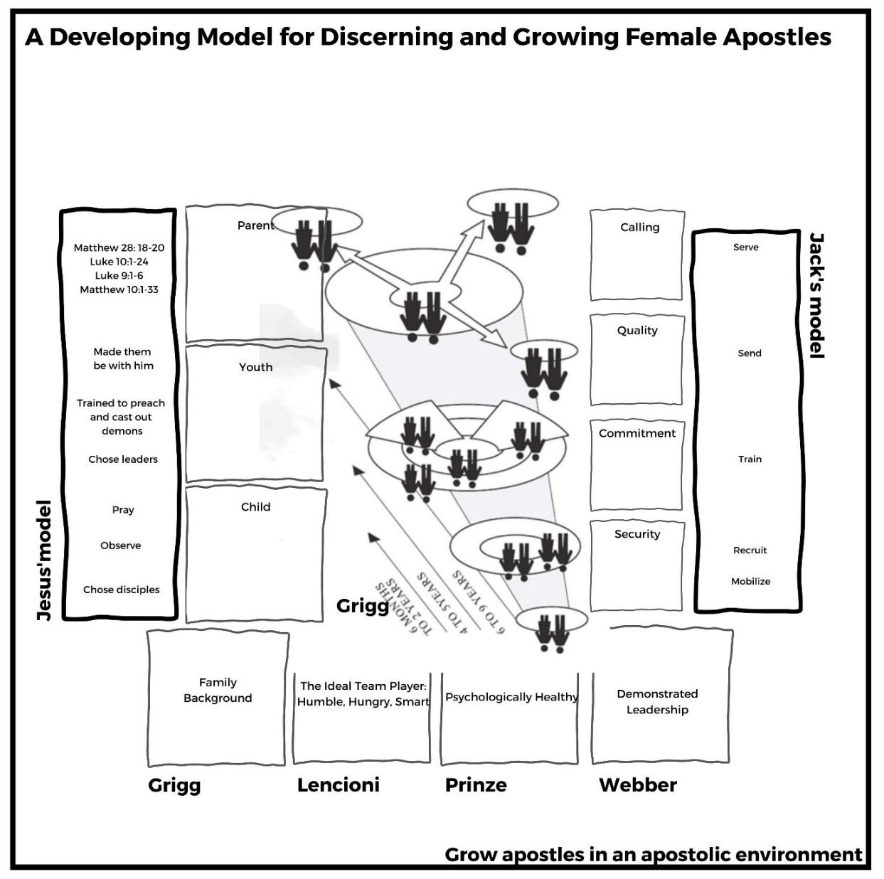

**Diagram 17: The final iteration of A Developing Model for Discerning Female Apostles Chart**

The apostle mentor creates incrementally more difficult training exercises to grow and prepare the budding apostle for a Parent Phase, Calling Stage and a fruitful life. This growth in phases and stages is measurable. I made a chart for these below:

|  |
| --- |
| **Themes from the Developing Model Diagram** |
| Foundations |
| Apostolic environment |
| Apostolic mentor initiative |
| The apostle calls, invites |
| Observation |
| Training: good content, context, method |
| Growth is incremental in phases and stages |
| One cannot become an apostle alone, the gift needs people to prune and shape it |

**Diagram 18: Themes from the Developing Model for Discerning and Growing Female Apostles.**

**Survey results**

Below are summaries of results of the survey to leaders in my mission organization. They explicitly deal with themes in discerning female apostles.

1. *What process would you use, or have you used, to discern a mature female apostle? Results from the people who responded “Yes” to Question 6.*

|  |  |
| --- | --- |
| **Process** | **Mentions** |
| Initiates, pioneers, has goals | 5 |
| Good character | 4 |
| They do signs and wonders | 4 |
| Planted churches, making disciples | 3 |
| They have a vision, call from God, visionary | 3 |
| Mature | 3 |
| Creative thinker | 3 |

**Diagram 19: Processes in discerning female apostles with the most mentions**

This is a summary of high scoring processes mentioned in survey responses from those who said they have identified a female apostle. There were many single responses. All are recorded in Annex 1. Frankly, all these processes seem valid. I would expect to see most of these developed traits in a female apostle. It’s interesting to note that initiating, signs & wonders and church planting rate high, but better still to see that good character and maturity is rated as important.

1. *Results from the people who responded “No” to Question 6.*

|  |  |
| --- | --- |
| **Process** | **Mentions** |
| Planting churches, making disciples | 5 |
| Producing fruit | 5 |
| They have a vision, call from God, visionary | 4 |
| Signs and wonders evident | 4 |
| They act on the vision, visionary | 3 |
| Good character | 3 |
| Strong prayer, worship relationship w God | 3 |
| Initiates, pioneers | 3 |

**Diagram 20: Processes in discerning female apostles with the most mentions form the “No” people**

The above chart is a summary of highest scoring mentions. There were many single responses. See Annex 1 for full details. I separated the results of respondents who claimed to have discerned a female apostle before from those who had not. The result is broader but also similar. Planting churches and producing fruit rate highest. Vision, signs & wonders also rated high. Other responses are also positive regarding effective missionary practice.

1. *What process would you use to discern a young or immature female apostle? Results from the people who responded “Yes” to Question 9.*

|  |  |
| --- | --- |
| **Proecess** | **Mentions** |
| They are brave, bold and take risks | 3 |
| Vision is strong | 3 |
| The implement and initiate | 2 |
| Willing to go where others won’t | 2 |
| Deep Walk with God | 2 |
| Willing to experiment, out of comfort zone | 2 |
| They have a clear calling | 2 |

**Diagram 21: Processes in discerning female apostles with the most mentions from the “Yes” people**

The above chart is a summary of high scoring mentions. There were many single responses. See Annex 1 for full details. Again, a helpful list of responses adding to my understanding that discerning and growing an apostle is a multifaceted task. There are many bases to cover. Can we domesticate the DNA of apostles to create groves of them?

1. *Results from the people who responded “No” to Question 9.*

|  |  |
| --- | --- |
| **Process** | **Mentions** |
| Takes initiative | 3 |
| They have a clear calling | 2 |
| A natural leader | 2 |
| May look compulsive | 2 |
| Want to plant churches or disciple | 2 |
| Mentor and coach them | 2 |
| Develop their calling within ministry, start small | 2 |
| Growing prayer life and intimacy with Jesus | 2 |
| They must be discipled | 2 |
| Stretch their faith activities to grow in | 2 |
| They want to train leaders | 2 |

**Diagram 22: Processes in discerning female apostles with the most mentions**

Diagram 22 is a summary of high scoring mentions. There were many single responses. See Annex 1 for full details. This question produced a broad result, again. There were twenty-four categories of response. All scored low. Nothing conclusive or even outstanding on this list, they all seem to be good and reasonable.

1. *How could your discerning process in Question 9 be integrated with a recruitment process?*

|  |  |
| --- | --- |
| **Integration** | **Mentions** |
| Provide an internship, trial or training | 7 |
| Confirm good foundations -character & walk with God, leadership, growth | 6 |
| Confirm they already have ministry fruit | 6 |
| Check they initiated, started, birthed | 6 |
| Confirm they are humble to be mentored, teachable | 5 |

**Diagram 23: Most mentions on how to integrate discernment of a female apostles.**

**Process of Analysing of the Data**

**Analysis of Surveys**

Answers to questions 1 to 5 gave me a good feel of where people in my Mission Partners are at regarding understanding apostles. Most mission partners believe in contemporary apostles but only around eighty percent of respondents allow for female apostles. That was disturbing.

Many could identify by name women in ministry in the Bible but only twenty two percent could identify Junia as an apostle. They could accurately identify female apostolic workers in history and also those functioning in our organization. Those in the organization training team were most identified probably because they are well known to many Mission Partners.

**Challenges With Using the Survey Data**

There were a few challenges in dealing with the data collected. My survey data pool was small, with only twenty-eight respondents. Despite the small pool the amount of survey data was significant. I mentioned earlier that this was the messiest part of the research. Twenty-eight respondents who use different wording to say the same things, slightly different things or nuances of topics. I made categories of responses and I’m sure that I did not get this perfect. I’m confident, however, that the data was used well to help create a broad understanding.

Questions 6 to 9 relate to the discernment of female apostles by respondents. About a third of respondents confirmed that at some point they had discerned a female apostle. I separated their results from those who had never discerned a female apostle. Their responses, however, were much the same, there was nothing on either list of responses that I thought inappropriate or startlingly different.

Question 10 sought to integrate a discernment process with a recruiting process. Here finally I began to get more consistent responses. Survey data was summarized on Diagram 26a and 26b with explicit data from the interviews. If the data category matched the interview category the numbers of mentions were noted. These major themes came directly out of the data. The themes here have significant overlap. They could be condensed further. These are in no particular order.

**Further Analysis of Themes on the Apostolic Journey**

I planned for two different kinds of data from the interviews. I wanted to hear the stories of apostolic people and look for Themes in the Apostolic Journey. I expected to be able find numerous themes coming out of the interview. I was correct.

I also wanted to cover and deal with interviewees specifically on discerning female apostles, collate and count them as with the surveys to find the trending themes. This data was collated, with the same challenges mentioned regarding dealing with the survey data, into Diagram 26a and 26b, below. A comprehensive list of responses given by interviewees can be found in Annex 1, Diagram 32a and 32b.

From the interviews I have the data which I call Themes in the Apostolic Journey. This data is given in full in Diagram 24, below. This information is essential to understanding the formation of an apostle. So, while a little broader than my topic the themes extrapolated from interviews certainly impact discerning of female apostles. I expected that by taking the time to hear the stories of these apostles, common themes would appear and the serendipitous might occur. The list below is not in order. These themes are:

|  |
| --- |
| **Themes in the Apostolic Journey** |
| Apostleship is a growing process  Affirmation, mentors and peers  Apostolic environment is crucial  Overcoming cultural hurdles to apostleship  Naming it: using the term apostle is difficult  Poor definitions and poor role models  A broader definition of apostle  Early indicators  Signs along the way  Seen Jesus?  Apostles have vision and calling  Apostles set up structures  Apostles suffer  Differences between men and women apostles  Training environment is crucial  Husbands and wives  Women can do it alone  Intentionality in mobilization of women  Women can get wounded on the way  Sliding gifts  Family background determines success  Deep level development |

**Diagram 24: Themes in the Apostolic Journey**

In the course of the interviews some Themes on the Apostolic Journey stood out from the others. Why so? They stood out because they highlighted aspects of themes in ways unexpected. Hearing them articulated in an interview caused me to see their importance in a new light. The themes impact the discernment and growth of female apostles.

**The standout themes**

|  |
| --- |
| **Standout Themes in the Apostolic Journey** |
| A broader definition of apostle  Affirmation, mentors and peers  Apostolic environment is crucial  Husbands and wives  Women can do it alone  Intentionality in regard to women  Women can get wounded along the way  Sliding gifts  Family background determines success  Deep level development |

**Diagram 25: Standout Themes in the Apostolic Journey**

I have written about the Themes in the Apostolic Journey above. Some Themes in the Apostolic Journey stood out from the others. This does not mean the others are less important, it merely means that they stood out in ways that I had not expected, adding greater depth to my understanding.

***Affirmation, Mentors, Peers***

I was reminded of the crucial role of affirmation, mentors and peers. All interviewees are apostles. Most had never been affirmed as an apostle in their Youth and Quality stages. Potima and Esther confessed that if I hadn’t affirmed them, they wouldn’t have dared to identify as apostles. Lorraine, in her seventies and functioning as apostolically for around fifty years, finally identified as an apostle after my interview with her.

On the flip side Jehu was affirmed as an apostle at around 20 and his apostolic ministry grew from there. Like Jehu I felt God has spoken to me clearly about apostleship in my teens. I shared that with a mentor who did not believe me. I learned two things, to keep my head down and to find my own way. How different my life could have been if that mentor put me track early in my life.

Affirmation must take place. Apostolic networks can play an important role in affirmation, providing peers and mentors. As Jehu stated above it behooves older apostles to be intentional in discerning and affirming our budding female apostles.

**Apostolic Environment.** Viv brought up the issue of the apostolic environment. When he said “You've got that team environment. That's really, really, really important” (Viv, p10) it brought startling self-awareness. This comment gave language to my training model in use over the last three years. And it is one of the reasons for my success in producing budding apostles. This resonated with my experience of training young female apostles.

The lack of apostolic training environment could explain, or be part of the explanation, as to why so few apostles are produced in the training systems of Christendom. Bible Schools are classroom based. Even The Nations Course and the School of Frontier Mission are classroom based. I’m not saying the above are bad. I am saying they are not producing the apostles as fruit because they are not a biblical model made to do so. The biblical model is to grow into an apostle, in an apostolic environment, with a mature apostle: a cultivated olive tree apostle in a grove.

***Husbands and Wives.*** I was reminded of the importance of synergistic husbands and wives together in apostolic ministry. The Aquilla who marries Priscilla will have to find his way differently to other men. Some wives may be content to be nameless or not part of the visible ministry. Some wives have giftings that need development. Reina and Junia reported affirmation from their husbands. Other husbands may unintentionally or even intentionally get in the way of their wife’s calling and gifting. Husbands and wives need to sort it out for themselves in good conscience before the Lord. Leaders need to be insightful and supportive.

***Women can do it Alone.*** Women can be apostles without a husband. A friend who attended my community presentation asked me if my husband and wives theme implied that women need to be married to be apostles. My short answer is no, not at all. Yet the reality is “mostly people get married. So, they're apostolic couples that you see rather than just women apostles” (Viv, p6). Bill knew a good number of single female catalysts-apostles.

***Intentionality Regarding Women.*** Intentionality is needed to mobilize women as movement-catalysts, as apostles. Reina and her organization have been very intentional about this. When women join missions what roles are they taking? What roles are they offered? What roles are they limited to? It’s been easy for us to mobilize women; it seems that God has been very intentional about providing women, as the majority of our internship recruits. But other organizations are not intentional. Others even stand in the way of women.

***Women can get Hurt Along the Way.*** Women can get hurt by significant others on the path to apostleship. Hurt by lack of affirmation. Hurt by denigrating attitudes and comments. Hurt by denigrating organizational rules. Hurt because “you can’t because you’re only a girl”. I was reminded that inner healing is needed by many. Repentance and apologies are in order.

***Sliding Gifts.*** Spiritual gifts and supernatural power are a theme in the life of an apostle. Viv reminded me that apostleship may, for want of a better term, *slide* from one Ephesians 4 ascension gift to another. David mentioned being a prophet before becoming an apostle. Viv said much along the same lines and that he still takes a prophet role from time to time. Paul was a teacher – prophet when he was sent in Acts 13:1-3. He is specifically named as an apostle for the first time in Acts 14:4. This is a potential PhD topic for someone.

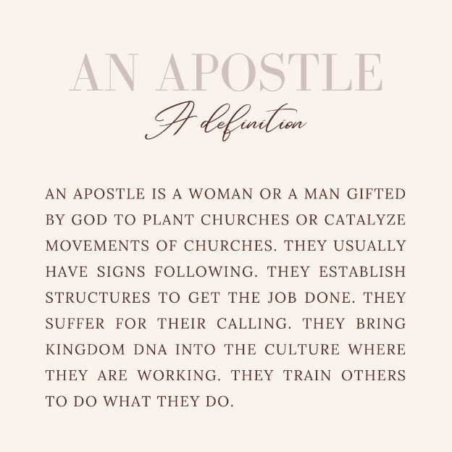***Family Background.*** Viv explained that “family background, my future is predicted by my family history” (Viv, p8) as we talked about foundations in the lives of budding apostles. This comment made me feel slapped across the face with a cold, dead fish. It’s so obvious that I missed it. Those from successful families can bring much with them, such as competence and confidence. On the flip side, those from less than ideal families have to overcome background to move forward. And they do. The theme of family background crosses over into the theme of good foundations.

***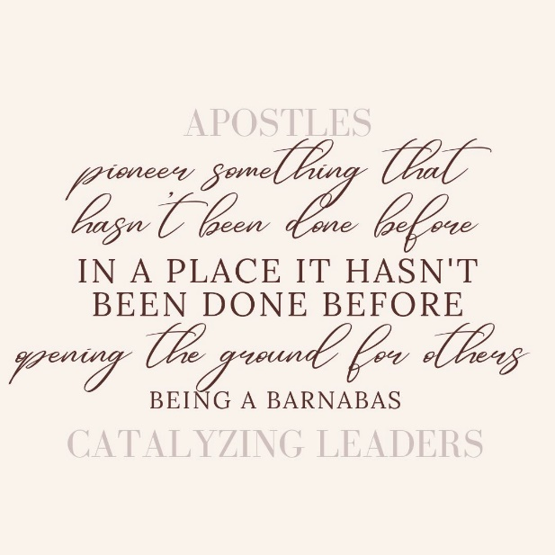*A Broader Definition of Apostle.** As I talked with the apostles about what an apostle does, I sat in the effulgence of wisdom so see a broader definition of apostle. Taking from the interviewed I would now add another sentence to my definition of an apostle: “Apostles pioneer something that hasn’t been done before, opening the ground for others – being a Barnabas, catalysing leaders”.

***Deep Level Development.*** Are movement leaders prepared for the trials of apostleship? Have they navigated grief, pain and betrayal well to be emotionally, psychologically and spiritually healthy? Will they survive the trials?

Training in spirituality for the long haul is needed for all to preserve longevity in the field. In my experience the MATUL and The Nations Course provide some teaching on this. I am not aware of other courses providing similar training. I need to prepare my interns for this more though we have touched on it in our Personal Development Key Result Area, see Diagram 14.

**Integrating all the Data Together.**

I then collated the explicit data on discerning female apostles from the interviews. (The full version of these can be found in Annex 1, Diagrams 32a and 32b. The chart is spread over two pages). I then integrated the interview data with the survey data, data from my literature review and the Developing Model for Discerning and Growing Apostles. Finally, the data really took shape, there was going to be a clear result – I had begun to doubt it would happen!

|  |  |  |  |  |
| --- | --- | --- | --- | --- |
| **Themes** | **Interviews** | **Lit Review** | **Surveys** | **Total** |
| They work hard | 1 |  |  | 1 |
| Dislike status quo | 3 | 1 | 1 | 5 |
| Have encompassing vision | 3 | 3 | 3 | 9 |
| Creative in approach, strategy | 2 |  | 5 | 7 |
| Loyalty to effectiveness | 1 |  |  | 1 |
| Flexible | 2 |  |  | 2 |
| Ability to pivot | 1 |  |  | 1 |
| Innovative | 3 |  | 1 | 4 |
| Obey God not people | 5 | 1 |  | 6 |
| A leader | 6 | 1 | 3 | 9 |
| Adventurous | 2 |  | 1 | 3 |
| Willing to experiment | 1 | 2 |  | 3 |
| Initiative, pioneer | 6 | 2 | 5 | 13 |
| Leave all | 1 |  |  | 1 |
| Teachable/willing to learn/able to teach | 5 | 1 | 3 | 9 |
| Pest/irritating | 1 |  |  | 1 |
| Confident | 1 |  |  | 1 |
| Competent | 1 | 1 |  | 2 |
| Sense of responsibility |  | 2 |  | 2 |
| Interest in other cultures |  | 1 | 1 | 2 |
| Aptitude for language learning |  | 1 |  | 1 |
| Observe them |  | 1 |  | 1 |
| Mentor them |  |  | 5 | 5 |
| Release them |  |  | 1 | 1 |
| Affirm them |  |  | 1 | 1 |

**Diagram 26a: Themes in discerning female apostles explicitly from interviews, the literature review, communications with authors and surveys of members of my organization**

I was pleasantly surprised by this collation of data from four sources, namely, authors in my literature review, surveyed Mission Partners from my mission organization, the interviewed apostles and my extrapolations from Diagram 17, the Model.

Diagram 26a and 26b reflect much of what I assumed would a result. I expected that initiative and pioneering, clear calling, leadership, and creativity would be high in the list of themes in discerning female apostles.

I was taken by surprise with several of the other high scoring themes. Foundations came up repeatedly. In fact, looking at the full list a good number of the themes cross over into this theme. Similarly, I was surprised that boldness, not liking the status quo and having had some mentoring already scored well.

What does this indicate? If this data was Truth-infallible it may indicate that good foundations are integral to finding a budding apostle – one that will finish the race well. It also seems to indicate the kind of person we hope to find, one whom the Holy Spirit has been working on for some time who is concerned for the lost, tired of the status quo who are looking for or open to creative and innovative ways to reach them. Keep in mind that this is an exploratory research paper. In future I hope that someone will test and verify these findings with a much larger pool.

|  |  |  |  |  |
| --- | --- | --- | --- | --- |
| **Themes** | **Interviews** | **Lit Review** | **Surveys** | **Total** |
| Prophetic insight | 2 |  | 1 | 3 |
| Want to go where others dont | 3 |  | 2 | 5 |
| Catalyze change | 1 |  |  | 1 |
| Already ministering to the lost | 2 | 2 | 1 | 5 |
| Willing to suffer | 2 |  |  | 2 |
| Bold, brave, courageous, gritty | 4 | 2 | 4 | 10 |
| Has faith | 2 |  |  | 2 |
| Has supernatural ministry | 1 |  | 2 | 3 |
| Has humility | 1 | 1 |  | 2 |
| Calling | 2 | 3 | 4 | 9 |
| Good at building relationships | 1 |  |  | 1 |
| Willing to do it alone | 2 |  |  | 2 |
| Supernatural guidance | 1 |  |  | 1 |
| Persistance | 1 |  | 2 | 3 |
| Desire to church plant | 1 | 3 | 2 | 6 |
| Work with others, team | 2 |  |  | 2 |
| Works cross-culturally | 1 | 1 |  | 2 |
| Passionate | 2 |  |  | 2 |
| Good foundation (family, mental health, maturity) | 2 | 1 | 10 | 13 |
| Train others to do the same |  | 3 | 1 | 4 |
| They already have fruit |  | 2 |  | 2 |
| Ask them directly |  |  | 1 | 1 |
| Excited about opportunities |  |  |  |  |
| Kingdom structures made |  | 1 |  | 1 |
| Networking |  | 1 |  | 1 |

**Diagram 26b: Themes in discerning female apostles explicitly from interviews, the literature review, communications with authors and surveys of members of my organization**

It’s good to keep in mind a few matters regarding Diagram 26a and 26b. This list is descriptive, not prescriptive. It is also from the perspective of an outsider looking in, not an insider (the budding apostle) looking out. For an individual these themes in their lives will be influenced by age, setting, status, culture, and a plethora of other internal and external factors.

Upon reflection it would have been informative to research how the interviewed apostles viewed themselves. Perhaps giving them all a Myers-Briggs test would find commonalities.

Diagram 27 collates most-mentioned responses from Diagrams 26a and 26b. Frankly I am relieved at the result. It is better than I had hoped for. How so? *The results are so sensible!* Good foundations must come first and foremost. I had expected that a theme like supernatural activity would be a major theme, I am a Pentecostal after all. Yet among most mentions there is not a sign nor wonder in sight!

|  |  |
| --- | --- |
| **Theme** | **Mentions** |
| They have good foundations.  Demonstrate initiative and pioneer.  They are bold and gritty.  They have a clear calling.  They can teach and are teachable.  They demonstrate leadership.  They demonstrate creativity.  They desire to plant churches.  They are obedient to God.  They have had mentoring.  They are already ministering to the lost.  They want to go where others won’t.  They don’t like the status quo.  They are innovative. | 13  13  10  9  9  9  7  6  6  5  5  5  5  4 |

**Diagram 27: Integrated data from literature review, survey, and interviews explicitly on themes discerning in female apostles check this is the same as above.**

I then brought all my themes together in Diagram 28, below. There are forty-one themes in total, twenty-two were explicitly about discerning female apostles. The remaining nineteen are predominantly generic themes in apostolic discernment, growth, and development. This is quite a hodge-podge but there is a significant crossover among the three categories of themes.

|  |  |  |
| --- | --- | --- |
| **Literature review, survey, and interview data explicitly on themes related to discerning (female) apostles** | **Themes from the apostolic growth model, an adaptation of the Four Seasons Chart.** | **Themes On the Apostolic Journey** |
| *They have good foundations  *Demonstrate initiative and pioneer  *They are bold and gritty *They have a clear calling  *They can teach and are teachable  *They demonstrate leadership  *They demonstrate creativity  *They desire to plant churches  *They are obedient to God, not people  *They have had mentoring  *They are already ministering to the lost  *They want to go where others won’t  *They don’t like the status quo  *They are innovative | *Foundations  *Apostolic environment  *Initiative of apostolic mentor needed  *The apostle calls, invites  *Observation  *Training: good content, context, method  *Growth is measurable in stages and phases  *One cannot become an apostle alone, the gift needs people to shape it, prune it | *Apostleship is a growing process  *Overcoming cultural hurdles to apostleship  *Naming it  *Poor definitions and poor role models  *A broader definition of apostle  *Early indicators  *Signs along the way  *Seen Jesus?  *Apostles have vision and calling  *Apostles set up structures  *Apostles suffer  *Differences between men and women apostles  *Training environment is crucial  *Husbands and wives  *Intentionality in mobilization of women  *Women can get wounded  *Sliding gifts  *Family background determines success  *Deep level development |

**Diagram 28: The combined data. Forty-one themes in discerning female apostles**

**Literature Review**

I also collected data regarding movement-catalysts and apostles while writing my literature review. Authors made their little lists, and I added them to the big picture. I also had personal communication with some authors who gave me more data to work with. I faced similar challenges with this data as with the survey data. It was messy.

**A Major gap in my Research**

Only at the very end of my research did I realize that I missed a significant opportunity. My definition of apostle includes the line “They bring Kingdom DNA into the culture where they are working”.

The DNA I refer to comes from the apostle, through her teaching and example. This DNA grows into social transformation. I did not ask the interviewees questions about the social impact of their work and upon transformation of that culture. I missed it!

I come from pietistic roots. Transformation as an integral goal of a movement is new to me. I should have asked themes about intentionality in promoting transformation. I fear the interviewees have a pietistic-no social focus like me. Am I being judgmental? No. None of the apostles interviewed even hinted at social transformation as a theme of their work.

**Integrating the Themes into Something Useful**

Forty-one themes is rather unwieldly. I wanted to decrease the number of themes to make them easier to work with. I integrated the themes where there is significant crossover. In Diagram 29 below I have adapted Diagram 28 by allocating a number to each major theme. Doing this my total number of themes has decreased to twenty-three themes.

**Integrating the Themes Through Story**

There are any number of ways to integrate the twenty-three themes related to discerning and growing female apostles above. I’m going to do it through *story*. Why story? Each person, each potential recruit and budding apostle has a story. The interviewed apostles each had a vivid and rich story. As we pay attention to the details of the story of a recruit or budding female apostle, we should hear the themes through their story.

Below I have written out two simple narratives, one about a young apostle and another from a stuck, unfruitful apostle. These stories are composites of actual stories. In practice this integration method would come through making time with a prospective recruit or field worker to hear their story.

|  |  |  |
| --- | --- | --- |
| **Literature review, survey and interview data explicitly on themes related to discerning (female) apostles** | **Themes from the apostolic growth model, an adaptation of the Four Seasons Chart.** | **Themes On the Apostolic Journey** |
| *They have good foundations **1**  *Demonstrate initiative and pioneer **2**  *They are bold and gritty **3**  *They have a clear calling **4**  *They can teach and are teachable **5**  *They demonstrate leadership **6**  *They demonstrate creativity **7**  *They desire to plant churches **8**  *They are obedient to God, not people **9**  *They have had mentoring **10**  *They are already ministering to the lost **11**  *They want to go where others won’t **12**  *They don’t like the status quo **13**  *They are innovative **2** | *Foundations **1**  *Apostolic environment **14**  *Initiative of apostolic mentor needed **15**  *The apostle calls, invites **15**  *Observation **15**  *Training: good content, context, method **13**  *Growth is measurable in stages and phases **14**  *One cannot become an apostle alone, the gift needs people to shape it, prune it **14** | *Apostleship is a growing process **14**  *Overcoming cultural hurdles to apostleship **15**  *Naming it **15**  *Poor definitions and poor role models **15**  *A broader definition of apostle **15**  *Early indicators **16**  *Signs along the way **16**  *Seen Jesus? **16**  *Apostles have vision and calling **4**  *Apostles set up structures **17**  *Apostles suffer **18**  *Differences between men and women apostles **15**  *Training environment is crucial **14**  *Husbands and wives **19**  *Intentionality in mobilization of women **20**  *Women can get wounded **22**  *Sliding gifts **23**  *Family background determines success **1**  *Deep level development **14** |

**Diagram 29: The combined data. Forty-one themes in discerning female apostles integrated to become twenty-three.**

Listening intentionally for mention of the themes will give an interviewer a good picture of where the prospective recruit is at. Note that I have interpreted the story and added the numbered themes as they appear. If many themes appear during the story there is good hope that the prospective recruit or missionary is a budding apostle.

Other ideas are worth exploring. The recruit could be given the task of writing a guided autobiographical piece which would cover the themes. Or a checklist may prove helpful. Even a multiple-choice questionnaire may be helpful.

***Integrating Mia’s Story***

July 2017. Jack was at the Mission Summit in Chiangmai. A break, a time away with the likeminded. Excellent food, some refreshment, a pool and even the old prophet was there. Nice. It was lunch time. The tiny redhead in front of him in the lunch queue had an Aussie accent. That was clear as she talked to the woman in front of her. She looked about 13. Jack said hello and found out that she, Mia, was actually in her twenties. They had lunch together.

A chat revealed that Mia had strong foundations (1) with a strong, professional, and Christian family (1). She demonstrated good initiative to come to Thailand from Sydney to co-lead the Summit’s children’s program (2, 3, 5, 6, 7, 11, 12). Mia had done some Bible school and different types of ministry back in Sydney (1, 13). Jack warmed to Mia as she talked about hiking alone for days on end, alone (2, 3). She seemed like a solid kid.

What was her goal in coming? Mia said she was asking ministry leaders in Thailand for an internship, but none would have her (2, 12, 16). Jack wasted no time “Crikey mate! Come do one with us” (9, 20). He then went on to explain that his internships were helping people to become church planters in his Muslim majority country. Mia gave immediate buy in (9), planting churches had instant appeal (8). It seemed to Jack at the time that she hadn’t thought of that before, even though her call to serve was strong (1, 4, 16) since a small child.

The Applications Committee and a friend asked Mia (5, 9,13) to finish her nursing degree before they would process her application. A few years passed. Jack and Mia would share Whatsapp messages a few times a year, touching base, preparing for the internship. On arrival, Mia was immediately taken to a village where the team settled in a rural shack (3, 12, 14). They talked and trained around the campfire at night. By day they hiked and canoed. Jack, fat and slow up the hills, made Mia repeat The Red Thread narrative over and over again while he caught his breath (5, 14, 15). They made their way into families and shared Jesus as they could, prayed for the sick as often as they could and even distributed literature (2, 3, 6).

After some time, Jack noted that Mia had a freakishly large vocabulary in the national language. She dressed as requested, like a respectable Muslim woman (5, 14). Jack had to return to Australia. Mia went to work with Esther. Esther previously interned with Jack. She is a budding apostle. So now Mia had another mentor to deal with (5, 15). The synergy was tangible. Soon exciting testimonies of miracles came pouring over WhatsApp (16). Esther has a social program running as a platform into the community (17) and Mia added to that providing primary health care (17) to the poorly serviced village (2, 6, 7, 11).

Their work was progressing well. They needed more team members. They recruited Mara to assist them (2, 7, 17). They saw her willingness to serve but did not see till too late that unresolved trauma had left Mara damaged (1). Her foundations were poor but like the house on dry sand she looked good. The stress brought by Mara was terrible. Too much time later they asked her to leave the team, and she still continued to give them grief (14).

In all this Jack continued to encourage (15). He’d ridden this rodeo many times and had the hoof shaped bruises to prove it. “Keep moving forward in the love of God”, he said. In all this it was now clear to Jack, he knew again in his spirit that the Lord had entrusted him with another apostle. Awesome! He explained it to Mia – what it meant, what it didn’t mean. “No need to get a big head, just do the job” (14). And since then, she has been doing just that.

End note: As I have been editing this story this morning, I am in WhatsApp conversation with Mia. She and Esther left for the north at 2am. Their person of peace died suddenly. They have gone to raise him up in the name of Jesus. She just wrote “Every 30 seconds I check him to see if he has started moving yet” (Mia, personal communication, 2023). To me at least this indicates the faith of an apostle.

**Integrating Jack’s Story.** Ben, a mission leader, asked Dr Bill Smith to provide CPM training to a Southeast Asia based team (17) that was struggling. After five years in their Muslim community there was no CPM (8, 14) nor a single remaining house church. They were all discouraged and the team leader, Jack, was displaying symptoms of burn out. There was talk of a return to Australia.

Despite the discouragement and burn out Bill had reason to hope for this team and its leaders (2, 10, 11, 12, 13). Their foundations were good (1). Jack had seen Jesus twice, at 9 and 18, but only momentarily (16). Jack and Asha had heard from God at 18 that they were to be “church planters”, in Jack’s words, but God had said “apostle” (19). Jack learned quickly that even in Pentecostal circles one does not blithely claim apostleship. He and Asha just ran with the church planting story (8, 15, 16).

Life was not kind to Jack and Asha (10, 14) with the loss of several babies. They pressed on to be as prepared as they could for service. They did Bible school and cross-cultural training (13). They did stints in three Southeast Asian nations (2, 3, 4, 5, 6, 7, 8, 9).

They demonstrated good pioneering and leadership (2, 3, 4). Despite the lack of a CPM the team functioned well (14), and they seemed to enjoy one another. They experimented plenty and made lots of resources. They had done a secretive but large and bold DVD distribution (3, 6, 7). 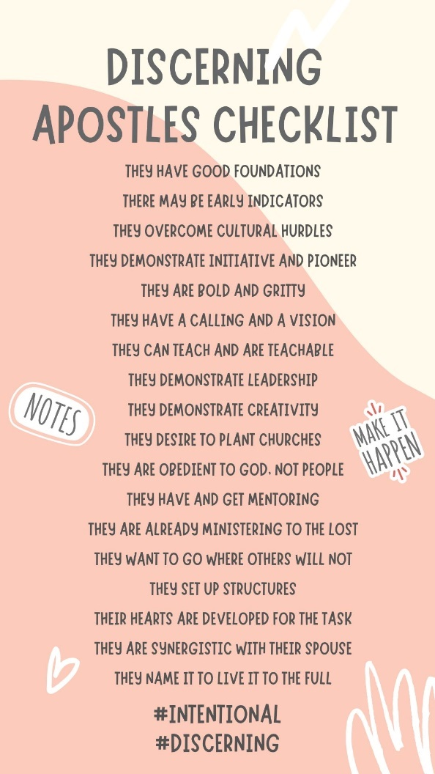Perhaps it was because of their military backgrounds or perhaps their fairly blunt ways of speaking. Whatever it was, Jack, Bill and Asha got along well. Emails, another visit, then Bill offered them an hour a week over Skype to mentor them and talk through issues (14, 15). This love and trust with Bill has been very significant in Jack and Asha’s life and walk with Jesus. He gave them time (14).

**Using the Themes**

I know these stories, and I know the people involved, consequently I have greater insight into the ongoing themes in their lives. In an interview or over coffee or a brief chat you may pick up on several themes. To go deeper will need more time and a variety of contexts may help as well.

**Diagram 30: A condensed checklist for discerning female apostles**

**Summing up my findings**

Through my research I came up with three categories of themes around discerning female apostles. I extracted themes from a survey of my organization’s Mission Partners, my Literature Review and several authors. I took data from explicit questions to those interviewed about discerning female apostles. In total I obtained 14 themes in discerning female apostles.

My missiological framework integrated several approaches to discerning and growing apostles. I gleaned my own themes from that integrated model. From this data I obtained eight themes in discerning female apostles.

I conducted interviews with eleven apostles. I uncovered nineteen generic themes through these life-giving conversations. See the checklist above.

In all I uncovered forty-one themes that may be helpful in discerning female apostles. There was considerable overlap between them. Attendees at one of my Focus Groups requested further editing. They requested a usable checklist of themes written as identifiers. This list drops the number of themes down to a much more manageable eighteen identifiers. This list appears above in Diagram 30.

My hope is that those themes can be used to help discern young and old female apostles and strengthen them in their journey. A mathematical formula, however, probably won’t help one find female apostles.

What is needed? The answer is a pithy story, a good yarn, a legend. In a narrative, the female disciple’s experience, calling, process and adventure with God is revealed. The Father has huge hands. His fingerprints over a woman’s life are not hard to see. A female’s apostleship can be discerned through her story and the themes are markers, headings and highlights in that narrative. By taking time to listen to a disciple and hear her story we can begin working through their life, *insyallah* discerning an apostle along the way.

**Developing it further**

To discern a female apostle their story must be clear. Consequently, I have devised a series of questions, arranged thematically to assist in the discernment process. Please see Annex 5, which has the questions presented in a written application form format. For the sake of the study, I have also added the numbers of the relevant themes to each section for clarity. These questions in this order could also be used for an informal or formal interview.

**One last iteration**

At the suggestion of someone in my community focus group I came up with several Discovery Bible Studies to assist leaders in the process of discerning female apostles. These are in Annex 6.

**Chapter 6:**

**Conclusion and Recommendations**

**Diagram 31: A Transformational Conversation**

This study is a transformational conversation. It’s a deviation and an invitation. I started this conversation with my own wild olive tree apostleship in hand, asking where the female apostles are. This thesis has provided forty-one themes in discerning them, which have been condensed further to eighteen identifiers.

I have engaged in a theological conversation which demonstrated that Junia was both female and an apostle. I exposed bias in Bible translation and the obfuscation of women leaders in history. I have hailed the Trinity as our Source and fired angry shots at Complementarians.

I have undertaken a missiological conversation working towards a realistic model to grow apostles. And from that model I extrapolated themes in discerning female apostles.

Interviews with eleven apostles uncovered many gems, constructive themes which can be used to assist in discerning female apostles. They also open many questions to be answered by further research (more on that below). The interviews provide a wholistic view of growing into an apostle.

I’ve engaged my mission community, my supporter base, my wife and friends as well as others to facilitate their involvement and development through my research process. I’ve seen three women identify as apostles through my influence. I’ve run worthy experiments which produce female apostles.

This conversation is a deviation. Typically, missionary books deal with testimony or merely that female apostles may possibly exist. Epp stopped dead at proclaiming Junia an apostle. She took it no further. This conversation has deviated from a theology or narrative to guiding women to find their way into apostleship. I’ve set women up for an adventure. And like Lucy in the forest Aslan will be their good guide even if they must walk alone for a while.

This transformational conversation is an invitation. This conversation is transformational because it opens multiple doors for research. This exploratory study, *insyallah*, will lay a foundation for inquiry for many related topics that will strengthen the missionary force and their effectiveness in Unreached People Groups, the urban poor, and megacities.

**In regard to Apostles in General**

Defining apostle through good teaching and solid living examples is required. Dent, Caldwell and Jack present reasonable definitions of apostle that is function centred, not authority centred. This seems to be a more accurate picture of a New Testament apostle. The fixation upon archetypal apostolic authority needs to be removed from the collective cultural understanding of Christians worldwide. It is a serious stumbling block to completing the Great Commission.

Establishing a universal minimal definition of apostle could be helpful. Movement has been defined. Should an apostle be defined, too? A definition may help deal with the flakes and deceivers. It may encourage the developing apostles. Apostleship was made for both sexes, it is not something unobtainable.

Is there a Christian culture apostle-archetype lurking in our subconscious? I think the answer is yes, and it appears he is not a pleasant fellow to deal with. Ten out of eleven interviewed apostles were very coy about their apostleship. Why is it considered pretentious to claim apostleship? It’s because, I believe, the archetype is more unrealizable, more untouchable than the risen Christ. Selah. *The archetype is not Truth.*

Could we reverse engineer Prinze’s work to assist with development of all apostles? I have heard, but have no sources to back up my claim, that Prinze trains people to work on their three weakest traits and competencies. Get coaching, whatever, just move forward on them. This will make the movement-catalyst more effective. That seems logical. Yet at this stage I cannot see how to use his valuable research to assist in the discernment phase.

If the problem is a lack of apostles, we need to devise some various worthy experiments in growing apostles in numbers, in groves. Church based structures could establish apostolic pathways through an apostolic environment within them. What mentoring and coaching can be provided? An apostolic sending hub? If you are a leader, be intentional about supporting the wild olive tree apostles God puts in your garden. How can you help them? Who can you network them with?

***In regard to Discerning Female Apostles***

The Bible and history support the existence and function of female apostles. Epp’s case is solid. And Barr revealing the intentional removal of women leaders from history or just making them an insipid caricature of who they were (Tea cake, anyone?) is a pattern that needs overturning. Could those old missionary books be re-researched and rewritten with ascension gift and gender inclusivity in the stories?

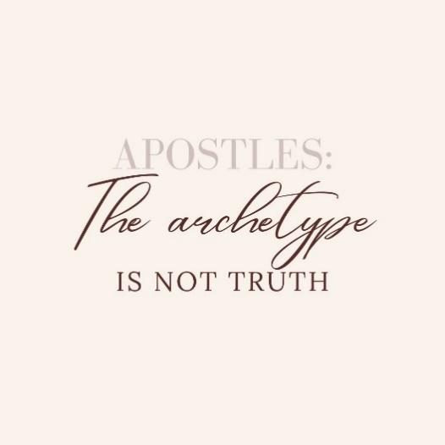Could we devise multifaceted testing for women apostles based on research? There are now 1965 (MF, Apr/Mar 23). movements in the world. There are many successful women catalysts in the available. Some research on a good pool of them could cover this need and many others.

Reconciliation is needed with wounded women. If you’re a leader and need to apologise for treating women in general or individuals poorly it’s never to late to apologise and make things right.

How are apostles bringing transformation? How does that work? Where is it happening? Why is it not happening? Do movement-catalysts have broader, social transformation movements on their radar? If they don’t, what training and vision casting can be provided? Jack has solid suggestions, please buy his book.

Dr Viv Grigg once challenged me. “Are you preaching the Good News of the Kingdom of God or the Good News of forgiveness of sins?” I had to confess that I’m proficient at the latter and growing from cluelessness in the former. The MATUL has helped me on my way to implementing the Kingdom. And now I need to learn how to, for want of a better term, structure DNA in the apostles whom I grow which will result in cultural transformation.

If you are an apostle, who needs to hear “Come follow me” from you? Who will you train? Mentor? And coach? Who will be your Elisha or Timothy? What network can you establish to strengthen the apostolic women around you?

Dismantle complementarianism. It looks and feels too much like Islam. It’s just not right. There is a better way. The Trinity demonstrates it for us every day.

**What Have I Learned From This Research?**

I’m grateful to God for being able to conduct this research. I have learned a lot. This research has confirmed much of what I practice already but has given me extensive insight into doing it more effectively.

This research has given me language for processes I was accessing but could not name in regard to a generic approach to discerning and growing apostles. The first key was to hear from all the apostles interviewed that the growing process is generic. And like Jesus with his apostles there is always a trajectory towards growth and effectiveness. Jesus takes the apostle on pilgrimage.

This research has taught me that discernment of female apostles is multifaceted and takes time. Using the themes I have articulated will assist in the discernment process. When faced with a mission recruit we can ask the right questions with the Holy Spirit’s help:

*“Wow. It’s clear that you have a call from God. But from what you’ve told me about your family background how about you get six months of counselling while doing some Bible training?”*

*“I think you’ve missed God’s point. It’s not about community development, it’s about establishing the Kingdom. You’ve preached up and down this province, you have DBS in six places and a function church in Banyu. My interpretation is that God has gifted you as an apostle – to establish movements – and though com-dev is important, it’s follow-up. Let the main thing be the main thing in your life. What is the main thing? The apostolic task!”*

*“There are not too many women, or men for that matter, who have a record of healing three lame people in the name of Jesus. And you use this to start DBS groups. Why is this happening with you? To me this an indication that you’re a budding apostle. Don’t get a big head about it. Keep quiet about it. But keep asking Jesus to release you more into the gift – not for your stinking pride but so the job gets finished in our generation, eh?”*

I’ve learned that regarding apostles, particularly female apostles, Christendom is a prisoner in cage of her own making. There is a lot of weird teaching out there. Like Lucy lost in the forest, female apostles will have to walk closely with Aslan to survive their calling among the faithful.

I’ve learned that the apostle is the ultimate team player. In my book (Jack, 2022) I note that the apostle is in the position of humility, the seed that falls into the ground and dies, the foundation, not seen nor admired, of a house. From this study I see that the work of the apostle is not the stand-alone cowboy but one who is successful because they create team and promote the leadership of others. Narcissists need not apply.

**The Impact of This Research Upon my Future Ministry**

God spoke to me in a dream during the Covid-19 pandemic lockdown in my country of service. In the dream I was in a hotel lobby, and I heard people talking of a tsunami that was coming in. The hotel was high and safe on coastal cliff. I decided to go down and watch the spectacle. As I walked through the lobby, I noticed two attractive young women. I said to myself out loud “I’m going to offer them an internship”. I then went outside, down onto the beach and sure enough a tsunami was on the way in. Since that dream the vast majority of our interns are women under thirty years old.

Through this research I’ve learned that coming up with a model of discerning and growing female apostles requires process and many iterations of process. I am still on a journey and reserve the right to experiment further, to fail forward, to grow.

This research confirms for me that my strategy of encouraging female led, female only apostolic teams, orders perhaps, has merit. Is this ideal? No. We need structures to free women to follow their calling without hindrance at a minimum.

This research confirms that God trusts me with the task of discerning and growing female apostles. I will keep my hands off the talent and do my best to bring them up right and upright!

This research confirms that I should leave organisational administration (I’m presently a field leader) and focus on recruiting, training and mentoring a generation of female and male apostles, as well as prophets and evangelists. Perhaps do this in the context of a Strategy Coordinator role for a UPG or two as well.

**Personal Challenges**

This study has been a significant leg in my journey, setting me up with further challenges and quests. I am a church planter, a movement catalyst, a late blooming apostle. I commenced the MATUL with the with the purpose of understanding the Kingdom of God - what to proclaim about it and how to establish it in my generation.

I need to learn how to grow those cultivated groves of apostles. This requires a structure - but how to develop that structure, the progressions and iterations, is not clear. I have learned a lot about discerning apostles through this study. This places me much closer to making my dream a reality.

This study has implications in regard to growing prophets and evangelists, other key players in the Great Commission. It seems the good foundations which I have articulated in this study are universal, for all leaders. Experimentation will be needed to find ways to grow cultivated groves of prophets and evangelists. Orchards are on the way!

**Photo 4: Mulan the Warrior (Disney, 2020).**

I will continue to discern, mobilize, train and send women. I’m already very intentional. God has trusted my wife and I with excellent women of quality. Like Fa Zhou, I put the sword into Mulan’s hands for her to launch into her destiny.

To complete the task I need others to join me in worthy experiments in growing groves of female and male apostles. How to do this? Frankly, I’m not sure. Publishing this thesis and writing articles will assist. Yet I see the need to develop a network of people, apostle trainers, around the world.

**General Recommendations**

I outline a number of general recommendations below in Diagram 32. These appear in no particular order.

|  |  |  |
| --- | --- | --- |
| **Recommendations** | **This is a Task for:** | **Expected result** |
| Marriages of missionaries need examination. | * Married missionaries * Mission agencies * Membercare ministries * The couples themselves | * More women in ministry * Happier marriages |
| Provide counsel & training for Aquila – men who’s wives who have outstanding ministry gifts | * Mission agencies * Membercare | * Aquila will be embraced rather than thought of as being inferior to his wife * More women in ministry |
| Training institutions need to be made or remade so that they produce female apostles. | * Bible schools * Mission training * YWAM bases * Sending hubs | * More APEST |
| Psychological testing tools need development to assist with discernment based upon the Themes in Discerning Female Apostles. | * Mission agencies working in conjunction with psychologists | * Greater clarity, more quickly for mission applicants and agencies |
| Write mission mobilization books which intentionally use and emphasize the themes. | * Publishing companies to commission biographies… Lotte Moon, without a tea cake emphasis! * Define apostle and other five-fold ministries in those books and use the term in regard to women. * My organisation could commission autobiographical stories from our female apostles and link them to the themes. | * Change mindsets, change paradigms, get more women into the roles to God has called them. |
| Create awareness of female apostles and women in leadership in general | * Mission agencies * Denominations * Christian schools * Churches, Elderships and deaconates * Collate good articles and exegeses of the |  |

**Diagram 32: General Recommendations**

**Recommendations for Further Studies**

This research is an exploratory study, a transformational conversation about themes in discerning female apostles. An exploratory study opens the way for more research. Please consider a doctorate

* that effectively redoes this research with a way broader field of data.
* on mobilizing, recruiting, training, sending and serving female apostles.
* on apostles leading by influence rather than authority.
* on limitations, scope and use of apostolic authority.
* on the authoritative apostle as an archetype.
* of the transformational impact of apostles in known movements.

***Afterword***

You are very diligent to have read this far. I’m impressed! If you would like to communicate with me regarding this topic, please feel free to do so. Perhaps we can assist each other in worthy experiments which will help us complete the Great Commission.

If in good conscience you cannot accept my Trinitarian and Continuist assumptions worked out to their logical extreme – having female apostles – I will not quarrel with you, ever. Asha and I will continue to grow female and male apostles. It’s integral to our calling and gifting. I will, however, leave you with a sweet memory. Here is the recipe (IMB, 2023) for Lottie Moon’s delicious tea cake.

***Plain Tea Cake***

3 teacups of sugar

1 teacup of butter

1 teacup of sour milk

4 pints flour

3 eggs, well beaten

1/2 teaspoon of soda

Flavor to taste, roll thin, bake in a quick oven.

God bless you all



Edward Jack

edward.jack@mm.st

Southeast Asia

September 2023

**Bibliography**

Addison, S. (2015). *Pioneering Movements: Leadership That Multiplies Disciples and Churches*. InterVarsity Press

Barr, B. A. (2022). *The Making of Biblical Womanhood. How the Subjugation of Woman Became Gospel Truth*. Brazos Press on Kindle.

Becker, J et al. (2019). *Fruitful Practices: A Guide for Learning from the Best Practices of Church Planters in the Muslim world*. Fruitful Practices Research

Booth, W. (1890). *In Darkest England and the Way Out*. Salvation Army.

Borland, J. (1991). Women in the Life and Teachings of Jesus. *SOR Faculty Publications and Presentations*, Jan. <https://digitalcommons.liberty.edu/sor_fac_pubs/110>.

Bruce, A. B. (2007). *The Training of the Twelve*. Cosimo, Inc.

Buckner, T. (2016). 21st Century Women Apostles: Answering the Call. Kindle

Burer, M. H. and Wallace, D.B. (2001). Was Junia Really an Apostle? A Re-Examination of Rom 16.7. *New Testament Studies*, vol. 47, no. 1, Jan. <https://doi.org/10.1017/S0028688501000066>.

CBMW. (2014). A Female Apostle. *The Council of Biblical Manhood and Womanhood*. Uploaded 18-09-2014. http://cbmw.org/uncategorized/a-female-apostle/

Clark, C. A. (2018). Exploring the True Identity of Junia: Prominent among the Apostles. *Journal of Early Christian History*, vol. 8, no. 3, Sept, pp. 96–106, <https://doi.org/10.1080/2222582X.2019.1585894>.

Caldwell, L.W. (1992). *Sent Out! Reclaiming the Spiritual Gift of Apostleship for Missionaries and Churches Today*. William Carey Library

Cook, J. (2008). 1 Cor 9,5: The Women of the Apostles. *Biblica*, vol. 89, no. 3, <https://www.jstor.org/stable/42614840>.

Damsteegt, P. (2000). *Shapes of Ministry in the New Testament*. Andrews University. <https://www.andrews.edu/~damsteeg/ministry_in_the_nt.pdf>

Danielson, R. (2021). Women Church Planters in the Early Work of The Church of God in Christ: The Case of the Singing Twins, Reatha and Leatha Morris. *The Asbury Journal 76:1/ 61-81.* Asbury Theological Seminary.

Dent, D. (2019). *The Ongoing Role of Apostles in Missions: The Forgotten Foundation*. WestBow Press. Kindle

Dzubinski, L.M. and Stasson, A. H. (2023) Chinese Women Led the 20th Century Revivalist Movements Missions Frontiers, Issue 45:2, MAR/APR 2023

Epp, E. (2005). *Junia: The First Woman Apostle*. Augsberg Fortress Press. Kindle.

Fellows, Richard G. (2022). Early Sexist Textual Variants, and Claims That Prisca, Junia, and Julia Were Men. *The Catholic Biblical Quarterly*, vol. 84, no. 2. Found at: <https://doi.org/10.1353/cbq.2022.0046>.

Foppen, A, et al. (2017). Personality Traits of Church Planters in Europe. *Journal of Empirical Theology*, vol. 30, no. 1, June. Found at <https://doi.org/10.1163/15709256-12341349>.

# Glorious Church. (8 August 2017). *TL & Daisy Osborn - God's Husband - Wife Team 01.* Found at: https://www.youtube.com/watch?v=Kr-ahJrmo1U

Griffiths, M.C. (1985). Today’s Missionary, Today’s Apostle. *EMQ*. April 1985, pp 158 – 165

Grigg, V. (2014). *Companion to the Poor*. Authentic media

Hamilton, M. (2022*).* Junia as a Female Apostle in Romans 16:7: A Literature Review of Relevant Sources from 2010 to Present. Liberty University. *Eleutheria,* Vol 6, Issue No 1, Article 5. Found at <https://digitalcommons.liberty.edu/cgi/viewcontent.cgi?article=1235&context=eleu>

Hutson, C. R. (2012). Laborers in the Lord. Romans 16 and Women in the Pauline Churches. *Leaven*: Vol. 4: Iss. 2, Article 9. Available at <http://digitalcommons.pepperdine.edu/leaven/vol4/iss2/9>

Hylen, S. (2015). *A Modest Apostle: Thecla and the History of Women in the Early Church*. Oxford University Press

International Mission Board. (2023). Who was Lottie Moon? Found at <https://www.imb.org/about/lottie-moon/>

International Mission Board Store. (2023). Downloadable Lottie Moon Photo and information Flier. Found at

<https://store.imb.org/downloadable-lottie-moon-photo-and-information-flier/>

Kateusz, A. (2019). Women Apostles: Preachers and Baptizers. *Mary and Early Christian Women: Hidden Leadership*, Springer International Publishing. Found at <https://doi.org/10.1007/978-3-030-11111-3_3>.

Jack, E. (2022). *A Guide For Growing Prophets, Evangelists and Apostles*. Kindle.

Kim, H. (2009). Church Planters Perception on Church Planting Education. *Great Commission research Journal.* *Vol. 1, No. 1,* Summer

Langford, J. (2017). Feminism and Leadership in the Pentecostal Movement. *Feminist Theology*, vol. 26, no. 1, Sept. <https://doi.org/10.1177/0966735017714402>.

Lathrop, J. (2008). *Apostles, Prophets, Evangelists, Pastors, and Teachers Then and Now*. Xulon Press

Lewis, C.S. (1998) Prince Caspian. Kindle.

## Lencioni, P. (2016). *The Ideal team Player: How to recognize and Cultivate The Three Essential Virtues.* Wiley.

Lin, Y. (2020) Junia: An Apostle before Paul. *Journal of Biblical Literature*, vol. 139, no. 1, Mar. Found at: https://doi.org/10.15699/jbl.1391.2020.10.

Livingstone, G. (n.d.) Apostolic Mission in the Muslim World. Found at: <https://docslib.org/doc/6476135/the-apostolic-mission-in-the-muslim-world>

MacArthur, J. (2006). *Twelve Ordinary Men: How the Master Shaped His Disciples for Greatness, and What He Wants to Do with You*. Thomas Nelson

Mimms, N. (2023). Strategy Coordinator – The Outside Catalyst. *Mission Frontiers*. Issue 44:6 NOV/DEC 2022 pp 17 - 19

Parks, S. (2023). Learning from Paul About the Mindsets of Movement Catalysts. *Mission Frontiers*. Issue 44:6 NOV/DEC 2022 pp 40 - 43

Pullinger, J. & Quicke, A. (1980). *Chasing the Dragon: One Woman’s Struggle Against the Darkness of Hong Kong’s Drug Dens*. Goodreads.

Moffett, E. (1995). Betsey Stockton: Pioneer American Missionary. *International Bulletin of Missionary Research*, vol. 19, no. 2, Apr. Found at: https://doi.org/10.1177/239693939501900205

Naiker, B. (2008) *Apostles*. Lumiere. ISBN: 9780955841200

Pateman, A. (2012). *APOSTLES: Can the Church Survive Without Them.* APMI Publications. Kindle.

Porterfield, S. (2022). *God Sent Me: A Woman Missionary in the Jungle*. Kindle.

Prinze, E. (2022). Movement Catalysts: Profile of an Apostolic Leader. Kindle.

Quek, S.Y. (2005). Cessation of the Apostolic and Prophetic Ministries. Far Eastern Bible College. Singapore. Found at: <https://www.febc.edu.sg/assets/pdfs/Charismatism/Cessation%20of%20the%20Apostolic%20and%20Prophetic%20Ministries.pdf>

Resane, K. (2016). The New Apostolic Reformation: The Critical Reflections of the Ecclesiology of Charles Peter Wagner. *HTS Teologiese Studies / Theological Studies*, vol. 72, no. 3, Aug. Found at: <https://www.ajol.info/index.php/hts/article/view/142327>.

Richardson, P. (1986). From Apostles to Romans 16 and the of Women in the Early Church. *Toronto Journal of Theology*, vol. 2, no. 2, Sept. Found at: <https://doi.org/10.3138/tjt.2.2.232>.

Schulz, R.R. (1987). Romans 16:7: Junia or Junias? *The Expository Times*, 98, No 4, Jan 1987.

Smith, P. (2006). The Story of Asenath Brewster: Pioneer in Urban Missions and Mentor of Southern Baptist Leaders. *Baptist History and Heritage*, Vol. 41, No. 1, Jan. 2006, pp. 102–14,

<https://go.gale.com/ps/i.do?p=AONE&sw=w&issn=00055719&v=2.1&it=r&id=GALE%7CA146344622&sid=googleScholar&linkaccess=abs>.

Stetzer, E. (2010). *Viral Churches: Helping Church Planters Become Movement Makers*. John Wiley & Sons

Tucker, R. (1987). *Daughters of the Church: Woman and Ministry from New Testament Times to the Present*. Zondervan

Tucker, R. (2004). *From Jerusalem to Irian Jaya: A Biographical History of Christian Missions*. Second Edition. Zondervan

Vermont, B. (2020). The strategic Role of Married Female Expatriate Missionaries in Muslim Majority Communities. SATS.

Vyhmeister, N. (2013). Junia the Apostle. Memory, Meaning & Faith. 115. Found at <https://digitalcommons.andrews.edu/mml/115>

Wagner, C. P. (1998). [*The New Apostolic Churches*](http://www.urbanleaders.org/620Leadership/92Readings/articles/Wagner-New%20Apostolic%20Churches.pdf)*.* Ventura, California, Regal

Wagner, C. P. (2012). *Apostles Today: Biblical Government for Biblical Power.* Amazon

Webber, M. (2014). How to Identify High-Potential Emerging Leaders. The Leader Development Consultation. Found at https://www.youtube.com/watch?v=I5jFlWP2tmk&t=3s

Williams, T. (2022). *Why Women can be Apostles, Prophets, Evangelists, Pastors, and Teachers: The Biblical Proof Text for why Women can receive the Ascension Gifts of Ephesians 4:11) and be called to the Five-fold Ministry.* Kindle.

Wijaya, E. (2019) Pragmatisme Kepemimpinan Debora Bagi Kepemimpinan Wanita Kristen Di Masa Kini.” *HARVESTER: Jurnal Teologi Dan Kepemimpinan Kristen*, vol. 4, no. 2. Found at <https://doi.org/10.52104/harvester.v4i2.17>.

Womack, W. (2008). Contesting Indigenous and Female Authority in the Burma Baptist Mission: the case of Ellen Mason. *Women's History Review*, 17:4, 543 — 559.

**Photos**

Photo 1: This is a personal photo from 2021.

Photo 2: Scrum photo’s publishing information unclear. Found at:

<https://i.pinimg.com/736x/50/e7/2f/50e72f160ec293bd070e009ecc57fec9.jpg>

Photo 3: Shepherd, J. (2016, October 20). *Future in good hands.* Examiner Newspapers Perth. <https://www.yourlocalexaminer.com.au/future-good-hands/>

Photo 4: Disney. (2020). Mulan. Source: <https://image.tmdb.org/t/p/original/8qGnUPWVKO2yJkfpeo1AmRV3WmD.jpg>

**Annexes**

**Annex 1**

**Collated data**

**Survey Results**

I emailed a Microsoft Forms based survey to 101 leaders in my missionary organization. Only twenty-eight responded in the allowed time frame. The survey was anonymous. This survey was designed to reveal the opinions and practices of my organization’s leaders in regard to the topic themes in discerning female apostles.

Below is an answer by description of survey results.

1. *Does your theology allow for present day apostles?*

Twenty six of twenty-eight respondents have theology that allows for present day apostles.

1. *Does your theology allow for female apostles?*

Twenty three of twenty-eight agreed. Five did not.

1. *Please list female apostles in Scripture*

|  |  |
| --- | --- |
| **Character** | **Mentions** |
| Priscilla | 11 |
| Lydia | 6 |
| Junia | 13 |
| Deborah | 6 |
| Potima | 2 |
| Mary Magdalena | 5 |
| None | 4 |
| Joanna | 1 |
| Suzanna | 1 |
| Phoebe | 2 |
| Nympha | 1 |

Around half of respondents mentioned Junia, the only named female apostle in the New Testament. Priscilla rated quite well also.

It’s interesting that Deborah even rated at all. And it’s disturbing that 8%, a small percentage, said none at all.

1. *Please list females in history who have worked apostolically.*

|  |  |
| --- | --- |
| **Character** | **Mentions** |
| Jackie Pullinger | 4 |
| Heidi Baker | 6 |
| They exist, don’t know their names | 2 |
| Any sent woman | 2 |
| Lillias Trotter | 3 |
| Lotte Moon | 4 |
| Catherine Booth | 3 |
| Mother Theresa | 5 |
| Hellen Keller | 1 |
| Elizabeth Elliot | 3 |
| Gladys Aylward | 2 |
| Amy Carmichael | 7 |
| Isobel Kuhn | 1 |
| Ellen Mason | 1 |
| Leilia Lewis | 1 |
| Mary Slessor | 1 |
| Lorraine Dierck | 1 |
| Pandita Rama Bai | 1 |
| None | 3 |
| New Testament women | 2 |
| Sojourner Truth | 1 |
| Bobbie Houston | 1 |
| Bertha of Canterbury | 1 |
| Aimee Semple McPherson | 2 |
| Perpetua | 1 |
| Clare of Assisi | 1 |
| Fanny Crosby | 1 |
| Paulina Clamini | 1 |
| Florence Nightingale | 1 |
| Priscilla Shirer | 1 |
| Kathryn Khulman | 1 |

These answers were more pleasing than the previous question. Pullinger, Baker, Trotter, Moon are widely accepted as apostolic. Some listed here are women well known in ministry such as Houston. St Theresa, perhaps. The mention of Helen Keller had me choking on my morning coffee. “What?”

1. *Please list females in our mission organization who work (or have worked) apostolically.*

|  |  |
| --- | --- |
| **WO worker** | **Mentions** |
| MK | 8 |
| N&J | 2 |
| LF | 5 |
| AJ | 12 |
| ML | 4 |
| MP | 1 |
| ID | 3 |
| Lorraine Dierck | 16 |
| MG | 1 |
| WT | 3 |
| A | 2 |
| SS | 4 |
| MW | 7 |
| LDF | 1 |
| CS | 1 |
| TL | 1 |
| LH | 1 |
| BC | 1 |
| VC | 1 |
| RB | 3 |
| SF | 2 |
| ME | 1 |
| PJ | 2 |
| NK | 1 |
| VB | 1 |
| RB | 1 |
| LB | 1 |
| AM | 1 |
| S | 1 |

It took me some time to understand the resulting numbers of the respondents to this question. Names have been obscured for security reasons. To date MK is our most effective female apostle with a movement of thousands. Sadly, she could not be interviewed. N&J are probably our most prominent experimenters with contextualization. Why did Lorraine, AJ and WT score well? Because they teach our pre-field course, and *everybody knows* and loves them. Their ministries and gifts are common knowledge in the organization.

1. *Have you ever discerned a female apostle under your leadership?*

Yes 10. No 18.

I was pleased with this answer because it means some respondents are aware of female apostles and have devised their own criteria (articulated and unarticulated) for a discernment process. Around two thirds had not ever discerned a female apostle – sadly, there was no option in my questioning to explain why.

1. *What process would you use, or have you used to discern a mature female apostle?*

*Results from the people who responded “Yes” to Question 6.*

|  |  |
| --- | --- |
| **Process** | **Mentions** |
| Mature | 3 |
| Good character | 4 |
| Planted churches, making disciples | 3 |
| Fruit remains over time | 1 |
| They have a vision or call from God, visionary | 3 |
| They do signs and wonders | 4 |
| Initiates, pioneers, has goals | 5 |
| They persevere | 1 |
| Large calling | 1 |
| Causing others to walk in their gifting | 1 |
| Creative thinker | 2 |
| Discipled by someone | 1 |
| Affirmed by others or prophecy | 1 |
| Socially confident | 1 |
| Strong prayer, worship, relationship w God | 1 |
| Can hear God | 1 |
| Possibility thinker | 1 |

1. *Results from the people who responded “No” to Question 6.*

|  |  |
| --- | --- |
| They have a vision or call from God | 4 |
| They act on the vision, visionary | 3 |
| They face their fears | 1 |
| They lead others | 1 |
| Observable gifting | 2 |
| Good character | 3 |
| Producing fruit | 5 |
| Strong prayer, worship, relationship w God | 3 |
| Loving | 1 |
| Rooted in Scripture | 1 |
| Humility | 1 |
| Initiates, pioneers | 3 |
| Movement orientation | 2 |
| Reproducing self | 2 |
| Releasing others | 2 |
| Signs and wonders evident | 4 |
| Perseverance (in work, suffering, persecution) | 2 |
| Theology of suffering | 2 |
| Strategic thinking | 1 |
| Unhappy with status quo | 1 |
| Planting churches, making disciples | 5 |
| Authority used to build church | 1 |
| Affirmed by leaders | 2 |
| Intimate with Jesus | 1 |
| Interview | 1 |
| Observe them in field | 1 |
| Established Kingdom structures | 1 |
| Knowledge of Scripture | 1 |

1. *What process would you use to discern a young or immature female apostle?*

*Results from the people who responded “Yes” to Question 9.*

|  |  |
| --- | --- |
| **Process** | **Mentions** |
| They are brave bold and take risks | 3 |
| They have new ideas | 1 |
| They have new directions | 1 |
| They implement and initiate | 2 |
| They have some leadership experience | 1 |
| They are evangelistic | 1 |
| Willing to go where others don’t go | 2 |
| Deep walk with God | 2 |
| Teachable | 1 |
| Seeks help | 1 |
| Outside of comfort zone | 1 |
| Willing to experiment, out of comfort zone | 2 |
| Observe them | 1 |
| Ask them | 1 |
| Mentor | 1 |
| Release | 1 |
| They have a clear calling | 2 |
| They make many mistakes | 1 |
| Vision is strong | 3 |
| Some may have plans but be too timid | 1 |
| Those excited about ministry opportunities | 1 |
| Want to move on to the next thing before the last thing is strong | 1 |
| Annoying | 1 |
| Socially capable | 1 |
| Faithful | 1 |

1. *Results from the people who responded “No” to Question 9.*

|  |  |
| --- | --- |
| **Process** | **Mentions** |
| They have a clear calling | 2 |
| They influence others | 1 |
| A natural leader | 2 |
| They hear from God | 1 |
| Takes initiative | 3 |
| May look compulsive | 2 |
| Want to plant churches or disciple | 2 |
| Teachable | 1 |
| Some signs and wonders | 1 |
| Curious | 1 |
| Dissatisfied with the status quo | 1 |
| Affirm their calling | 1 |
| Mentor and coach them | 2 |
| Develop their calling within ministry, start small | 2 |
| Signs follow them | 1 |
| They are annoying | 1 |
| Growing prayer life and intimacy with Jesus | 2 |
| Have a heart to travel | 1 |
| Cast vision for them | 1 |
| They must be discipled | 2 |
| Develop out of the box thinking | 1 |
| Promote character forming situations | 1 |
| Stretch their faith activities to grow in | 2 |
| They want to train leaders | 2 |
| They want to change culture | 1 |
| Look at what they are doing now… for clues | 1 |
| Socially capable | 1 |

1. *How could your discerning process in Question 9 be integrated with a recruitment process?*

|  |  |
| --- | --- |
| **Integration** | **Mentions** |
| Talk with them to discern gifting | 3 |
| Grow sons and daughters | 1 |
| Check they initiated, started, birthed | 6 |
| Cast them vision | 3 |
| Take time to get to know them | 2 |
| Put them in a team for a time | 1 |
| Identify if they have confidence, passion | 3 |
| Identify they have a calling | 3 |
| Confirm good foundations -character & walk with God, leadership, growth | 6 |
| Confirm they already have ministry fruit | 6 |
| Confirm they are interested in UPG | 2 |
| Confirm they already have supernatural ministry | 2 |
| Provide an internship,mm trial or training | 7 |
| Recruit and let them function | 1 |
| Provide a place to be free and thrive | 1 |
| Confirm they are humble to be mentored, teachable | 5 |
| Seek pastoral recommendations | 1 |
| Provide written criteria for recruitment purposes | 1 |
| Check have long and quality commitment in the process | 1 |

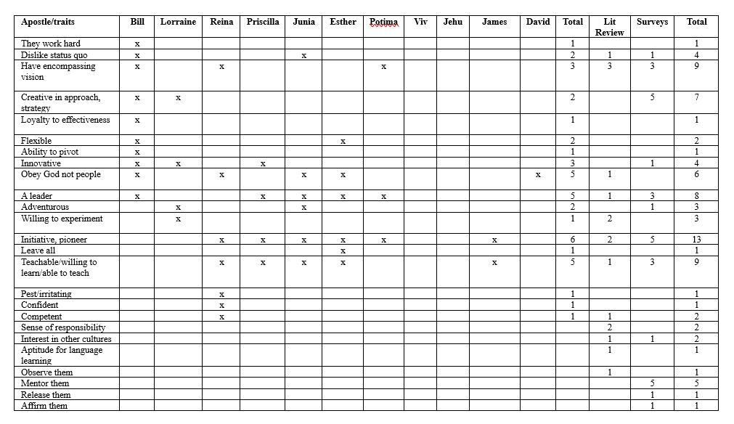

**Diagram 32a: A total collation of data on Themes in Discerning Female Apostles from surveys, literature review and communications with authors, and explicit data from interviews.**

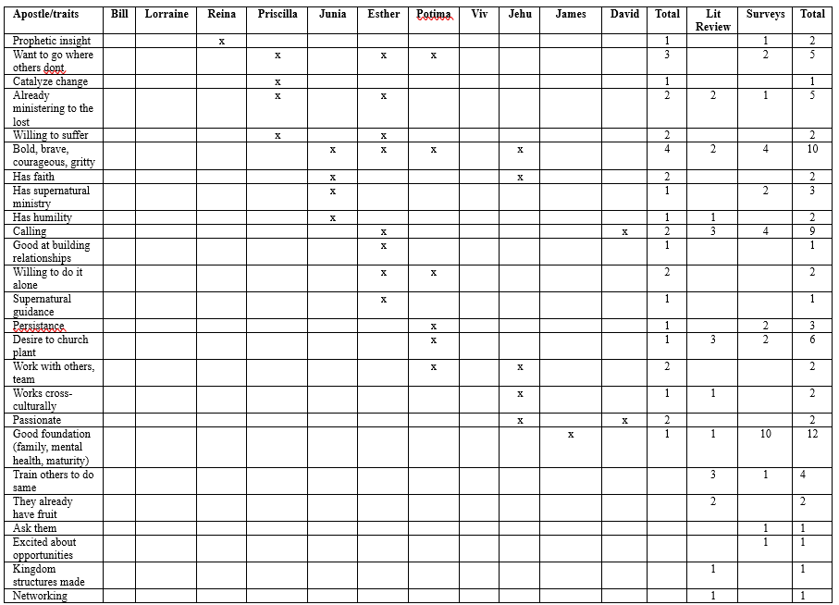

**Diagram 32b: A total collation of data on Themes in Discerning Female Apostles from surveys, literature review and communications with authors, and explicit data from interviews.**

**Annex 2: Ethics Approval**

Ethics approval was given by WCIU.

**Annex 3: Survey, Interview and Community Focus Group Questions**

1. Interview questions

Interview questions for apostolic women and men.  
  
You were asked to participate in this research because I have identified you as an apostolic worker. Here is my definition so you can see how you fit. “An apostle is a woman, or a man gifted by God to plant churches or catalyze movements or churches. They usually have signs following. They establish structures to get the job done. They suffer for their calling. They bring Kingdom DNA into the culture where they are working They train others to do what they do.”

* 1. Please describe the evolution or growth of your life and ministry till now.
  2. What have been key moments, epiphanies, or revelations in your personal and spiritual development?
  3. Describe some key signs, wonders and miracles God has given you.
  4. Have you had personal revelations from Jesus? If yes, please describe.
  5. Do you identify as an apostle? If yes, how did you come to identify as an apostle? What was your process?
  6. What gifts or qualities associated with being an apostle do you see in yourself or have others observed in you?
  7. What role did others play in discerning your apostleship?
  8. What gifts or qualities associated with being an apostle do you see in yourself or have others observed in you?
  9. In what ways have you suffered because of this calling?
  10. Which biblical leaders do you identify with and in what ways?
  11. How did your background (religion/church/org) influence your identification as an apostle?
  12. Who are your female apostle role models?
  13. What differences and similarities are there between female and male apostles?
  14. What processes do you suggest to discern female apostles? How would you identify a woman as an apostle?
  15. What specific training(s) would you recommend for budding women apostles?
  16. What is the time span and process between identification as an apostle and apostolic fruit?

1. Questions for the written survey

World Outreach leaders were surveyed in regard to the topic. The questions were:

1. Does your theology allow for present day apostles?
2. Does your theology allow for female apostles?
3. Please list female apostles in Scripture.
4. Please list females in history who have worked apostolically.
5. Please list females in WOI who work (or have worked) apostolically.
6. Have you ever discerned a female apostle under your leadership?
7. What process would you use to discern a mature female apostle?
8. What process would you use to discern a young or immature female apostle?
9. How could your discerning process in Question 8 be integrated with a recruitment process?
10. Questions for the Focus Group – Community Presentation

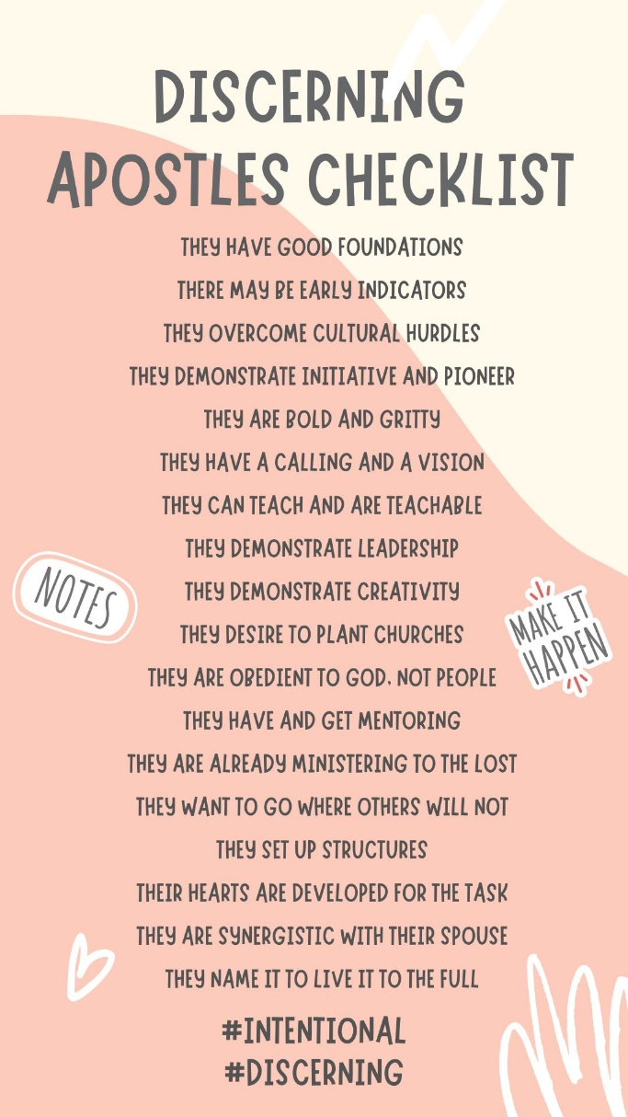

Questions for online group discussion once initial data has been collected and interpreted.

1. What themes in discernment of female apostles come from the WOI leaders survey?
2. What themes in discernment of female apostles come from the interviews?
3. What do similarities and differences in responses show us?
4. How could we build upon this research to structure discernment, recruitment and growth of female apostles?

**Annex 4: Communication back to the community and Partner Organization**

The MATUL is a degree in Theology, Missiology and Community Development. For security reasons I made mission organisation my community. At the time of writing, I have already presented to my community twice. A letter from my International Director was posted on WCIU Populi but not here for security reasons.

**Diagram 30: A Discerning for apostles checklist**

My first presentation was face to face with Mission Partners at a one-hour workshop during our Global Summit in Chiangmai. About forty people attended. I gave attendees a free hardcopy of my book *A Guide for Growing Prophets, Evangelists and Apostles*. WO provided an excellent afternoon tea as well. Mission Partners listened dutifully as I discussed my research to date.

My presentation was a PowerPoint with discussion and free questioning from the floor. I gave reflection questions and challenged them to conduct worthy experiments to find apostles, prophets and evangelists.

There was a good level of interest particularly from West African members where women in ministry has become a very divisive issue recently. A church planter asked my opinion on how to handle it. I suggested teaching his churches a women in ministry apologetic and that he should continue on training women for ministry as before. And don’t bother getting embroiled in the debate: just keep doing good.

I presented all my findings at length in my second community presentation to WO Mission Partners over Zoom. I had invited all interviewees, all one hundred and one Mission Partners who were asked to fill in the survey and a few interested friends.

This was, in fact, my Focus group. It was a group of about 12 MPs and Dr Viv Grigg attended as well. There was good interaction with MPs asking good questions. Most indicated that the research was helpful. Sadly no one committed doing any experiments.

**Responses from the Community and Partner Organization**

From my second presentation one MP, Arabella, decided to work with me to condense my forty-one themes into eighteen identifiers on a checklist. The result was Diagram 30, above. This is a much more useable list. Apart from that, frankly, there is has been little community interest generated in terms of MPs enquiring about setting up their own experiments to grow female apostles.

**Annex 5: Questions for Interview or a Written Application Using the Themes**

The more we know you, the more we understand your training and mentoring needs. This form requires you to tell your story. Please take your time and give us some detail.

|  |
| --- |
| **Family 1**  Tell us about your parents, their relationship, and their achievements.  Tell us how your parents coped with life.  How have mental health issues affected you and your family historically? |

|  |
| --- |
| **Teams 1**  Tell us about your experience of working in teams such as sports teams, study groups, bands and scouts.1 |

|  |
| --- |
| **Call 4, 14, 15, 16, 19**  What has God called you to do with your life? Please articulate what he has placed in your heart.  How did this call come to you? Describe your process and your interactions with God in that process?  What 1 Cor 12-14 and Ephesians 4 giftings are growing in your life?  If you’re in a romantic relationship, engaged or married does that significant other have a call that is synergistic with yours? |

|  |
| --- |
| **Leadership 2, 6, 7, 8, 9**  What can you point to as evidence demonstrated leadership?  Describe some things which you have initiated or pioneered such as social groups, sports groups, welfare or community programs.  Please provide examples of how you have been creative in leadership. |

|  |
| --- |
| **Grit 3, 15, 18**  Please provide examples of how you have demonstrated grit, determination, boldness and perseverance in your life to date. |

|  |
| --- |
| **Mentoring 10, 14, 15, 22**  What mentoring have you received along life’s way that has impacted you positively?  What negative experience of organizations or leaders have you had to work through to maintain trajectory to your calling? |

|  |
| --- |
| **The Lost 5, 8, 10, 11, 12, 13, 14, 16**  Explain your attitude towards the lost.  What have you done so far in your life to reach the lost?  What training have you had to reach the lost?  What price have you paid to reach the lost?  What mission or vision trips have you done? Where to? Purpose? |

|  |
| --- |
| **Vision 4, 16**  What vision is stirring in you for the lost?  How does your vision involve discipleship?  How does your vision involve discipling people in groups or communities?  Describe your interaction with the Lord in developing this vision. |

|  |
| --- |
| **Training 1, 5, 13, 16**  Please list up to five impactful training courses which you have completed.  Who has mentored you directly and indirectly till now?  What mentoring do you need now? |

**Annex 6: Discovery Bible Studies on Growing Apostles**

How do we grow apostles?

1. How did Jesus grow apostles?

Mark 3:13-14, Mark 6: 6-13, Luke 6:12-13

1. How long were the disciples with Jesus before he named some of them apostles?
2. What three things did Jesus call the apostles to do?
3. How can we “be with him” today?
4. How did three years of being with him affect the apostles?
5. There are four bible stories of Jesus sending the apostles. What did they have to do this time?
6. Describe the apostle’s training environment. What trajectory did this give them?
7. How did Barnabas grow an apostle?

Read Acts 9: 26-28, 11:19-26, 12: 25 – 13:1-13

1. Outline the process of Barnabas growing Paul
2. How much time did Barnabas give Paul?
3. Did Paul have a good foundation to build apostleship on?
4. What environment did Barnabas train Paul in?
5. At what point in Paul’s story is he called an apostle for the first time?
6. How do we see Barnabas’ humility in this story? How is he the grain of wheat that fell into the ground to die?
7. How did Paul grow apostles?

Read Acts 15: 36 - !6: 1-5

1. Why do apostles always have a team?
2. Why did Barnabas take Mark?
3. What foundations made Timothy a good potential choice as a budding apostle?
4. What environment did Silas, Mark and Timothy get mentored in?
5. How much time did Barnabas and Paul give their co-workers?
6. What do apostles do?

Read Romans 15: 17-29, Ephesians 2: 19-20, Luke 4: 14-21,

1. What foundation is Paul referring to in Romans and Ephesians?
2. What was the outworking of Paul’s vision?
3. What structures did Paul make to help complete the vision?
4. How do apostles join Jesus in proclaiming the jubilee (See Lev 25: 8-54)

**Annex 7: An Exegetical Study of 1 Timothy 2:11-15**

**An Exegetical Study of 1 Timothy 2:11-15**

All verses and headings taken from the NIV. Please read them first.

Timothy Charged to Oppose False Teachers

1:3As I urged you when I went into Macedonia, stay there in Ephesus so that you may command certain people not to teach false doctrines any longer 4or to devote themselves to myths and endless genealogies. Such things promote controversial speculations rather than advancing God’s work—which is by faith. 5The goal of this command is love, which comes from a pure heart and a good conscience and a sincere faith. 6Some have departed from these and have turned to meaningless talk. 7They want to be teachers of the law, but they do not know what they are talking about or what they so confidently affirm.

Instructions on Worship

2:1I urge, then, first of all, that petitions, prayers, intercession and thanksgiving be made for all people— 2for kings and all those in authority, that we may live peaceful and quiet lives in all godliness and holiness. 3This is good, and pleases God our Savior, 4who wants all people to be saved and to come to a knowledge of the truth. 5For there is one God and one mediator between God and mankind, the man Christ Jesus, 6who gave himself as a ransom for all people. This has now been witnessed to at the proper time. 7And for this purpose I was appointed a herald and an apostle—I am telling the truth, I am not lying—and a true and faithful teacher of the Gentiles. 8Therefore I want the men everywhere to pray, lifting up holy hands without anger or disputing. 9I also want the women to dress modestly, with decency and propriety, adorning themselves, not with elaborate hairstyles or gold or pearls or expensive clothes, 10but with good deeds, appropriate for women who profess to worship God. 11A woman should learn in quietness and full submission. 12I do not permit a woman to teach or to assume authority over a man; she must be quiet. 13For Adam was formed first, then Eve. 14And Adam was not the one deceived; it was the woman who was deceived and became a sinner. 15But women will be saved through childbearing—if they continue in faith, love and holiness with propriety.

**Linguistic issues**

To start with there are a number of linguistic issues to be aware of in this passage:

1. The Greek word 'woman' can also be translated ‘wife’ or even ‘female’.

1. The Greek word 'man' can be translated ‘husband’ or ‘male’.

1. The Greek word authority that appears in 2:12 appears only once in the New Testament. It can be translated as "usurp authority" (KJV, NIV), "rule over" (BBE), "exercise authority" (NET, NHEB, WEB) and "domineer" (LV).

1. The Greek word 'men' (1:8) can also be translated males or people. Clearly this is the case because women are at this meeting mentioned.

**Contexts**

The primary context of this letter gives many of the clues to a better hermeneutic. This we find in 1:3 - 7. Timothy was to commanded stop "certain people" (which is also translated "a certain one" by Thayer). Some had been led astray from a focussed life of faith to valueless activities such as genealogies (1:4), and meaningless talk, probably about Mosiac Law (1:6-7).

Paul says directly that the goal of the above command is love. Why? Clearly the believers were having difficulties loving each other with a pure heart, good conscience and a sincere faith (1:5). Why? Because some people, "certain ones," wanted to teach the Mosaic Law (the only existing “Bible” at that time) even though they didn't understand it.

There could be a variety of motivations as to why they were doing that. Clearly the interpersonal conflicts were stopping them loving each other. More detail of what was going on becomes very obvious later in the passage.

The second context in this passage is the location of the issue. It is in the meeting of the saints - a church meeting for corporate prayer. Now let's get to the where troublesome translation and interpretation begins.

**Exegesis**

In 2:1-8 Paul tells Timothy whom they are to pray for and why. The issues arise in the rest of the chapter. Let's look at them verse by verse. Bible translators and Bible expositors choices in translation affect the exegesis greatly and badly.

In 2:8 Paul commands "all people" to pray "without anger and disputing." Huh? He wouldn't mention it if it wasn't happening. People were getting angry at public corporate prayer meetings and getting into disputes. Nice work Christians! What are they arguing about? From the initial context it seems likely that it was the false teachings about the value of genealogies and the role of the Mosaic Law.

In 2:9 we get clues about where the disputes are coming from. Some of the women are making a problem. Paul addresses how women dress, "adorning themselves." He's talking about how they look. But he's not majoring on modesty in clothing but upon behaviour, particularly since these meetings are public. He's saying "dress yourselves in saintly behaviour" which is much more valuable than looking physically beautiful.

2:10. A side point here. Paul is not forbidding the wearing of jewellery, hairstyles nor nice clothes in this verse. He is merely stating what is really valuable in public. Disputing in public is bad in appearance. It is ugly dressing. A woman's "good deeds" include her behaviour in public because this is how godly women live. A good hermeneutic makes this verse equally applicable to men, but in the specific historical context it was women.

In 2:11-15 we come to the third context of this passage. This context is the relationship between husbands and wives in the church and how they related to each other. In these verses the Greek word 'woman' is singular. In 2:11 "a woman" can also be translated "a wife". And in 2:12 "a man" can be translated as "a husband". 2:13 confirms this as Paul's intention by addressing married couples here by referring to the first husband and wife, Adam and Eve.

Apparently, the Greek is a singular (a) woman and (a) man. In 2:11 Paul tells wives to learn in "quietness" (or calmness, meaning without disputing publicly with their husbands) and submissively. Submissively is not passively. Submissively is working humbly together for the good of all. Note that "quietness" (NIV) is not the same as "silence" (KJV). Women are meant to be active here in this context of a prayer meeting, but not arguing and disputing publicly with their husbands or others.

Are these verses talking to and about all women at all times? No. This is a localised issue in one church. In 1 Corinthians Paul writes about a man living in sexual immorality. Paul commands the man “be handed over to Satan”. We don’t know what that means, but we assume it isn’t going to be fun for him nor pleasant to watch from the outside. My point? If we want to apply this Scripture in 1 Timothy to all women at all times why aren’t we handing our fornicating and adulterous men over to Satan on a regular basis? Consistency is a harsh task master to us all.

This is my translation of 2:12: "I don't allow a wife to deliver didactic discourses to usurp authority over a husband but to be calm." What is going on here? Some of these women were publicly disputing with their husbands and then attempting to teach them in the church meeting. That's great way to throw ice water over a church meeting. Aaaawkard. No wonder Timothy had to make it stop!

In 2:13 Paul reminds them that Adam was formed first. Why? By actively disrespecting their husbands in public disputes these women had moved away from the mutual submission of marriage (see Ephesians 5:21) to putting themselves first. Paul reminds them that historically the man, the husband, was made first and by implication should be respected and honoured.

In 2:14 Paul warns the women in that church with this verse. Eve took the fruit because she was confident in her belief that what she was doing was going to be good for her. She had, in fact, deceived herself. She had wanted to be the wise one in the family but ended up a deceived sinner. These Ephesian women would do damage to themselves and their families, like Eve, if they didn't change their ways.

I've retranslated 2:15: "The wife will be healed (made whole) in childbearing if she continues in faith, love, holiness with self control." Other translations of 2:15 undermine Paul's own teaching about justification by faith. Therefore, we should ignore those translations.

So, what do we end up with now? Paul is still referring to Eve. Sin resulted in painful and often fatal childbirth (Gen 3:16) for all women. Paul actually gives a promise to wives here (only wives are meant to have babies, right?). He has humbled them in 2:14 reminding them that Eve was not living in submission and ended up deceived and with painful childbirth. But here Paul gives the promise of divine help with childbirth for women who live a life of faith, love, holiness and self control. He has, therefore leapt back to 1:5 to his original intent in sending the letter.

**A summary of this passage**

The Ephesian church was in trouble. Paul commanded Timothy to stop the problem. Some women were leading disputes in public prayer meetings. They were being disrespectful to their husbands in the process. This is ugly behaviour. Paul reminds the women about how to behave and live right in visible ways. He reminds them about the dangers of not being in submission with the reminder about Eve. By this I mean Eph 5:21 submission of husbands and wives to each other, not Eph 5:22 submission of wives only. He finishes with a promise for God's help in childbirth as a consequence of living right.

**Conclusions about this passage**

This is not a passage intended to stop women (females) teaching men (males). To teach that this is the intention of this passage is bad exegesis. It is probably eisegesis based upon historical and cultural assumptions.

This is not a passage intended to keep women out of leadership. In fact, women in leadership positions are not even close to what this passage is dealing with. If someone uses this passage to keep women out of leadership, their exegesis is bad.

This passage does not prove that women are more easily spiritually deceived than men. Paul uses the example of Eve's self-deception to make the point that mutual submission, faith and holiness are healthy and can help keep you from sin and deception. This passage is about focussing on the life of faith and living in mutual submission (honour, respect) particularly with one's spouse. Being *seen* to live correctly is important – let your light shine before all men, particularly in public, especially in church!

This passage does not forbid make up, jewellery, perfume and fancy clothes. These can make a person beautiful but biblical beauty is better seen through a harmonious, mutually submissive husband-wife team and churches that live that out.

This passage confirms that church meetings are to be decent and in order. Public disputes and anger are not appropriate. This passage teaches that a godly life is *visibly* beautiful. It doesn't damage the Scripture to say this applies to women AND men.

This passage teaches women to have hope in childbirth, that their righteousness can influence that process and undo in some way the consequences of Eve's sin. Healing and wholeness is there for them in child birth.

This verse in no way undermines other Scriptures where women lead a nation (Deborah), are prophets to the nation (Isaiah's wife), deacons (Phoebe) and even apostles (Junia). Rather, this verse actually confirms that all believers, male and female, play active roles in the Kingdom by living in love shown through mutual submission, faith, holiness and self-control.

This passage has been the centre of so much debate. It has been used to exclude women from ministry for centuries. I see a number of factors that have made matters worse:

1. Poor translation
2. Poor translation with preconceived cultural notions of women's roles
3. The wiles of Satan who wants half the redeemed saints, women, out of the game.